Work: The work done on a system by a constant force is the product of the component of the force in the direction of motion times the distance through which the force acts. For one-way motion in one dimension, this is expressed in equation form as
W=Fdcosθ
where W is work, F is the magnitude of the force on the system, d is the magnitude of the displacement of the system, and θ is the angle between the force vector F and the displacement vector d.
Work- energy Theorem
The net work on a system is equal to difference between final kinetic energy to initial kinetic energy. Let’s the net force is parallel to the displacement, so angle is zero. The net work is done by
$$W=F_{net}S$$
$$W=m\left(aS\right)---(1)$$
The effect of the net force accelerates the object from V0 to V. We know $V^{2}=U^{2}+2as$
$$V^{2}-U^{2}V^{2}-U^{2}=2as$$
$$as=\frac{1}{2}\left(V^{2}-U^{2}\right)----(2)$$
From equation (1) and (2),
$$W=\frac{1}{2}mV^{2}-\frac{1}{2}mU^{2}$$
$$W=K_{f}-K_{i}---(verified)$$
Friction
What is Frictional force:
Frictional force is the resistive force that acts opposite to the direction of motion when two surfaces come into contact and try to slide past each other. It’s a contact force meaning it only exists when objects are physically touching and it plays a crucial role in everyday life, from walking to driving to writing.

Key Characteristics of Frictional Force
- Direction: Always acts opposite to the direction of motion or attempted motion.
- Cause: Arises due to microscopic irregularities and interlocking between surfaces.
Frictional force arises due to the electromagnetic interactions between the molecules of two surfaces in contact. Even seemingly smooth surfaces have microscopic irregularities, and when they come into contact, these tiny bumps and valleys interlock. As one surface tries to move over the other, molecular adhesion and resistance to deformation create opposition to motion. This resistance converts some kinetic energy into heat, making friction both a mechanical and thermodynamic phenomenon. The stronger the normal force pressing the surfaces together and the rougher the textures, the greater the frictional force. Thus, friction is not merely a result of surface roughness but also of molecular-level forces that resist relative motion.
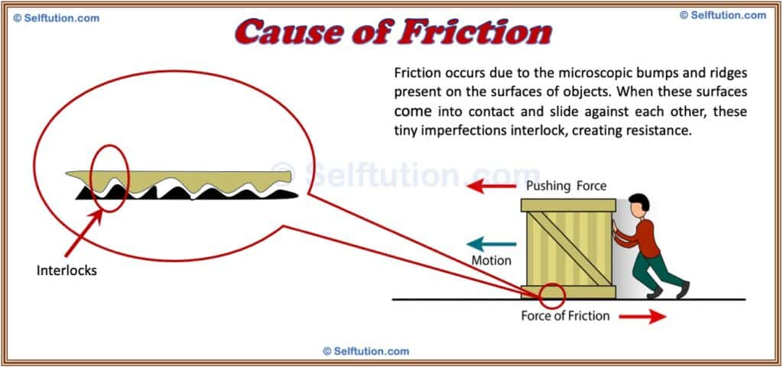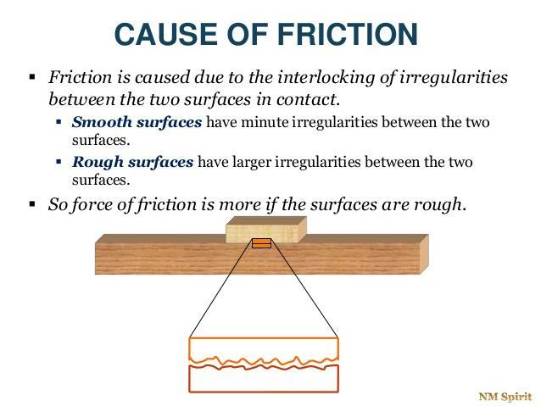
Changing Frictional force with applied external force
$$N$$
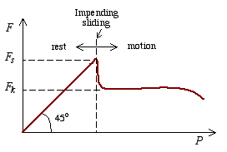
$$N=W=mg$$
$$S$$
$$W$$
$$F$$
λ
$$f_{s}$$

- If the body does not move, then the static frictional force and the component of F that is parallel to the surface are equal in magnitude and are oppositely directed.
- The ratio of the magnitude of the maximum force of static friction to the magnitude of the normal force is called the coefficient of static friction for the surface involved. If fs represents the magnitude of the force of static friction, we can write coefficient of static friction as,
$$μ=\frac{f_{s}}{N}$$
If the magnitude of the component of the F that is parallel to the surface exceeds fs_{max} then body begin to slide along the surface.
Equation to follows:
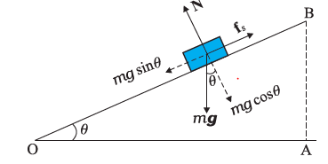
$$N=mgCosθ$$
$$f_{s}=μN=μmgCosθ$$

$$F$$
$$F$$
$$f$$

X-direction |  | Inclination
Smooth Surface | Rough Surface | Smooth Surface | Rough Surface
Without friction | With friction | Without friction | With friction
$$∑F=ma$$  $$F=ma$$  F=External force | $$∑F=ma$$  $$F-f=ma$$  $$F-μN=ma$$  If external force F=0  $$-μN=ma$$ | $$∑F=ma$$  $$mgSinθ=ma$$ | $$∑F=ma$$  $$mgSinθ-μmgCosθ=ma$$
Acceleration  $$a=\frac{F}{m}$$ | Acceleration  $$a=\frac{F-μN}{m}$$ | Acceleration  $$a=gSinθ$$ | Acceleration  $$a=\frac{mgSinθ-mμgCosθ}{m}$$
Final Velocity  $$V^{2}=U^{2}+2as$$ | Final Velocity  $$V^{2}=U^{2}+2\left(\frac{F-μN}{m}\right)s$$ | Final Velocity  $$V^{2}=U^{2}+2gSinθs$$ | Final Velicity  $$V^{2}=U^{2}+2\frac{mgSinθ-mμgCosθ}{m}s$$
Time  $$S=ut+\frac{1}{2}at^{2}$$  If initial velocity is U=0  $$t=\sqrt{\frac{2s}{a}}$$ | Time  $$S=ut+\frac{1}{2}at^{2}$$  If initial velocity is U=0, a=$\frac{F-μN}{m}$  $$t=\sqrt{\frac{2s}{\frac{F-μN}{m}}}$$ | Time  $$S=ut+\frac{1}{2}at^{2}$$  If initial velocity is U=0  $$t=\sqrt{\frac{2s}{gSinθ}}$$ | Time  $$S=ut+\frac{1}{2}at^{2}$$  If initial velocity is U=0  $$t=\sqrt{\frac{2s}{mgSinθ-mμgCosθ}}$$

Angle of friction  The angle of friction is the angle between the resultant of the normal force and the limiting frictional force when an object is just about to slide over a surface. From Figure-2  $$N=SCosλ (1)$$  $$f_{s}=SSinλ (2)$$  Taking its ratio  $$μ_{s}=\frac{f_{s}}{N}=tanλ$$  The tangent of the angle of friction is equal to the coefficient of static friction. | Angle of repose  It is the maximum angle between the surface of a pile and the horizontal ground at which the material stays in place without movement.  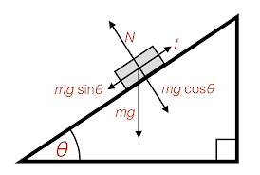  We can write $N=mgcosθ$  $$and f_{s}=mgsinθ$$  $$μ{}_{s}=\frac{f_{s}}{N}=tanθ$$  $$tanθ=tanλ$$  $$θ=λ$$  So, the angle of repose is equal to angle of friction.
Kinetic friction  kinetic friction comes into play after motion has started and always acts in the opposite direction to the movement.  Kinetic friction co-efficient: It is the ratio of the kinetic frictional force to the normal force acting between two surfaces in relative motion:  $$μ{}_{K}=\frac{f_{K}}{N}$$  If a body of mass m sliding over a surface with kinetic friction co-efficient after applying force F then the equation of motion is given by,  $$F-f_{K}=ma$$  $$a=\frac{F-f_{K}}{m}$$ | Problem: A 10 Kg box rests on a surface with a coefficient of static friction 0.4 and a coefficient of kinetic friction of 0.3. What is the maximum static friction and the kinetic friction?  Answer: Normal force = Weight of the object=mg=10*9.8=98N  Maximum static friction $f_{sMax}=μ*N=39.2$  Maximum kinetic friction $f_{kMax}=μ*N$=29.4
Problem 2: A block is projected along a rough horizontal road with a speed of 10m/s. If the coefficient of kinetic friction is 0.10, how far it will travel before coming to rest? g=10m/s^2  Answer: Net force=ma  $$0-f_{k}=ma$$  $$-μ*N=ma$$  $$-μ*mg=ma$$  $$-μg=a$$  $$a=-\left(0.1\right)*\left(10\right)=-1ms^{2}$$  Now  $$V^{2}=U^{2}+2as$$  $$0^{2}={10}^{2}+2\left(-1\right)s$$  $$s=50m.$$ |   Problem Case-1: A block slides down an inclined surface of inclination with the horizontal. Starting from rest it covers 8m in the first two seconds. Find the coefficient of kinetic friction between the two.  Answer:  Here $N=mgCos30°$  Total force =ma  $$mgsinθ-f_{k}=ma$$  $$mgsinθ-μ_{K}N=ma$$  $$mgsinθ-μ_{K}mgCosθ=ma$$  $$gsinθ-μ_{K}gCosθ=a$$  $$9.8*sin30°-μ_{K}*9.8*Cos30°=a-----(1)$$  Since u=0, s=8, t=2sec  From equation of motion,  $$s=ut+\frac{1}{2}at^{2}$$  $$a=4ms^{-2}---------\left(2\right)$$  From equation (1) and (2) we get,  $$9.8*sin30°-μ_{K}*9.8*Cos30°=4$$  $$μ_{K}=0.11$$  2nd Case: If we pushed down the block with 4N and the block mass is 4kg and friction $μ_{K}=0.11$ . Then what will be the case,  Total force =ma  $$F+mgsinθ-f_{k}=ma$$  $$4+4\left(10\right)sin30°-μ_{K}N=ma$$  $$4+4\left(10\right)sin30°-0.11*4\left(10\right)Cos30°=4a$$  $$a=5ms^{-2}$$  Since u=0, a=5ms-2, t=2sec  From equation of motion,  $$s=ut+\frac{1}{2}at^{2}$$  $$s=10m---------\left(2\right)$$

Problem: Two blocks are released from rest at the same point B on the top of a track. Use g=9.80 ms⁻²
B

M’=20kg
D

C

A

$$θ=30°$$
$$θ'=45°$$
S’=30m
S=15m
M=40kg

Which block reaches the ground first?
- Find the time to reach at the bottom A for block M  Answer: On a rough surface, the length along AC is A$C=d=SCos45=15Cos30°$  $$d=ut+\frac{1}{2}(gSinθ-μgCosθ)t^{2}$$  $$t=\sqrt{\frac{2d}{gSinθ-μgCosθ}}$$ | - Find the time to reach at the bottom C for block M’  Answer: For smooth surface, the length along BC is $BC=d=S’Cos45=30Cos45°$  $$d=ut+\frac{1}{2}gSinθt^{2}$$  $$t=\sqrt{\frac{2d}{gSinθ}}$$
- Velocity at point A  Answer: $V^{2}=U^{2}+2as$  $$V^{2}= 2s\left(gSinθ-μgCosθ\right)$$ | - Velocity at point C  Answer: $V^{2}=U^{2}+2as$  $$V^{2}=2sgSinθ$$
- Calculate friction coefficient for which object will be static on rough plane.
Answer: The net force on object is
$$∑F=ma$$

$$mgsinθ-μmgcosθ=ma$$
Here a=0
$$mgsinθ=μgcosθ$$
$$tanθ=μ$$

- What is friction?
Friction is a force that resists the motion of objects when they slide, roll, or move through a fluid. It acts in the opposite direction of movement and is caused by surface irregularities and molecular interactions.
2. What are the main types of friction? There are four main types:
- Static friction (prevents motion)
- Kinetic/sliding friction (acts during motion)
- Rolling friction (when objects roll)
- Fluid friction (resistance in liquids or gases)
- What is static friction and when does it occur?
Static friction occurs when an object is at rest and a force is applied. It prevents the object from moving until the applied force exceeds the maximum static friction.
- What is kinetic friction and how is it different from static friction?
Kinetic friction acts on moving objects. It is usually weaker than static friction because once motion starts, fewer surface irregularities remain locked together.
- What is the coefficient of friction (μ)?
It’s a dimensionless number that represents how much friction exists between two surfaces. It depends on the materials involved and whether the friction is static or kinetic.
- How does surface texture affect friction?
Rough surfaces have more microscopic bumps and ridges, increasing friction. Smooth surfaces reduce contact points and therefore lower friction.
- What role does normal force play in friction?
The normal force is the perpendicular force pressing two surfaces together. Greater normal force increases friction because it enhances contact between surfaces.
- How can friction be reduced in machines?
By using lubricants like oil or grease, adding ball bearings, or designing smoother surfaces, engineers reduce friction to improve efficiency and reduce wear.
- Is friction always a disadvantage?
No! Friction is essential in many situations—like walking, driving, or writing. Without it, we’d slip constantly and machines wouldn’t function properly.
- What is fluid friction and where is it observed?
Fluid friction occurs when objects move through liquids or gases. Examples include air resistance on a car or drag on a swimmer in water.

