**Bikroy.com**

**Issue**: Accepting wrong email address for signup

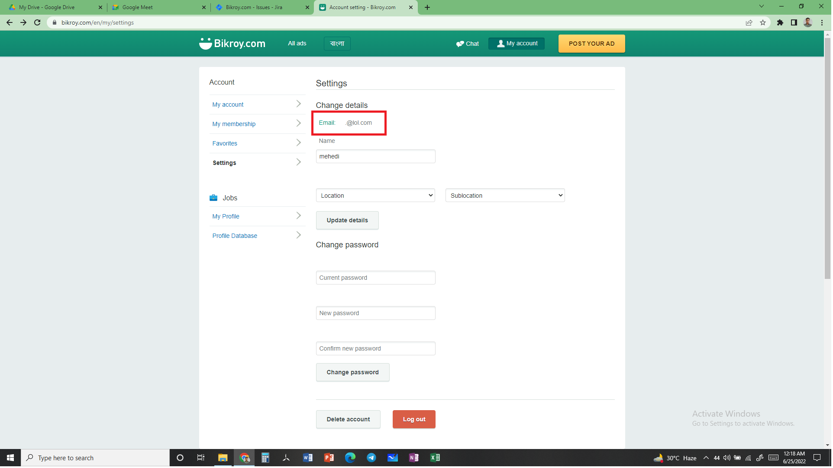

Description:

* Go to URL = bikroy.com
* Click on login button.
* Click on continue with email.
* Click on sign up button.
* Enter wrong email address
* Enter valid data for other fields.
* Click on sign up button to create account.
* It will accept the wrong email to create new account

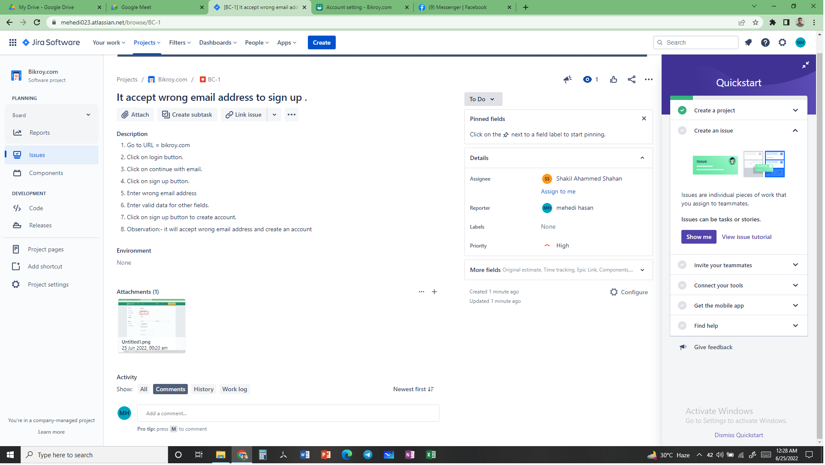

Description: The work was assigned to Shakil Ahammed Shahan for solving the issue.

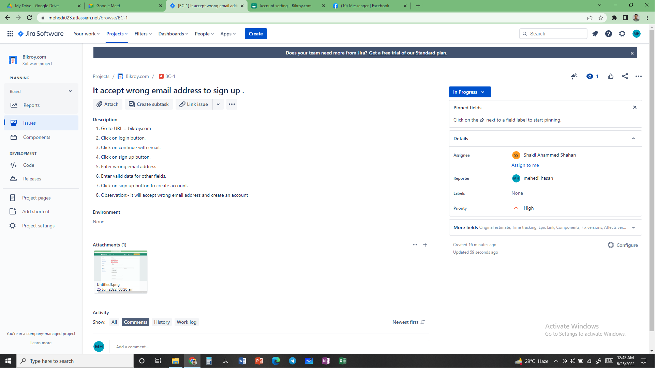

Description: The developer was working and it was in progress stage.

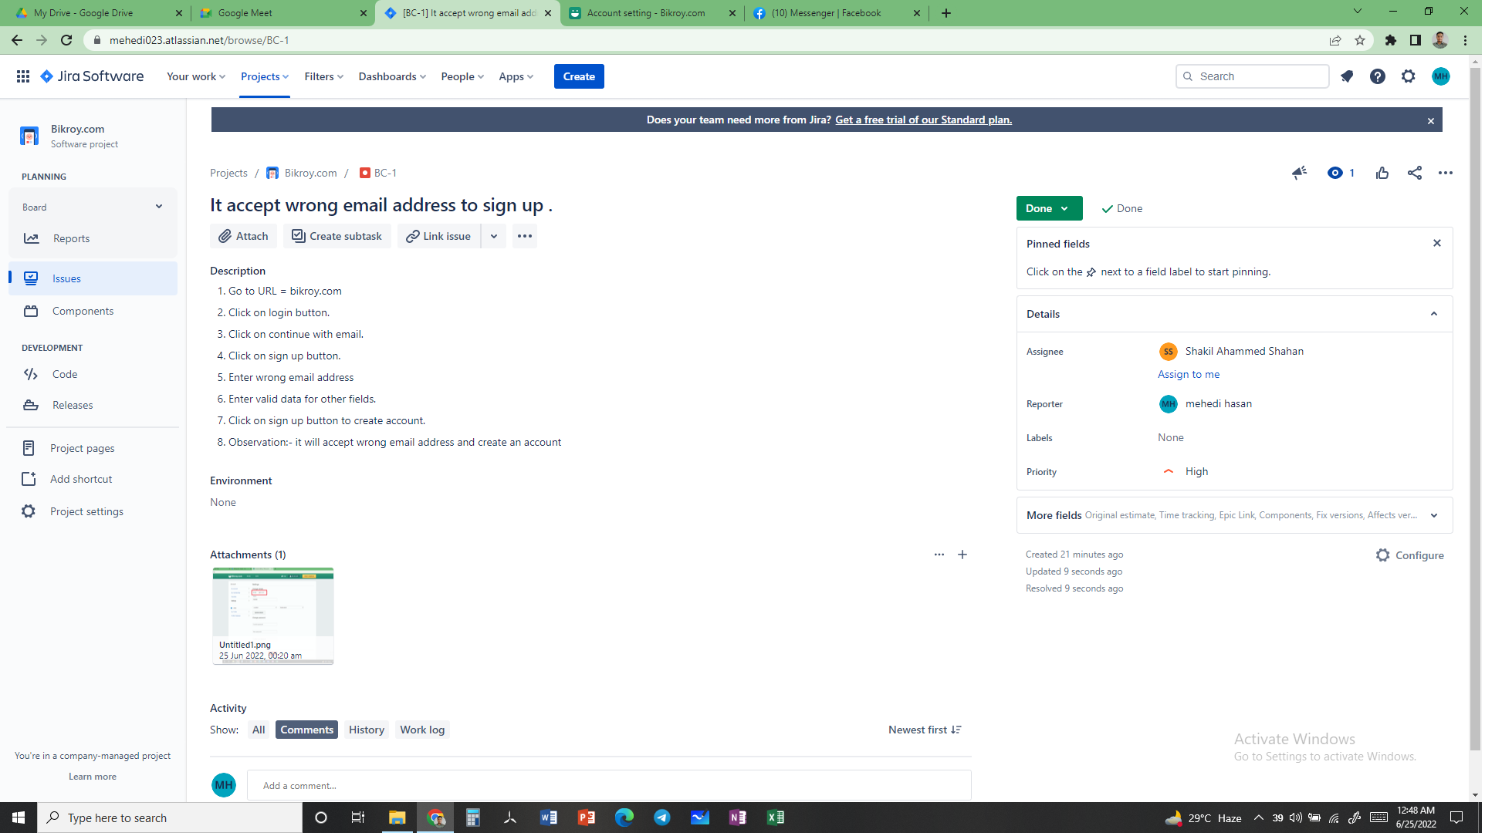

Description: Developer completed the work and the work is done.