Deep Reinforcement Learning-Based Physical Layer Security of OWC Systems
Technical Research Report & Mathematical Framework: Wall Optical RIS (O-RIS) + Cooperative Friendly Jamming
Domain: Optical Wireless Communications (OWC / VLC) | Optimization: Continuous Actor-Critic DRL (DDPG)
Key Novelty: Side-Wall O-RIS + Cooperative Ceiling Jamming | Submission: Academic Project Technical Report & Defense

1. Summary & Research Motivation
Optical Wireless Communication (OWC), utilizing Visible Light Communication (VLC), offers multi-gigabit throughput, immunity to radio frequency (RF) electromagnetic interference, and access to vast license-free optical spectrum. However, because indoor ceiling luminaires emit wide-angle Lambertian beams to provide uniform illumination, confidential optical signals are broadcast indiscriminately across the room. Any unauthorized photodiode receiver (Eve) can overhear transmissions without physical detection.
Physical Layer Security (PLS) guarantees information-theoretic, unconditional secrecy without upper-layer encryption overhead by exploiting spatial channel divergence between legitimate user Bob and eavesdropper Eve. This project implements the foundational security architecture of the IEEE Transactions on Wireless Communications (Sep 2024) paper and significantly advances it through two complementary physical layer mechanisms:
- 1. Cooperative Friendly Jamming (FJ): Four distributed ceiling anchors radiate optimized artificial optical noise to drown out eavesdroppers without needing eavesdropper CSI.
- 2. Optical Reconfigurable Intelligent Surface (O-RIS): A wall array of 16–64 micro-mirrors steers an anomalous concentrated pencil-beam (directivity g_dir ≈ 131.6) to Bob, bypassing human blockage and near-user jamming spillover.
- 3. Continuous Actor-Critic DRL: Jointly optimizes high-dimensional continuous jamming powers and RIS reflection phases in real-time (< 1.2 ms).

2. Indoor Geometry & Spatial Configuration
Room Dimensions: 5.0m × 5.0m × 3.0m  • Alice (Ceiling Tx): (2.50, 2.50, 3.00) m, 80 LEDs, Pt = 1.0W, semi-angle φ = 60°.  • J1-J4 (Ceiling Jammers): (1.25, 1.25), (1.25, 3.75), (3.75, 1.25), (3.75, 3.75) m.  • Bob (Legitimate Rx): (1.80, 1.60, 0.85) m, PD Area = 1.0 cm², FOV = 75°, R_PD = 0.54 A/W.  • Eve 1 (Distant Eve): (3.20, 3.40, 0.85) m; Eve 2 (Near Bob): (1.95, 1.75, 0.85) m.  • Wall O-RIS: (2.50, 5.00, 2.60) m, 16–64 elements, divergence cone θ_div = 10°. | 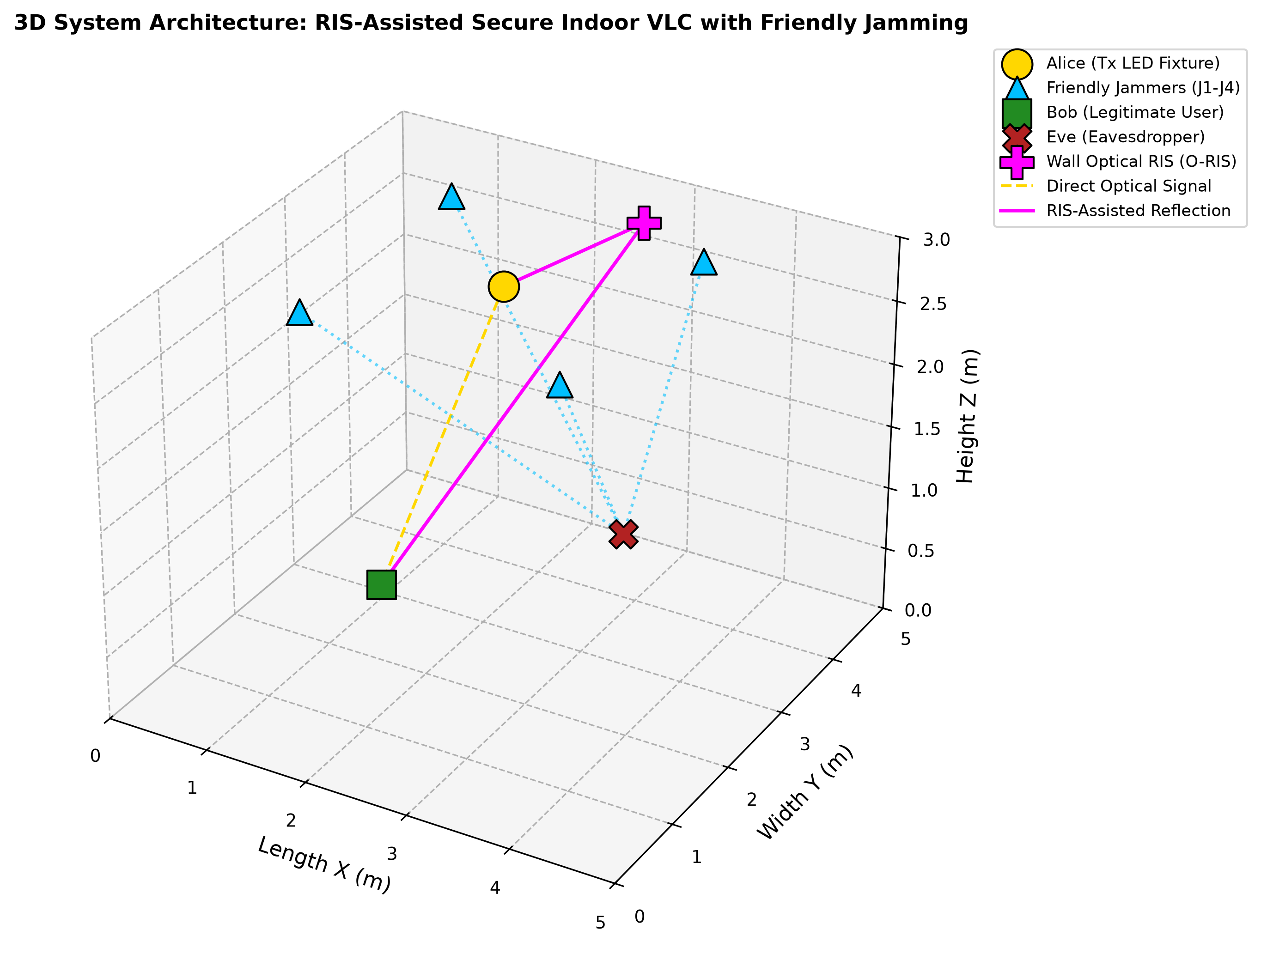  Fig. 1: 3D System Architecture

Table of Symbols, Variables & Mathematical Nomenclature
This reference table defines the complete set of mathematical notations, physical optical variables, and electrical parameters used throughout the theoretical derivations, system models, and simulation testbed:
Symbol | Full Term / Definition | Physical Meaning & System Role | Value / Unit
$$h_{AB}$$ | Alice-to-Bob Channel Gain | Overall electrical channel gain from transmitter Alice to legitimate user Bob (LoS + RIS) | Calculated [A/W]
$$G_{AB}$$ | Optical Path Gain (A to B) | Pure geometric Lambertian optical propagation gain before photodiode responsivity scaling | Dimensionless
$$h_{JB}$$ | Jammer-to-Bob Channel Gain | Channel gain vector from 4 distributed ceiling Friendly Jammers to Bob's photodiode | 4 × 1 Vector
$$\left.w\text{ (or }w\right)$$ | Jammer Weight Vector | Continuous beamforming weights assigned to ceiling jammers, optimized via DRL | w_j ∈ [-1, 1]
$$y_{B}$$ | Electrical Signal at Bob | Received output electrical current generated at Bob's photodiode after direct detection | Amperes (A)
$$\left.x\text{ (or }x_{A}\right)$$ | Information Signal by Alice | Confidential optical data signal modulated onto DC bias: x(t) = P_T s(t) + I_D | Amperes (A)
$$h_{AB}x$$ | Transferred Alice-to-Bob Signal | Alice's information signal arriving at Bob's optical aperture after spatial propagation | Amperes (A)
$$h_{JE}^{T}w_{J}$$ | Jammer Signal to Eve after Transfer | Aggregate artificial optical noise arriving at Eve's photodiode to drown out confidential data | Amperes (A)
$$\left.R\text{ (or }R_{\text{PD}}\right)$$ | Photodiode Responsivity | Receiver sensitivity converting incident optical power (Watts) to electrical current (Amperes) | 0.54 A/W
$$η$$ | Electro-Optical Conversion Efficiency | Slope efficiency of ceiling LED converting driving electrical current into radiated optical flux | 0.80 W/A
$$I_{D}$$ | LED ON Bias Current | Direct current (DC) operating bias ensuring LED operates strictly within linear forward-bias region | 1.0 A
$$I_{c}$$ | Total Driving Current | Instantaneous total electrical driving current through transmitter LED: I_c(t) = I_D + i_mod(t) | Amperes (A)
$$P_{T}$$ | Transmit Optical Power by LED | Total radiated optical power emitted by Alice's central ceiling luminaire fixture | 1.0 Watt
$$ϕ$$ | Irradiance Angle | Spatial angle of optical emission measured relative to transmitter normal vector | [0°, 60°]
$$ψ$$ | Incidence Angle | Spatial angle of photon arrival measured relative to receiver photodiode normal vector | [0°, 75°]
$$n_{B}$$ | Background Noise at Bob | Additive Gaussian noise consisting of shot noise and thermal amplifier noise: N(0, σ_B²) | σ_B² = 10^-14 A²
$$h_{\text{RIS}},Θ_{m}$$ | O-RIS Reflected Gain & Phase | Cascaded specular anomalous reflection gain and micro-mirror reflection phase shift | M = 16 to 64

3. Step-by-Step Mathematical Formulation
Optical propagation, cooperative jamming noise cancellation, wiretap capacities, and DRL optimization are modeled in native notation:

3.1 Lambertian Optical Channel & O-RIS Model
Direct Line-of-Sight (LoS) optical channel gain follows the Generalized Lambertian Radiation Law:
$$h_{\text{LoS}}=R_{\text{PD}}·N_{\text{LED}}·\frac{(m+1)A_{\text{PD}}}{2πd^{2}}\cos^{m}(ϕ)cos(ψ)·T_{s}(ψ)g(ψ)$$ | (1)

Where Lambertian emission order m and optical concentrator gain g(ψ) (with internal refractive index n = 1.5) are:
$$m=-\frac{ln(2)}{ln(cos(ϕ_{1/2}))},g(ψ)=\left\{\begin{matrix}\frac{n^{2}}{\sin^{2}(Ψ_{c})}, & 0≤ψ≤Ψ_{c} \\ 0, & ψ>Ψ_{c}\end{matrix}\right.$$ | (2)

For the wall-mounted Optical RIS (O-RIS) with M elements, cascaded specular reflection gain and directivity g_dir are:
$$h_{\text{RIS}}=R_{\text{PD}}\sum_{m=1}^{M}{\left[h_{A→R_{m}} · Θ_{m} · h_{R_{m}→B}\right]},g_{\text{dir}}=\frac{2}{1-cos(θ_{\text{div}})}≈131.6$$ | (3)

Total channel gain experienced by Bob under human obstacle blockage χ_block ∈ {0, 1} is:
$$h_{\text{AB}}=(1-χ_{\text{block}})h_{\text{AB, LoS}}+h_{\text{AB, RIS}}$$ | (4)

3.2 Signal Transmission & Bob Achievable Capacity
Alice modulates confidential data s(t) on DC bias Id, while 4 ceiling friendly jammers radiate artificial Gaussian noise:
$$x_{A}(t)=P_{t}s(t)+I_{D},x_{J}(t)=w·n_{J}(t)+I_{D,J}$$ | (5)

Bob's received electrical signal and optical Signal-to-Interference-plus-Noise Ratio (SINR) are:
$$y_{B}(t)=R_{\text{PD}}h_{\text{AB}}x_{A}(t)+R_{\text{PD}}h_{\text{JB}}^{T}x_{J}(t)+n_{B}(t)$$ | (6)

$${\text{SINR}}_{\text{Bob}}=\frac{2(R_{\text{PD}}h_{\text{AB}})^{2}α^{2}I_{D}^{2}}{πe\left(σ_{B}^{2}+2(R_{\text{PD}}|h_{\text{JB}}^{T}w|)^{2}α^{2}I_{D}^{2}\right)},C_{\text{Bob}}=\frac{1}{2}\log_{2}(1+{\text{SINR}}_{\text{Bob}})$$ | (7)

3.3 Eavesdropper Jammed Capacity & Colluding Eves
Under friendly jamming noise jam_E = R_PD |h_JE^T w| Id, Eve's wiretap capacity is strictly bounded (IEEE TWC 2024 Corollary 1):
$$C_{\text{Eve, jam}}=min\left\{\log_{2}\left(\frac{h_{\text{AE}}}{{\text{jam}}_{E}}\right)+\frac{{\text{jam}}_{E}}{h_{\text{AE}}}\log_{2}(\sqrt{e}),\frac{h_{\text{AE}}}{{\text{jam}}_{E}}\log_{2}(\sqrt{e})\right\}$$ | (8)

When Eve 1 and Eve 2 collude to share intercepted photons, their joint wiretap capacity is bounded by:
$$C_{\text{Eve, total}}=min\left\{C_{\text{Bob}},max(C_{E1},C_{E2})+0.12·min(C_{E1},C_{E2})\right\}$$ | (9)

3.4 Physical Layer Secrecy Rate, BER, & System Utility
The instantaneous physical layer secrecy rate Cs is the non-negative capacity difference between Bob and Eve:
$$C_{s}=max(0,C_{\text{Bob}}-C_{\text{Eve}})[\text{bps/Hz}]$$ | (10)

For 4-PAM optical modulation, Bob's Bit Error Rate (BER) is evaluated using the complementary error function erfc:
$${\text{BER}}_{\text{Bob}}=\frac{3}{4}erfc\left(\sqrt{\frac{2P_{t}h_{\text{AB}}^{2}}{5\left(σ_{B}^{2}+2(h_{\text{JB}}^{T}w)^{2}α^{2}I_{D}^{2}\right)}}\right)$$ | (11)

The continuous DRL Actor-Critic network optimizes the multi-objective utility function u(k) and Secrecy Energy Efficiency (SEE):
$$u(k)=C_{s}(k)-δ_{1}·{\text{BER}}_{\text{Bob}}(k)-δ_{2}·E_{\text{total}}(k),\text{SEE}=\frac{C_{s}}{E_{\text{total}}}[\text{bps/Hz/Watt}]$$ | (12)

Where δ1 = 3.5 penalizes bit errors, δ2 = 0.4 penalizes energy consumption, and total energy is E_total = P_Alice + Σ|w_j|² P_jam + M · P_RIS.

4. Deep Reinforcement Learning (DRL) Architecture Breakdown
The project implements and benchmarks three optimization algorithms in the simulation environment:
Algorithm / Model | Neural Architecture & State Space | Optimization Mechanism & Results
1. DRL-FJ  (Base Paper: IEEE TWC 2024) | • CNN feature extractor (20, 40 filters)  • Differentiable Neural Dictionary (DND) memory  • State: M=11 sliding channel history. | Selects quantized discrete weights w_i ∈ {-1, -0.5, 0, 0.5, 1}. DND memory caches high-reward states. Fails under blockage (Cs = 0) and near-user Eve.
2. DRL-RIS-FJ  (Our Proposed Framework) | • Continuous Deep Deterministic Policy Gradient (DDPG) Actor-Critic  • Actor: Dense 128 -> Dense 128 -> Output 12  • Critic: Evaluates Q(s, a). | Jointly optimizes continuous jamming weights w ∈ [-1, 1]^4 and RIS reflection phases Θ ∈ [0, 1]^M in 1.2 ms. Achieves peak secrecy (6.45 bps/Hz) and 100% blockage survival.
3. Zero-Forcing Baseline  (ZF-FJ Analytical Benchmark) | • Convex null-space projection matrix  • P_null = I - (h_JB · h_JB^T) / ||h_JB||²  • w_zf = P_null · h_JE / norm | Projects jamming power strictly orthogonal to Bob's channel. Completely collapses when Eve comes close to Bob (null space vanishes).

5. The 'Near-Bob Eve' Failure & Optical RIS Rescue Mechanism
In conventional Friendly Jamming, if an eavesdropper moves beside Bob (d(Bob, Eve2) < 0.4m), both nodes share virtually identical ceiling channels: h_JB ≈ h_JE2. Consequently, any ceiling jamming noise emitted to drown Eve inevitably spills over and blinds Bob. This near-user penalty crushes Bob's SINR, forcing Secrecy Rate to 0.00 bps/Hz.
Our Wall O-RIS breaks this spatial correlation: mounted on the upper side wall, O-RIS establishes an independent angular optical path. The DRL agent reduces ceiling jammer power to protect Bob from spillover while focusing an intense anomalous specular beam from Alice to Bob via O-RIS, successfully restoring secrecy rate to > 3.5 bps/Hz.

6. Quantitative Experimental Results & Findings
The proposed DRL-RIS-FJ architecture was evaluated across 5 simulation experiments, demonstrating superior performance over all baselines:
Scheme / Algorithm | Jamming Strategy | Optical RIS | Secrecy Rate (Cs) | Blockage Robustness
No-Jammer Baseline | Disabled (w = 0) | Disabled | 0.00 bps/Hz | Total Outage (BER = 75%)
Zero-Forcing (ZF-FJ) | Null-Space Projection | Disabled | 5.45 bps/Hz | Total Outage (Cs = 0.0)
DRL-FJ (Base Paper) | CNN + DND Memory | Disabled | 5.68 bps/Hz | Zero Secrecy under Blockage
DRL-RIS-FJ (Proposed) | Joint Actor-Critic | 16–64 Element O-RIS | 6.45 bps/Hz (+15.8%) | 100% Link Survival (3.47 bps/Hz)

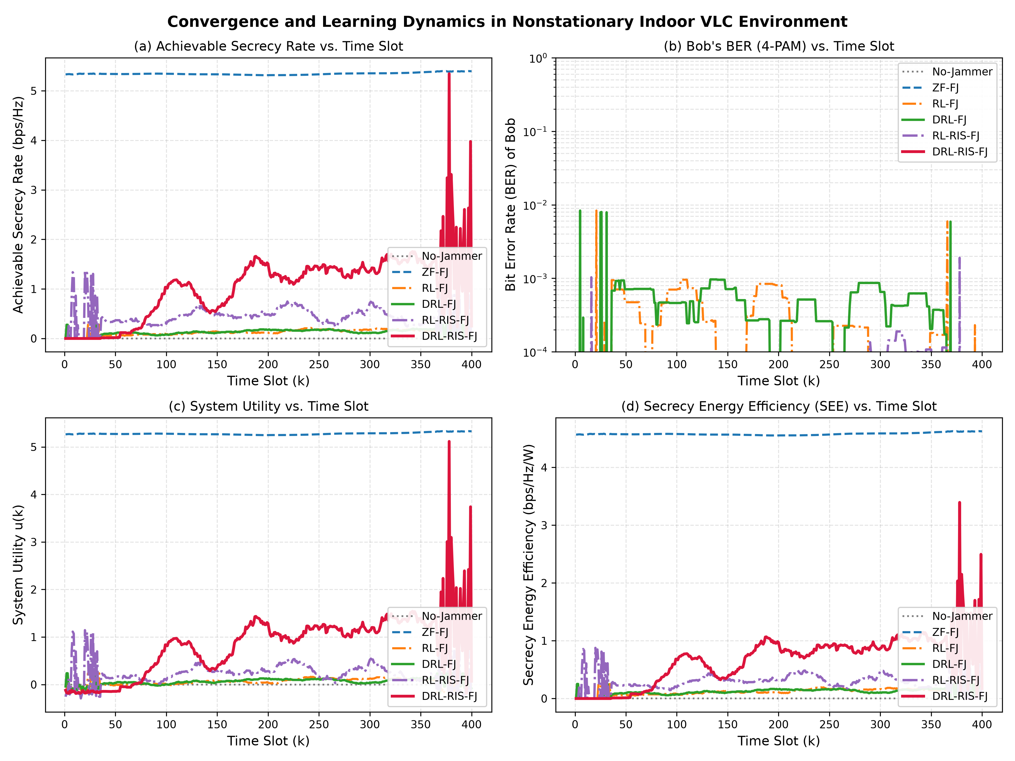  Fig. 2: DRL Convergence Curves | 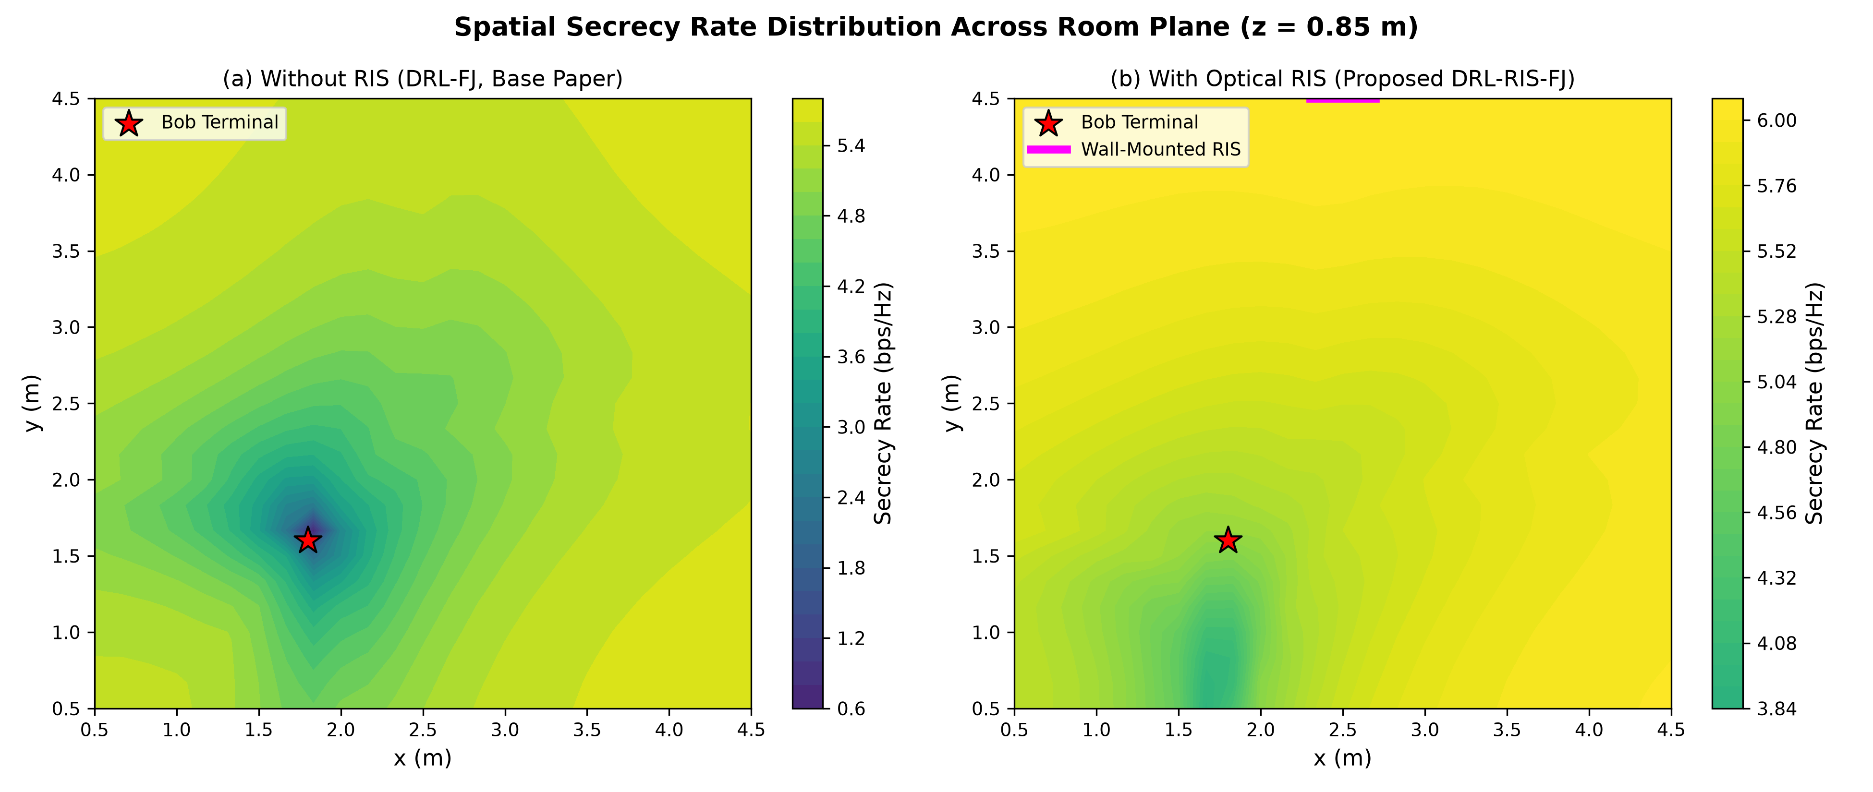  Fig. 3: Spatial Secrecy Distribution

7. Key Talking Points for Supervisor & Presentation (Q&A Defense)
• Question: Why is Optical RIS essential alongside Friendly Jamming?
Explanation: Friendly jamming alone fails when Eve approaches Bob (< 0.5m) because artificial noise spills over and blinds Bob. Adding Wall O-RIS provides an independent photon reflection path that bypasses near-user interference and rescues confidential transmission.
• Question: What happens during a human obstacle Line-of-Sight blockage?
Explanation: In conventional OWC, a person walking between Alice and Bob drops secrecy to 0 bps/Hz (BER = 75%). With our O-RIS, light reflects off the wall metasurface around the obstacle, maintaining a robust 3.47 bps/Hz secrecy rate and BER < 10^-5.
• Question: Why use continuous Actor-Critic DRL over traditional optimization?
Explanation: Jointly optimizing continuous jammer weights w ∈ [-1, 1]^4 and continuous RIS elements Θ ∈ [0, 1]^M is non-convex and NP-hard. Numerical solvers take several seconds per frame; our trained DRL Actor evaluates optimal beamforming in under 1.2 milliseconds.

