* Annotations

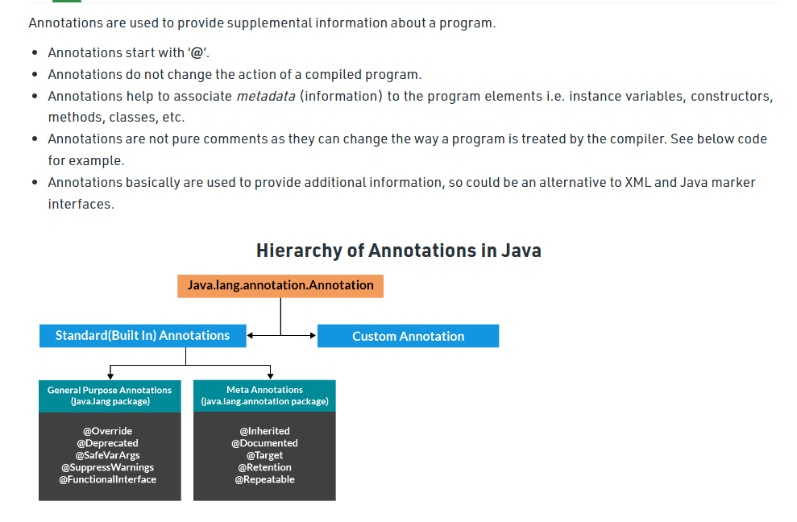

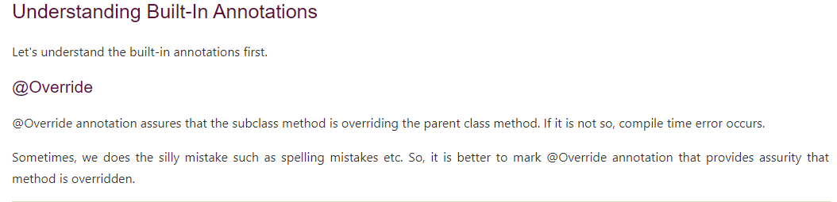

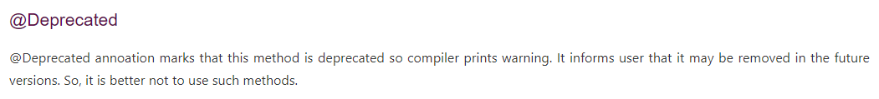

* Reflection



