* Exceptions

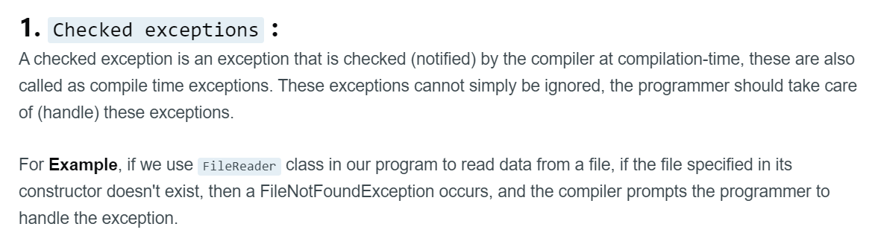

* Finally

Java finally block is a block used to execute important code such as closing the connection, etc.

Java finally block is always executed whether an exception is handled or not. Therefore, it contains all the necessary statements that need to be printed regardless of the exception occurs or not.

The finally block follows the try-catch block.

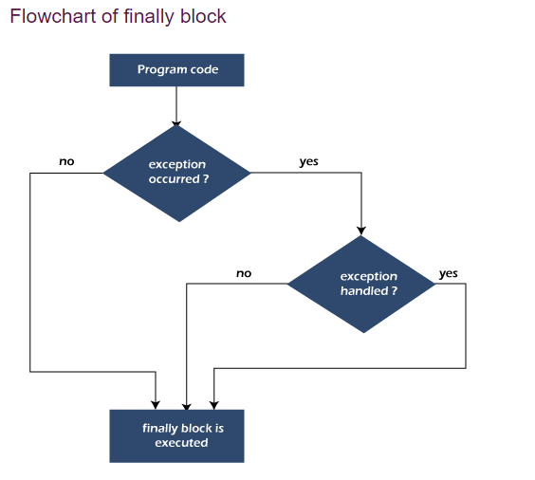

* Throw

The throw keyword in Java is used to explicitly throw an exception from a method or any block of code. We can throw either [checked or unchecked exception](https://www.geeksforgeeks.org/checked-vs-unchecked-exceptions-in-java/).

The throw keyword is mainly used to throw custom exceptions.

* Throws

The **Java throws keyword** is used to declare an exception. It gives an information to the programmer that there may occur an exception. So, it is better for the programmer to provide the exception handling code so that the normal flow of the program can be maintained.

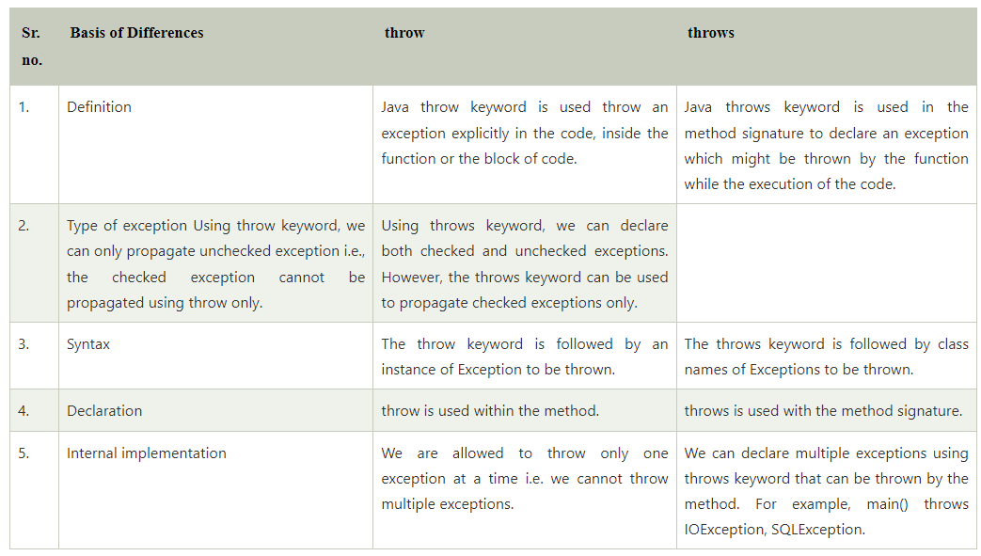

* Rethrow

The exception we caught in catch block will be throw again from catch block is called rethrow exception.