* Lambda Expressions

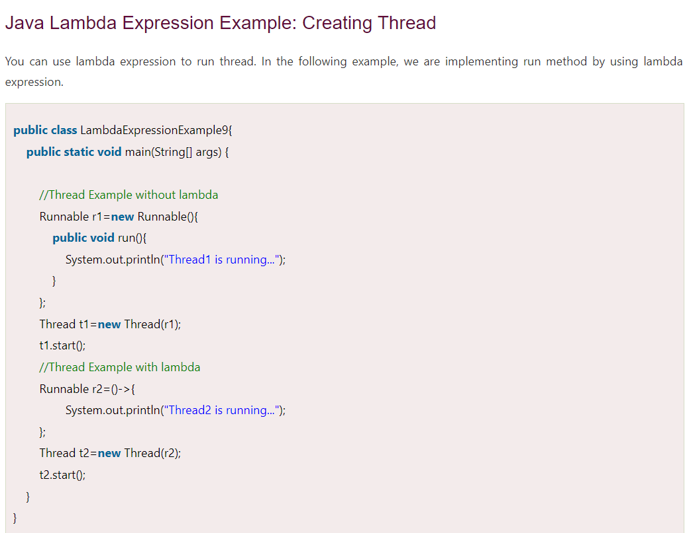

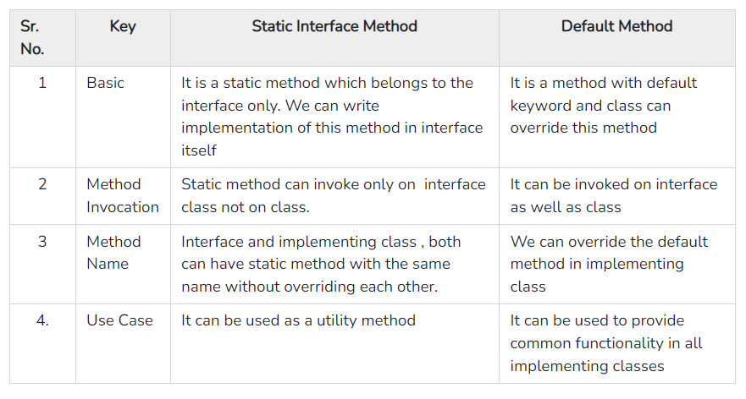



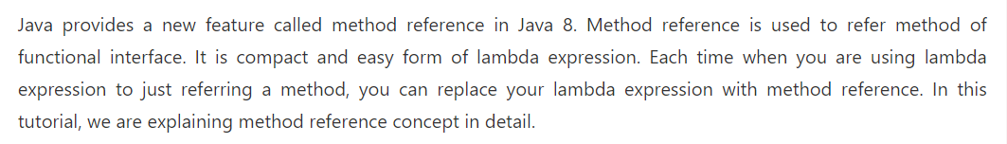

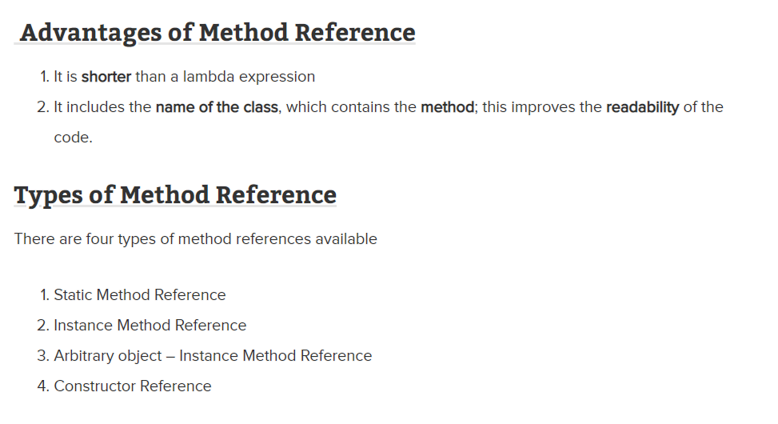

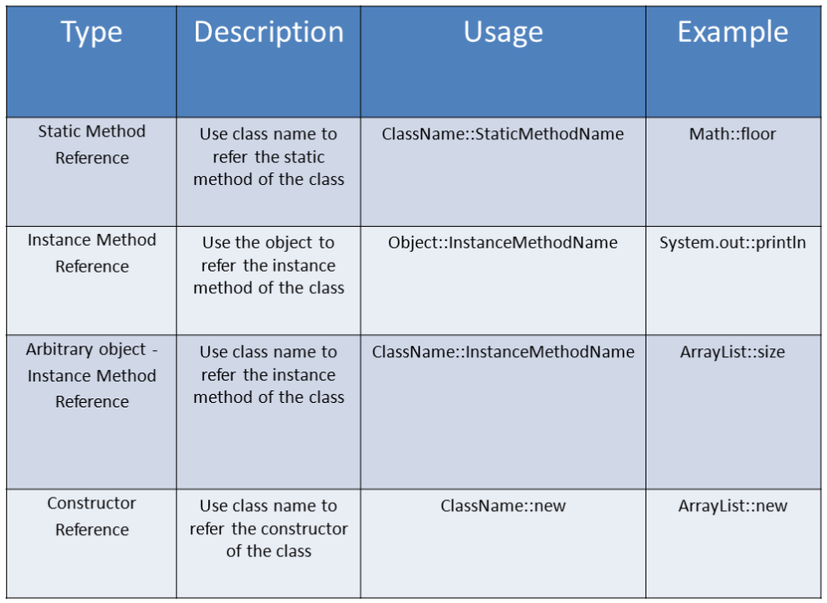

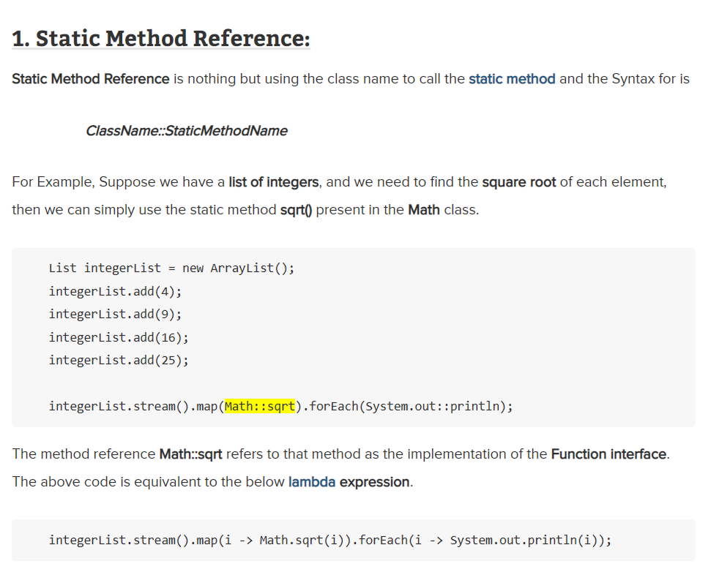

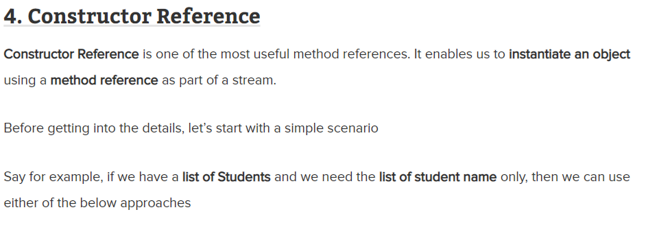



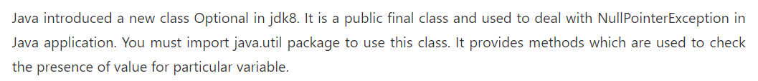

* Stream API



