* Package

A **java package** is a group of similar types of classes, interfaces, and sub-packages.  
Package in java can be categorized in two form, built-in package, and user-defined package.  
There are many built-in packages such as java, lang, awt, javax, swing, net, io, util, sql etc.

Advantage of Java Package

1. Java package is used to categorize the classes and interfaces so that they can be easily maintained.

2) Java package provides access protection.

3) Java package removes naming collision.

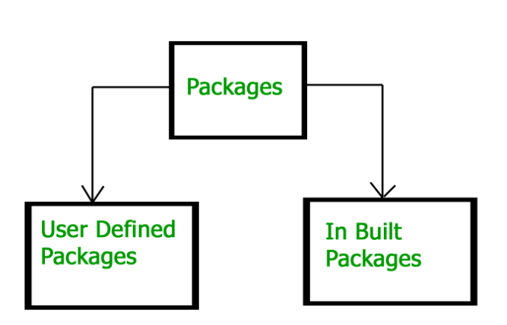

* static import

Static import allows you to access the static member of a class directly without using the fully qualified name.

* Inner classes

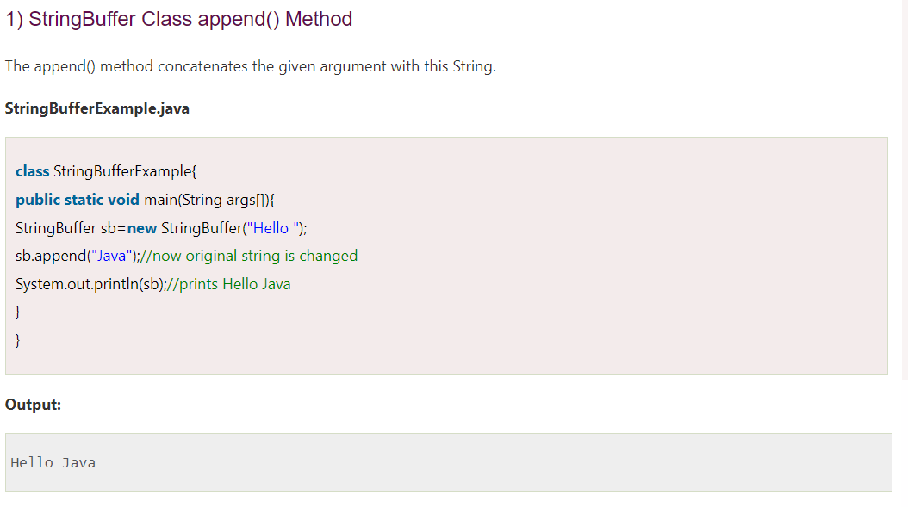

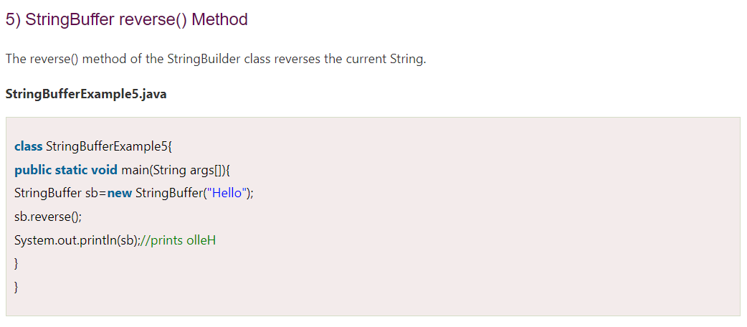



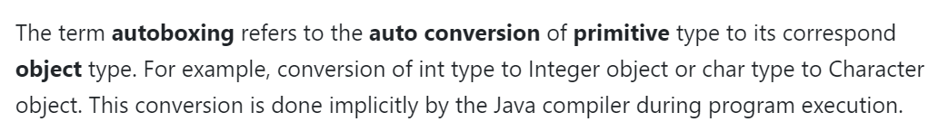

Why is String immutable in Java?

String is immutable in Java because this offers several benefits:

It increases security because any hacker can’t change its value and it’s used for storing sensitive information such as a database username or password.

Since String is immutable, it’s safe to use in multi-threading and you don’t need any synchronization.

Strings are used in Java class loaders and immutability provides assurance that the correct class is getting loaded by the ClassLoader class.