ADTU – Campus Chatbot
A report submitted in partial fulfillment of the requirement for the award of the degree
Of
Bachelor of Technology in Computer Science & Engineering
in
Faculty of Engineering



Submitted by
ATIKUR RAHMAN
Roll no: ADTU/0/2023-27/BTCS/191

MAHIDUL AHASAN
Roll no: ADTU/0/2023-27/BTCS/174

Assam down town University
Guwahati-26, Assam
Session: July-December, 2025

CONTENTS

Declaration | i
Acknowledgment | ii
Abstract | iii

1. Introduction
1.1 Overview of the Project ............................................................................................................... 1
1.2 Motivation .................................................................................................................................... 1
1.3 Scope and Objective .................................................................................................................... 1
1.4 Existing System ........................................................................................................................... 1
1.5 Problem Definition ....................................................................................................................... 2
1.6 Proposed System .......................................................................................................................... 2
2. Project Analysis
2.1 Project Requirement Analysis ...................................................................................................... 2
2.2 Advantages and Disadvantages ................................................................................................ 2-3
2.3 Project Life Cycle ........................................................................................................................ 3
2.4 Project Feasibility ........................................................................................................................ 3
3. Project Design
3.1 System Architecture ..................................................................................................................... 3
3.2 Diagram for Application and Data Integration ................................................................... 4
4. Project Implementation
4.1 User Interface Screens .............................................................................................................. 4-5
6. Conclusion and Future Scope
6.1 Conclusion ................................................................................................................................... 5
References ......................................................................................................................................... 5



DECLARATION
We, Atikur Rahman, bearing Roll No. ADTU/0/2023-27/BTCS/191, and Mahidul Ahasan, bearing Roll No. ADTU/0/2023-27/BTCS/174, hereby declare that the project entitled “Campus Chatbot System” is an original work carried out in the Department of Computer Technology, Assam Down Town University, Guwahati, except for the guidance and suggestions received from our supervisor.
The design, development, implementation, and results presented in this report are the outcome of our own effort, research, and understanding. This report is being submitted to Assam down town University in partial fulfillment of the requirements for the degree of Bachelor of Technology (B.Tech) in Computer Science and Engineering.

Atikur Rahman  Enrolment: ADTU/0/2023-27/BTCS/191  Semester: 5th Semester  Program: B. Tech (CSE)  Faculty of Computer Technology  Assam down town University  Guwahati | Mahidul Ahasan  Enrolment: ADTU/0/2023-27/BTCS/174  Semester: 5th Semester  Program: B. Tech (CSE)  Faculty of Computer Technology  Assam down town University  Guwahati

ACKNOWLEDGMENT
We would like to express our sincere appreciation to everyone who supported us during the development of our project titled “Campus Chatbot System.”
We extend our heartfelt gratitude to our supervisor for providing valuable guidance, constructive suggestions, and continuous encouragement throughout the project. Their support helped us improve the quality and effectiveness of our work.
We also thank the faculty members and the Department of Computer Technology for providing the resources and environment needed to successfully complete this project.
We are grateful to our classmates and friends for their cooperation, helpful discussions, and motivation during different phases of the project. Finally, we express deep appreciation to our families for their constant support, patience, and encouragement, which kept us focused and determined throughout this journey.

ABSTRACT
The Campus Chatbot System is designed to simplify student interaction with university information by offering instant answers to common academic and administrative queries. Built using a client–server architecture, the system features a web-based interface where users can ask questions, which are processed by a Flask backend using Natural Language Processing (NLP). The chatbot responds by retrieving accurate information from a dedicated knowledge base, providing a fast and user-friendly experience.
An admin panel is included, allowing university staff to update FAQs, monitor chatbot activity, and analyse popular queries. The system aims to reduce administrative workload, improve communication efficiency, and enhance student satisfaction through 24/7 accessibility.
Overall, the project demonstrates the use of modern web technologies, NLP integration, and user-focused design to create a scalable and efficient campus support solution.

1. INTRODUCTION
1.1 Overview of the project
The Campus Chatbot System is a web-based application designed to help students quickly access important university information. Using Natural Language Processing (NLP), the chatbot answers questions related to courses, deadlines, campus services, rules, and general queries.
The system includes a web interface built with HTML, CSS, and JavaScript, while the backend is developed using Python and Flask. A structured knowledge base ensures accurate answers, and an admin panel allows staff to update questions, monitor performance, and manage content.
This project aims to provide fast, reliable, and user-friendly support for students and reduce the workload on university staff.
1.2 Motivation
Students often face difficulties finding correct information about university procedures, schedules, or academic requirements. Searching through long webpages or visiting departments physically can be time-consuming.
Our motivation is to create a simple chatbot that provides instant answers anytime, making campus communication easier. The goal is to support students, improve accessibility, reduce confusion, and use technology to modernize university services.
1.3 Scope and Objectives
The scope of this project includes developing a complete chatbot system with a student interface, NLP processing backend, and an admin panel for staff. It covers real-time answering, knowledge base management, content monitoring, and analytics.
Objectives:
- To provide quick answers to common university questions.
- To offer a user-friendly interface accessible anytime.
- To reduce the workload on administrative departments.
- To allow staff to manage and update information easily.
- To build a scalable chatbot system that can grow with future requirements.
1.4 Existing System
Currently, students depend on university websites, notice boards, or manual help desks to get information. These systems are often slow, confusing, or difficult to navigate.
Many universities lack integrated platforms where students can instantly ask questions and receive accurate answers. Traditional systems also require staff involvement, increasing workload and delaying responses.
These issues show the need for an automated, user-friendly system that delivers quick and accurate information.
1.5 Problem Definition
Students struggle when information is scattered across multiple platforms or is hard to find. University staff also face pressure when answering repeated questions from students.
Existing systems may be slow, outdated, or lack proper search features.
Therefore, the problem is to build a chatbot that is:
- Easy to use
- Fast and accurate
- Available 24/7
- Capable of reducing staff workload
This project solves these issues by creating an intelligent campus chatbot with NLP and a complete admin panel.
1.6 Proposed System
The proposed system provides a smart chatbot that answers student queries instantly using NLP. The system uses a Flask backend, a structured knowledge base, and a simple web interface.
It also includes a secure admin panel to update FAQs, manage data, and track chatbot performance. The system is reliable, responsive, and capable of supporting continuous improvements.
Overall, it offers a modern solution to improve university communication and student satisfaction.

2. PROJECT ANALYSIS
2.1 Project Requirement Analysis
This project requires analyzing both functional and non-functional requirements to ensure a smooth and reliable chatbot system.
Functional Requirements:
- User query input through web interface
- NLP-based intent detection
- Knowledge base search
- Admin login system
- Add/Edit Q&A in admin panel
- Analytics dashboard
Non-Functional Requirements:
- Fast response time
- High accuracy of answers
- Secure user and admin access
- Easy scalability
- Smooth UI and usability
User feedback and prototypes help improve the system and refine features before final development.

2.3 Advantages and Disadvantages
Advantages:
- Instant answering system for student queries.
- Easy-to-use interface for both students and staff.
- Reduces administrative workload.
- Provides 24/7 support.
- Stores data for analytics and performance review.
Disadvantages:
- Requires an active internet connection.
- NLP accuracy depends on dataset and training.
- Heavy usage may slow down responses if the server is not scaled properly.

2.4 Project Lifecycle
- Planning & Design:
Define features, create system flow, design UI, and plan NLP logic.
- Development:
Build student interface, Flask backend, knowledge base, and admin panel.
- Testing & Deployment:
Test chatbot accuracy, interface flow, admin features, and deploy the system for real-time use.

2.5 Project Feasibility
Technical Feasibility:
The project uses Flask, Python, HTML, CSS, JavaScript, and NLP libraries, making it completely feasible with current tools and technologies.
Economic Feasibility:
Low development cost as it uses open-source tools and free frameworks. No expensive external APIs are required.
Operational Feasibility:
The system is easy to operate, maintain, and update. Students and staff can use it without technical knowledge, making it practical for daily use.

3. PROJECT DESIGN
3.1 System Architecture
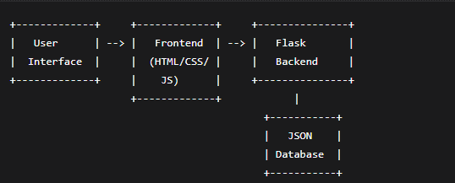
3.2 Diagram for Application and Data Integration

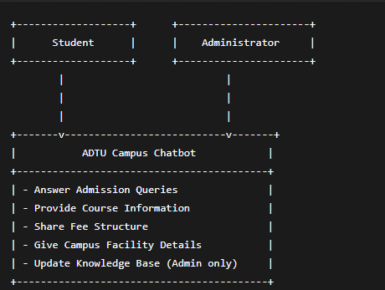

4.2Wireframes/ UI
Home Page
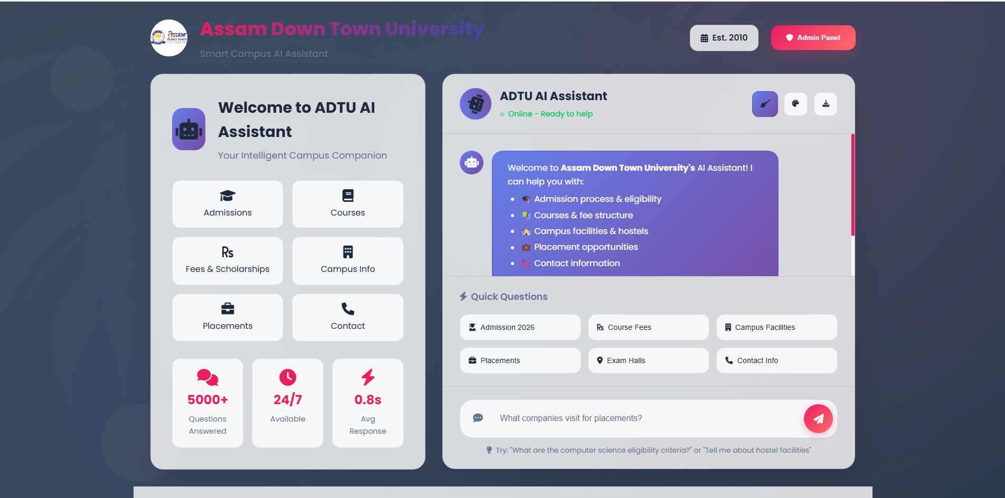
Admin Login page
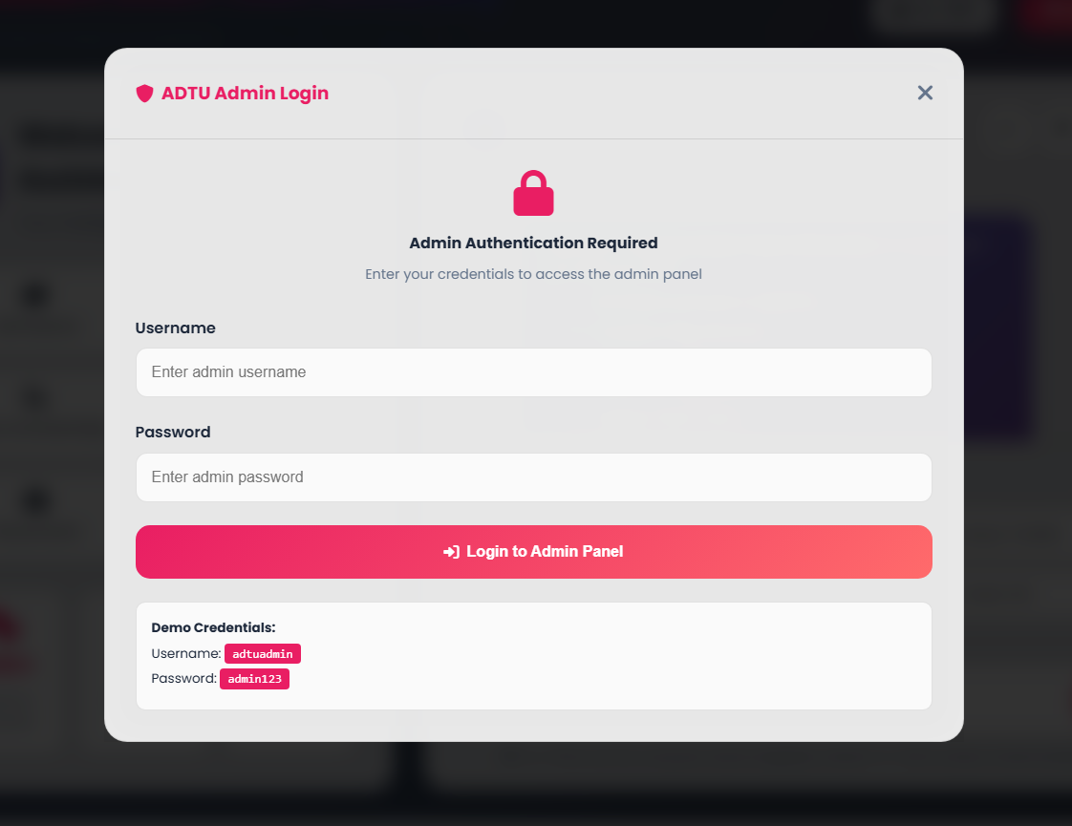
Admin Dashboard
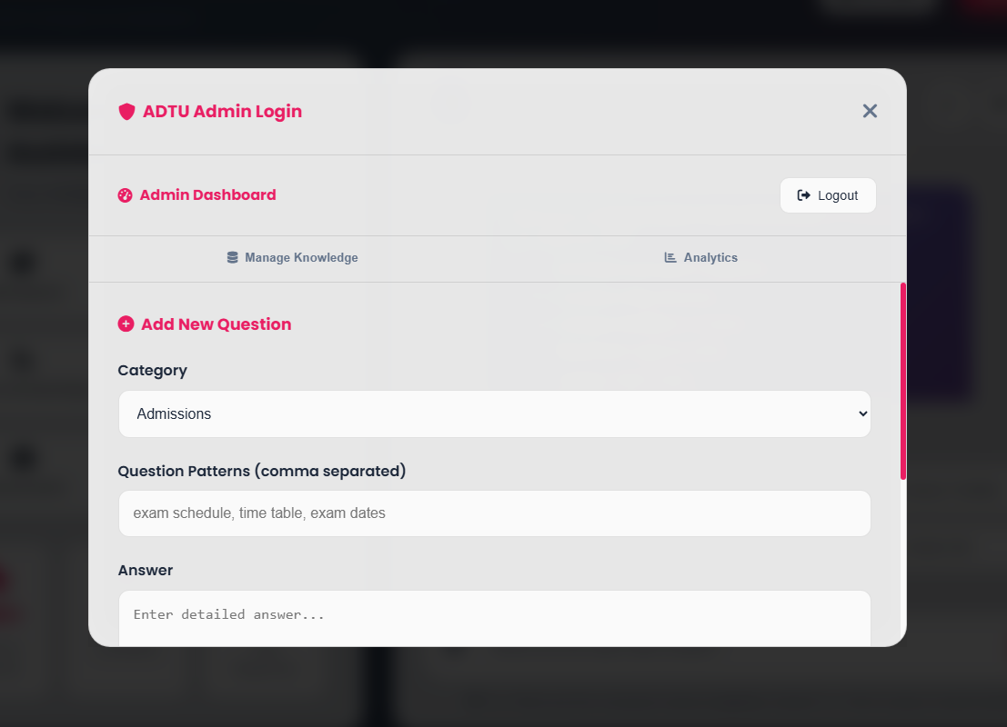

6.1 Conclusion
The Campus Chatbot System provides a fast, convenient, and user-friendly platform for students to access important university information. Built with a web interface (HTML, CSS, JavaScript) and a Flask-based Python backend, the system uses Natural Language Processing (NLP) to understand student queries and deliver accurate responses instantly.
With features such as 24/7 availability, instant answers, a structured knowledge base, and an easy-to-use interface, the chatbot significantly improves communication between students and the university.
The admin panel adds further value by allowing staff to update information, monitor chatbot performance, and analyses frequently asked questions. This reduces administrative workload and ensures students always receive up-to-date information.
Through careful testing—including functional, performance, and usability tests—the system has been built to be stable, efficient, and reliable. Overall, this project showcases how AI and modern web technologies can enhance campus operations, improve student support, and create a smarter, more connected university environment.
It also lays a strong foundation for future improvements such as voice commands, multilingual support, system integration, and advanced AI capabilities.

6.2 References
- Flask Documentation – Flask: A lightweight WSGI web application framework.
https://flask.palletsprojects.com
- Python Documentation – Python Programming Language.
https://www.python.org
- Natural Language Toolkit (NLTK) – NLP tools and libraries.
https://www.nltk.org
- HTML & CSS Documentation – Web design and structure guidelines.
https://developer.mozilla.org
- JavaScript Documentation – MDN Web Docs for JavaScript.
https://developer.mozilla.org/en-US/docs/Web/JavaScript
- Chatbot Research Papers & Articles – Concepts of NLP-based chatbot systems.
(Your institution’s library / online academic resources)

