Nested Patient-Grouped Benchmarking of 3D Deep-Learning Pipelines for Multiclass Postoperative Glioma Segmentation on Longitudinal MRI

Atilla Mustafa, Jamila Jabrayilli, Elkhan Aghakishiyev, Alasgar Aliyev
Supervisor and corresponding author: Alasgar Aliyev [AUTHOR TO COMPLETE: postal address and email]

ABSTRACT

Segmenting post-operative gliomas is challenging due to treatment-related changes, post-resection cavities, longitudinal imaging, and the absence of target structures in specific MRI scans. Model comparisons can be compromised by inter-patient data leakage, checkpoint selection based on test data, insufficient training duration, reliance on a single random initialization, and the use of metrics that fail to account for boundaries, distinct lesions, or the absence of target structures.
This retrospective internal benchmark compares 3D U-Net, Residual 3D U-Net, 3D V-Net, and 3D U-Net++ models within a controlled Keras-based pipeline and evaluates nnU-Net v2 (full-resolution mode) as a practical benchmark for the entire pipeline. The study utilizes 594 annotated post-operative MRI scans acquired at various time points from 203 patients, sourced from the publicly available MU-Glioma-Post dataset. Five patient-grouped outer folds provide out-of-fold evaluation, while separate patient-grouped inner splits are used for checkpoint selection. The experimental design also incorporates additional training runs with varying random initializations.
The evaluation covers patient-level overlap, surface accuracy, lesion detection, false-positive behavior in the absence of reference annotations, variability across folds and random initializations, and computational efficiency. Complete model checkpoints, logs, configurations, and prediction volumes are preserved to facilitate a standardized and auditable comparison.

Keywords: postoperative glioma; magnetic resonance imaging; semantic segmentation; cross-validation; 3D U-Net; V-Net; U-Net++; nnU-Net

Introduction
Postoperative MRI for gliomas can reveal residual or recurrent contrast-enhancing tissue, non-enhancing tumor components, peritumoral hyperintensity on FLAIR images, treatment-related changes, and the post-resection cavity. These manifestations vary both between patients and across longitudinal studies of the same patient. Automated volumetry can enhance the reproducibility of imaging studies and facilitate longitudinal patient assessment; however, technical data must be evaluated beforehand—avoiding data leakage and employing metrics appropriate for postoperative anatomy.
MU-Glioma-Post is a publicly available dataset comprising longitudinal, multimodal postoperative MRI scans and voxel-wise reference segmentations from 203 patients [1,2]. Its hierarchical structure poses a specific risk during validation. If scans from a single patient taken at different time points are distributed across both training and test sets, stable anatomical features and imaging characteristics can become a direct source of data leakage. Consequently, random splitting at the individual scan level can lead to an overestimation of the model's generalization capability. Data partitioning and statistical aggregation must be performed at the patient level.
The models under consideration rely on similar yet distinct architectural designs. U-Net employs an encoder-decoder structure with long skip connections [3]. V-Net introduced the use of volumetric convolutions and residual learning for segmentation [4]. Residual blocks learn adjustments relative to identity or projected short connections, potentially improving optimization [5]. U-Net++ utilizes nested, dense skip pathways designed to reduce the semantic gap between encoder and decoder features [6]. nnU-Net goes beyond a mere architecture: it adapts preprocessing, network configuration, patch sampling, augmentation, optimization, and inference to the specific dataset [7]. Thus, the four models implemented in Keras can be compared within a unified pipeline, whereas nnU-Net should be viewed as a practical comparator for the entire pipeline.
A single overlap metric is insufficient for this task. The Dice score can mask significant boundary errors, fragmented predictions, missed small lesions, and predictions made in the absence of a corresponding reference class. Recommendations for metric selection also emphasize the importance of the hierarchical level of analysis and a specific approach to handling empty structures [8]. Therefore, a robust benchmark for post-operative segmentation must preserve full prediction volumes and apply consistent evaluation rules—covering overlap, surface accuracy, lesion detection, and false positives in the absence of a reference structure—across all models.
Previous studies have shown that 3D nnU-Net is capable of segmenting and longitudinally quantifying post-treatment glioma tissue [10], while the publicly available UCSF-ALPTDG dataset demonstrates the importance and feasibility of using expert-annotated post-treatment data [12]. This study addresses a more specific methodological question using the MU-Glioma-Post dataset: how do fixed 3D architectures compare when patient grouping, checkpoint selection, training opportunity, and the evaluation procedure are standardized beforehand?
The study aims were to: (1) compare 3D U-Net, Residual 3D U-Net, 3D V-Net, and 3D U-Net++ models within a unified, controlled Keras pipeline using five-fold cross-validation predictions; (2) compare a predefined baseline Residual U-Net model against nnU-Net as a benchmark for the entire pipeline; and (3) quantify variability across folds and different random training initializations; and (4) evaluate class overlap, boundary definition accuracy, lesion detection, and the rate of false-positive results in the absence of a reference structure, using complete and auditable prediction sets.

- Materials and methods

  - Study design and reporting boundary
This is a retrospective secondary analysis of a publicly available medical image dataset and an internal technical study comparing models. The study was not an assessment of diagnostic accuracy, a prospective study, or a study aimed at clinical implementation. The run matrix, outer data splits, analysis plan, requirements for preserved artifacts, and working notebooks were established prior to finalizing the adjusted experiment matrix. The patient served as the independent statistical unit of analysis. Terminology and reporting principles were developed in accordance with the CLAIM 2024 and Metrics Reloaded guidelines [8, 9].

  - Dataset, reference standard, and eligibility
The local MU-Glioma-Post registry contained 596 longitudinal study records from various time points. A study was considered to meet the inclusion criteria if it included native T1-weighted images, contrast-enhanced T1-weighted images, T2-weighted images, T2-FLAIR images, and reference segmentation volumes. Two studies lacking reference masks were excluded, resulting in 594 annotated studies from various time points across 203 patients. The original article reports a cohort of 119 men and 84 women, with a mean age of 57.55 years and 192 (94.6%) patients of White ethnicity [1]; no analysis of model performance across demographic subgroups was conducted in the present study.
The provided images underwent skull stripping, co-registration, and resampling, and were saved as NIfTI volumes [1]. Reference labels included background (0), non-enhancing tumor component (1), surrounding non-enhancing FLAIR hyperintensity (2), contrast-enhancing tissue (3), and post-resection cavity (4). Initial automated segmentations for the dataset were obtained using an ensemble of deep learning models comprising nnU-Net, DeepMedic, and DeepScan [1]. Subsequently, the dataset creators implemented a three-tier quality control process: initial correction, independent review by radiologists in training, and final consensus by two board-certified neuroradiologists [1]. Therefore, we use the term "reference standard" rather than "ground truth." Such rigorous quality control significantly reduces, yet does not allow for the full assessment or elimination of, the residual influence of the initial automatic initialization.
Six target structures were defined for evaluation: labels 1, 2, 3, and 4 individually; a combined tumor region comprising labels 1–3; and a combined postoperative region comprising labels 1–4.

  - Patient-grouped outer and inner partitions
All scans for each patient at various time points remained within the same subset. Patients were deterministically assigned to five outer folds using a random state seed of 2026. The outer folds contained 41, 41, 41, 40, and 40 patients, respectively, along with 119, 119, 119, 119, and 118 scans across different time points. Thus, within the main experimental matrix, each patient contributed one out-of-fold result for each architecture.
For each fold, patients not included in the outer test set were further split into fitting and inner-tuning groups using seeds 6203–6207. Model checkpointing, learning rate scheduling, and early stopping were based solely on the inner-tuning group. The outer test fold was accessed only once for full-volume inference using the selected checkpoint. The fixed split files and their SHA-256 identifiers are preserved in the research package and in every submitted results archive.
Table 1. Frozen patient-grouped fold sizes

Outer fold | Fit patients / scans | Inner-tuning patients / scans | Outer-test patients / scans
1 | 130 / 381 | 32 / 94 | 41 / 119
2 | 130 / 381 | 32 / 94 | 41 / 119
3 | 130 / 381 | 32 / 94 | 41 / 119
4 | 130 / 379 | 33 / 96 | 40 / 119
5 | 130 / 380 | 33 / 96 | 40 / 118
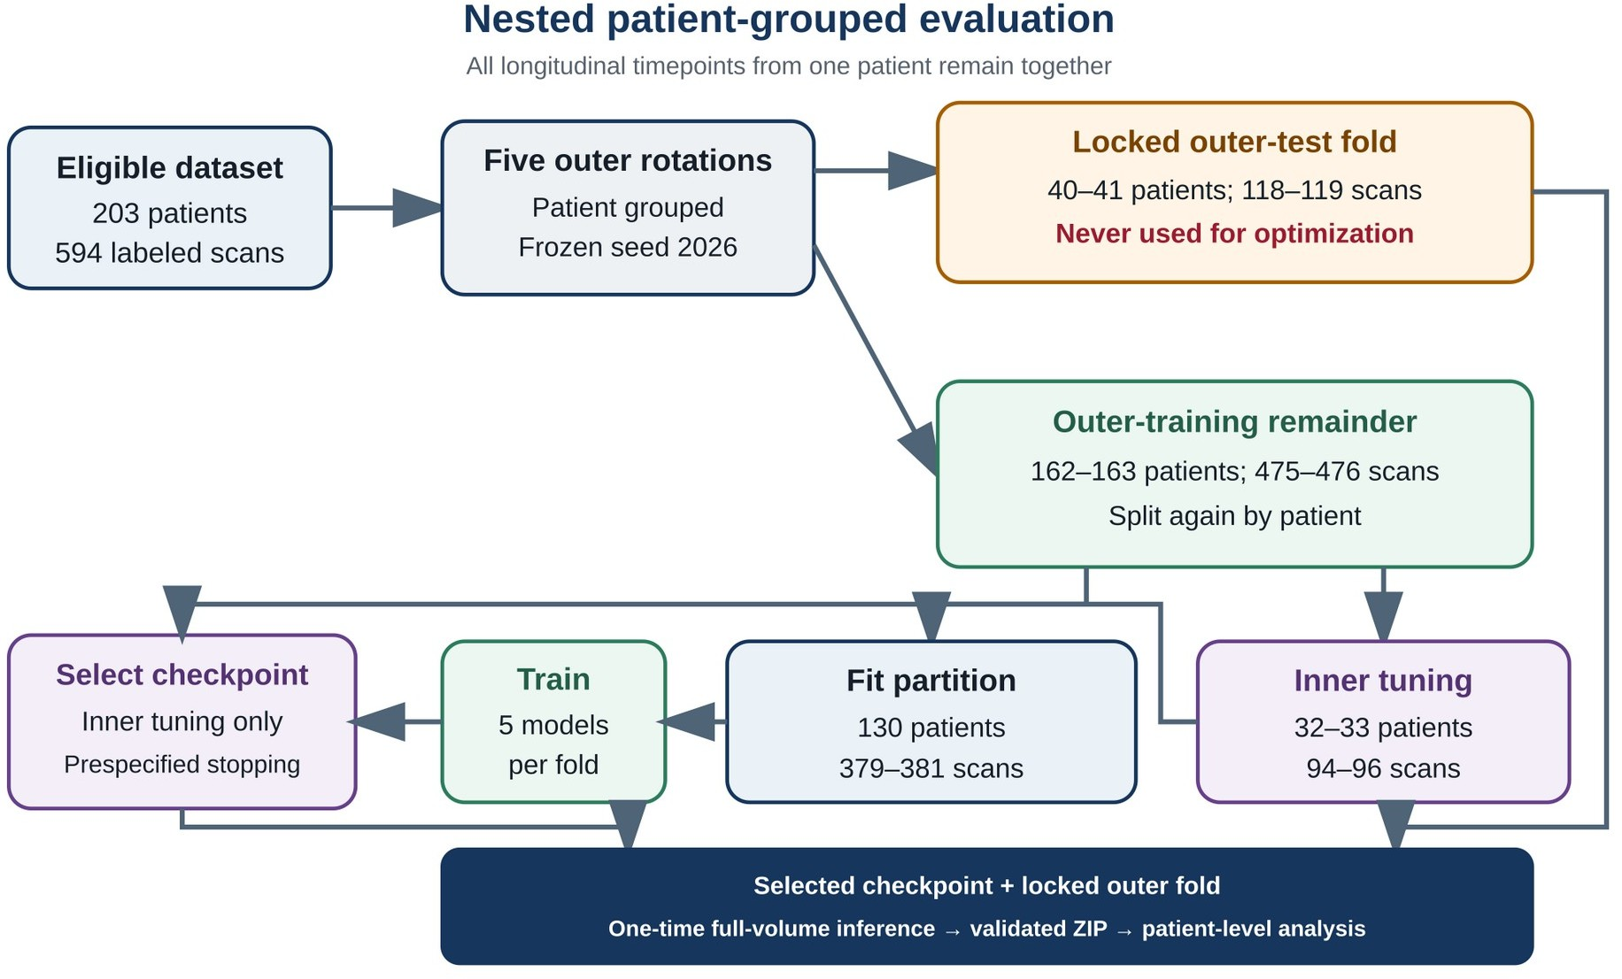

Figure 1. Nested design with patient-level grouping. All longitudinal scans for a single patient at different time points remained within the same sample. A model checkpoint was selected during the internal tuning phase, while the outer fold was used once for the internal testing of the full volumes.

  - Prespecified run matrix
The primary experimental matrix comprised 25 runs: five architectures and five outer folds, all using a random state seed of 2026. An additional ten runs consisted of repetitions of fold 1 using seeds 2027 and 2028 for each architecture; these repetitions allowed for an assessment of sensitivity to the optimization process but did not increase the independent sample size and were never combined with the primary matrix.
A single fixed, specifically tuned configuration was used for each architecture. No performance-based hyperparameter search was conducted, and no metrics calculated on the outer test set were used to select the configuration. Parameter counts and training termination rules are presented in Table 2.
Table 2. Model families and fixed training rules

Model | Parameters | Framework | Runs | Maximum epochs | Earliest stop / min delta / patience
3D U-Net | 5,647,749 | Keras | 5 + 2 | 80 | 20 / 0.002 / 8
Residual 3D U-Net | 5,736,325 | Keras | 5 + 2 | 80 | 20 / 0.002 / 8
3D V-Net | 10,082,069 | Keras | 5 + 2 | 80 | 20 / 0.002 / 8
3D U-Net++ | 6,554,101 | Keras | 5 + 2 | 80 | 20 / 0.002 / 8
nnU-Net v2 3D fullres | 31,200,601 | PyTorch/nnU-Net | 5 + 2 | 150 | 100 / 0.002 / 15
“5 + 2” denotes five primary folds at seed 2026 plus two fold-1 seed repeats.

  - Controlled Keras pipeline
Four Keras models received input channels in the following order: native T1-weighted image, contrast-enhanced T1-weighted image, T2-weighted image, and FLAIR. Each channel underwent z-normalization based on non-zero brain voxels. Training was performed on 96 × 96 × 96 voxel patches with a batch size of 1, using four patches per selected case and an 80% probability of centering the sample on a foreground region (applying a random center shift of up to 16 voxels). Augmentation was performed independently along each spatial axis with a probability of 0.5; intensity scaling (range 0.9–1.1) combined with the addition of Gaussian noise (standard deviation 0.03) within the brain region was applied with a probability of 0.30.
All four models employed a five-class softmax output layer, the Adam optimizer with an initial learning rate of 2 × 10⁻⁴, and a loss function defined as the sum of categorical cross-entropy and (1 minus the mean soft Dice coefficient across present foreground classes). Each epoch consisted of 256 training steps and 64 internal tuning steps. Inference on the full volume utilized overlapping 96-voxel windows with a stride of 64 voxels. TensorFlow version 2.20.0 and Keras version 3.13.2 were fixed; precise details regarding Python, NumPy, CUDA, GPU, and package versions were recorded for each run.
The 3D U-Net featured a four-level encoder-decoder architecture with 16, 32, 64, and 128 features at the encoder and decoder levels, and a bottleneck with 256 features. The architecture incorporated blocks consisting of two convolutions, group normalization, ReLU, upsampling via transposed convolutions, and long skip connections. In the Residual U-Net, standard blocks were replaced by learnable residual blocks. V-Net employed learnable strided downsampling, upsampling via transposed convolutions, residual stages with PReLU, and long skip connections between the encoder and decoder. U-Net++ utilized a fully nested 3D decoder with dense skip pathways from x(0,0) to x(0,4). The source code for the architectures is preserved in the notebooks used to conduct the experiments.
Early stopping was monitored based on the mean foreground Dice coefficient on the internal tuning set. Monitoring began after the 20th epoch; an improvement of at least 0.002 was required, and training ceased after eight consecutive epochs without significant improvement. The checkpoint yielding the best result on the internal tuning set was restored.

  - nnU-Net pipeline
nnU-Net v2.8.1, using PyTorch 2.8.0, employed the `3d_fullres` configuration. The planned patch size was 128 × 128 × 128, and the batch size was 2. The system retained nnU-Net’s self-configuring procedures for preprocessing, network planning, patch sampling, augmentation, optimization, and inference [7]. Patient identities in the outer and inner partitions matched those used in the Keras experiments; however, the full pipeline was intentionally not forced to replicate the Keras preprocessing steps. Consequently, this comparison does not constitute an architectural ablation study.
Training was limited to 150 epochs. Early stopping was permitted only after 100 epochs; it was monitored based on the foreground Dice coefficient on the internal tuning set—calculated using an exponential moving average—and required an improvement of at least 0.002 with a patience parameter of 15. The checkpoint achieving the best result on the internal tuning set was used for outer-fold inference. Run #30 was initiated on a T4 GPU and continued on an A40 GPU using a checksum-verified checkpoint; both execution stages were recorded in the archive.

  - Artifact integrity and reproducibility
To accept a run for evaluation, the following were required: a selected checkpoint; training history or convergence data; configuration details; the software and hardware environment; a fixed patient split; metrics for each case and patient; a single hard-label NIfTI prediction for each expected outer-test case; performance telemetry; metric definitions; an artifact manifest; and checksums for all components. The organizer rejected results due to incorrect identifiers, split hashes, or object counts; missing predictions or checkpoints; checksum mismatches; or incomplete preflight data.

The final matrix contains 4,160 predictions: 2,970 from 25 main folds and 1,190 from ten runs assessing sensitivity to the initial random state (seed). The analysis script reads metrics directly from the validated archives and records the SHA-256 identifier for each input archive.

  - Outcomes and metric definitions
The primary outcome was the average Dice coefficient across time points for each patient, calculated for the combined tumor region (tumor-related union) at outer-test time points where reference annotations were available. Two of the 594 time points had no labels 1–3; however, each patient had at least one time point with a reference annotation of the combined tumor region, so all 203 patients were included in the primary analysis.
Secondary outcomes included the Dice coefficient for each class and for all regions combined, Intersection over Union (IoU), precision, recall, the 95th percentile of the Hausdorff distance (HD95) in millimeters, the mean surface distance in millimeters, the surface Dice coefficient at a 1 mm threshold, and lesion sensitivity based on 26-connectivity. Summary overlap metrics were calculated only for scans with reference annotations. For each patient, pixel-wise IoU, precision, and recall were aggregated across all relevant scans; Dice coefficients and surface Dice coefficients for individual scans were averaged, while HD95 values ​​were summarized using the median. When subsequently generating summary metrics for the models, each patient was assigned equal weight. Calculating HD95 and mean surface distance required both a non-empty reference annotation and a non-empty prediction; the number of undefined values ​​was recorded. The surface Dice coefficient was set to zero if a reference region was present but the prediction was empty.
A reference lesion was considered detected if at least one predicted voxel overlapped with its 26-connected component. A predicted component that did not overlap with the reference annotation was classified as a false-positive lesion. In cases where no reference lesion was present, a scan containing at least one predicted voxel within the target region was classified as a false positive. Denominators at the scan and patient levels, Wilson 95% confidence intervals, predicted region volume, and the number of false-positive lesions were reported separately; scans lacking a reference lesion were never included in the summary overlap metrics calculated for scans containing reference annotations.

  - Statistical analysis
The five validated outer folds were pooled by architecture, yielding a single out-of-fold metric per patient for each model. For patient-level averages (weighted equally), 95% percentile confidence intervals (CIs) were calculated based on 100,000 bootstrap samples of patients using a seed of 2026. Four controlled Keras architectures were initially compared using a two-sided Friedman test at a significance level of α = 0.05. As the gatekeeping test was statistically significant, Residual U-Net, V-Net, and U-Net++ were individually compared against 3D U-Net using a two-sided Wilcoxon signed-rank test, with zero differences handled via the Pratt method and p-values ​​adjusted using the Holm method. Median pairwise differences at the patient level, bootstrap 95% CIs for the median difference, and rank-biserial correlations for paired samples were reported.
Separately, and in accordance with a pre-defined plan, the complete nnU-Net and Residual U-Net pipelines were compared, independently of the observed rankings of the Keras models. This comparison utilized the same pairwise metrics and a separately designated Wilcoxon test, which was excluded from the family of comparisons adjusted via the Holm method for the Keras models. The secondary confidence intervals are exploratory in nature and were not adjusted for multiple comparisons.
A prior study involving 41 patients from the held-out development sample was conducted before amendments were made to this protocol. Therefore, we repeated the primary descriptive and pairwise analyses using an additional sample of 162 patients. The values ​​at the individual fold level were descriptive in nature; the five folds were not treated as a sample for statistical inference. Sensitivity to the initial state (seed) for fold 1 was assessed based on changes in patient metrics and the variability of the three mean values ​​at the seed level.
Python 3.11.16, NumPy 2.4.6, pandas 3.0.5, and SciPy 1.17.1 were used for the analysis. Matplotlib 3.11.1 and NiBabel 5.4.2 were used to generate the figures. All numerical results are provided in machine-readable CSV and JSON files.

- Results

  - Completion and integrity
All 35 planned runs were completed, and each archive passed verification in accordance with the established validation protocol. No predictions on the outer test set were missing or recovered via imputation. All 20 primary Keras runs concluded according to the pre-set early stopping rule after 34–68 epochs. Four of the five primary nnU-Net runs concluded after 100–144 epochs; one run reached the established limit of 150 epochs. Across all seven nnU-Net runs, the second replicate—using a different random seed—also reached the 150-epoch limit. No runs were excluded from the analysis.

  - Primary controlled comparison
The four controlled Keras models exhibited generally overlapping distributions of patient-level metrics (Table 3 and Figure 2A). The highest mean value in this group was obtained for Residual U-Net (0.785), followed by V-Net (0.781), 3D U-Net (0.774), and U-Net++ (0.761). The Friedman test, used to preliminarily assess differences, rejected the hypothesis of equal rank distributions (χ²[3] = 47.29; P = 3.01 × 10⁻¹⁰).
Table 3. Primary Dice score for the combined tumor region on out-of-fold data, with equal weight for each patient

Model | Patients | Mean (bootstrap 95% CI) | Median (IQR)
3D U-Net | 203 | 0.774 (0.748–0.799) | 0.833 (0.733–0.890)
Residual U-Net | 203 | 0.785 (0.759–0.808) | 0.843 (0.745–0.896)
V-Net | 203 | 0.781 (0.755–0.805) | 0.844 (0.729–0.888)
U-Net++ | 203 | 0.761 (0.735–0.786) | 0.823 (0.715–0.888)
nnU-Net | 203 | 0.879 (0.856–0.900) | 0.936 (0.887–0.957)

Residual U-Net outperformed 3D U-Net in terms of the median pairwise Dice coefficient by 0.009 (95% bootstrap confidence interval [CI]: 0.005–0.012; Holm-adjusted P = 2.60 × 10⁻⁶). V-Net outperformed it by 0.006 (0.003–0.008; adjusted P = 7.79 × 10⁻⁴). For U-Net++, the median difference was −0.005 (−0.009 to 0.0002; adjusted P = 2.02 × 10⁻⁴). The bootstrap confidence interval for the median difference of U-Net++ slightly crosses zero, whereas the Wilcoxon signed-rank test remains statistically significant, as the confidence interval and the test relate to different distribution functionals. Therefore, both effect sizes and both statistical inference metrics are presented, without reducing the results to a single binary conclusion.
Table 4. Pre-specified pairwise comparisons of the primary endpoint at the patient level

Comparison | Median Dice difference (95% bootstrap CI) | Mean difference | Rank-biserial | Raw P | Holm-adjusted P
Residual U-Net vs 3D U-Net | 0.009 (0.005–0.012) | 0.010 | 0.398 | 8.66 × 10^-7 | 2.60 × 10^-6
V-Net vs 3D U-Net | 0.006 (0.003–0.008) | 0.006 | 0.272 | 7.79 × 10^-4 | 7.79 × 10^-4
U-Net++ vs 3D U-Net | -0.005 (-0.009–0.0002) | -0.013 | -0.315 | 1.01 × 10^-4 | 2.02 × 10^-4
nnU-Net vs Residual U-Net* | 0.076 (0.068–0.089) | 0.095 | 0.969 | 4.76 × 10^-33 | —
* A separate, pre-defined comparison of full pipelines; it is not part of the Keras family of comparisons with the Holm correction. A positive value favors the first model.
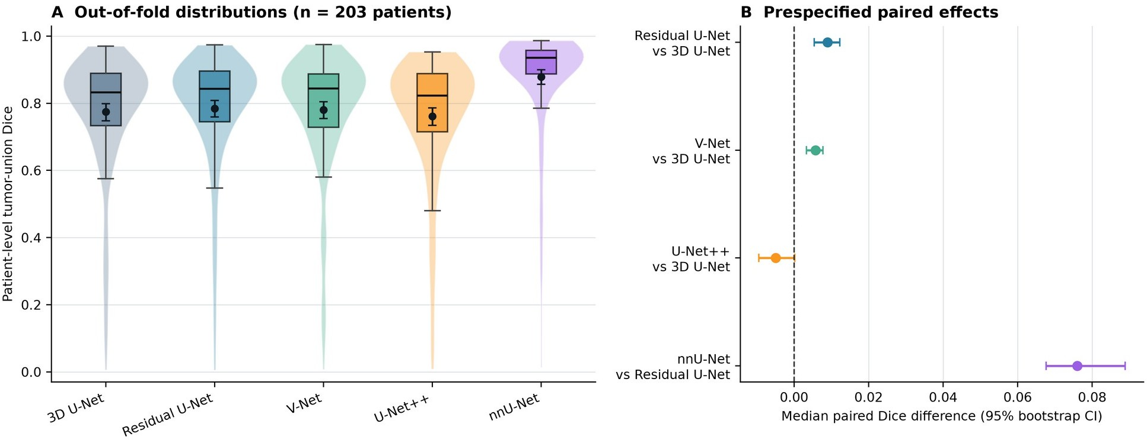

Figure 2. Main results on out-of-fold data. (A) Distributions of the Dice coefficient for the combined tumor region at the patient level; boxes indicate the interquartile range and median, while dark dots with vertical bars represent the unweighted mean per patient and the 95% bootstrap confidence interval. (B) Median pairwise differences with 95% bootstrap confidence intervals. nnU-Net represents a comparison of the full pipelines.

  - Prespecified nnU-Net whole-pipeline comparison
The mean patient-level Dice score for the combined tumor region was 0.879 (95% CI, 0.856–0.900) for nnU-Net, compared to 0.785 (0.759–0.808) for Residual U-Net. The median paired difference was 0.076 (0.068–0.089), the mean paired difference was 0.095, and the rank-biserial correlation for paired samples was 0.969 (P = 4.76 × 10⁻³³). This effect was observed across a significant proportion of patients rather than being driven by just a few folds: the mean value for nnU-Net in each fold exceeded the mean value in each of the Keras folds (Figure 5A).
The result demonstrates a substantial advantage of the tested nnU-Net pipeline on this internal reference standard. However, it does not allow us to determine whether the differences stemmed from preprocessing, sampling, augmentation, optimization, architecture, inference, or an interaction between them.

  - Class, surface, and lesion performance
nnU-Net demonstrated a higher mean patient-level Dice score than all controlled models for each of the four individual classes (Table 5 and Figure 3A). The largest absolute difference for an individual class compared to the best result among the controlled models was observed for the non-enhancing tumor core (0.525 vs. 0.355); for enhancing tissue, the scores were 0.796 vs. 0.698; for FLAIR hyperintensity, 0.874 vs. 0.765; and for the cavity, 0.620 vs. 0.470. The same trend was observed for the combined postoperative region: the mean patient-level Dice score for nnU-Net was 0.898 (95% CI, 0.876–0.918), whereas values ​​for the controlled models ranged from 0.778 to 0.811.
Table 5. Dice coefficient by individual class and HD95 for scans with reference annotations.

Model | Non-enhancing core | FLAIR / edema | Enhancing tissue | Resection cavity
3D U-Net | 0.300 / 11.49 | 0.756 / 24.67 | 0.670 / 9.22 | 0.455 / 64.97
Residual U-Net | 0.355 / 11.58 | 0.765 / 21.70 | 0.698 / 6.78 | 0.470 / 45.52
V-Net | 0.297 / 11.15 | 0.765 / 18.97 | 0.678 / 9.43 | 0.443 / 50.92
U-Net++ | 0.287 / 11.75 | 0.742 / 36.05 | 0.653 / 12.85 | 0.414 / 75.30
nnU-Net | 0.525 / 7.52 | 0.874 / 1.91 | 0.796 / 1.50 | 0.620 / 6.71

The cells show the mean per-patient Dice coefficient (equally weighted) / median per-patient HD95 in millimeters. The number of patients and scans with reference annotations was 145 patients (315 scans) for the non-enhancing tumor core, 202 (591) for FLAIR hyperintensity, 195 (546) for enhancing tissue, and 189 (520) for the cavity. HD95 excludes scans with empty predictions and should therefore be interpreted in conjunction with the number of undefined values ​​and the lesion sensitivity score.
Metrics characterizing the boundaries of the segmented regions demonstrated an even more pronounced advantage for nnU-Net compared to overlap-based metrics. The patient-level median HD95 for the combined tumor region was 2.83 mm for nnU-Net versus 23.42–39.33 mm for the benchmarked models; for the combined postoperative region, the corresponding values ​​were 2.00 mm versus 33.91–48.42 mm. The patient-level mean surface Dice coefficient at a 1 mm threshold for the combined tumor region was 0.875 for nnU-Net and 0.701–0.734 for the benchmarked models. Full tables of metrics—including IoU, precision, recall, mean surface distance, surface Dice coefficient, and indeterminate cases—are provided in the machine-readable results.
Overlap and lesion detection did not yield identical model rankings. The mean patient-level lesion sensitivity for the combined tumor region was 0.746 for nnU-Net, which was below the 0.796–0.827 range observed for the controlled models. For the cavity, this figure was 0.681, compared to 0.718–0.782 for the controlled models. nnU-Net also had a higher number of scans containing the target region where the surface distance remained undefined due to an empty prediction: 18 for the non-enhancing tumor core, seven for enhancing tissue, 25 for the cavity, and four for each of the combined regions. Thus, nnU-Net’s smoother and more conservative predictions reduced the burden associated with boundary errors and false positives but failed to detect every small component present in the reference annotation.

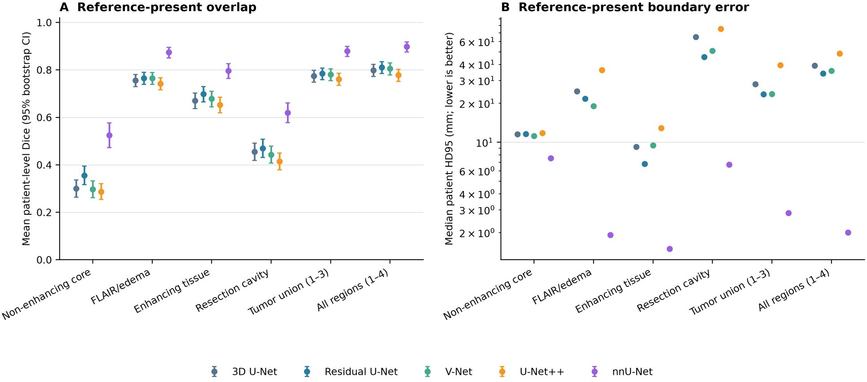

Figure 3. Results for target regions in scans with reference annotations. Panel A shows the mean Dice coefficient (weighted equally per patient) and exploratory 95% bootstrap confidence intervals. Panel B shows the median of patient-level median HD95 values ​​on a logarithmic scale; lower values ​​indicate better performance. Distance metrics are undefined if one or both surfaces are empty.

  - Absent-reference behavior
Reference annotations for the target region were absent in 279 scans for the non-enhancing tumor core, in 48 for enhancing tissue, and in 74 for the cavity. In these scans, nnU-Net predicted the absent target region in 22.2%, 52.1%, and 58.1% of cases, respectively. The corresponding ranges for controlled models were 56.3–76.0%, 95.8–100%, and 100% (Table 6 and Figure 4). The median volumes of predicted regions in scans lacking reference annotations were also lower for nnU-Net: 0 mL for the non-enhancing tumor core, 0.006 mL for enhancing tissue, and 0.002 mL for the cavity. For controlled models, the corresponding ranges were 0.015–0.043 mL, 0.130–0.401 mL, and 1.676–2.789 mL.
Table 6. Frequency of false-positive scans and volume of the predicted region in the absence of reference annotations

Model | Non-enhancing core | Enhancing tissue | Resection cavity
3D U-Net | 63.1% / 0.015 mL | 100% / 0.130 mL | 100% / 2.059 mL
Residual U-Net | 56.3% / 0.017 mL | 95.8% / 0.144 mL | 100% / 1.676 mL
V-Net | 76.0% / 0.030 mL | 97.9% / 0.157 mL | 100% / 2.789 mL
U-Net++ | 71.0% / 0.043 mL | 95.8% / 0.401 mL | 100% / 2.658 mL
nnU-Net | 22.2% / 0.000 mL | 52.1% / 0.006 mL | 58.1% / 0.002 mL

The cells show the frequency of false-positive scans / median volume of the predicted region across all scans lacking reference annotations. Wilson 95% confidence intervals are presented in Figure 4. At the patient level, 122, 29, and 43 patients had at least one scan lacking a non-enhancing tumor core, enhancing tissue, and a cavity, respectively. nnU-Net yielded at least one false-positive result in 39.3%, 65.5%, and 67.4% of these patients; the corresponding ranges for the controlled models were 75.4–91.0%, 96.6–100%, and 100%. FLAIR hyperintensity was absent in only three scans from a single patient, precluding an accurate interpretation.

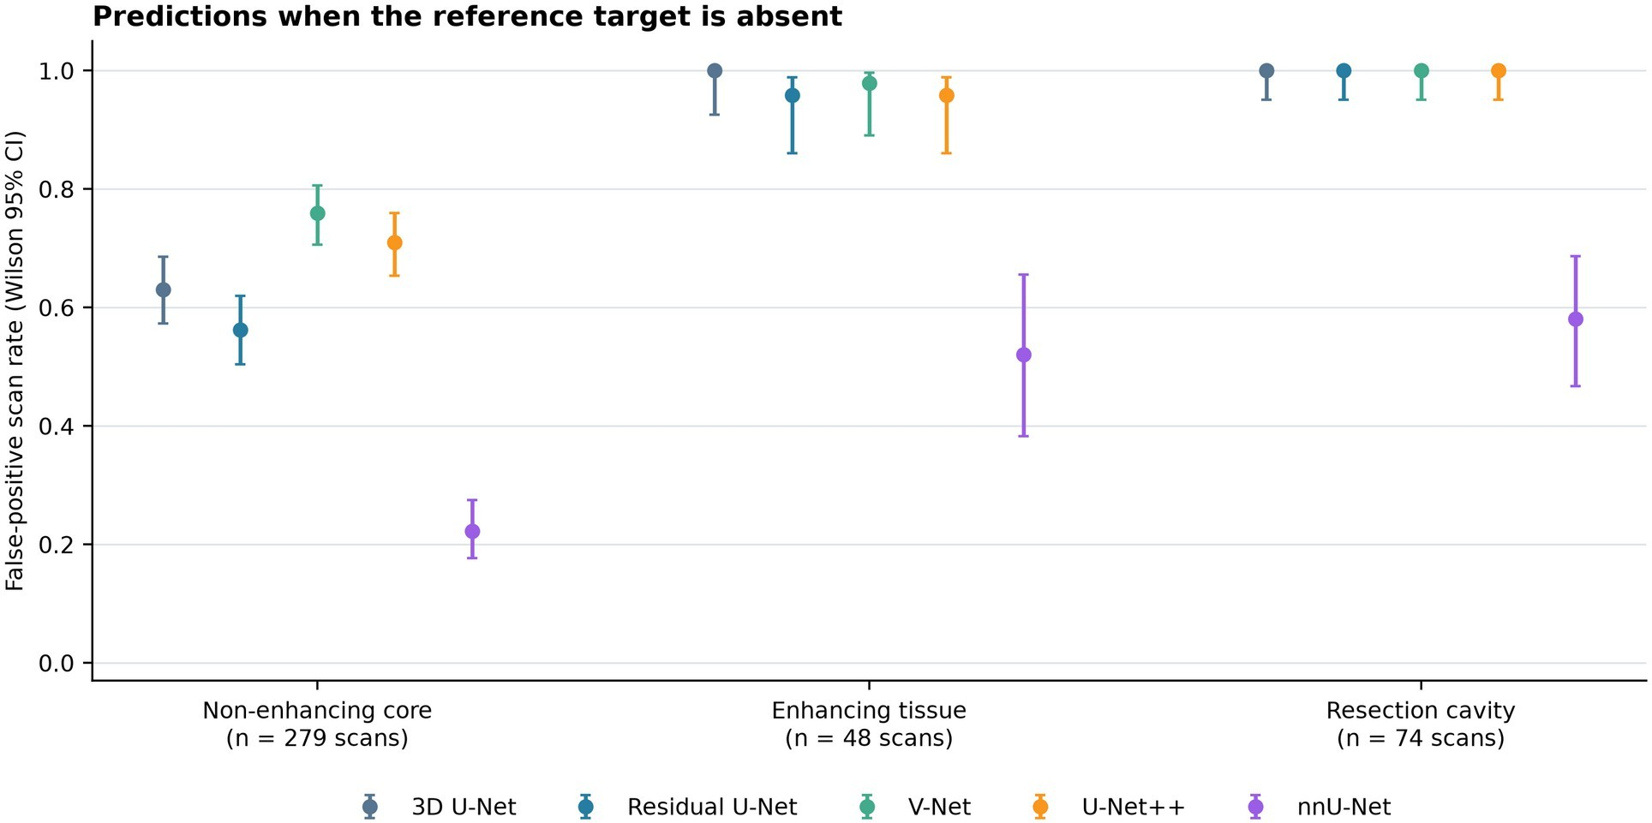

Figure 4. Predictions in the absence of a reference target region. Data points show the false-positive rate at the scan level and the Wilson 95% confidence interval. Scans without reference annotations were excluded from the calculation of average overlap metrics. Confidence intervals for enhancing tissue and the cavity remain wider than those for the non-enhancing tumor core because their denominators are smaller.

  - Sensitivity to prior inspection, fold, and training seed
Excluding the previously analyzed development hold-out set (comprising 41 patients) yielded similar results in the complementary subset of 162 patients: mean values ​​were 0.778 for 3D U-Net, 0.789 for Residual U-Net, 0.783 for V-Net, 0.765 for U-Net++, and 0.882 for nnU-Net. The median difference between nnU-Net and Residual U-Net was 0.074 (95% bootstrap confidence interval, 0.066–0.089; P = 1.94 × 10⁻²⁶). The direction of the differences between the evaluated models also remained unchanged. This sensitivity analysis reduces the likelihood that the primary result was driven by the prior examination of this development subset.
Average fold values ​​ranged from 0.759 to 0.795 for 3D U-Net, 0.775 to 0.796 for Residual U-Net, 0.772 to 0.799 for V-Net, 0.722 to 0.786 for U-Net++, and 0.835 to 0.900 for nnU-Net. Fold 4 had the smallest mean for both U-Net++ and nnU-Net, indicating an effect of cohort composition that would not be noticeable using splitting alone.
For the three initial states (seeds) of fold 1, the ranges of mean values ​​at the seed level were 0.019 for 3D U-Net, 0.011 for Residual U-Net, 0.027 for V-Net, 0.026 for U-Net++, and 0.013 for nnU-Net. The median ranges of differences between seeds for a single patient were 0.020–0.029. Thus, seed-related variability was substantial for individual patients but smaller than the observed difference between the nnU-Net and Residual U-Net pipelines on fold 1.

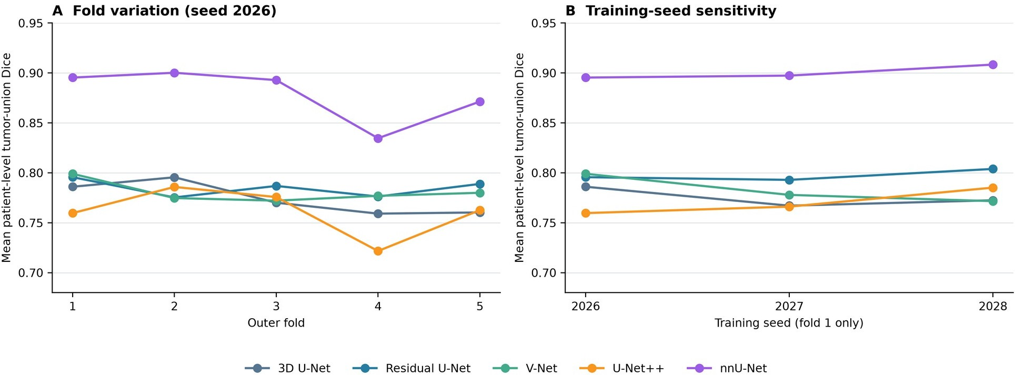

Figure 5. Sensitivity to the fold and the initial training state (seed). Panel A shows the mean patient-level Dice coefficient for the combined tumor region for each outer fold using the primary seed. Panel B shows three mean values ​​obtained with different seeds for Fold 1. Repeated runs with different seeds do not increase the patient sample size.

  - Efficiency and qualitative examples
The total recorded training time across the entire experiment was 110.0 GPU-hours; however, the hardware and software environments were not experimentally balanced. Therefore, the summary metrics for the main runs are descriptive in nature (Table 7). The median number of training epochs was 62, 47, 53, 51, and 107 for 3D U-Net, Residual U-Net, V-Net, U-Net++, and nnU-Net, respectively. The median observed peak memory usage was approximately 2.53, 1.44, 1.50, 2.56, and 8.02 GiB, respectively. nnU-Net had more parameters and a longer training duration but demonstrated a higher recorded inference speed per case; the latter comparison is complicated by differences in GPUs, software frameworks, I/O operations, and implementation details.
Table 7. Descriptive performance metrics for the five main runs of each model.

Model | Epochs, median (range) | Training hours, median (range) | Peak GPU GiB, median | Inference seconds/case, median | Execution platforms
3D U-Net | 62 (53–68) | 3.35 (2.03–4.01) | 2.53 | 10.70 | T4, P100, RTX 3050
Residual U-Net | 47 (38–55) | 1.74 (1.21–2.80) | 1.44 | 6.99 | P100, RTX 3050
V-Net | 53 (40–57) | 1.68 (1.19–1.86) | 1.50 | 7.46 | RTX 3050
U-Net++ | 51 (34–65) | 2.30 (1.52–3.00) | 2.56 | 8.60 | A40
nnU-Net | 107 (100–150) | 6.72 (4.31–10.80) | 8.02 | 2.74 | P100, T4/A40 resume, A40

Representative cases were selected based on a reproducible rule following numerical analysis: the case closest to the median across all models, the case closest to the lower decile, and the case with the highest standard deviation of the Dice coefficient across models. A requirement was that all selected cases had to involve different patients. For each model, the same axial slice was displayed—specifically, the slice showing the maximum area of ​​the combined tumor region according to the reference annotation (Figure 6). These examples demonstrate both the sharper boundaries achieved with nnU-Net and instances where small components were missed; they were not manually selected based on visual appeal.

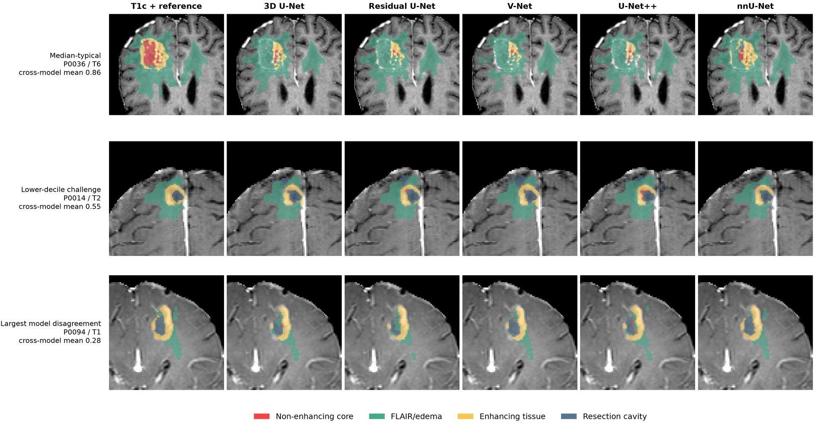

Figure 6. Representative predictions on out-of-fold data. Contrast-enhanced T1-weighted images are shown overlaid with multiclass reference annotations or predictions from the corresponding model of the main outer fold. The rows display a typical case (corresponding to the median), a challenging case (corresponding to the lower decile), and the case with the greatest discrepancy between models. All predictions were obtained for patients excluded from the datasets used to train and tune the respective model.

- Discussion

  - Principal findings
In this benchmark, utilizing five-fold cross-validation with patient-based grouping, variations in the Keras architectures under evaluation resulted in statistically significant yet minor differences. Residual U-Net and V-Net improved the median patient-level Dice coefficient for the combined tumor region by less than one percentage point compared to 3D U-Net, whereas the tested U-Net++ implementation showed no improvement. The practical conclusion is that architectural novelty alone was not the primary determinant of performance when using a shared pipeline that employed identical patch parameters, loss function, sampling strategy, optimization, early stopping, and inference procedures.
The nnU-Net pipeline demonstrated a substantially greater improvement during internal testing. Its median advantage in pairwise comparisons against the predefined Residual U-Net baseline was 0.076 in terms of the Dice coefficient, accompanied by a pronounced positive rank-biserial effect. nnU-Net improved Dice scores for every individual class, significantly reduced HD95, increased the surface Dice coefficient at a 1 mm threshold, and reduced the number of predictions in cases where target regions were absent. This effect persisted after excluding the 41 previously studied patients and was observed across all five outer folds.
A broader set of metrics significantly alters the interpretation of the results. nnU-Net outperformed other models in terms of overlap, boundary accuracy, and specificity in the absence of a target region; however, its patient-level lesion sensitivity was not consistently higher. In some instances, nnU-Net’s more conservative masks failed to capture small components, resulting in undefined surface-to-surface distance values ​​when the target region was not detected at all. Thus, the model can produce more sharply defined segmented regions and achieve a higher Dice coefficient while simultaneously detecting fewer small lesions. The acceptability of this trade-off depends on the intended clinical or research application; this technical study does not define the appropriate utility function.

  - Relation to prior work and annotation provenance
In a previous study on post-treatment gliomas, 3D nnU-Net achieved Dice scores in the approximate range of 0.72–0.89 for various tissue target regions and demonstrated the potential of automated longitudinal volumetry [10]. A direct numerical comparison is inappropriate due to differences in cohorts, segmentation class definitions, aggregation methods, and evaluation schemes.
The present study complements these findings by employing a controlled family of architectures, a pairwise patient-level comparison within a five-fold cross-validation framework, repeated runs with different random seeds, an analysis of empty target regions, and a consistent approach to saving all predictions.
The magnitude of nnU-Net’s advantage should also be interpreted in light of the origin of the reference annotations. The MU-Glioma-Post masks were initially generated using an automated ensemble comprising nnU-Net, DeepMedic, and DeepScan [1]. They subsequently underwent initial manual correction, independent verification by radiology trainees, and consensus review by two board-certified neuroradiologists [1]. Such a rigorous process significantly reduces the likelihood of the annotations simply inheriting the automated predictions. Nevertheless, since the tested nnU-Net belongs to the same model family as one of the models used during the initial generation phase—even though it employs neither the same weights nor the same training split—one cannot entirely rule out a residual influence from the original predictions or a specific model-family effect on the published annotations. The result remains a valid comparison against the expert-refined reference standard; however, independent external evaluation is required to determine whether the observed model ranking holds true when using independently annotated data.

  - Methodological strengths
Several study design features mitigate the typical limitations of small-scale AI studies in medical image analysis. All longitudinal time points remained within their respective patient groups. Each outer fold included a distinct patient-level subset designated for model checkpoint selection, thereby preventing data from the outer test set from influencing early stopping or model selection. The primary matrix included each patient once per architecture; repeated runs with different random seeds were treated separately and excluded from the patient count used for statistical inference. The statistical plan pre-specified the control model and the family of comparisons—including adjustments for multiple testing—prior to the finalization of the dataset. In accordance with the pre-defined sensitivity analysis plan, patients whose results had already been analyzed in a previously used hold-out set were excluded.
Preserving the full results also enabled the use of standardized metrics that were not feasible in earlier experiments relying solely on aggregated data. All models were evaluated using consistent criteria for scans with reference annotations, surface-based metrics in physical spatial units, lesion definitions based on connected components, and a separate analysis of cases lacking a reference target region. Selected checkpoints, predictions, logs, configurations, data split hashes, hardware and software environment details, telemetry, manifests, and checksums have been preserved and are available for audit.

  - Limitations
First, this involves internal testing on a single publicly available dataset. While cross-validation allows for the efficient use of the cohort, it does not assess the generalizability of results across different institutions, scanner manufacturers, magnetic field strengths, imaging protocols, populations, or independently generated annotations. The results obtained do not provide a basis for drawing conclusions regarding the feasibility of clinical implementation.
Secondly, the reference annotation was initially generated using an ensemble that included nnU-Net and subsequently underwent a rigorous three-level manual review, culminating in a consensus reached by two board-certified neuroradiologists [1]. This process significantly reduces the likelihood of systematic bias stemming from the initial generation. However, since the independently created de novo annotations and individual masks were not published, the residual influence of the initial annotation, inter-rater variability, and boundary uncertainty cannot be quantified. While this represents a potential source of bias associated with the use of the same model family, it does not indicate that such bias determined the obtained results.
Third, each architecture is represented by a single implementation and a single fixed hyperparameter configuration. The chosen parameters were robust and consistent; however, the study does not demonstrate that they are optimal. Exhaustive or nested hyperparameter optimization was beyond the available computational budget; therefore, the findings pertain to the specific, predefined implementations of these architectures rather than the best potentially achievable version of each.
Fourth, nnU-Net modifies multiple components simultaneously. Its difference from Keras models cannot be explained solely by network topology. It also featured a larger number of parameters, different patch and batch sizes, framework-specific augmentation and optimization methods, and a longer training duration before stopping. This was a deliberately chosen practical comparison of complete pipelines.
Fifth, robustness to changes in the initial state (seed) was evaluated using only two additional seeds on fold 1. Although this approach is more informative than an analysis based on a single seed, it does not fully characterize optimization variability or the interaction between seeds and folds. Two nnU-Net runs reached the set limit of 150 epochs; therefore, the possibility of further performance improvements with continued training cannot be ruled out. All Keras models adhered to the established early stopping rule.
Sixth, some subsets of the target regions remain small. Enhancing tissue was absent in 48 scans, and a cavity in 74; FLAIR hyperintensity was absent in only three scans. Consequently, the corresponding confidence intervals for cases where the reference annotation is absent are characterized by low precision. Lesion sensitivity also depends on the chosen definition of 26-connectivity and the "any-overlap" detection rule; small, disconnected components of the reference annotation can significantly affect the number of detected lesions.
Seventh, due to resource constraints, runs were performed on P100, T4, A40, and RTX 3050 (laptop) GPUs. While fixed seeds and preserved software environments enhance reproducibility and allow for experiment tracking, exact floating-point computation trajectories may vary depending on the hardware. GPU allocation was tied to specific model families; consequently, comparisons of execution time, memory usage, and inference speed are descriptive in nature rather than controlled benchmarks.
Finally, the study did not evaluate calibration, the presentation of uncertainty information, the accuracy of longitudinal volume change measurements, the impact on clinical decisions and outcomes, fairness across different demographic or molecular groups, or the impact on prospective workflows. The limited racial diversity of the published cohort further restricts the ability to assess fairness and the generalizability of the results [1].

  - Future work
The next priority step is external testing using annotations created independently of the MU-Glioma-Post/nnU-Net workflow. UCSF-ALPTDG is a relevant publicly available resource for post-treatment data [12]; however, prior to its use, it is necessary to harmonize target region definitions, data preprocessing, and the permissible overlap between training and test sets. Future research should establish the correspondence between external datasets prior to reviewing results and, where possible, supplement the evaluation with a blinded review by certified neuroradiologists.
Future studies should replicate multiple runs with different initial states (seeds) for each fold, conduct nested hyperparameter optimization using consistent computational budgets, and investigate the trade-off between suppressing false positives and maintaining sensitivity to small lesions. Uncertainty estimation, calibration, metrics for longitudinal changes, and subgroup analysis should be pre-specified in the protocol and possess sufficient statistical power to support the claimed conclusions.

- Conclusion
Five-fold patient-wise cross-validation showed that Residual U-Net and V-Net yielded slight improvements over 3D U-Net when using a common Keras pipeline, whereas the tested U-Net++ implementation did not demonstrate such an improvement. nnU-Net provided significantly better alignment with reference annotations, boundary accuracy, and performance in cases where the target region was absent, though it did not consistently improve lesion sensitivity. This result is best interpreted as a robust internal comparison of complete pipelines on the MU-Glioma-Post dataset. Independent external evaluation is required to determine the generalizability of these results beyond this expert-refined reference dataset.

Declarations

Ethics approval and consent to participate
This computational study utilized a publicly available, de-identified dataset; no participants were recruited, and no access to identifiable information took place. The original dataset description states that approval from the relevant institution was obtained for its creation [1]. Because the present study involved secondary analysis of publicly available, de-identified data, no additional ethics approval or participant consent was required.

Data availability
MU-Glioma-Post is available through The Cancer Imaging Archive under a Creative Commons Attribution license [1,2]. The imaging dataset is not redistributed in the accompanying research package.

Code, model, and derived-artifact availability
The curated research package contains the frozen splits, exact execution notebooks, validated result archives, selected checkpoints, all out-of-fold prediction volumes, per-case and per-patient metrics, analysis code, configurations, environment records, manifests, and checksums. [AUTHOR TO COMPLETE: deposit the package in a public archival repository and insert its persistent DOI or URL before submission. Confirm that redistribution of all derived model artifacts complies with the dataset terms.]

Declaration of generative AI and AI-assisted technologies
OpenAI Codex assisted with execution-notebook adaptation, code development and validation, implementation of the statistical analysis, figure generation, and manuscript drafting and language editing. The authors reviewed and verified the resulting code, analyses, figures, references, and text and take full responsibility for the content of this work.

References
- Mahmoud E, Gass J, Dhemesh Y, et al. MU-Glioma Post: a comprehensive dataset of automated MR multi-sequence segmentation and clinical features. Scientific Data. 2025;12:1847. doi:10.1038/s41597-025-06011-7.
- Yaseen D, Garrett F, Gass J, et al. University of Missouri Post-operative Glioma Dataset (MU-Glioma-Post), Version 1 [data set]. The Cancer Imaging Archive. 2025. doi:10.7937/7K9K-3C83.
- Ronneberger O, Fischer P, Brox T. U-Net: convolutional networks for biomedical image segmentation. In: MICCAI 2015. 2015:234–241. doi:10.1007/978-3-319-24574-4_28.
- Milletari F, Navab N, Ahmadi SA. V-Net: fully convolutional neural networks for volumetric medical image segmentation. In: 2016 Fourth International Conference on 3D Vision. 2016:565–571. doi:10.1109/3DV.2016.79.
- He K, Zhang X, Ren S, Sun J. Deep residual learning for image recognition. In: 2016 IEEE Conference on Computer Vision and Pattern Recognition. 2016:770–778. doi:10.1109/CVPR.2016.90.
- Zhou Z, Rahman Siddiquee MM, Tajbakhsh N, Liang J. UNet++: a nested U-Net architecture for medical image segmentation. In: Deep Learning in Medical Image Analysis and Multimodal Learning for Clinical Decision Support. 2018:3–11. doi:10.1007/978-3-030-00889-5_1.
- Isensee F, Jaeger PF, Kohl SAA, Petersen J, Maier-Hein KH. nnU-Net: a self-configuring method for deep learning-based biomedical image segmentation. Nature Methods. 2021;18:203–211. doi:10.1038/s41592-020-01008-z.
- Maier-Hein L, Reinke A, Godau P, et al. Metrics reloaded: recommendations for image analysis validation. Nature Methods. 2024;21:195–212. doi:10.1038/s41592-023-02151-z.
- Tejani AS, Klontzas ME, Gatti AA, et al. Checklist for Artificial Intelligence in Medical Imaging (CLAIM): 2024 update.
Radiology: Artificial Intelligence. 2024;6(4):e240300. doi:10.1148/ryai.240300.
- Rudie JD, Calabrese E, Saluja R, et al. Longitudinal assessment of posttreatment diffuse glioma tissue volumes with three-dimensional convolutional neural networks. Radiology: Artificial Intelligence. 2022;4(5):e210243. doi:10.1148/ryai.210243.
- Helland RH, Ferles A, Pedersen A, et al. Segmentation of glioblastomas in early post-operative multi-modal MRI with deep neural networks. Scientific Reports. 2023;13:18897. doi:10.1038/s41598-023-45456-x.
- Fields BKK, Calabrese E, Mongan J, et al. The University of California San Francisco Adult Longitudinal Post-Treatment Diffuse Glioma MRI Dataset. Radiology: Artificial Intelligence. 2024;6(4):e230182. doi:10.1148/ryai.230182.

