Angular Fron.
It is one of the components of the "Dancing Pipes." In our project, it facilitates a clearer visualization for users, showing the consequences of their commands issued via gestures in the camera component. This integration ensures that users can intuitively interact with the system, seeing the real-time impact of their actions on the interface.
Technologies and reasoning.
- Angular: It is popular for its powerful features like data-binding, which helps the app stay responsive and up-to-date without manual refreshes.
  - Reason: We use Angular as the main framework to build the frontend application. It's chosen for its strong ability to create dynamic single-page applications (SPAs). This framework is great for learning advanced web development skills too.
- TypeScript: We use TypeScript for writing the application because it comes with Angular. TypeScript adds rules about data types to JavaScript, making the code cleaner and reducing common errors.
  - Reason: It helps manage large projects by catching errors early in development, which saves time and improves the quality of the code.
- Material Design: We incorporate Google’s Material Design via Angular Material to make sure the app looks good and works well across different platforms.
  - Reason: Angular Material provides ready-to-use and good-looking UI components that help speed up development and improve the overall user experience.
- RxJS: This is used to handle data streams and updates in the app, important for keeping everything running smoothly and up-to-date.
  - Reason: It allows the app to handle multiple events and data changes efficiently, ensuring the interface reacts quickly to new information from the server.
- Server-Sent Events (SSE): We use SSE to get real-time updates from the backend, so the app always shows the latest data without needing to reload the page.
  - Reason: SSE is a simple way for the server to send new data to the app directly, which is great for applications where timely updates are crucial.
Frontend Architecture
In the frontend architecture of our project, we have structured the application using a variety of Angular components and services to ensure a cohesive and efficient user experience.
Components: LoginComponent, DashboardComponent, NumberDisplayComponent, OrganSettingsComponent, AppComponent.
Services: LoginDataService, SseService.
Guards: authGuard.
Pipes: CommandDisplayNamePipe, TempoPipe.
Enums: TempoLabels.
Intefaces: WebClientDTO.
Components.
AppComponent
The AppComponent is the main part of the Angular application that manages the main page and how users move around in the app. It's set up to handle everything in one place, making it easier to manage.
Key Features:
- Updates Based on User Actions: It changes what it shows based on what the user is doing, like logging in or moving to different parts of the app.
Methods:
- ngOnInit(): When the app starts, this method sets up to watch for changes in the user's login status and where they are in the app.
  - Purpose: Makes sure the app responds right when the user logs in or goes to other pages, updating things like welcome messages and links.
- updateGreeting(): Changes the welcome message if the user is on the dashboard page, showing they're logged in.
  - Purpose: Gives a friendly message to logged-in users, making the app feel more personal.
HTML Structure:
- Includes a space to show a greeting to the user, which changes depending on if they're logged in.
- Shows or hides a "Log out" link based on whether the user is at the dashboard.
- Uses <router-outlet> to show content from other parts of the app depending on what the user chooses to do, which is central to how the app works.
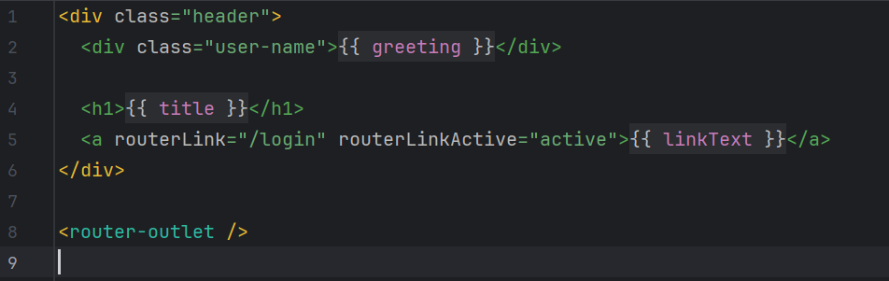

LoginComponent
The LoginComponent is an Angular component responsible for handling user authentication in the frontend of the application. It provides a form interface for users to enter login credentials and handles the submission of these credentials to verify user access.
Key Properties:
- form: Holds the FormGroup instance that contains the login and password form controls.
- isAuthenticatedFailed: A boolean that flags whether authentication has failed, used to display error messages.
- hide: Controls the visibility of the password in the form, allowing users to toggle between showing and hiding their password.
- apiUrl: Stores the API URL from the environment settings, used to construct the request endpoint.
Methods:
- ngOnInit(): Initializes the form with predefined validators, setting default values for the login and password fields.
  - Purpose: Sets up the form controls with required validations to ensure data integrity before submission.
- toggleVisibility(): Toggles the hide property to switch the password input between text and password types.
  - Purpose: Enhances user experience by providing an option to view the password as they type.
- onSubmit(): Called when the form is submitted; validates the form and proceeds to check credentials if the form is valid.
  - Purpose: Initiates the authentication process by verifying the user credentials against the backend.
- checkCredentials(credentials: any): Takes the username and password from the form, calls submitCredentials() to send them to the server, and handles the response.
  - Purpose: Authenticates the user by interacting with the backend API and updates the application state based on the authentication result.
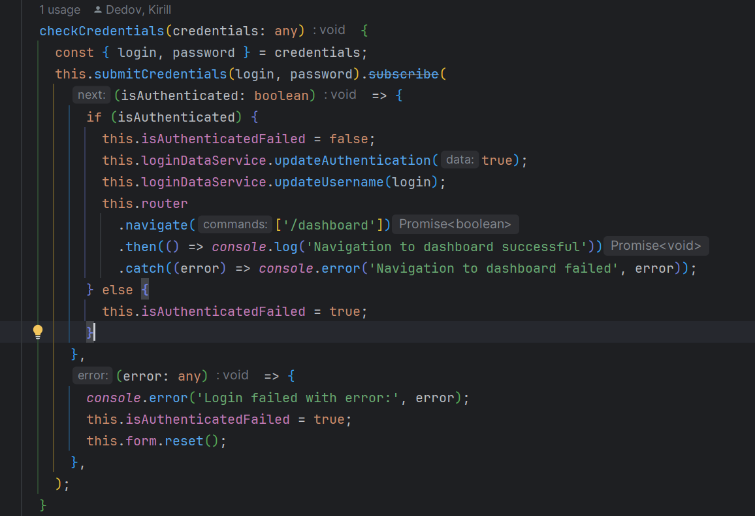
- submitCredentials(username: string, password: string): Sends a POST request to the backend with the username and password.
  - Purpose: Directly communicates with the backend to verify user credentials.
  - Returns: Observable<boolean> indicating the success or failure of the login attempt.

DashboardComponent
The DashboardComponent serves as a central hub for the application's user interface, primarily responsible for aggregating and displaying major functional components related to the musical instrument control system. It integrates key components of the application, allowing for centralized and intuitive user interactions.
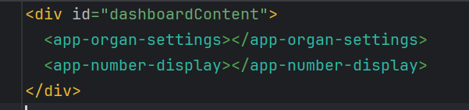
The template for the DashboardComponent is designed to serve as a container that embeds the OrganSettingsComponent and the NumberDisplayComponent. This layout ensures that users have immediate access to both the settings of the organ and the real-time feedback on number-related commands as they interact with the system.
The DashboardComponent acts as a critical element in the architecture, enabling efficient management of sub-components and ensuring that the user interface is not only functional but also aesthetically pleasing and user-friendly.
NumberDisplayComponent
The NumberDisplayComponent is an Angular component designed to display real-time command data related to the operation of the musical instrument system. It interfaces directly with server-sent events (SSE) to receive updates and present them to the user in an engaging and informative way.
Key Features:
- Dynamic Data Handling: The component subscribes to SSE updates via the SseService, ensuring that the data displayed is always current and reflects the latest server state.
- Reactive User Interface: Utilizes Angular's NgZone to ensure that state changes triggered by SSE updates are processed within the Angular's change detection context, ensuring smooth and performant UI updates.
HTML Structure:
- The component's template includes interactive elements such as buttons for toggling the view of command details and clearing the displayed data, enhancing user interaction.
- Commands are displayed in a list, with visual indicators for executed and non-executed commands, making it easy for users to understand the outcome of their actions.
Methods:
- ngOnInit(): Sets up the subscription to the SSE data stream, initializing the component's state with live data from the server.
  - Purpose: Ensures that the component starts receiving and displaying data as soon as it is initialized.
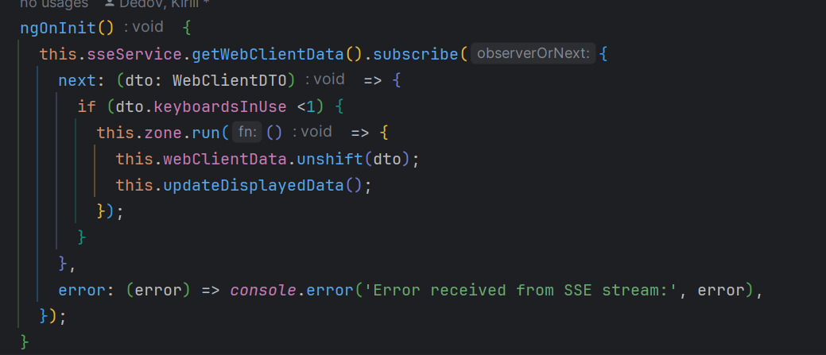
- toggleView(): Allows users to toggle between viewing all commands or a limited set, enhancing usability for different user preferences.
  - Purpose: Provides flexibility in how data is displayed, making it easier for users to manage large volumes of command information.
- clearData(): Clears the current command data from the display, offering a way to reset the view or manage data visibility.
  - Purpose: Helps maintain a clean interface, particularly useful in scenarios where data needs to be refreshed or if the display becomes too cluttered.
- updateDisplayedData(): Manages which data is shown based on user interactions, such as toggling between full and limited views.
  - Purpose: Dynamically adjusts the amount of data displayed, ensuring that the interface remains manageable and relevant to the user’s current needs.
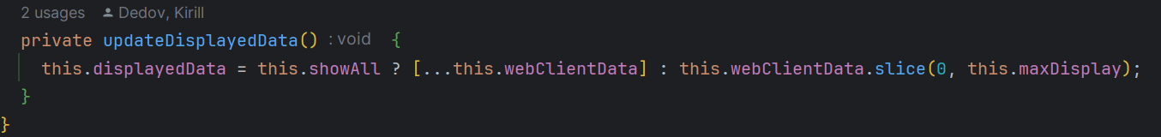
OrganSettingsComponent
The OrganSettingsComponent is an Angular component dedicated to displaying and managing settings related to the organ's operational parameters. It provides a user interface for real-time interaction with the organ, such as adjusting keyboards and setting tempo, ensuring users have direct control over these aspects.
Key Features:
- Real-time Data Interaction: Subscribes to data updates from the SseService, ensuring that the component displays current information and reacts to changes as they occur.
HTML Structure:
- The component template includes sections for displaying composition details such as title, composer, and the number of bars. It also features visual indicators for the status of each keyboard and command received.
- Provides visual feedback on connectivity and command reception, with status bars that change colour based on the connection status and whether a start command has been received, thereby informing the user of the system's readiness to receive further commands.

Methods:
- ngOnInit(): Initiates a subscription to the SseService to receive updates on the organ settings. It processes incoming data within Angular's NgZone to ensure proper UI rendering and state management.
  - Purpose: Keeps the component's state synchronized with the backend, providing users with up-to-date information and control capabilities.
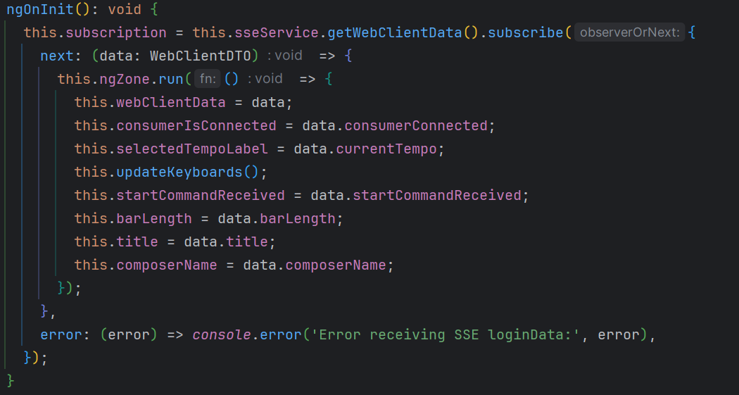
- updateKeyboards(): Dynamically adjusts the visual representation of the keyboards based on the current data, such as which keyboards are active, inactive, or disabled.
  - Purpose: Allows users to visually perceive the current configuration of the organ in real time, enhancing the interactive experience.
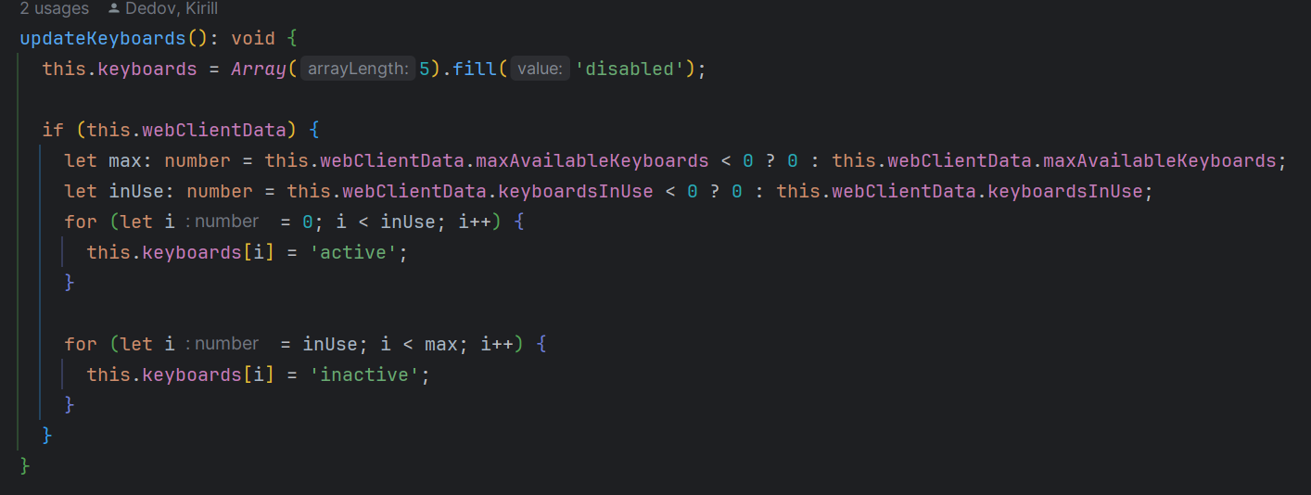
- getKeyboardImage(index: number): Returns the appropriate image path based on the keyboard's status, aiding in creating a visually intuitive interface.
  - Purpose: Enhances the user interface by providing visual tipps that reflects the current state of each keyboard.
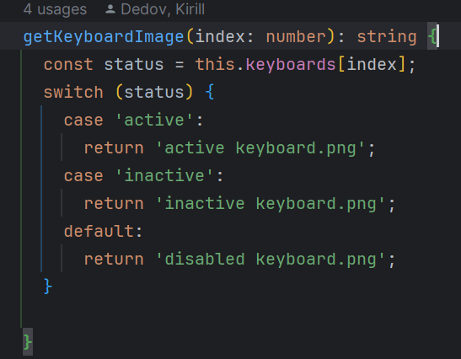
- getKeyboardName(index: number): Maps each keyboard index to its corresponding name, ensuring accurate labeling and enhancing usability.
  - Purpose: Facilitates user understanding of the organ's configuration, making the interface more accessible and easier to navigate.

Services.
SseService
The SseService is an Angular service designed to handle real-time data connections using Server-Sent Events (SSE). It's crucial for updating the application with live data from the server without needing to refresh the page. This service plays a key role in ensuring that the user interface displays the most current system information.
Key Features:
- Automatic Updates: The service uses SSE to listen for updates from the server and immediately updates the application's state with any new data.
- Central Data Management: Manages a central stream of data updates using a BehaviorSubject, which allows components throughout the application to access the latest data easily.
Methods:
- initEventSource(url: string): Initializes the SSE connection to the server.
  - Purpose: Opens a continuous channel between the server and the client for sending real-time updates. It also handles data parsing and updates the application state using Angular's NgZone to ensure UI updates are processed in the Angular context
  - Creation of Dummy State on Error: In the onerror event handler, it handles cases where no commands have been sent or when there's a problem with the connection. It sets up a basic fallback or "dummy" state with simple default values like command: '', currentTempo: 0, and title: 'stopped'. This smart move makes sure that the application stays stable and behaves as expected, even if no commands come through or if there are unexpected issues with data coming from the server.
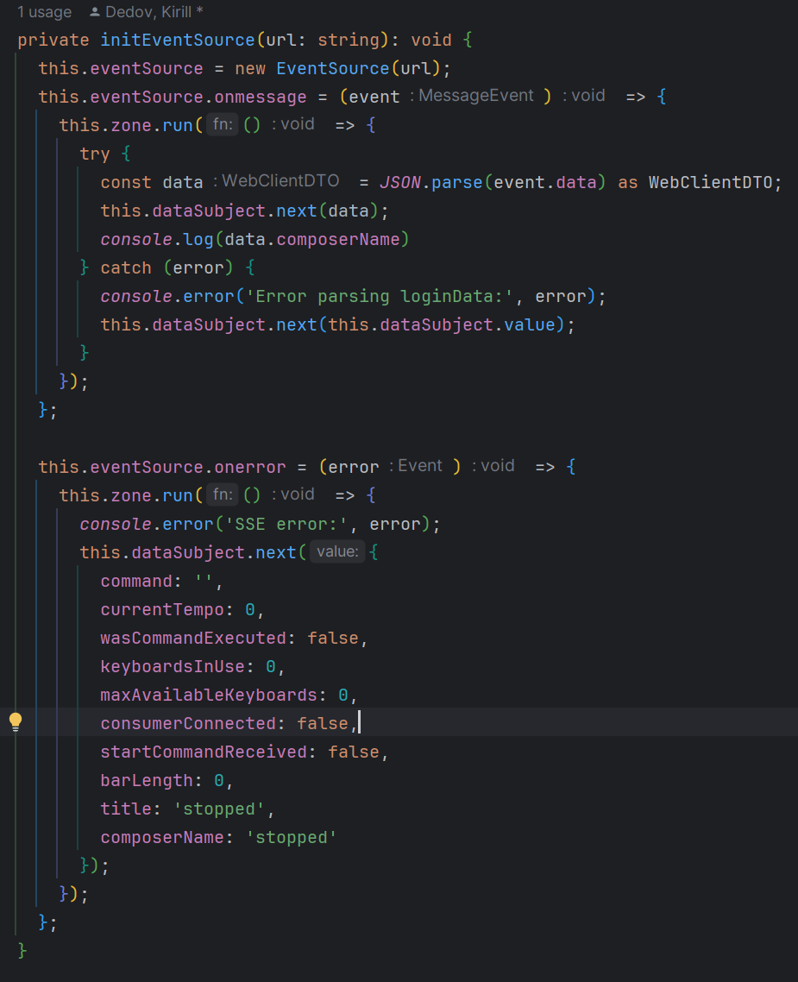.
- getWebClientData(): Observable<WebClientDTO>: Provides an observable that components can subscribe to receive updates.
  - Purpose: Allows any part of the application to listen for real-time data updates, ensuring the UI is always synchronized with the server state.
- ngOnDestroy(): Cleans up the SSE connection when the service is destroyed.
  - Purpose: Prevents memory leaks and other performance issues by ensuring that the connection is properly closed when the service instance is no longer needed.
LoginDataService
The LoginDataService is a service, designed to manage user authentication.
Key Features:
- Reactive Data Streams: Utilizes BehaviorSubject from RxJS to handle changes in the user's authentication status and username. This reactive approach allows various parts of the application to immediately respond to any changes in user status.
- Centralized User State Management: Centralizes the management of user authentication and identity, simplifying the process of accessing and reacting to user data throughout the application.
Methods:
- updateAuthentication(data: boolean): Updates whether the user is authenticated.
  - Purpose: This method is invoked to reflect changes in the user's authentication status (logged in or logged out). It ensures that all parts of the application that rely on the user's authentication status receive updates in real-time.
- updateUsername(newUsername: string): Updates the stored username.
  - Purpose: This is used to set or update the username whenever a user logs in.
Guards.
authGuard.
The authGuard. This guard ensures that only authenticated users can access dashboard.
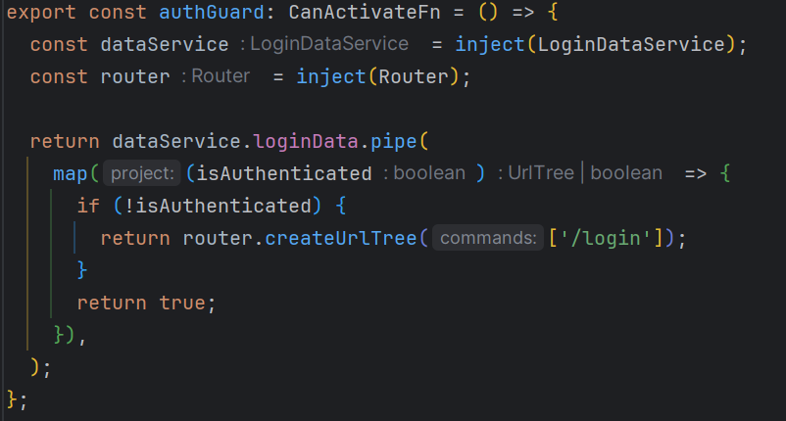
Integration with Routes:
- Dashboard Route with Guard: The authGuard is directly applied to the dashboard route in the application's routing configuration:
This setup means that when a user tries to navigate to the /dashboard route, the authGuard is invoked before the route is activated.
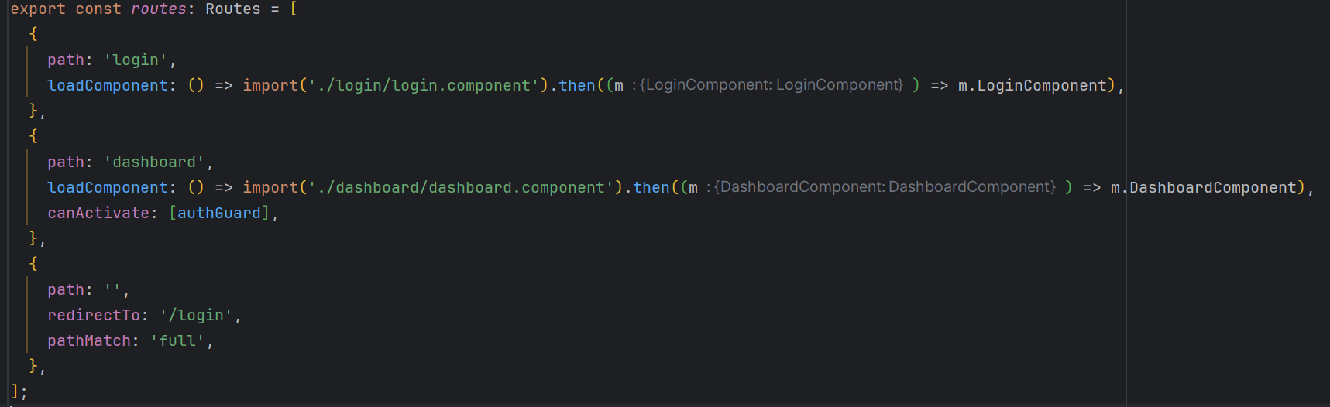
Functionality of authGuard in Routing:
- Authentication Check: When the authGuard is triggered by a route access attempt, it consults the LoginDataService to determine if the user is currently authenticated.
- Conditional Routing:
  - If the user is authenticated (isAuthenticated is true), the guard allows the routing to proceed, granting access to the dashboard.
  - If the user is not authenticated, the guard redirects the user to the /login route using a URL tree created by the Router. This redirection prevents access to the dashboard and guides the user to a place where they can log in.
Pipes.
TempoPipe.
This pipe designed to transform tempo enum values into user-friendly string descriptions.
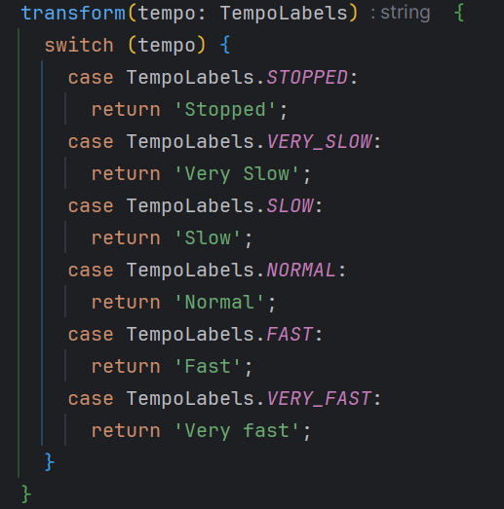
CommandDisplayNamePipe.
This pipe is designed to transform command keys into user-friendly string descriptions.
