HTTP Server.
It is one of the components of the "Dancing Pipes." In our project, it connects the other components together and allows these components to be used on different computers.
Technologies and reasoning.
The server is built using the following main technologies:
- Spring Boot: Provides the framework for building and running the server, including support for web and web services.
  - Reason: Very popular framework that simplifies development with embedded servers, sensible defaults, and extensive ecosystem support. Additionally, gaining experience with Spring Boot is valuable for future projects and career growth.
- Gradle: Used as the build automation tool to manage dependencies and build processes.
  - Reason: Offers flexibility, incremental builds, and efficient dependency management. No special reasons for choosing Gradle, but I previously used Maven and now want to try something different.
- JUnit: Utilized for writing and running tests to ensure code quality and correctness.
  - Reason: Widely used, comprehensive features for testing, and strong IDE integration.
- Lombok: Helps reduce boilerplate code, improving code readability and maintainability.
  - Reason: Reduces boilerplate code, making the codebase more readable and maintainable.
- Jackson: Used primarily with ObjectMapper for JSON data binding, facilitating the conversion between Java objects and JSON.
  - Reason: High performance in parsing and generating JSON, and powerful and flexible ObjectMapper.
- Spring Security Crypto: Used to secure passwords in the login part of the frontend application, enhancing security in the application.
  - Reason: Provides robust mechanisms for securing passwords and seamless integration with Spring Security.
- SseEmitter: Utilized for server-sent events (SSE), enabling the server to push real-time updates to the client.
  - Reason Ideal for real-time updates, reduces network overhead, and supports a push-based architecture for live notifications and data feeds. SSE is a simpler alternative to WebSockets for one-way communication, making it suitable for applications that require real-time data updates without the complexity of bidirectional communication. Additionally, since the goal was to build an HTTP server, SSE aligns well with this architecture.

Server Architecture
The main components of the server are three controllers: ConsumerController, ProducerController, and WebController; and four services: EmitterService, LoginService, NumberService, and OrganSettingsService.
Controllers
ConsumerController
The ConsumerController is a REST controller that handles incoming HTTP requests related to "Organ Sequencer" component. It is annotated with @RequiredArgsConstructor to automatically generate a constructor with required dependencies, which are EmitterService and NumberService. This controller provides functionality through two HTTP methods on the /consumer endpoint.
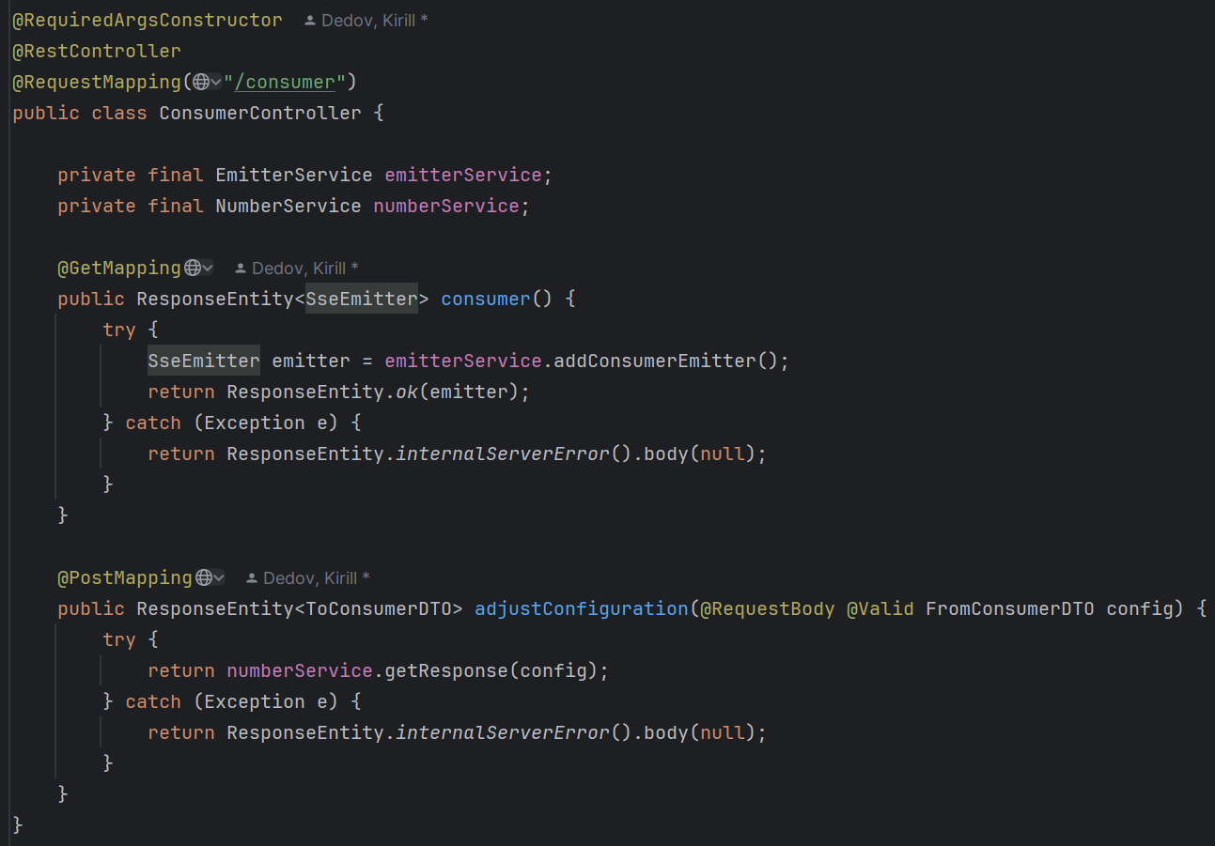
Endpoint: /consumer
HTTP Methods:
GET
- Purpose: This method is used to send commands to be executed in the "Organ Sequencer" component.
- Method: public ResponseEntity<SseEmitter> consumer()
- Functionality:
  - When a GET request is made to this endpoint, it triggers the consumer().
  - Consumer() attempts to create a new SseEmitter object via the EmitterService and returns it in the response.
  - SseEmitter is used to send server-sent events to the client, which is useful for real-time updates.
  - If the SseEmitter is created successfully, it returns an HTTP 200 OK response with the SseEmitter object. If an exception occurs, it returns a 500 Internal Server Error response with no body.
POST
- Purpose: This method is used to receive and adjust the configuration settings, which include information such as the number of keyboards, title name, and other related parameters.
- Method: public ResponseEntity<ToConsumerDTO> adjustConfiguration(@RequestBody @Valid FromConsumerDTO config)
- Functionality:
  - When a POST request is made to this endpoint with a valid FromConsumerDTO object in the request body, it triggers the adjustConfiguration method.
  - The adjustConfiguration method uses the NumberService to process the request and generate a response.
  - If successful, it returns a ToConsumerDTO object in the response. If an exception occurs, it returns a 500 Internal Server Error response with no body.

ProducerController
The ProducerController is a REST controller that handles incoming HTTP requests related to the "Camera" component. It is annotated with @RequiredArgsConstructor to automatically generate a constructor with required dependencies, which is NumberService. This controller provides functionality through a single HTTP method on the /producer endpoint.
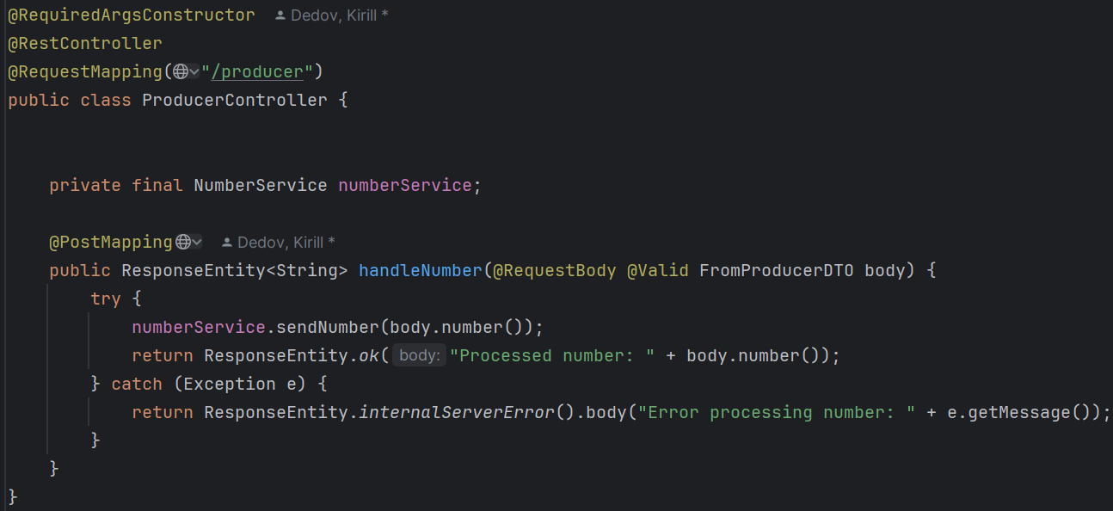
Endpoint: /producer
HTTP Methods:
POST
- Purpose: This method is used to receive commands from the "Camera" component and process them using the sendNumber method from NumberService.
- Method: public ResponseEntity<String> handleNumber(@RequestBody @Valid FromProducerDTO body)
- Functionality:
  - When a POST request is made to this endpoint with a valid FromProducerDTO object in the request body, it triggers the handleNumber method.
  - The handleNumber method uses the NumberService to process the number by calling the sendNumber method with the number from the request body.
  - If the number is processed successfully, it returns HTTP 200 OK with a message indicating the processed number. If an exception occurs, it returns a 500 Internal Server Error with an error message.

WebController
The WebController is a REST controller that handles incoming HTTP requests related to frontend. It is annotated with @RequiredArgsConstructor to automatically generate a constructor with required dependencies, which are LoginService and EmitterService. This controller provides functionality through two HTTP methods on the /web endpoint.
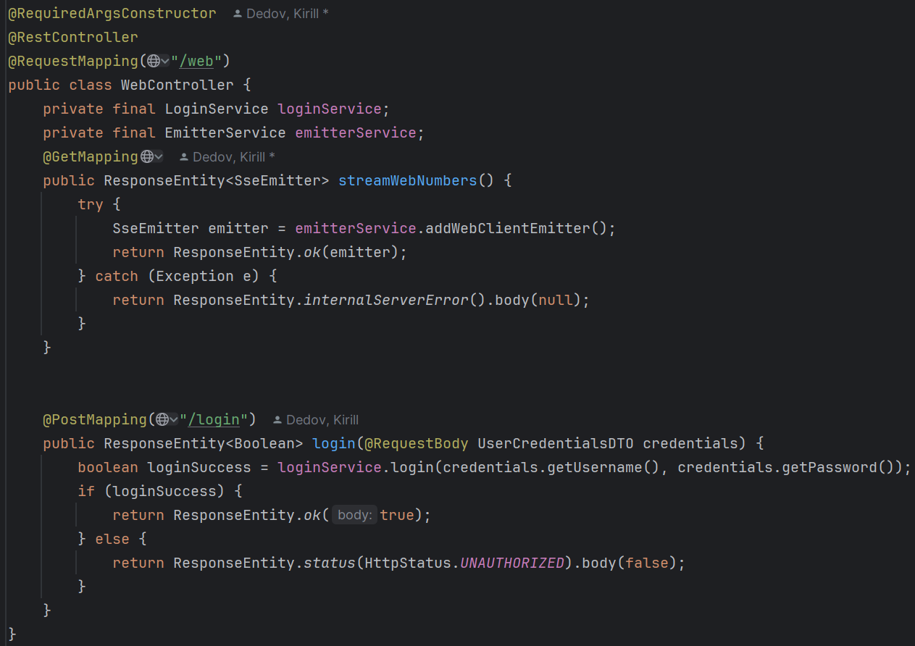
Endpoint: /web
HTTP Methods:
GET
- Purpose: This method is used to send actual information to the frontend.
- Method: public ResponseEntity<SseEmitter> streamWebNumbers()
- Functionality:
  - When a GET request is made to the /web endpoint, it triggers the streamWebNumbers().
  - The streamWebNumbers() attempts to create a new SseEmitter object via the EmitterService and returns it in the response.
  - On Success: If the SseEmitter is created successfully, it returns an HTTP 200 OK response with the SseEmitter object.
  - On Failure: If an exception occurs, it returns a 500 Internal Server Error response with no body.
Endpoint: /web/login
HTTP Methods:
POST
- Purpose: This method is used to check user credentials.
- Method: public ResponseEntity<Boolean> login(@RequestBody UserCredentialsDTO credentials)
- Functionality:
  - When a POST request is made to the /web/login endpoint with a UserCredentialsDTO object in the request body, it triggers the login method.
  - The login method calls the loginService.login method, passing the username and password from the UserCredentialsDTO.
  - On Success: If the credentials are correct, it returns an HTTP 200 OK response with true.
  - On Failure: If the credentials are incorrect, it returns an HTTP 401 Unauthorized response with false.

Services
LoginService
The LoginService is a Spring service responsible for managing user authentication in the frontend. It achieves this by loading user credentials from a file and verifying login attempts using secure password hashing.
Key Fields:
- users: Stores usernames and their encoded passwords.
- passwordEncoder: Used to encode and verify passwords.
- CREDENTIALS_FILE: The name of the file that contains user credentials.

Methods
- init()
  - Purpose: Initializes the service by loading credentials from a file.
  - Annotation: @PostConstruct - This annotation ensures that the init() method is executed after the bean is constructed and dependencies are injected.
- loadCredentialsFromFile()
  - Purpose: Loads user credentials from credentials.txt, encodes passwords, and stores them in a map.
  - Throws: IOException - Propagates the exception to be handled by the caller.
- login(String username, String password)
  - Purpose: Verifies the provided username and password.
  - Returns: true if the credentials match; false otherwise.

EmitterService
The EmitterService is a Spring service responsible for managing Server-Sent Events (SSE) emitters for different types of clients. It handles the creation, management, and sending of events to these emitters.

Key Fields
- consumerEmitter: Manages SSE events for the "Organ Sequencer" client.
- webClientEmitter: Manages SSE events for frontend clients.
- objectMapper: Used to serialize messages into JSON format for sending via SSE.

Methods
- addConsumerEmitter()
  - Purpose: Initializes and returns a new SSE emitter for a “Organ Sequencer” client.
  - Returns: SseEmitter - a new emitter instance configured with maximum timeout and event handlers for completion, timeout, and error.
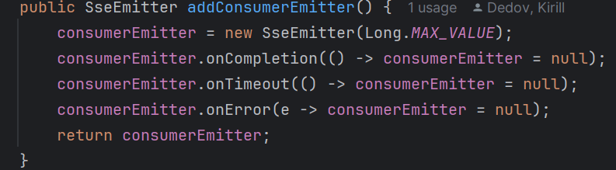
- addWebClientEmitter()
  - Purpose: Initializes and returns a new SSE emitter for a frontend client.
  - Returns: SseEmitter - a new emitter instance configured with maximum timeout and event handlers for completion, timeout, and error.
- sendToConsumer(ToConsumerDTO message)
  - Purpose: Sends a message to the “Organ Sequencer” client via SSE.
  - Parameters:
  - ToConsumerDTO message - the message to be sent to the “Organ Sequencer” client.
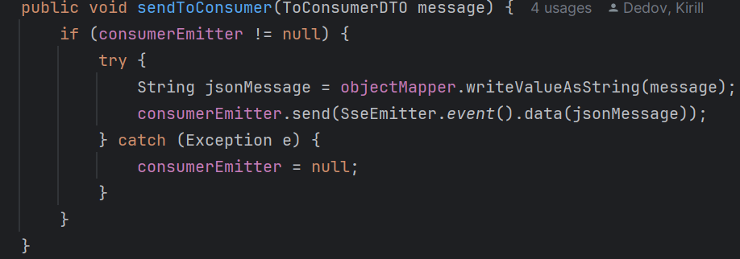
- Functionality: Serializes the message to JSON and sends it. If an error occurs, it nullifies the consumer emitter.
  - sendToWebClient(ToWebClientDTO message)
  - Purpose: Sends a message to the web client via SSE.
  - Parameters: ToWebClientDTO message - the message to be sent to the web client.
  - Functionality: Sends the message directly. If an error occurs, it nullifies the web client emitter.
- hasActiveConsumerEmitters()
  - Purpose: Checks if there are any active consumer emitters.
  - Returns: boolean - true if there is an active consumer emitter, false otherwise.

NumberService
The NumberService is a Spring service that processes numerical commands from “Camera” component, updates organ settings, and communicates with clients via Server-Sent Events (SSE). It interacts with the EmitterService and OrganSettingsService to handle these tasks.
Key Fields
- emitterService: Manages the sending of messages to clients via SSE.
- organSettingsService: Manages the state and settings of the organ simulator.

Methods

- sendNumber(int number)
  - Purpose: Processes a numerical command to perform various actions related to organ settings and sends updates to clients.
  - Parameters: int number - the command number to process.
  - Functionality:
    - Determines the action based on the number using the Action enum.
    - Performs the corresponding action by calling methods in OrganSettingsService.
    - If the action results in a message, it updates and sends the message to the clients.
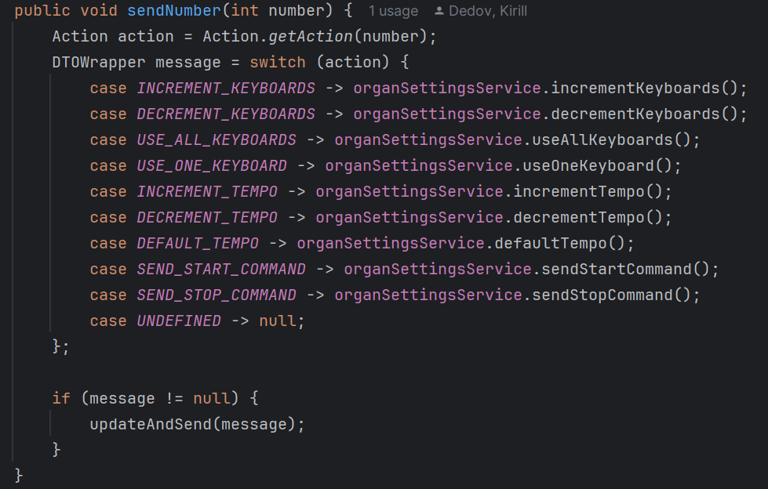
- updateAndSend(DTOWrapper message)
  - Purpose: Sends the message to the consumer and web client emitters if applicable.
  - Parameters: DTOWrapper message - the message to be sent.
  - Functionality:
    - Sends the message to the consumer emitter if there are active consumer emitters.
    - Checks conditions before sending the message to the web client emitter.
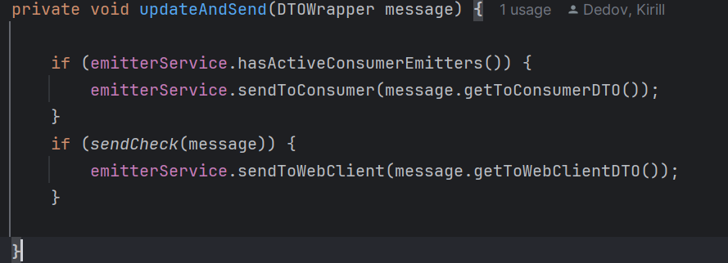
- sendCheck(DTOWrapper message)
  - Purpose: Checks whether the message should be sent to the web client.
  - Parameters: DTOWrapper message - the message to be checked.
  - Returns: boolean - true if the message should be sent; false otherwise.
  - Functionality:
    - Ensures the message is not sent if the consumer is connected and the command is either "start" or "stop".

- getResponse(FromConsumerDTO config)
  - Purpose: Updates organ settings based on the provided configuration and returns the updated settings to the consumer client.
  - Parameters: FromConsumerDTO config - the configuration settings to apply.
  - Returns: ResponseEntity<ToConsumerDTO> - the response containing the updated settings for the consumer client.
  - Functionality:
    - Updates the organ settings state based on the provided configuration.
    - Sends the updated state to the web client emitter.
    - Returns the updated configuration to the consumer client.

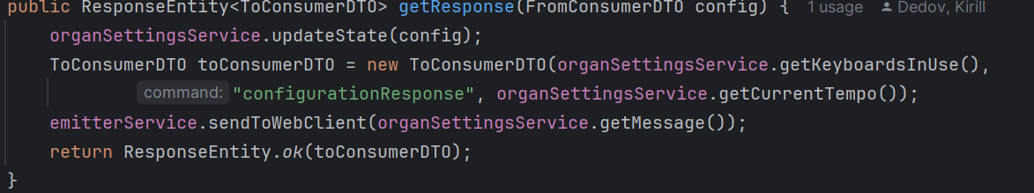

OrganSettingsService
The OrganSettingsService is a Spring service responsible for managing the state and settings of an organ simulator. It includes functionality to increment and decrement keyboards and tempo, as well as to handle start and stop commands. The service communicates updates to clients via Server-Sent Events (SSE) using the EmitterService.
Key Fields
- keyboardsInUse: Number of keyboards currently in use.
- maxAvailableKeyboards: Maximum number of keyboards available.
- startCommandReceived: Boolean flag indicating if the start command was received.
- minTempo: Minimum allowable tempo.
- maxTempo: Maximum allowable tempo.
- currentTempo: Current tempo of the organ.
- defaultTempo: Default tempo setting.
- barLength: Length of the musical bar.
- title: Title of the current piece.
- composerName: Name of the composer.
- message: Current message to be sent to the web client.
- command: Current command name.
- wasCommandExecuted: Boolean flag indicating if the last command was executed.
Methods
- setKeyboardsInUse(int keyboards)
  - Purpose: Sets the number of keyboards in use if there are active consumer emitters.
  - Parameters: int keyboards - the number of keyboards to be set.

- setMaxAvailableKeyboards(int keyboards)
  - Purpose: Sets the maximum number of available keyboards if there are active consumer emitters.
  - Parameters: int keyboards - the maximum number of keyboards.

- sendStartCommand()
  - Purpose: Handles the start command and updates the state accordingly.
  - Returns: DTOWrapper - the updated state.
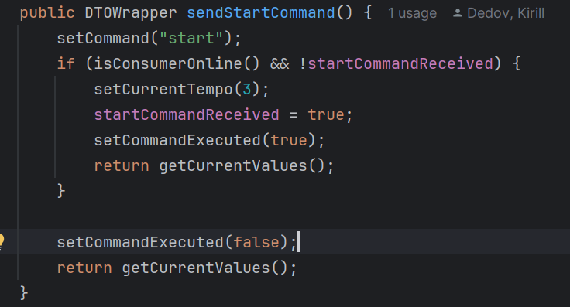
- sendStopCommand()
  - Purpose: Handles the stop command and updates the state accordingly.
  - Returns: DTOWrapper - the updated state.
- incrementKeyboards()
  - Purpose: Increments the number of keyboards in use if the start command was received and the maximum number of keyboards is not exceeded.
  - Returns: DTOWrapper - the updated state.
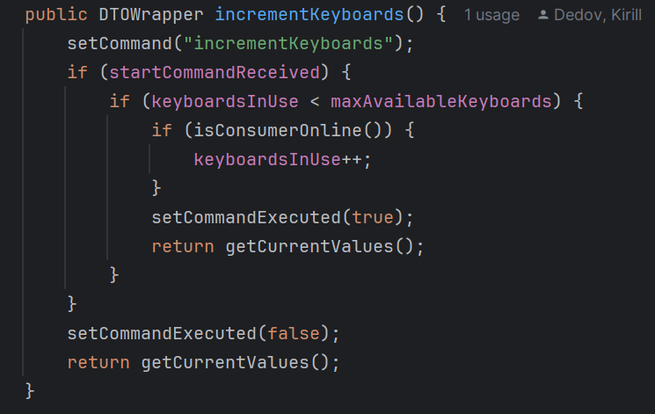
- decrementKeyboards()
  - Purpose: Decrements the number of keyboards in use if the start command was received and more than one keyboard is in use.
  - Returns: DTOWrapper - the updated state.
- useOneKeyboard()
  - Purpose: Sets the number of keyboards in use to one if the start command was received and more than one keyboard is in use.
  - Returns: DTOWrapper - the updated state.
- useAllKeyboards()
  - Purpose: Sets the number of keyboards in use to the maximum available if the start command was received and not all keyboards are in use.
  - Returns: DTOWrapper - the updated state.
- incrementTempo()
  - Purpose: Increments the tempo if the start command was received and the maximum tempo is not exceeded.
  - Returns: DTOWrapper - the updated state.
- decrementTempo()
  - Purpose: Decrements the tempo if the start command was received and the minimum tempo is not exceeded.
  - Returns: DTOWrapper - the updated state.
- defaultTempo()
  - Purpose: Sets the tempo to the default value if the start command was received and the current tempo is not the default.
  - Returns: DTOWrapper - the updated state.
  - getCurrentValues()
  - Purpose: Gets the current state of the organ settings and returns it wrapped in a DTOWrapper.
- updateState(FromConsumerDTO config)
  - Purpose: Updates the state of the organ settings based on the provided configuration.
  - Parameters: FromConsumerDTO config - the new configuration settings.
  - Returns: DTOWrapper - the current state.
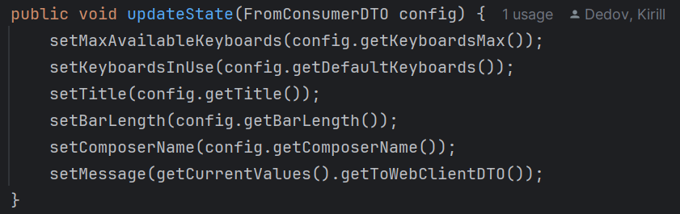
- isConsumerOnline()
  - Purpose: Checks if there are any active consumer emitters connected, indicating whether Organ Sequenser is connected and interacting with the server.
  - Returns: boolean - True if at least one consumer emitter is active, False otherwise.
- getCurrentValues()
  - Purpose: Retrieves the current state of the organ settings, wrapping them in a DTOWrapper. This includes both ToWebClientDTO and ToConsumerDTO, providing a snapshot of current configurations and states, useful for syncing states across components or updating client-side displays.
  - Returns: DTOWrapper - The wrapper containing the current settings and states, structured for both consumer and web client use.
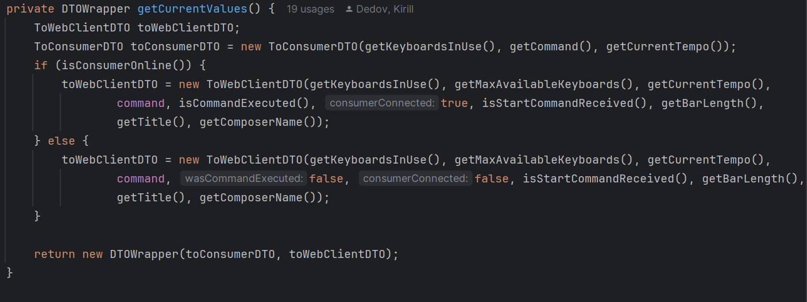

How the Server Handles Camera Commands
The task of the server is to receive signals from the "Camera" component, process them, decide whether they need to be sent to the "Organ Sequencer" component for execution, receive information from the "Organ Sequencer" about the piece being played, send information for display on the frontend, as well as store credentials and verify them for frontend login.
