Dancing-Pipes
Documentation
Programmierprojekt, Sommersemester 2024
Atilla Özdemir
Kirill Dedov
Matsvei Tsiareshka
Toni Kostov
Table of contents
1. Motivation and goal setting 1
2. Pose Estimation (By Atilla and Matsvei) 2
2.1. Evaluation of Tested Models 2
2.1.1. Kinect (Atilla and Matsvei) 2
2.1.2. Webcam-Based Pose Estimation with MoveNet (Atilla) 2
2.1.3. Webcam-Based Hand Recognition with Mediapipe+Tensorflow (Matsvei) 3
2.2. Model Mechanism Overview (Atilla) 6
Recommended Setup and Conditions 8
3. HTTP Server (By Kirill) 8
3.1. Technologies and reasoning. 8
3.2. Server Architecture 9
3.2.1. Controllers 10
3.2.2. Services 14
3.2.3. How the Server Handles Camera Commands 23

Motivation and goal setting

Pose Estimation (By Atilla and Matsvei)

Evaluation of Tested Models
In this section, we compile and analyze the models for capturing and interpreting movements for the project, highlighting their advantages and disadvantages. The tests conducted here were carried out according to the specific purpose of the project and were evaluated in line with the limited resources of the developers. Therefore, it's important to note that these results may not apply universally to all scenarios.

This evaluation provides a comprehensive overview of the performance and suitability of each model in the context of motion detection, music track control, and data transmission, thereby guiding the selection of the most effective approaches for the system's development.

Kinect (Atilla and Matsvei)
The initial phase of the project explored the use of the Microsoft Kinect device for capturing and interpreting user movements. The Kinect offered a significant advantage:

- 3D Data Capture: The Kinect's dual camera system and various sensors enabled the capture of 3D positional data of the user's body, providing detailed information for movement analysis.
However, the development process encountered several challenges:
- Limited Compatibility: The Kinect device's reliance on Windows operating systems posed a challenge for team members using different platforms.

- Accessibility Issues: The discontinuation of Kinect production made acquiring the device difficult, limiting the ability to support concurrent testing across multiple team members and significantly slowing down development.

Due to these accessibility limitations affecting both the development process and potential users, the project shifted focus towards more modern, versatile, and user-friendly solutions for capturing and interpreting movements.

Webcam-Based Pose Estimation with MoveNet (Atilla)
Following the exploration of the Kinect device, the project pivoted towards leveraging artificial intelligence-supported models for capturing and interpreting movements. This shift offered several advantages:
- Accessibility: Webcams are readily available on most personal computers, eliminating the need for additional sensors or specialized equipment. This significantly reduces barriers to both development and user adoption.
- Cross-platform Compatibility: Webcam functionality is inherent to most operating systems, ensuring broader compatibility compared to the Windows-specific Kinect.
- Development Efficiency: The widespread availability of webcams allows each team member to conduct independent testing and development cycles, accelerating the iterative process.
Given these advantages, the project explored MoveNet’s Lightning model as the initial approach. This selection utilized the TensorFlow and OpenPose libraries, providing a well-established framework for pose estimation tasks. While initial tests with MoveNet demonstrated promising results in detecting the movements of a seated user, the model exhibited several limitations:
- Limited Posture Recognition: MoveNet struggled to accurately perceive the movements of a standing person with the same efficacy as those in a seated position. Extensive testing across various environments (lighting conditions, background variations) and user demographics (gender, height, skin tone) failed to yield significant improvements in this area.
- Performance Issues with Speed: The model’s processing speed proved to be a bottleneck, particularly when dealing with fast movements or movements performed at low angles. These situations resulted in stuttering, slowdowns, and instances of missed detections.
Due to these limitations, the project redirected its focus towards finding alternative models that offered:
- Lightweight Architecture: A smaller, more efficient model would improve processing speed and address the performance issues encountered with MoveNet.
- Posture Agnostic Detection: The chosen model should be capable of accurately detecting and interpreting human movements regardless of the user’s posture (standing or sitting).
By addressing these shortcomings, the project aims to establish a more robust and versatile solution for capturing and interpreting user movements.

Hand Recognition with Mediapipe+Tensorflow (Matsvei)
As an alternative, it was decided to implement hand gesture recognition. It provides tools for hand sign and finger gesture recognition using MediaPipe. The models for recognition are implemented using TensorFlow, and data can be trained and collected using provided scripts and notebooks.

Hand recognition is divided into two parts: gesture recognition and index finger tracking. Both parts use the sequential neural network model from tensorflow.

Gesture recognition
keypoint_classification.ipynb trains the model based on input data (42 numbers - coordinates of 21 key points (X and Y of each key point)). Key points are indicated below in the picture.

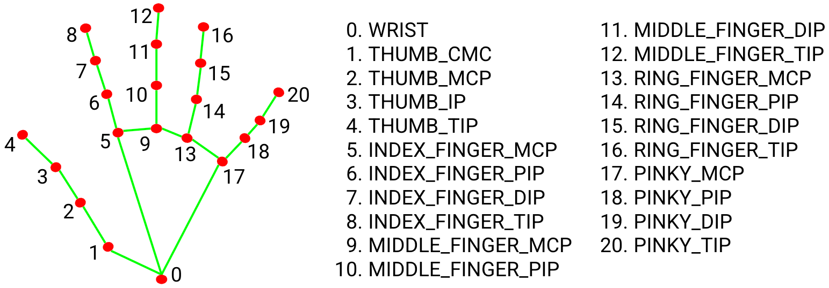
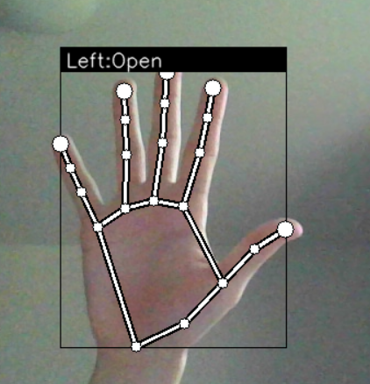

Each point is displayed on the screen and the territory of the hand is also shown with frames. The name of the gesture is written at the top. It also displays which hand (left or right) is on the camera.
There are currently three gestures available(close,open,pointer) . It is also possible to add your own gestures
How to add your own gesture?
- Please open the file keypoint_classifier_label
- Write the name of your gesture
- Remember the serial number of your gesture (remember that the countdown starts from zero)
- Start app.py
- press k (you will go to the mod for installing new gestures).
- Select a hand pose for the gesture and press a number equal to the serial number of the gesture that you added a couple of steps ago
*please do as many different poses as possible for one gesture, since when you press a number, it is the coordinate data at the moment you press the number that is remembered
- Restart app.py

How it works?
In file keypoint_classifier_label are indicated possible labels for gestures. In file keypoint there is a table where the first number is the serial number of the label as well as the coordinates of the pose belonging to this label. When you press a number in the mode of adding gestures, the camera captures this pose at the moment and the table is supplemented with the pressed number + coordinates of this pose
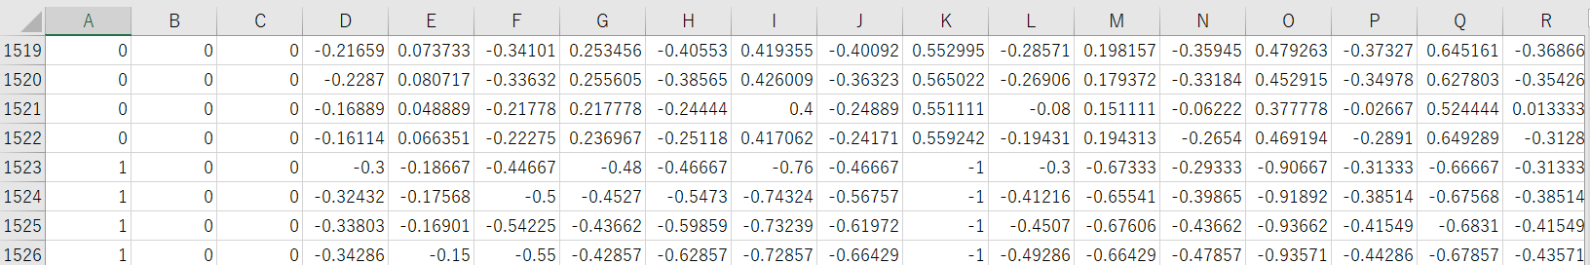

Index finger tracking

Webcam-Based Pose Estimation with MediaPipe (Atilla)
Following the limitations encountered with MoveNet, the project explored MediaPipe as a potential alternative for capturing and interpreting user movements. MediaPipe shares some similarities with MoveNet in its model architecture but offers distinct advantages:
- Simplified Installation: MediaPipe boasts a streamlined installation process compared to MoveNet, reducing development setup time and streamlining project workflow.
- Enhanced Performance: Our evaluation revealed that MediaPipe outperformed MoveNet in terms of processing speed, frame capture rate, and overall detection accuracy. This translates to a smoother user experience with minimal latency and improved responsiveness to user movements.
However, during the evaluation process, one potential drawback of MediaPipe was identified:
- Limited Customization: While MediaPipe offers pre-built solutions for various tasks, its customizability for highly specialized applications might be less extensive compared to frameworks like TensorFlow.
Considering the project's time constraints and the positive results from the performance evaluation, MediaPipe was chosen as the preferred model for further development. However, the project acknowledges the need for potential future adjustments to address any limitations in customization or potential biases within the model.

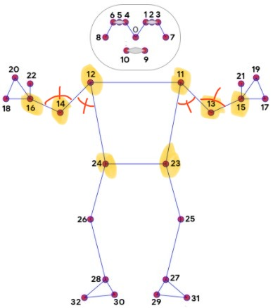
Model Mechanism Overview (Atilla)
This section provides a comprehensive overview of how the developed model operates using MediaPipe and OpenCV to detect and interpret body movements for controlling a digital pipe organ. The system identifies 32 distinct points on the body, displaying both the detected points and the image to the user in a new pop-up window. In current version, 8 of these points are utilized for controlling the music system.

Detection and Display
Body Points Detection: The model detects 32 distinct points on the user's body. These points are visualized on the screen, with 8 specific points used for the control mechanism.
- Angle Calculation: The coordinates of these 8 points are used to calculate angles, which are marked in red on the image. The relevant points for these calculations are highlighted in yellow.
- Intermediate Codes Generation: Based on the calculated angles, two intermediate codes are generated, one of these is for the tempo and the other is for the keyboard. These codes are displayed on the screen for user reference, allowing the user to monitor their current position.
- Pose Detection: If the user maintains a specific pose for more than 2 seconds, the intermediate codes of that pose are combined and transmitted to the server.

Control Mechanism
The control mechanism is divided into two primary functions: adjusting the tempo of the musical piece and changing the number of keyboards engaged. Additionally, a special pose controls the start and stop of the music track.
- Tempo Control:
  - The left side of the body is used for tempo control.
  - Angles centered on points 12 (shoulder) and 14 (elbow) are used to determine the control action.
  - Three different positions adjust the tempo:
    - Decrease Tempo: Lowers the current tempo by one unit.
    - Increase Tempo: Raises the current tempo by one unit.
    - Default Tempo: Resets the tempo to the default value.
- Keyboard Control:
  - The right side of the body manages the number of keyboards.
  - Angles centered on points 11 (shoulder) and 13 (elbow) are used to determine the control action.
  - Four different positions are defined for keyboard adjustments:
    - Increase Keyboard: Adds one to the number of keyboards.
    - Decrease Keyboard: Subtracts one from the number of keyboards.
    - Max Keyboards: Sets the number to the maximum value.
    - Min Keyboards: Sets the number to the minimum value.
- Music Track Control:
  - If both arms are lifted straight up in a certain pose, the server is notified that the player is ready to start the music track and ON/OFF appears on the screen.
  - If this action is repeated after a music track has been started, the server is notified that the player wants to stop streaming and ON/OFF appears on the screen.
If the user presses the 'q' key, the camera detection process will halt.

Meanings of values
Elbow Angle | Shoulder Angle | Keyboard Value | Server Value | Tempo Value | Server Value
135°-180° | 135°-180° | ON/OFF | 0 | ON/OFF | 0
135°-180° | 0°-45° | Ignored | Ignored | Ignored | Ignored
135°-180° | 45°-90° | DELETE | 6 | MINUS | 2
90°-135° | Insignificant | ADD | 11 | PLUS | 3
45°-90° | Insignificant | MIN | 16 | Ignored | Ignored
0°-45° | Insignificant | MAX | 21 | DEFAULT | 5

Recommended Setup and Conditions
To ensure optimal performance and avoid potential issues, the following preliminary steps are recommended:
- Lighting: Ensure that the light source shines from behind the camera towards the player.
- Background: Use a plain background that contrasts with the player's clothing and skin color.
- Camera Distance: Maintain a minimum distance between the player and the camera to ensure all body points are distinguishable.
- Frame Rate: For image detection to work well, a camera that supports 30 FPS images is required.
These setup recommendations help improve the accuracy of body point detection and enhance the overall functionality of the system.

HTTP Server (By Kirill)
It is one of the components of the "Dancing Pipes." In our project, it connects the other components together and allows these components to be used on different computers.

Technologies and reasoning.

The server is built using the following main technologies:
- Spring Boot: Provides the framework for building and running the server, including support for web and web services.
  - Reason: Very popular framework that simplifies development with embedded servers, sensible defaults, and extensive ecosystem support. Additionally, gaining experience with Spring Boot is valuable for future projects and career growth.
- Gradle: Used as the build automation tool to manage dependencies and build processes.
  - Reason: Offers flexibility, incremental builds, and efficient dependency management. No special reasons for choosing Gradle, but I previously used Maven and now want to try something different.
- JUnit: Utilized for writing and running tests to ensure code quality and correctness.
  - Reason: Widely used, comprehensive features for testing, and strong IDE integration.
- Lombok: Helps reduce boilerplate code, improving code readability and maintainability.
  - Reason: Reduces boilerplate code, making the codebase more readable and maintainable.
- Jackson: Used primarily with ObjectMapper for JSON data binding, facilitating the conversion between Java objects and JSON.
  - Reason: High performance in parsing and generating JSON, and powerful and flexible ObjectMapper.
- Spring Security Crypto: Used to secure passwords in the login part of the frontend application, enhancing security in the application.
  - Reason: Provides robust mechanisms for securing passwords and seamless integration with Spring Security.
- SseEmitter: Utilized for server-sent events (SSE), enabling the server to push real-time updates to the client.
  - Reason: Ideal for real-time updates, reduces network overhead, and supports a push-based architecture for live notifications and data feeds. SSE is a simpler alternative to WebSockets for one-way communication, making it suitable for applications that require real-time data updates without the complexity of bidirectional communication. Additionally, since the goal was to build an HTTP server, SSE aligns well with this architecture.

Server Architecture
The main components of the server are three controllers: ConsumerController, ProducerController, and WebController; and four services: EmitterService, LoginService, NumberService, and OrganSettingsService.

Controllers
ConsumerController
The ConsumerController is a REST controller that handles incoming HTTP requests related to "Organ Sequencer" component. It is annotated with @RequiredArgsConstructor to automatically generate a constructor with required dependencies, which are EmitterService and NumberService. This controller provides functionality through two HTTP methods on the /consumer endpoint.
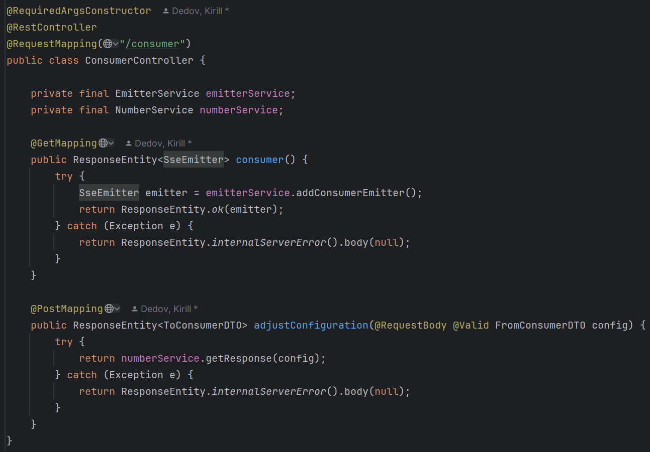

Endpoint: /consumer

HTTP Methods:

GET
- Purpose: This method is used to send commands to be executed in the "Organ Sequencer" component.
- Method: public ResponseEntity<SseEmitter> consumer()
- Functionality:
  - When a GET request is made to this endpoint, it triggers the consumer().
  - Consumer() attempts to create a new SseEmitter object via the EmitterService and returns it in the response.
  - SseEmitter is used to send server-sent events to the client, which is useful for real-time updates.
  - If the SseEmitter is created successfully, it returns an HTTP 200 OK response with the SseEmitter object. If an exception occurs, it returns a 500 Internal Server Error response with no body.

POST
- Purpose: This method is used to receive and adjust the configuration settings, which include information such as the number of keyboards, title name, and other related parameters.
- Method: public ResponseEntity<ToConsumerDTO> adjustConfiguration(@RequestBody @Valid FromConsumerDTO config)
- Functionality:
  - When a POST request is made to this endpoint with a valid FromConsumerDTO object in the request body, it triggers the adjustConfiguration method.
  - The adjustConfiguration method uses the NumberService to process the request and generate a response.
  - If successful, it returns a ToConsumerDTO object in the response. If an exception occurs, it returns a 500 Internal Server Error response with no body.

ProducerController
The ProducerController is a REST controller that handles incoming HTTP requests related to the "Camera" component. It is annotated with @RequiredArgsConstructor to automatically generate a constructor with required dependencies, which is NumberService. This controller provides functionality through a single HTTP method on the /producer endpoint.

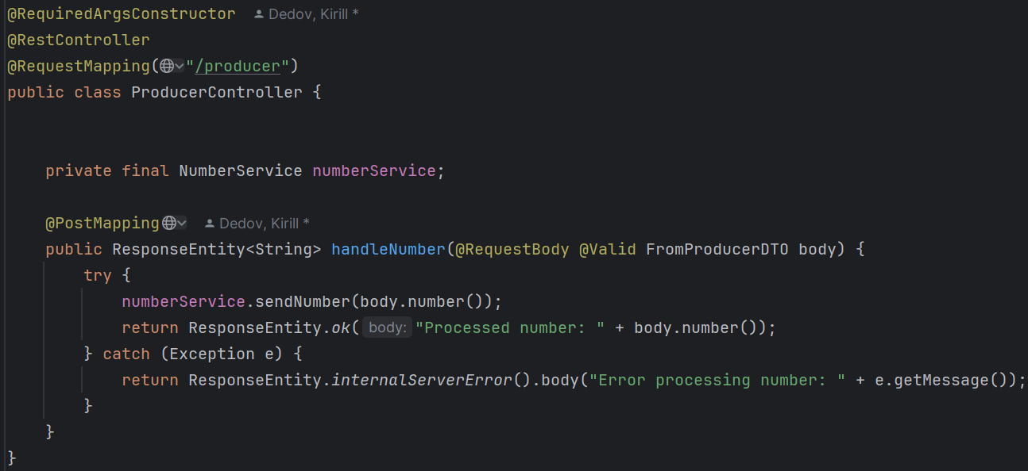

Endpoint: /producer

HTTP Methods:

POST
- Purpose: This method is used to receive commands from the "Camera" component and process them using the sendNumber method from NumberService.
- Method: public ResponseEntity<String> handleNumber(@RequestBody @Valid FromProducerDTO body)
- Functionality:
  - When a POST request is made to this endpoint with a valid FromProducerDTO object in the request body, it triggers the handleNumber method.
  - The handleNumber method uses the NumberService to process the number by calling the sendNumber method with the number from the request body.
  - If the number is processed successfully, it returns HTTP 200 OK with a message indicating the processed number. If an exception occurs, it returns a 500 Internal Server Error with an error message.

WebController
The WebController is a REST controller that handles incoming HTTP requests related to frontend. It is annotated with @RequiredArgsConstructor to automatically generate a constructor with required dependencies, which are LoginService and EmitterService. This controller provides functionality through two HTTP methods on the /web endpoint.

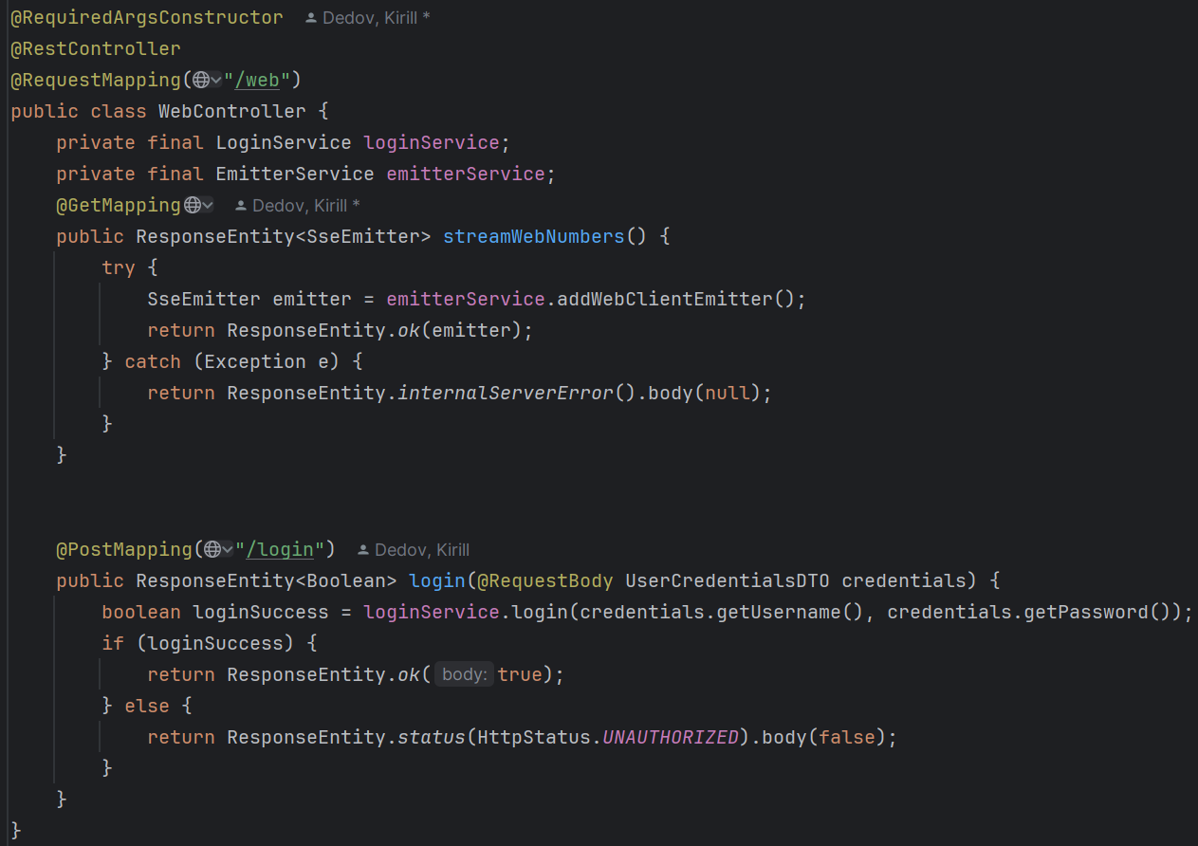
Endpoint: /web

HTTP Methods:

GET
- Purpose: This method is used to send actual information to the frontend.
- Method: public ResponseEntity<SseEmitter> streamWebNumbers()
- Functionality:
  - When a GET request is made to the /web endpoint, it triggers the streamWebNumbers().
  - The streamWebNumbers() attempts to create a new SseEmitter object via the EmitterService and returns it in the response.
  - On Success: If the SseEmitter is created successfully, it returns an HTTP 200 OK response with the SseEmitter object.
  - On Failure: If an exception occurs, it returns a 500 Internal Server Error response with no body.
Endpoint: /web/login

HTTP Methods:

POST
- Purpose: This method is used to check user credentials.
- Method: public ResponseEntity<Boolean> login(@RequestBody UserCredentialsDTO credentials)
- Functionality:
  - When a POST request is made to the /web/login endpoint with a UserCredentialsDTO object in the request body, it triggers the login method.
  - The login method calls the loginService.login method, passing the username and password from the UserCredentialsDTO.
  - On Success: If the credentials are correct, it returns an HTTP 200 OK response with true.
  - On Failure: If the credentials are incorrect, it returns an HTTP 401 Unauthorized response with false.

Services
LoginService
The LoginService is a Spring service responsible for managing user authentication in the frontend. It achieves this by loading user credentials from a file and verifying login attempts using secure password hashing.
Key Fields:
- users: Stores usernames and their encoded passwords.
- passwordEncoder: Used to encode and verify passwords.
- CREDENTIALS_FILE: The name of the file that contains user credentials.

Methods
- init()
  - Purpose: Initializes the service by loading credentials from a file.
  - Annotation: @PostConstruct - This annotation ensures that the init() method is executed after the bean is constructed and dependencies are injected.
- loadCredentialsFromFile()
  - Purpose: Loads user credentials from credentials.txt, encodes passwords, and stores them in a map.
  - Throws: IOException - Propagates the exception to be handled by the caller.
- login(String username, String password)
  - Purpose: Verifies the provided username and password.
  - Returns: true if the credentials match; false otherwise.

EmitterService
The EmitterService is a Spring service responsible for managing Server-Sent Events (SSE) emitters for different types of clients. It handles the creation, management, and sending of events to these emitters.

Key Fields
- consumerEmitter: Manages SSE events for the "Organ Sequencer" client.
- webClientEmitter: Manages SSE events for frontend clients.
- objectMapper: Used to serialize messages into JSON format for sending via SSE.

Methods
- addConsumerEmitter()
  - Purpose: Initializes and returns a new SSE emitter for a “Organ Sequencer” client.
  - Returns: SseEmitter - a new emitter instance configured with maximum timeout and event handlers for completion, timeout, and error.
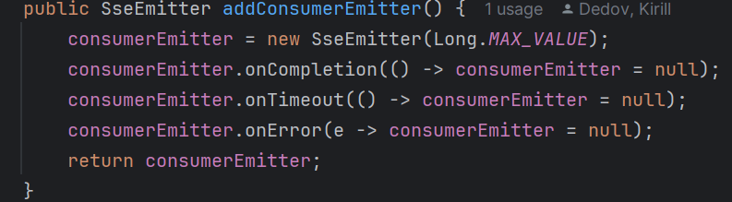
- addWebClientEmitter()
  - Purpose: Initializes and returns a new SSE emitter for a frontend client.
  - Returns: SseEmitter - a new emitter instance configured with maximum timeout and event handlers for completion, timeout, and error.
- sendToConsumer(ToConsumerDTO message)
  - Purpose: Sends a message to the “Organ Sequencer” client via SSE.
  - Parameters:
  - ToConsumerDTO message - the message to be sent to the “Organ Sequencer” client.
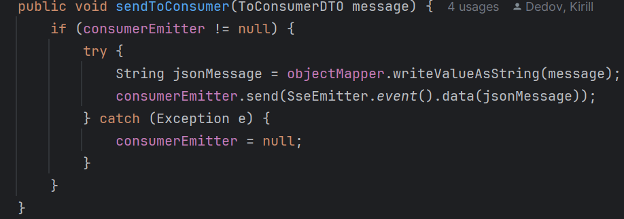

- Functionality: Serializes the message to JSON and sends it. If an error occurs, it nullifies the consumer emitter.
  - sendToWebClient(ToWebClientDTO message)
  - Purpose: Sends a message to the web client via SSE.
  - Parameters: ToWebClientDTO message - the message to be sent to the web client.
  - Functionality: Sends the message directly. If an error occurs, it nullifies the web client emitter.
- hasActiveConsumerEmitters()
  - Purpose: Checks if there are any active consumer emitters.
  - Returns: boolean - true if there is an active consumer emitter, false otherwise.

NumberService
The NumberService is a Spring service that processes numerical commands from “Camera” component, updates organ settings, and communicates with clients via Server-Sent Events (SSE). It interacts with the EmitterService and OrganSettingsService to handle these tasks.
Key Fields
- emitterService: Manages the sending of messages to clients via SSE.
- organSettingsService: Manages the state and settings of the organ simulator.

Methods

- sendNumber(int number)
  - Purpose: Processes a numerical command to perform various actions related to organ settings and sends updates to clients.
  - Parameters: int number - the command number to process.
  - Functionality:
    - Determines the action based on the number using the Action enum.
    - Performs the corresponding action by calling methods in OrganSettingsService.
    - If the action results in a message, it updates and sends the message to the clients.
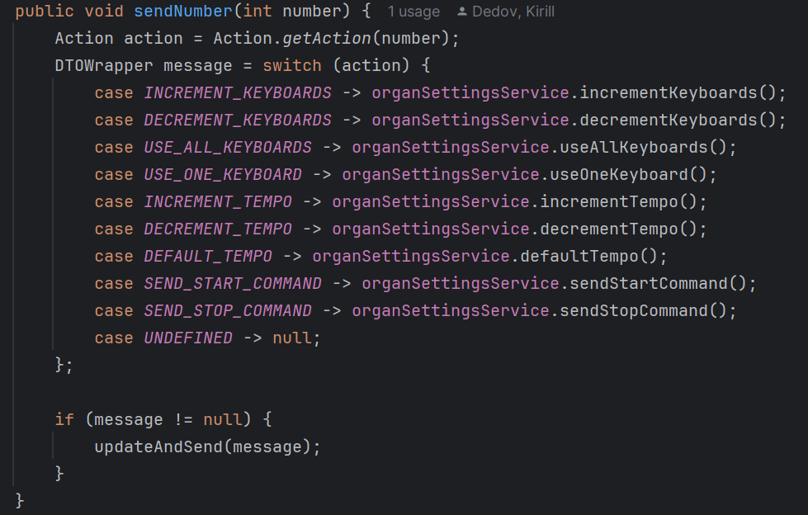
- updateAndSend(DTOWrapper message)
  - Purpose: Sends the message to the consumer and web client emitters if applicable.
  - Parameters: DTOWrapper message - the message to be sent.
  - Functionality:
    - Sends the message to the consumer emitter if there are active consumer emitters.
    - Checks conditions before sending the message to the web client emitter.
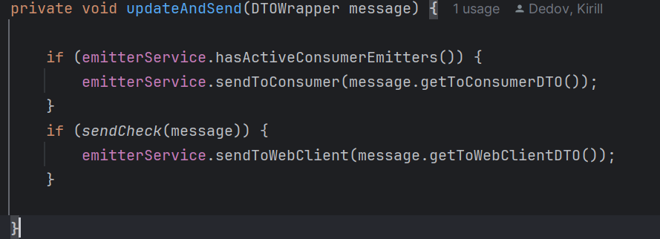
- sendCheck(DTOWrapper message)
  - Purpose: Checks whether the message should be sent to the web client.
  - Parameters: DTOWrapper message - the message to be checked.
  - Returns: boolean - true if the message should be sent; false otherwise.
  - Functionality:
    - Ensures the message is not sent if the consumer is connected and the command is either "start" or "stop".

- getResponse(FromConsumerDTO config)
  - Purpose: Updates organ settings based on the provided configuration and returns the updated settings to the consumer client.
  - Parameters: FromConsumerDTO config - the configuration settings to apply.
  - Returns: ResponseEntity<ToConsumerDTO> - the response containing the updated settings for the consumer client.
  - Functionality:
    - Updates the organ settings state based on the provided configuration.
    - Sends the updated state to the web client emitter.
    - Returns the updated configuration to the consumer client.
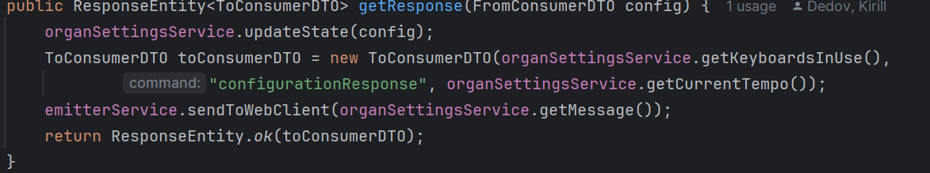
OrganSettingsService
The OrganSettingsService is a Spring service responsible for managing the state and settings of an organ simulator. It includes functionality to increment and decrement keyboards and tempo, as well as to handle start and stop commands. The service communicates updates to clients via Server-Sent Events (SSE) using the EmitterService.
Key Fields
- keyboardsInUse: Number of keyboards currently in use.
- maxAvailableKeyboards: Maximum number of keyboards available.
- startCommandReceived: Boolean flag indicating if the start command was received.
- minTempo: Minimum allowable tempo.
- maxTempo: Maximum allowable tempo.
- currentTempo: Current tempo of the organ.
- defaultTempo: Default tempo setting.
- barLength: Length of the musical bar.
- title: Title of the current piece.
- composerName: Name of the composer.
- message: Current message to be sent to the web client.
- command: Current command name.
- wasCommandExecuted: Boolean flag indicating if the last command was executed.
Methods
- setKeyboardsInUse(int keyboards)
  - Purpose: Sets the number of keyboards in use if there are active consumer emitters.
  - Parameters: int keyboards - the number of keyboards to be set.

- setMaxAvailableKeyboards(int keyboards)
  - Purpose: Sets the maximum number of available keyboards if there are active consumer emitters.
  - Parameters: int keyboards - the maximum number of keyboards.

- sendStartCommand()
  - Purpose: Handles the start command and updates the state accordingly.
  - Returns: DTOWrapper - the updated state.
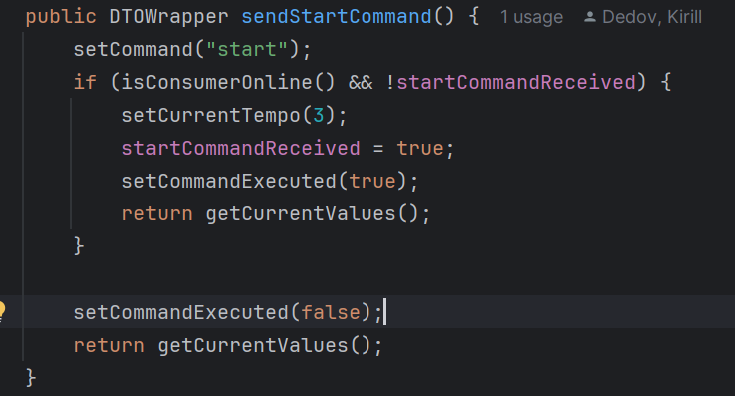
- sendStopCommand()
  - Purpose: Handles the stop command and updates the state accordingly.
  - Returns: DTOWrapper - the updated state.
- incrementKeyboards()
  - Purpose: Increments the number of keyboards in use if the start command was received and the maximum number of keyboards is not exceeded.
  - Returns: DTOWrapper - the updated state.
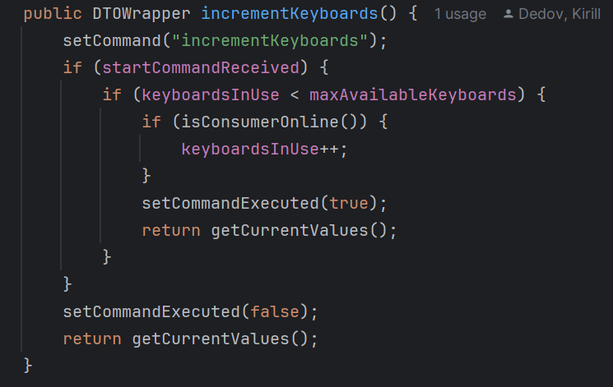
- decrementKeyboards()
  - Purpose: Decrements the number of keyboards in use if the start command was received and more than one keyboard is in use.
  - Returns: DTOWrapper - the updated state.
- useOneKeyboard()
  - Purpose: Sets the number of keyboards in use to one if the start command was received and more than one keyboard is in use.
  - Returns: DTOWrapper - the updated state.
- useAllKeyboards()
  - Purpose: Sets the number of keyboards in use to the maximum available if the start command was received and not all keyboards are in use.
  - Returns: DTOWrapper - the updated state.
- incrementTempo()
  - Purpose: Increments the tempo if the start command was received and the maximum tempo is not exceeded.
  - Returns: DTOWrapper - the updated state.
- decrementTempo()
  - Purpose: Decrements the tempo if the start command was received and the minimum tempo is not exceeded.
  - Returns: DTOWrapper - the updated state.
- defaultTempo()
  - Purpose: Sets the tempo to the default value if the start command was received and the current tempo is not the default.
  - Returns: DTOWrapper - the updated state.
  - getCurrentValues()
  - Purpose: Gets the current state of the organ settings and returns it wrapped in a DTOWrapper.
- updateState(FromConsumerDTO config)
  - Purpose: Updates the state of the organ settings based on the provided configuration.
  - Parameters: FromConsumerDTO config - the new configuration settings.
  - Returns: DTOWrapper - the current state.
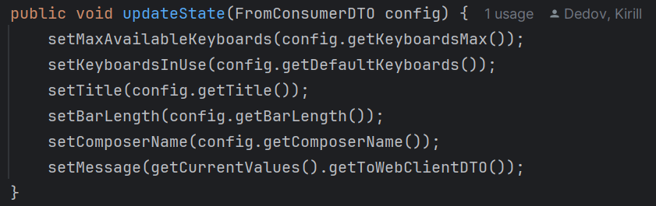
- isConsumerOnline()
  - Purpose: Checks if there are any active consumer emitters connected, indicating whether Organ Sequenser is connected and interacting with the server.
  - Returns: boolean - True if at least one consumer emitter is active, False otherwise.
- getCurrentValues()
  - Purpose: Retrieves the current state of the organ settings, wrapping them in a DTOWrapper. This includes both ToWebClientDTO and ToConsumerDTO, providing a snapshot of current configurations and states, useful for syncing states across components or updating client-side displays.
  - Returns: DTOWrapper - The wrapper containing the current settings and states, structured for both consumer and web client use.
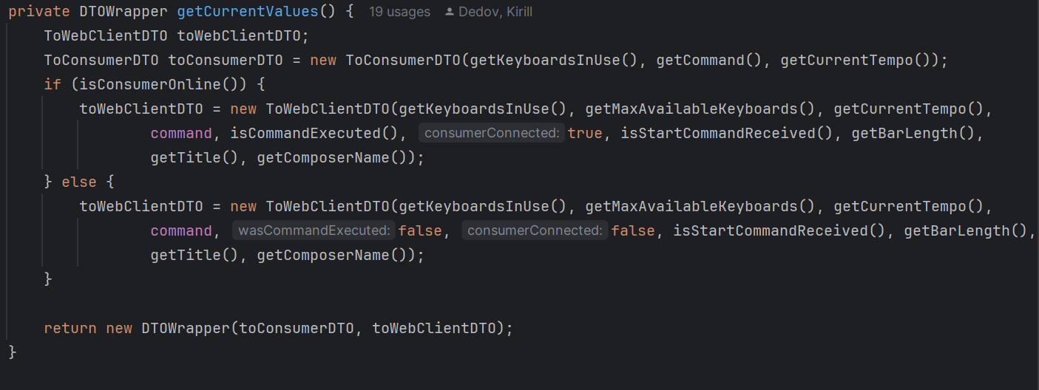

How the Server Handles Camera Commands
The task of the server is to receive signals from the "Camera" component, process them, decide whether they need to be sent to the "Organ Sequencer" component for execution, receive information from the "Organ Sequencer" about the piece being played, send information for display on the frontend, as well as store credentials and verify them for frontend login.
