**E-commerce**

**System Design Document**

**22.03.2019**

Metin Berk KARATAŞ

Selin ATALAY

Nevzat Atilla ÖZDER

Alper Tunga ÇEVİK

Prepared for

SE302 Software Engineering



Table of Contents

1. Introduction 1

1.1. Purpose of the System 1

1.2. Design Goals 1

1.3. Definitions, Acronyms, and Abbreviations 2

1.4. References 2

2. Current Software Architecture 2

3. Proposed Software Architecture 2

3.1. Overview 2

3.2. System Decomposition 2/3

3.3. Hardware Software Mapping 4

3.4. Persistent Data Management 5

3.5. Access Control and Security 5/6

3.6. Global Software Control 7

3.7. Boundary Conditions 7

4. Subsystem Services 8

5. References 9

SYSTEM DESIGN DOCUMENT

# **Introduction**

Design is the abstraction of an answer; it's the common description of the answer to an issue without a details. Design is view sample seen within the evaluation part to be a sample in a design part. After design part we are able to reduce the time required the implementation.

## **Purpose of the System**

As said within the Requirements Analysis Doc, the aim of the system is a scholarship management system. The aim of this technique supplies the next causes: Distributors can sell and sell the products they want to sell safely and easily on this site. Customers can choose the right one by filtering the products. They can purchase the products of their choice if they wish and the product is in stock.   
This system serves as a bridge between customers and distributors. They will be able to access the products they want to reach easily.

## **Design Goals**

The design objectives signify the specified qualities of scholarship management system and supply a constant set of standards that should be thought of when making design choices. Based on non-functionality requirements the next design targets must achieved as a way to qualify the system as profitable:

* **Security**

The system security is one of the most important non-functional requirements.

* **Reliability**

The system has to carry out the scholarship management operations with no errors. The web site developed needs to be extremely dependable and safe in order that details about any questions and many others shouldn’t be leaked earlier than the precise examination is held.

* **End User**

Distributors may only sell approved products.System should be able to deal with a number of users. Customers can only purchase products in stock.This system should run on a number of operating systems and support windows operating system.

* **Performance**

The system has to be sturdy enough to manage any valid input from the users.

## **Definitions, Acronyms, and Abbreviations**

**Customer**: The system user who will buy products

**Admin**: The system administrator who will manage all data system data and user controls.

**Distributor:** Distributors are actors who can sell their products

## **References**

* **www.gittigidiyor.com**

# **Current Software Architecture**

The system helps in the connection between distributors and costumers. Customers can easily filter the products they want to have. In order for the products to be sold, it is necessary to have administrator approval. In the same way, administrator approval will be required to be a distributor in the system. Product sales will be carried out safely. The products added to the basket can be removed from the basket if the customer has ceased to take it. We will develop this system in order to eliminate the problems such as improper product sale, unsafe sales process.

# **Proposed Software Architecture**

This system is web based. It will be a very useful website for sellers. Anyone who wants to sell products is not the only real sellers. In this case, the only thing that needs to happen is the approval of the manager. The unsuitable user will not be registered to the system. Likewise, products with inappropriate content will not be available in the system. Anyone who wants to perform a purchase will be able to register on my site. Of course, the only justification will be the approval of the manager. The system we have developed will be very useful and reliable.

* 1. **Overview**

During the system design modeling of scholarship management system, we divided our system into subsystems. This provides us a strong coherence. Our subsystems are ; Account management system, which has account transactions. Distributor management system, has functions of distribuotr actor, customer management system which has costumer’s functions and database subsystem to control storage.

## **System Decomposition**

The decomposition shows the existence of the following subsystems:

* Account management subsystem
* Student management subsystem
* Instructor management subsystem
* Database subsystem

**Account management subsystem**

This subsystem managing user accounts. It offers perform for creating an account, updating an, approve and close an account for admin side. Admin is the only actor who has permission to access close and approves functions. Create and update functions are accessed by distributor and customer. This subsystem uses login services of the distributor management and customer management subsystems

**The operations provided by this subsystem are:-**

* Login ()
* Change password ().
* Create account ()
* Update account ()
* Close account ()
* Approve account ()

# **Customer management system**

This subsystem in managing customer actor’s function, offers customer side to its functions after authenticate. Managing customer access to buying product, filtering product, viewing basket and viewing products detail. Displaying products purchased after purchasing the product.

**The operations provided by this subsystem are:**

* buyProduct()
* viewProduct()
* viewBasket()
* filterProduct()

**Distributor management system**

This subsystem in managaing distributor actor’s function, offers distributor side to its functions after authenticate. Managing distributor Access to adding product, deleting product, updating product , view his/her products. Displaying products sold after the product is sold.

**The operations provided by this subsystem are:**

* AddProduct()
* DeleteProduct()
* updateProduct()
* viewProducts()

**Database subsystem**

This subsystem will be implemented by relational database management system used to store the president data. All subsystems are related and having service with this subsystem.

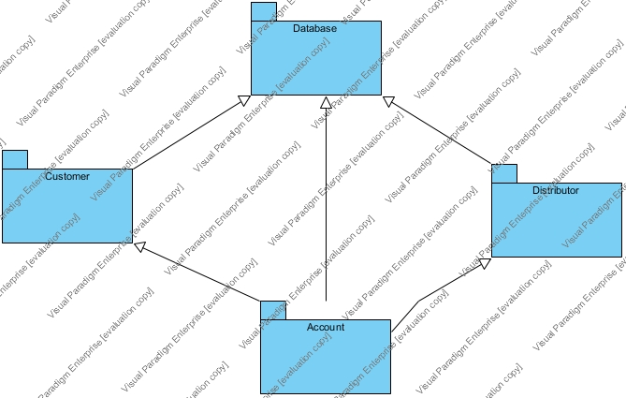

## **Hardware Software Mapping**

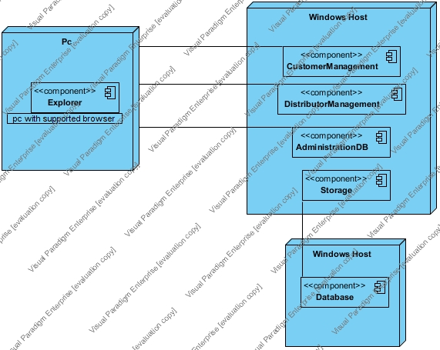

* 1. **Persistant Data Management**

Our system will use the SQLite3 database engine to store data. This will allow the database to be easily integrated with and accessed by the rest of the system. The database will retain user information for functions such as login for user, product details, purchased products, product stocks, order details, address information and cart details.

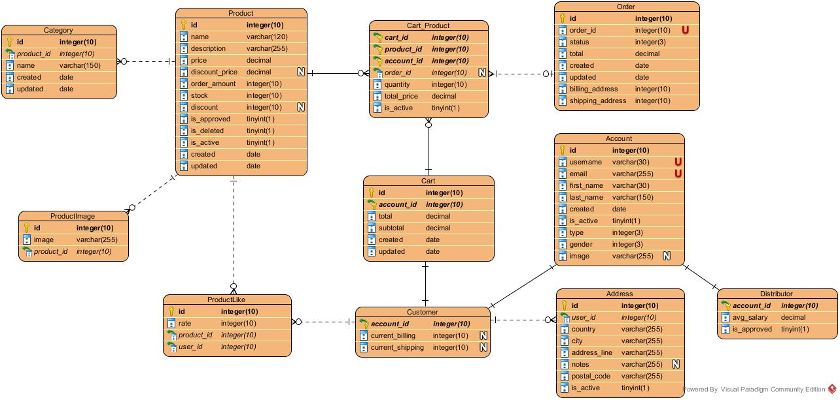

* 1. **Access Control and Security**

The website is a multiuser application so it consists of 3 types of users which are instructor, student and administrator. Because of this, the website will provide different interfaces for each user type.

First, the administrator will connect to the system with the membership interface, and will do the administrator's duties on the e-commerce system, such as adding, updating, editing, deleting etc. By the way, registration is not necessary for the administrator through the system website, information will be entered manually into the database at the beginning of the system and the administrator will be the authority that will access the database directly. As a summary, the administrator does not have to register because it is initially registered in the database and the system. The administrator registers the distributor. Each registration process included the distributor registration made by the administrator, will be done with the user interfaces of the system. The system will store all the information in the database and in the login processes again the system will use them by collecting data from the database. The information in the database will use both the confirmation and the use of the system for users. All types of users must log in to the system with their username and password.

After these steps, the system will be ready for the appointment of the distributor. The distributors will register in the website, the system will send the request to admin and admin will approve the request of the distributor, the system will add a new user to the database. The distributor will then connect to the system with your information such as username and password. During the login procedure, the data in the user database table will be obtained and compared to the data entered by the user. Since this operation requires read-only access to the database, it can be performed from different access points simultaneously.

During registration, field filling does not require access to the database, while completion of the process requires the data to be written to the database, which requires read and write access to the database. In that case, the required database fields will be blocked and simultaneous access of multiple users will be denied.

For some situation like updating or deleting information it is necessary to update one of the tables in the database in its phase of completion and therefore must be handled with more care since several users can be the cause of updating the table at the same time. This will also be avoided by blocking.

Finally, viewing the information or lists again requires read-only access to the database. Therefore, multi-user access does not impose problems and new restrictions.

As last words, the usernames and passwords of users will be stored in the user table. No one else accepts the administrator can have access to this information. Authentication interfaces are different for each type of user and will be directed to their own main pages after the login process.

|  |  |  |  |
| --- | --- | --- | --- |
|  | Product | Authentication | Buy Product |
| Visitor | searchProduct(Product product),viewProduct(Product product) | signUp() |  |
| Customer | searchProduct(),viewProduct(Product product),chooseProduct(),rateProduct(intrate),showMyOrders() | Login(),forgetpassword(),logout(),updateProfile(),deleteAccount(),changePassword() | choosePaymenInfo(),chooseAddress(),createAddress(),order(int numOfProduct), |
| Distributor | addProduct(),deleteProduct(),updateProduct(), | Login(),forgetpassword(),logout(),updateProfile(),deleteAccount(),changePassword |  |
| Admin | addProduct(Product product),deleteProduct(Product product),updateProduct(Product product),approveProduct(Product product),rejectProduct(Product product),monitorProductPedingList() | Login(),forgetpassword(),logout(),updateProfile(),deleteAccount(),changePassword() |  |

* 1. **Global Software Control**

External Control Flow (Between Subsystems): ES system defined by the web application with a simple feature. Web server requests request submission of user data. Because the system is multi-user, simultaneous executions can occur. However, the control flow of a single user has a predefined form. After the login step, the system has a web page structure in the form of a tree formed by links or buttons.

Concurrent Control: Because the application is web-based, all subsystems and components can run simultaneously for different users in the application.

Internal Control (Within a Single Process): The process control is carried out by means of the designed forms on the web. The system is based on the page structure of the page request page. This makes the designed procedures simple and mostly linear. However, procedure calls can be made to other subsystems or to the current subsystem. Threads or multiple processes can be required for a process. The system uses a database so that the response time from the database should be minimized.

User Interface: The system user interface will be made through web pages. The control of the next step depends on the user. In addition to this, the flow is implemented within the web page. Most subsystems have a different web page. Due to the system event-driven design, subsystems cannot be considered to have their own event loop. However, events are controlled by web pages.

* 1. **Boundry Conditions**

Startup: go to system URL and login

Shut Down : click logo ut and close browser

Error Conditions:

* Logging in:
* Username or password field cant be blank
* Password and username don’t match.
* Username is wrong or does not exist.
* User settings
  + User is unable to change certain settings or changes don’t reflect.
  + Between the time of editing and updating, the system crashes.
* Distributor entry
* Distributor informations cant be exist .
* Distributor informations cant be blank .
* Product entry
* Product name, price, stock cant be blank.