|  |  |
| --- | --- |
| DEPARTMENT OF MECHANICAL ENGINEERING  INDIAN INSTITUTE OF TECHNOLOGY ROPAR  RUPNAGAR-140001, INDIA | **IIT Ropar** |

**GE107: Tinkering Lab**

**Lab Assignment 3**

On

**Google Earth Engine**

**NDVI Time Series Analysis**

*Submitted by*

**Atinderpal Singh**

**(2020MEB1274)**

*Supervised by*

Reet Kamal Tiwari

Extended Second Semester, 2021-2022

Report Submitted on: 07-04-2022

1. **Aim of the Experiment**

To study time series analysis of one year by plotting graphs for a Particular area using NDVI.

1. **Software and data used**

Google earth engine and data used is MODIS.

Time period: 1 JAN 2016 to 31 DEC 2016.

1. **Theory Related to NDVI**

The NDVI is a dimensionless index that describes the difference between visible and near-infrared reflectance (NIR) of vegetation cover and can be used to estimate the density of green on an area of land. Formula for NDVI is as follows:

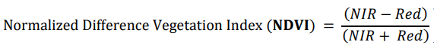

1. **Procedure**
2. Import the data using MOD09A1.005 Surface Reflectance 8-Day Global 500m.
3. Import FAO GAUL 500m: Global Administrative Unit Layers 2015, Second-Level Administrative Units and GFSAD1000: Cropland Extent 1km Crop Dominance, Global Food-Support Analysis Data.
4. Select the city or district, which is Patiala and mark the boundary using filter function.
5. Select the random points naming farm locations to study the NDVI with change in time.
6. Using the code, we remove the clouds from data for getting a clear image.
7. Now, we select the data from 1 JAN 2016 to 31 DEC 2016 for study.
8. Then we plot the chart from NDVI data by writing the code.
9. **Selected District**

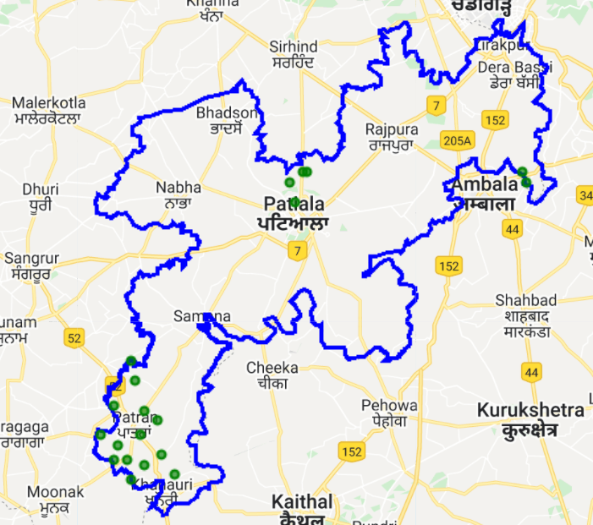

This image shows the selected boundary with the points i.e. farm locations for study.

1. **NDVI layer**



1. **All Composition layers**

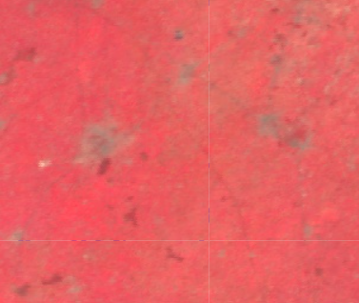

MODIS Composition Layers

1. **Band Values in Different region**

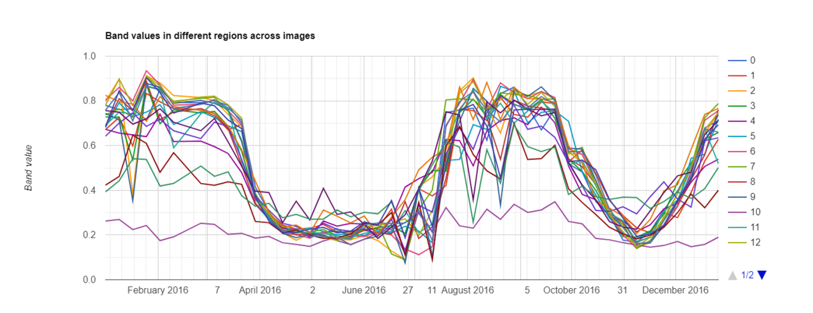

1. **NDVI over time at single location**

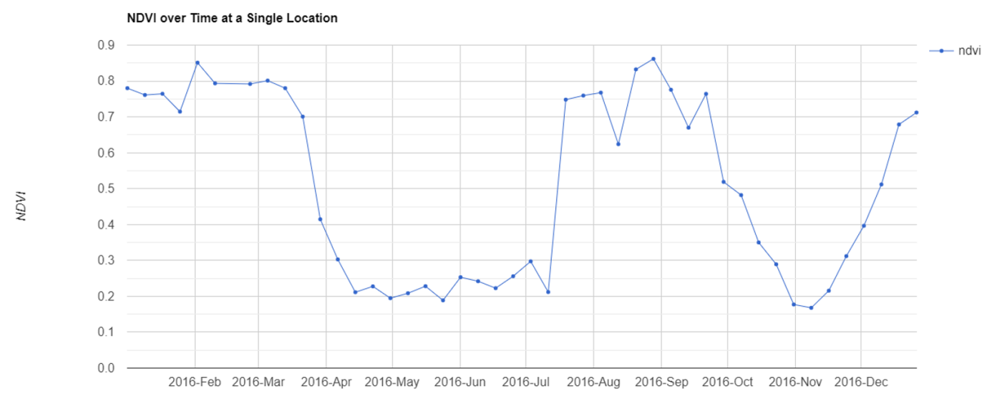

1. **Conclusion**

From the time series analysis, we observed that during the first 4 months of the NDVI is more compare to the month of the May, June and July. This is because Patiala is in Punjab and Punjab is an agricultural dependent state. During the first four months of the year wheat crop is sown, grown and nurtured while in the next four months the grown crop is harvested and the farms are prepared from the next wave of sowing the seeds of next crop.

That’s why during first four months and next four from August NDVI is more.