**Assignment 1: Some Terminology of Network:**

* **IP Address (Internet Protocol Address):** A unique address assigned to each device connected to a network that uses the Internet Protocol for communication. IPv4 and IPv6 are two versions of IP addresses.
* **MAC Address (Media Access Control Address**): A hardware address that uniquely identifies each device on a network. It's embedded in the network interface card (NIC) of the device.
* **Router:** A device that forwards data packets between computer networks, directing the data along the most efficient routes.
* **Switch:** A device that connects devices on a local area network (LAN) and uses MAC addresses to forward data to the correct destination.
* **Gateway:** A network point that acts as an entrance to another network, often used to connect different networks or systems.
* **Subnet:** A subdivision of an IP network that helps organize and improve network performance and security. Subnetting involves dividing a larger network into smaller, more manageable pieces.
* **DNS (Domain Name System):** A system that translates human-friendly domain names (like www.example.com) into IP addresses that computers use to identify each other on the network.
* **DHCP (Dynamic Host Configuration Protocol):** A protocol used to assign IP addresses automatically to devices on a network, simplifying the management of IP addresses.
* **Firewall:** A network security device or software that monitors and controls incoming and outgoing network traffic based on predetermined security rules.
* **VPN (Virtual Private Network):** A service that encrypts your internet connection and hides your online identity, providing secure and private access to the internet.
* **LAN (Local Area Network):** A network that connects devices in a limited area, such as a home, office, or building.
* **WAN (Wide Area Network):** A telecommunications network that extends over a large geographic area, often composed of multiple LANs.
* **Bandwidth:** The maximum rate of data transfer across a given path. It's typically measured in bits per second (bps).Latency: The time it takes for a data packet to travel from its source to its destination. Lower latency means faster communication.
* **NAT (Network Address Translation**): A method used by routers to translate private (local) addresses to public addresses before packets are forwarded to another network, often the internet.
* **Topology:** The arrangement of different elements (links, nodes, etc.) in a computer network. Common topologies include star, ring, mesh, and bus.
* **Packet:** A unit of data transmitted over a network. It contains both the data being sent and the control information needed to deliver it.
* **Protocol:** A set of rules governing the exchange or transmission of data between devices. Examples include TCP/IP, HTTP, and FTP.

**Assignment 2: Draw your Home Network Topology and explain how you are accessing the RPS Lab environment.**

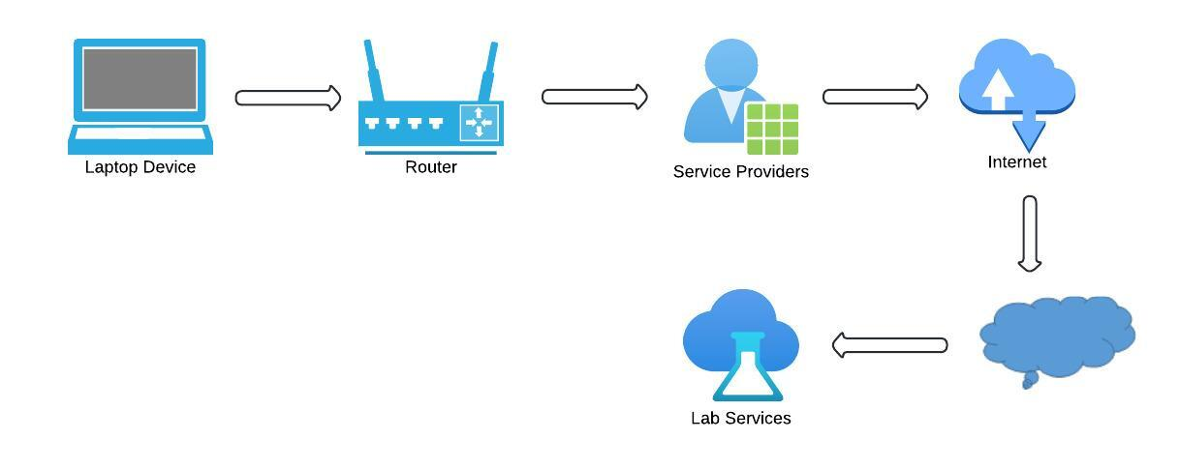

**FLOW:**

Laptop -> Home Router -> ISP -> Internet -> VPN Server (Corporate/Cloud) -> RPS Lab Environment

**PROCESS:**

* Connect to the Internet: Ensure your home device is connected to your home network (either via Wi-Fi or Ethernet).
* Launch VPN Client: Open your VPN client application on your home device and connect to the VPN server using your credentials.
* Authenticate: Enter any required authentication details (username, password, multi-factor authentication).
* Establish VPN Tunnel: Once authenticated a secure VPN tunnel is established between your home device and the VPN server.
* Access RPS Lab: Use a remote desktop client (e.g., Microsoft Remote Desktop) or an SSH client (e.g., PUTTY) to connect to the servers in the RPS lab environment.
* For RDP: Enter the IP address or hostname of the Windows server in the RPS lab.
* For SSH: Enter the IP address or hostname of the Unix/Linux server and provide your SSH credentials.