**Assignment 1: SDLC Overview - Create a one-page infographic that outlines the SDLC phases (Requirements, Design, Implementation, Testing, Deployment), highlighting the importance of each phase and how they interconnect.**

**Software Development Life Cycle (SDLC):**

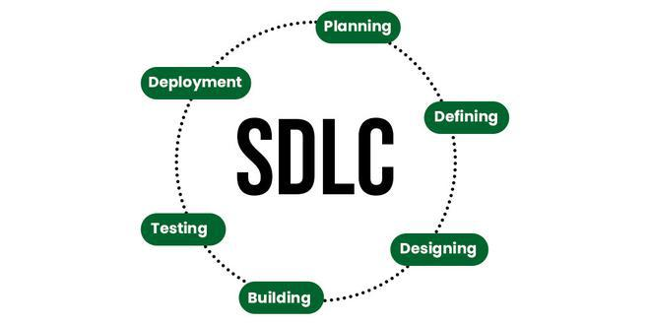

The Software Development Life Cycle (SDLC) is a systematic process for planning, creating, testing, and deploying an information system. It consists of several phases, each critical to the successful completion of a software project.

1. **Requirement Analysis or Planning:**

Description:

* Gathering and documenting the functional and non-functional requirements of the project.

Importance:

* Foundation of the project: Defines the project's purpose and scope.
* Stakeholder Input: Involves stakeholders to gather detailed requirements.
* Documentation: Requirements are documented in detail for the next phases.

Interconnections:

* Feeds into Design: Clear requirements lead to an accurate design.
* Informs Testing: Establishes criteria for test cases.

1. **Design:**

**Description:**

* Creating the architecture and design specifications for the software solution.

Importance:

* Blueprint of the system: Translates requirements into design specifications.
* Architecture Design: Defines overall system architecture and components.
* Detailed Design: Specifies data models, interfaces, and algorithms.

Interconnections:

* Guides Implementation: Provides a roadmap for developers.
* Ensures Quality: Helps in creating detailed test plans.

1. **Coding:**

**Description:**

* Actual coding of the software based on the design specifications.

Importance:

* Building the System: Developers write code to implement the design.
* Code Reviews: Ensures quality and adherence to standards.
* Version Control: Manages changes and maintains code integrity.

Interconnections:

* Based on Design: Uses design documents as guidelines.
* Prepares for Testing: Code needs to meet requirements for testing.

1. **Testing:**

**Description:**

* Verifying that the software functions correctly and meets requirements.

Importance:

* Verification and Validation: Ensures the system meets requirements and is defect-free.
* Types of Testing: Includes unit testing, integration testing, system testing, and acceptance testing.
* Bug Tracking: Identifies and fixes defects.

Interconnections:

* Feedback Loop: Results in iterative improvements to the code.
* Deployment Preparation: Ensures the system is ready for deployment.

1. **Deployment:**

Description:

* Releasing the finished product to users.

Importance:

* Releasing the Product: Moves the system to a live environment.
* Deployment Planning: Includes deployment scripts, rollback plans, and user training.
* Monitoring: Ensures system stability and performance.

Interconnections:

* End of Development Cycle: Completes the SDLC with a functional product.
* Ongoing Maintenance: Leads into maintenance and updates.

1. **Maintenance:**

**Description:**

* Ongoing support and improvement of the software post-deployment.

**Importance:**

* Ensures the software continues to function correctly, adapts to changing needs, and remains secure.

**Interconnection:**

* Continuously monitors the software; provides feedback to Requirements for updates and enhancements.

**Assignment 2: Develop a case study analysing the implementation of SDLC phases in a real-world engineering project. Evaluate how Requirement Gathering, Design, Implementation, Testing, Deployment, and Maintenance contribute to project outcomes.**

Case Study: Implementation of SDLC Phases in the Development of a Smart Home System

**Introduction:**

This case study examines the application of the Software Development Life Cycle (SDLC) in the development of a Smart Home System by Tech Innovators Inc. The project aimed to create an integrated system that allows homeowners to control and monitor various aspects of their home (e.g., lighting, security, temperature) through a single mobile application.

**Phase 1: Requirements Gathering**

Activities:

* Conducted stakeholder meetings with homeowners, tech experts, and security consultants.
* Utilized surveys and focus groups to understand user needs and preferences.
* Compiled a detailed requirements document outlining functional and non-functional requirements.

Outcomes:

* Identified key features such as remote control of devices, real-time monitoring, security alerts, and energy usage reports.
* Established performance, security, and compatibility standards.
* Created user personas and scenarios to guide development.

Contribution to Project Outcomes:

* Ensured a clear understanding of customer needs, reducing the risk of scope creep and rework.
* Aligned project goals with user expectations, fostering stakeholder buy-in and satisfaction.

**Phase 2: Design**

Activities:

* Developed high-level system architecture, including hardware components (sensors, cameras) and software components (mobile app, backend server).
* Created detailed design specifications and wireframes for the mobile application.
* Established protocols for data communication and security measures.

Outcomes:

* Produced comprehensive design documents and prototypes for review.
* Selected appropriate technologies and platforms (e.g., IOT protocols, mobile OS).
* Designed user-friendly interfaces with intuitive navigation.

Contribution to Project Outcomes:

* Provided a clear roadmap for developers, reducing ambiguity and errors during implementation.
* Ensured system scalability and flexibility to accommodate future enhancements.
* Facilitated early detection of design flaws through prototyping and stakeholder feedback.

**Phase 3: Implementation**

Activities:

* Divided the project into manageable modules and assigned them to development teams.
* Followed an Agile methodology with iterative sprints, frequent code reviews, and daily stand-up meetings.
* Developed the mobile application, backend server, and integrated hardware components.

Outcomes:

* Delivered functional modules incrementally, allowing for continuous integration and testing.
* Ensured code quality through peer reviews and automated testing tools.
* Maintained detailed documentation for each module.

Contribution to Project Outcomes:

* Enabled early identification and resolution of issues, ensuring steady project progress.
* Facilitated collaboration and communication among team members.
* Delivered a high-quality, maintainable codebase.

**Phase 4: Testing**

Activities:

* Conducted unit testing, integration testing, and system testing to verify functionality and performance.
* Performed user acceptance testing (UAT) with a group of beta testers.
* Implemented automated test scripts for regression testing.

Outcomes:

* Identified and fixed critical bugs and performance bottlenecks.
* Validated system behaviour under various conditions and load scenarios.
* Obtained user feedback and made necessary adjustments before final release.

Contribution to Project Outcomes:

* Enhanced system reliability and user satisfaction by delivering a thoroughly tested product.
* Reduced the risk of post-deployment issues and costly fixes.
* Ensured compliance with security and performance standards.

**Phase 5: Deployment**

Activities:

* Prepared deployment plans, including rollout strategies and user training materials.
* Deployed the system in a phased manner, starting with a pilot release followed by a full-scale rollout.
* Monitored the system closely for any issues during the initial deployment phase.

Outcomes:

* Successfully launched the Smart Home System to the market.
* Provided comprehensive user support and training sessions.
* Collected user feedback to identify any immediate post-deployment issues.

Contribution to Project Outcomes:

* Ensured a smooth transition from development to live environment.
* Minimized disruptions for users during the deployment phase.
* Established a foundation for user trust and product adoption.

**Phase 6: Maintenance**

Activities:

* Set up a dedicated support team to handle user queries and technical issues.
* Released regular updates to address bugs, add new features, and enhance security.
* Monitored system performance and usage analytics to guide future improvements.

Outcomes:

* Maintained system stability and security through timely updates and patches.
* Continuously improved the product based on user feedback and emerging trends.
* Ensured long-term user satisfaction and retention.

Contribution to Project Outcomes:

* Kept the system relevant and up-to-date with changing user needs and technology advancements.
* Fostered ongoing user engagement and loyalty.
* Enabled proactive issue resolution, minimizing downtime and enhancing user experience.

**Assignment 3: Research and compare SDLC models suitable for engineering projects. Present findings on Waterfall, Agile, Spiral, and V-Model approaches, emphasizing their advantages, disadvantages, and applicability in different engineering contexts.**

Description:

Choosing the right Software Development Life Cycle (SDLC) model is crucial for the success of engineering projects. This comparison examines four widely-used SDLC models: Waterfall, Agile, Spiral, and V-Model. Each model's advantages, disadvantages, and suitability for different engineering contexts are analysed.

1. **Waterfall Model:**

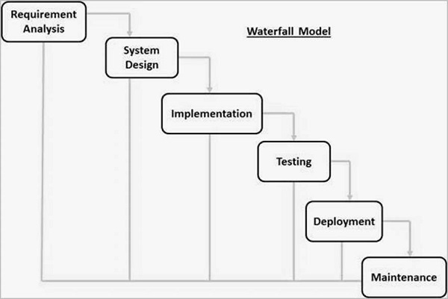

Description:

The Waterfall model is a linear sequential approach where each phase must be completed before the next begins. It follows a fixed sequence: Requirements, Design, Implementation, Testing, Deployment, and Maintenance.

Advantages:

* Simplicity: Easy to understand and manage due to its linear nature.
* Clear Documentation: Each phase has specific deliverables and a review process.
* Discipline: Strict phase progression ensures thorough documentation and review.

Disadvantages

* Inflexibility: Difficult to accommodate changes once the project is in later stages.
* Late Testing: Issues are often found late in the process, potentially causing significant rework.
* Poor Adaptability: Not suitable for projects where requirements are likely to change.

Applicability:

* Best suited for projects with well-defined requirements and low risk of changes, such as infrastructure or construction projects.

1. **Agile Model**

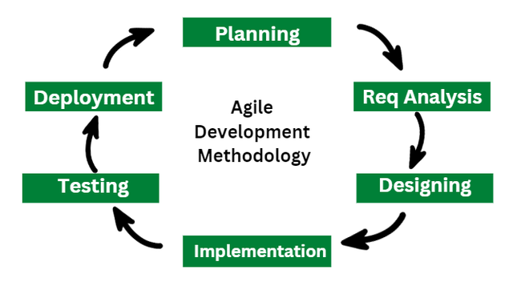

Description:

Agile is an iterative and incremental approach that emphasizes flexibility, collaboration, and customer feedback. Development is carried out in small iterations called sprints, typically lasting 2-4 weeks.

Advantages:

* Flexibility: Easily accommodates changes in requirements throughout the project lifecycle.
* Customer Collaboration: Regular feedback from stakeholders ensures the product meets user needs.
* Early and Continuous Delivery: Frequent releases provide early visibility of progress and functionality.

Disadvantages:

* Scope Creep: Continuous changes can lead to scope creep if not managed properly.
* Requires High Customer Engagement: Regular involvement from stakeholders is necessary.
* Less Predictable: Less predictability in terms of final outcomes and timelines compared to linear models.

Applicability:

* Ideal for projects with dynamic requirements, such as software development, where customer needs evolve rapidly.

**3.** **Spiral Model**

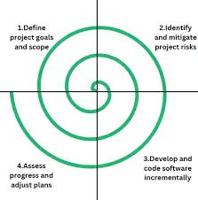

Description:

The Spiral model combines iterative development with risk management. It consists of repeating cycles (or spirals) that involve planning, risk analysis, engineering, and evaluation.

Advantages:

* Risk Management: Explicit focus on identifying and mitigating risks early.
* Flexibility: Iterative nature allows for refinements and changes in each cycle.
* Customer Feedback: Regular customer feedback is integrated into the process.

Disadvantages:

* Complexity: More complex and harder to manage compared to linear models.
* Cost: Can be more expensive due to the extensive risk analysis and iterative cycles.
* Requires Expertise: Effective risk analysis requires experienced personnel.

Applicability:

* Suitable for large, complex projects with significant risk factors, such as aerospace or defence projects.

**4. V-Model**

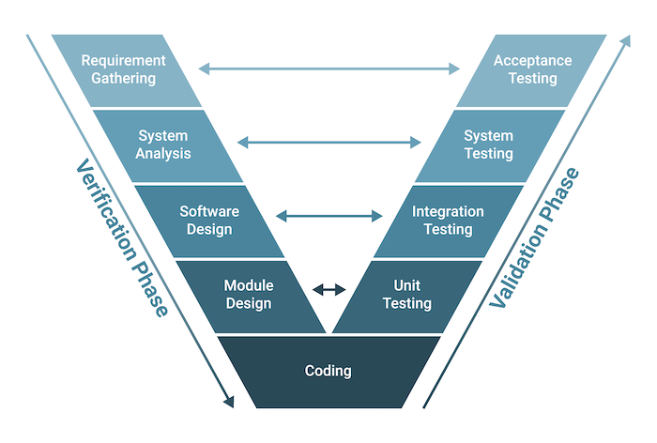

Description:

The V-Model, or Verification and Validation model, is an extension of the Waterfall model. It emphasizes the parallel relationship between development and testing activities. Each development stage has a corresponding testing phase.

Advantages:

* Clear Relationships: Direct correlation between development stages and testing activities ensures thorough validation.
* Structured: Well-defined phases and milestones provide a clear project roadmap.
* Early Test Planning: Test planning starts early in the project lifecycle, leading to better preparation and fewer issues later.

Disadvantages:

* Inflexibility: Similar to the Waterfall model, it is rigid and less adaptable to changes.
* Sequential: Late discovery of issues can still cause significant rework.
* High Cost of Change: Changes in requirements or design can be costly to implement.

Applicability:

* Suitable for projects where verification and validation are critical, such as safety-critical systems in healthcare or automotive industries.