**Loyalty Manage System**

Design Architecture

|  |  |
| --- | --- |
| Date | 02/01/2010 |
| Version | 1.1 |
| Status | updating |
| Author | Hung Pham |
| Review By | Dat Tran |
| Approved By |  |

**Revision History**

|  |  |  |  |
| --- | --- | --- | --- |
| Date | Version | Description | Author |
| 02/01/2010 | 1.0 | Initial | Hung Pham |
| 02/03/2010 | 1.1 | Add some packages diagram picture. | Hung Pham |

Table of Contents

1 System Architecture 3

2 Detail Architecture: 4

2.1 Database module: 4

2.1.1 Org.hcmus.dao.package: 5

2.1.2 Org.hcmus.dao.idao 5

2.1.3 Org.hcmus.dao.lms 6

2.1.4 Org.hcmus.bus 6

2.2 Participant Module: org.hcmus.participant 6

2.3 Utilily Module: org.hcmus.util 7

2.4 Listener Module : org.hcmus.lms 7

# System Architecture

System is designed with System includes 4 modules: database module, participant module, utility module and listener module.

Database module: Include all class and interface that take care of relationship with database. Each class maps to table of database and object in class. Module is designed with architecture 1 tier and 2 players. At this point, DAO player is designed with DAO pattern. Detail for this module I demonstrate beneath.

Participant module: Include all class that takes care of the business rule and flow of the transaction which is configured in transaction Q2 xml.

Utility module: Include all class that defines constants, support many functions which is used common in other module.

Listen module is very basically. It only receive request from client. And put it to space of the system.

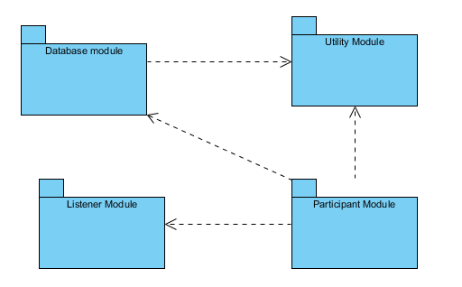

# Detail Architecture:

## Database module:

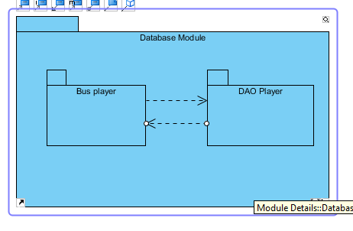

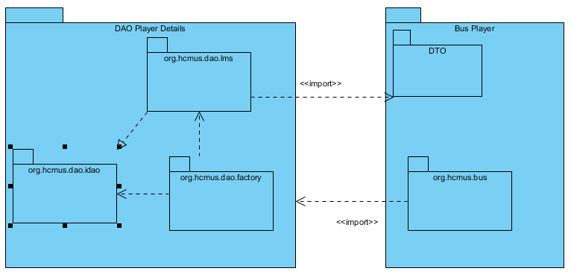

### Org.hcmus.dao.package:

SQLDAOFactory

LMSDAOFactory

|  |  |
| --- | --- |
| Class | Description |
| LMSDAOFactory | This is abstract class. To add new database type you must extend this class |
| SQLDAOFactory | This is an instances of factory which is dedicated for SQL database type. |

### Org.hcmus.dao.idao

|  |  |
| --- | --- |
| Interface | Description |
| IJPOS_Card | This is interface for card class. |
| IJPOS_Customer | This is interface for customer class. |
| IJPOS_Gift | This is interface for gift class. |
| IJPOS_Log_Exchange | This is interface for log exchange class. |
| IJPOS_Log | This is interface for log class. |
| IJPOS_Merchant | This is interface for merchant class. |
| IJPOS_PoSCC | This is interface for PoSCC class. |
| IJPOS_Task | This is interface for task class. |

### Org.hcmus.dao.lms

All class in this package implements interface in org.hcmus.dao.idao.

|  |  |
| --- | --- |
| Class | Description |
| JPOS_CardDAO | This is class for card class. |
| JPOS_CustomerDAO | This is class for customer class. |
| JPOS_GiftDAO | This is class for gift class. |
| JPOS_Log_ExchangeDAO | This is class for log exchange class. |
| JPOS_LogDAO | This is class for log class. |
| JPOS_MerchantDAO | This is class for merchant class. |
| JPOS_PoSCCDAO | This is class for PoSCC class. |
| JPOS_TaskDAO | This is class for task class. |

### Org.hcmus.bus

All class in this package does business for corresponding to all class in org.hcmus.dao.lms package.

|  |  |
| --- | --- |
| Class | Description |
| JPOS_CardBUS | This is class for card class. |
| JPOS_CustomerBUS | This is class for customer class. |
| JPOS_GiftBUS | This is class for gift class. |
| JPOS_Log_ExchangeBUS | This is class for log exchange class. |
| JPOS_LogBUS | This is class for log class. |
| JPOS_MerchantBUS | This is class for merchant class. |
| JPOS_PoSCCBUS | This is class for PoSCC class. |
| JPOS_TaskBUS | This is class for task class. |

## Participant Module: org.hcmus.participant

|  |  |
| --- | --- |
| Class | Description |
| AddPoint | Add point for card. |
| CheckField | Check field of the message receive. |
| CheckCard | Check card in database for message receive |
| CheckMerchant | Check merchant in database |
| Check PoSCC | Check PoSCC in database. |
| SendResponse | Send Response to client |

## Utilily Module: org.hcmus.util

|  |  |
| --- | --- |
| Class | Description |
| Constants | All constants are defined here. |
| ExchangeHelper | Get rate for changing money to point. |
| MLSConfig | Get database configuration from xml file |
| MessageHelper | Function to make message easier. |

## Listener Module : org.hcmus.lms

This is a small package but it is very important.

|  |  |
| --- | --- |
| Class | Description |
| LMSISOListener | Receive message from client for system. |