'Frightened To Death': Cheerleader Speech Case Gives Supreme Court Pause
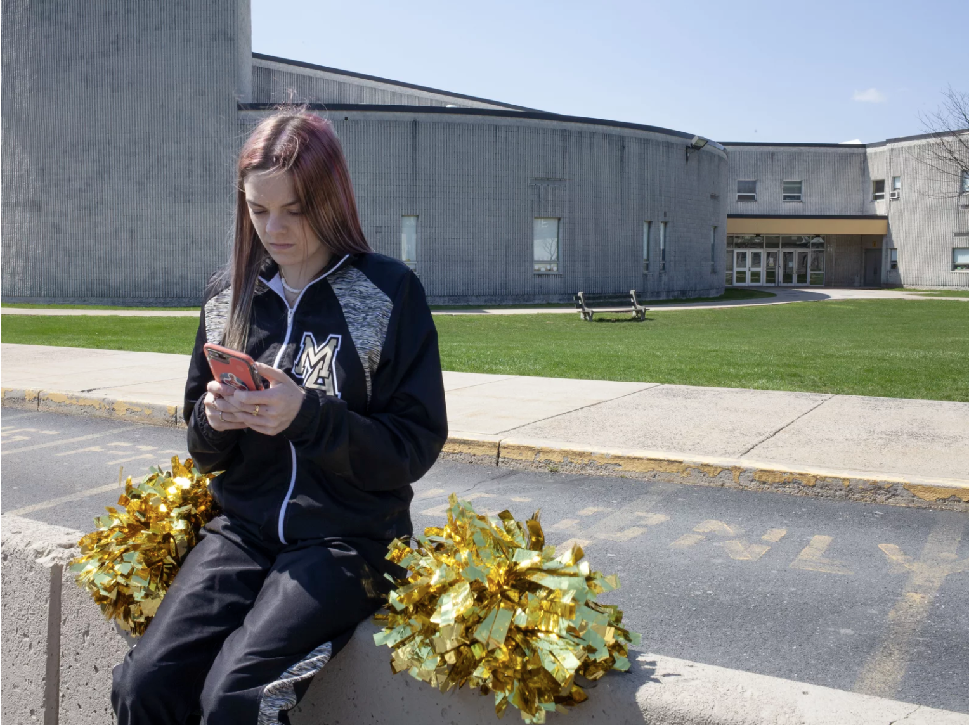
April 28, 2021
Brandi Levy wears her former cheerleading outfit as she looks at her mobile phone while sitting outside Mahanoy Area High School in Mahanoy City, Pa., on April 4.Facing its biggest student speech case in a half-century, the Supreme Court seemed to be looking for a narrow exit door on Wednesday.At issue was whether schools may punish students for speech that occurs online and off-campus but that may affect school order.The case has been billed as the most important student speech case since 1969.
That landmark ruling came at the height of the Vietnam War. Mary Beth Tinker and four other students went to court after they were suspended for wearing black armbands to school to protest the war.By a vote of 7 to 2, the high court ruled at the time for the first time that kids do have First Amendment free speech rights at school, unless school officials reasonably forecast it will cause disruptions.Wednesday's case did not involve such serious speech.
And on Wednesday, the Supreme Court faced a question that did not exist in 1969: Can schools punish students for their online but off-campus speech?Justice Stephen Breyer got to the heart of the matter quickly, wondering whether online swearing off-campus should even qualify for school punishment.
"If swearing off-campus did [qualify], my goodness, every school in the country would be doing nothing but punishing," he said.Justice Sonia Sotomayor chimed in.
"Kids basically talk to classmates, most of their exchanges have to do with their perceptions of the authoritarian nature of their teachers and others."Justice Brett Kavanaugh, who coaches his daughters' sports teams, seemed to understand Brandi's frustration, acknowledging that even NBA legend Michael Jordan had sore feelings more than 40 years after not making the varsity team in high school.
Siding with the Mahanoy school district in the case, the Justice Department argued that schools could regulate off-campus speech only if it is related to school matters and could cause a "substantial disruption.""That means really everything that mentions a school at all is school speech, right?" asked a skeptical Justice Elena Kagan.Deputy Solicitor General Malcolm Stewart tried to offer a nuanced distinction, but Kagan was having none of it.
Cutting right to the question of which speech is punishable, she asked, "Can I give you a few hypotheticals, and you just tell me school speech or not school speech?"Each of these, conceded Stewart, would be considered school speech under the standard proposed by the Justice Department.
In other words, all of these messages sent from off campus might well be punishable school speech.The ACLU's David Cole, representing Brandi Levy, said that once schools can discipline students for off-campus speech, that would dramatically expand the disciplinary reach of schools set out by the court in the Tinker case in 1969."Expanding Tinker would transform a limited exception into a 24/7 rule that would upend the First Amendment's bedrock principle," argued Cole, "and would require students to effectively carry the schoolhouse on their backs in terms of speech rights everywhere they go."But, the justices wanted to know, what about cases of harassment and bullying?
After all, some 47 states require enforcement of anti-bullying laws.Justice Kagan posited an off-campus website set up by high school boys to rank their female classmates appearance and sexual availability.
All of the justices probed repeatedly for workable standard to adopt — a rule that would guide schools as to how to handle these tricky questions.Cole said student speech should be protected online.
"Outside of school, the priority is not to give the school discretion to regulate kids' speech," he said.But the school district's lawyer, Lisa Blatt said that standard would be a "nightmare." It would, she said, mean "open season" on schools and produce "chaos" in the lower courts.

