NOMAD AUTOMATIC
ROLLBACK LAB
FINAL TECHNICAL PROJECT REPORT
Controlled Canary Deployment · Automatic Recovery · CI/CD Failure Reporting
Isolated Ubuntu VM: mariana
Verified demonstration: 13 November 2026
GitHub Actions · GHCR · Docker · Nomad · Consul · Tailscale

CONTENTS
• Executive summary and objectives
• Implemented system and architecture
• Methodology and verified tests
• Recovery measurements and CI failure
• Security, limitations, and conclusion
• Screenshot evidence appendix
This formal report is paired with the clickable documentation index in the package README.

Final Technical Project Report

Nomad Automatic Rollback Lab
Report date: 13 November 2026
Project category: DevOps / CI-CD / controlled infrastructure lab
Execution scope: Isolated Ubuntu virtual machine mariana
Status: Engineering phases 1–5 completed and evidenced; documentation package prepared for Phase 6 handover
Change control: GitHub repository atiqa-ai/nomad-auto-rollback-lab, reviewed pull requests and an opt-in deployment switch

1. Executive summary
The Nomad Automatic Rollback Lab demonstrates a safe, observable software release process for a small containerized web application. GitHub Actions tests the code, builds an immutable Docker artifact, and—when explicitly enabled—deploys it to HashiCorp Nomad in an isolated Ubuntu VM. Nomad uses canary updates and Consul HTTP health checks to decide whether a candidate is healthy enough to promote. Deliberately unhealthy candidates are rejected; configured auto-reversion restores the previously stable job configuration. Crucially, the initiating GitHub Actions run still fails, rather than hiding the unsuccessful release behind the successful recovery.
The delivered demonstration includes a Flask application with configurable version and health behavior, nine automated unit tests, GHCR image publishing, protected VM connectivity through Tailscale and SSH, Nomad deployments, controlled failure injection, manual rollback, and recorded evidence. The most recent supplied verification shows stable job version 8, a healthy v2 response, and automatic deployments disabled following the test.

2. Problem and motivation
A successful image build does not guarantee a safe release. A new application container may start yet return a failed readiness/health response. Without deployment health gates, an operator may promote a broken candidate or leave a failed rollout unresolved. Likewise, a pipeline may incorrectly appear green if it treats a successful rollback as success for the original release. This project isolates those failure modes in a reproducible learning environment and makes the release outcome visible in both the scheduler and CI/CD system.

3. Objectives and acceptance boundaries
• Build and test a minimal version-aware HTTP application.
• Produce and publish commit-identifiable Docker artifacts, deploying by immutable image digest.
• Integrate a protected GitHub Actions runner-to-VM deployment path.
• Deliver changes through Nomad canary updates controlled by Consul HTTP health checks.
• Automatically recover from a deliberately unhealthy release while retaining failed-release visibility.
• Demonstrate manual recovery with recorded timing and evidence.
• Provide operational, security, testing and handover documentation for a personal lab.
Not part of the verified implementation: production multi-node high availability; zero-downtime measurement; service-level objective/SLA validation; production security hardening; a confirmed one-command fresh-VM bootstrap. These are deliberately reported as gaps, not accomplishments.

4. Implemented solution

4.1 Application and container
A Python Flask application exposes GET /, GET /health and GET /version. APP_VERSION controls the displayed version; HEALTH_MODE=healthy returns a passing health state and HEALTH_MODE=unhealthy creates an intentional HTTP 503 failure. It is a controlled exercise: an unhealthy response is not assumed to represent an unanticipated defect in unrelated application code. Gunicorn serves port 8080 from a non-root image configuration. The historical record documents a Gunicorn control-socket issue and a later --no-control-socket correction; a separate clean-container regression log for that correction is not included in the supplied evidence.

4.2 CI/CD and artifact identity
GitHub Actions runs Python unit tests on proposed changes. On main runs, it builds and publishes a Docker image to GHCR under a commit-specific SHA tag and supplies its immutable SHA256 digest to deployment. Deployment is controlled by LAB_CD_ENABLED; it is not run by default when the switch is false. The deployment workflow uses a tagged temporary Tailscale connection and pinned SSH host key to reach mariana. The VM-side deployment script validates its input SHA and digest, confirms the commit is on main, performs Nomad validation and planning, uses -check-index to limit concurrent update races, and monitors the job outcome. The Phase 5 opt-in failure_test workflow input selects HEALTH_MODE=unhealthy only for intentional testing.

4.3 Nomad, Consul and release control
The rollback-demo Nomad job uses one web task allocation, host networking to the container's port 8080, a Consul-registered HTTP health check on /health, and these tested update-policy values:
Setting | Value | Role
count | 1 | One desired stable service instance
canary | 1 | Start one candidate allocation before promotion
max_parallel | 1 | Bound parallel service-group updates
auto_promote | true | Promote the candidate after health requirements pass
auto_revert | true | Restore last stable job after failed deployment
health_check | checks | Use service checks for health evaluation
min_healthy_time | 10s | Require a minimum passing period
healthy_deadline | 2m | Bound time to achieve healthy state
progress_deadline | 4m | Fail a rollout that stops progressing
Consul check | HTTP /health, every 5s, timeout 2s | Evaluates actual app health

The system is a single-VM personal lab, not a distributed control plane. The recorded final state was one running and one healthy allocation.

5. Architecture and release sequence
Reviewed source / workflow_dispatch
|
v
GitHub Actions
[Python unit tests]
|
v
Docker build + GHCR
immutable digest
|
LAB_CD_ENABLED == true?
|
v
Tailscale temporary runner
SSH pinned host key
|
v
Ubuntu VM mariana
Nomad service job web
|
Canary allocation
|
Consul HTTP /health
/ \
healthy unhealthy
| |
auto-promote deadline failure
| |
stable new job auto-revert to last stable
|
CI deployment stays failed
The actual nomad job run output and CI logs demonstrate both branches; see the detailed rollback tests.

6. Implementation methodology
The engineering work was performed in six planned phases. Phases 1–5 were completed and demonstrated; Phase 6 is documentation, reproducibility review and handover.
Phase | Implemented activity | Evidence basis
1 — Preparation | Isolated VM, Git, Docker/Nomad/Consul environment checks | Active daemons and ready Nomad client
2 — Application | Flask service, unit tests, Docker healthy/unhealthy behavior | Nine passing tests; earlier container response evidence
3 — Orchestration | Nomad service job, Consul health and baseline v1 deployment | Running job and stable history
4 — CI/CD | GitHub Actions tests, GHCR digest, Tailscale/SSH VM deployment | Green run 43426413120
5 — Recovery | Healthy v2, automatic and manual rollback, CI failure propagation | Nomad job/deployment logs, failed run 43442086173
6 — Handover | Report, runbook, audit, evidence index and safety checklist | Documentation ZIP; clean-VM reproduction not yet independently tested

7. Test execution and actual results

7.1 Unit and container tests
A terminal screenshot on mariana records 9 tests run, 9 successful, using python3 -m unittest discover -s tests -v. Earlier Docker exercise outputs reported HTTP 200 for a healthy instance and HTTP 503 for an intentionally unhealthy instance. These results validate the controlled health mode; they are not performance/load testing.

7.2 Healthy canary deployment
On 13 November 2026 at 13:00:30 UTC, a healthy candidate with APP_VERSION=v2 was submitted using an immutable GHCR image digest. Deployment 5f0c7bd0 (Nomad job version 2) completed successfully at 13:00:43 UTC: promoted=true, healthy=1, unhealthy=0. Independent endpoint responses were {"version":"v2"} and {"status":"healthy","version":"v2"}.

7.3 Automated recovery exercise
A deliberately broken v3 canary (Nomad version 3, deployment 752b186e) started at 13:31:16 UTC. It did not become healthy, was not promoted, and failed at 13:35:16 UTC due to the progress deadline. Nomad logged that it was rolling back to job version 2. Recovery deployment 36110492 produced job version 4 and succeeded at 13:35:28 UTC. The full nomad job run command exited 1, correctly signaling failed release, and its measured wall time was 252 seconds. Post-recovery responses showed healthy v2.

7.4 Manual revert exercise
With auto_revert=false in a temporary test copy of the HCL, candidate v3-manual became failed job version 5, deployment 4b1f2d2d, at 13:45:08 UTC. The operator then invoked nomad job revert rollback-demo 4. Recovery deployment 76dfe0ac (job version 6) succeeded at 13:45:40 UTC, with exit code 0 and a measured 12-second revert command duration. The application again returned healthy v2.

7.5 End-to-end CI failure propagation
On GitHub Actions run 43442086173, the Python test job passed in 9 seconds and GHCR build/publish passed in 31 seconds. The workflow supplied HEALTH_MODE=unhealthy, published immutable digest sha256:0c4c1f3120846efb11aec72fef4a48575074b9b2c09b4353c5979f3e291073d2, and attempted deployment of main commit 55407040f51bbcce07a157f5004cb8f1c26363f3. The candidate failed its Nomad progress deadline at 14:27:35 UTC and Nomad logged automatic rollback to stable job version 6. Recovery was reported successful at 14:27:47 UTC. The GitHub deployment job and overall run remained failed (exit code 1). Later verification showed version 8 stable and healthy v2.

7.6 Consolidated result matrix
Requirement | Evidence and observed outcome | Verdict
Nine unit tests | Ran 9 tests / OK on mariana | Pass
Full healthy CI/CD release | Three green jobs in run 43426413120 | Pass
GHCR immutable digest deployment | Commit-matched SHA digest supplied to Nomad | Pass
Healthy canary auto-promotion | Version 2, promoted=true, healthy=1 | Pass
Unhealthy canary rejection | Version 3 failed progress deadline | Pass
Automatic revert | Failed v3 restored stable v2 configuration | Pass
Manual revert | Revert to version 4, exit 0, recovery success | Pass
CI failure propagation | Deliberate workflow run failed after successful recovery | Pass
Final health | version=v2, health=healthy, stable job version 8 | Pass
Clean VM one-command bootstrap | No independent fresh-VM run recorded | Not verified
Zero-downtime SLO | No continuous external availability measurements | Not measured

8. Recovery metrics: interpretation and limits
Exercise | Recorded interval | Interpretation
Standalone unhealthy v3 test | 252s | Whole failed rollout command through recovery, including detection deadlines
Automatic recovery segment | ~12s | From 13:35:16 failure log to 13:35:28 successful recovery
Manual revert command | 12s | From operator execution to successful return, after the failure was recognized
CI-triggered recovery segment | ~12s | From 14:27:35 failure/rollback log to 14:27:47 successful recovery

These figures have different start events and must not be treated as like-for-like recovery-time benchmarks. No independent continuous traffic probe, outage measurement, throughput test, or SLA claim was produced.

9. Security and governance controls
The demonstrated lab uses separate GitHub environment secrets for Tailscale OAuth and SSH identity, repository variables for target VM and a guarded deployment switch, a GHCR digest rather than a mutable latest tag, and a pinned SSH host key. The Nomad and Consul management APIs were kept on VM loopback; Tailscale tags scoped the runner-to-VM path to TCP 22. Source updates were reviewed via pull requests; the intentionally unhealthy workflow_dispatch input was limited to a controlled demonstration.
Remaining production gaps include Nomad ACL/mTLS, Consul ACLs, secret rotation records, a hardened low-privilege deployment identity, multi-node fault tolerance, guaranteed artifact provenance verification beyond the recorded digest, and a security review of workflow permissions. Do not describe this project as production-secure.

10. Limitations and operational concerns
• Single Nomad node and single desired service allocation; no high-availability claim.
• Health-check-based failure detection, not complete application correctness or user-experience assurance.
• No verified one-command bootstrap or measured full clean-room replay.
• CI-induced failure injection intentionally exercises a bad configuration and must remain restricted to authorized testing.
• Recovery may preserve user-visible service, but zero downtime was not measured.
• Historic demo version v2 is not necessarily the same as a source commit or Docker digest; version labels and image identity must be distinguished.
• Phase 2 historic Gunicorn correction has no separately supplied post-fix container-log proof, despite later successful Nomad/GHCR execution.
• The supplied evidence images include two similar Nomad overview captures and a manual-revert screen without the original revert invocation in view; corresponding terminal logs provide the command-level evidence.

11. Outcome and conclusion
The project demonstrated the principal engineering objective: safe canary rollout decisions based on live service checks and controlled recovery from a broken release, with failure propagated back to GitHub Actions. Healthy v2 was promoted, intentionally unhealthy versions were rejected, automatic and manual recovery were each exercised, and final verification showed a healthy service. The key result is correct release-state accounting: restoring an older stable application does not retroactively make the broken candidate successful.
This is a completed lab demonstration with a handover documentation set. Future engineering priorities are a clean-VM end-to-end bootstrap test, continuous availability instrumentation, strengthened deployment credentials/ACLs, deeper resilience testing, and retention of evidence as a versioned release artifact.

12. Document map and submitted evidence
• Full design: architecture
• Prerequisites and reproduction: installation guide
• Operational steps: runbook
• Tested outcomes: Phase 5 report and validation matrix
• Safety and residual risks: security assessment
• Screenshot-by-screenshot register: evidence index
• Transfer and acceptance: handover checklist

Appendix A — Additional screenshot evidence
The following eight visual records supplement the test-result tables and log summary. Images are historical captures provided on 13 November 2026. They should not be interpreted as live monitoring output.
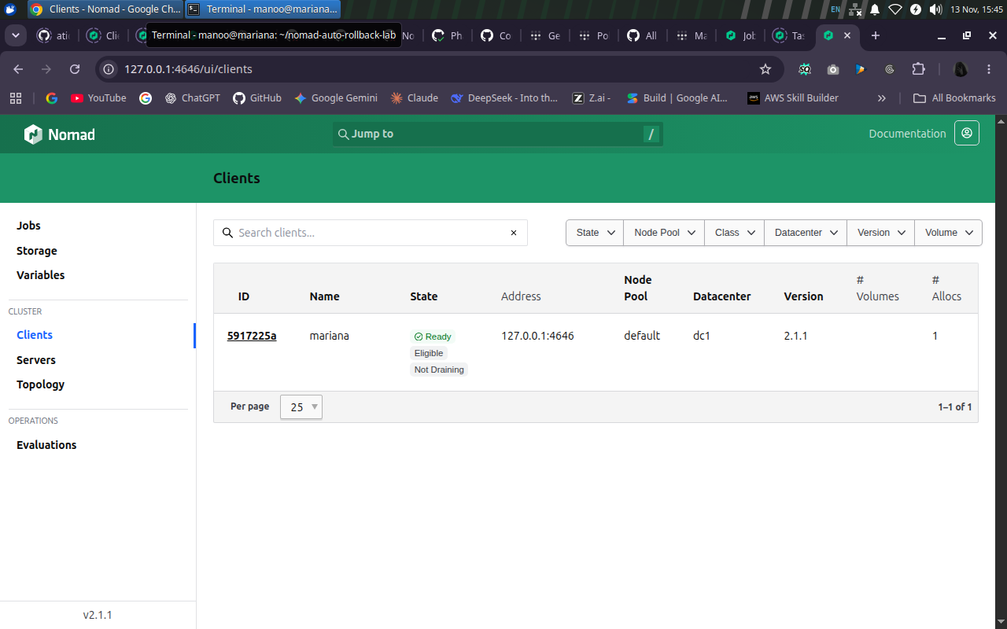
Figure 01 — Docker, Nomad and Consul service readiness, plus Nomad client state.
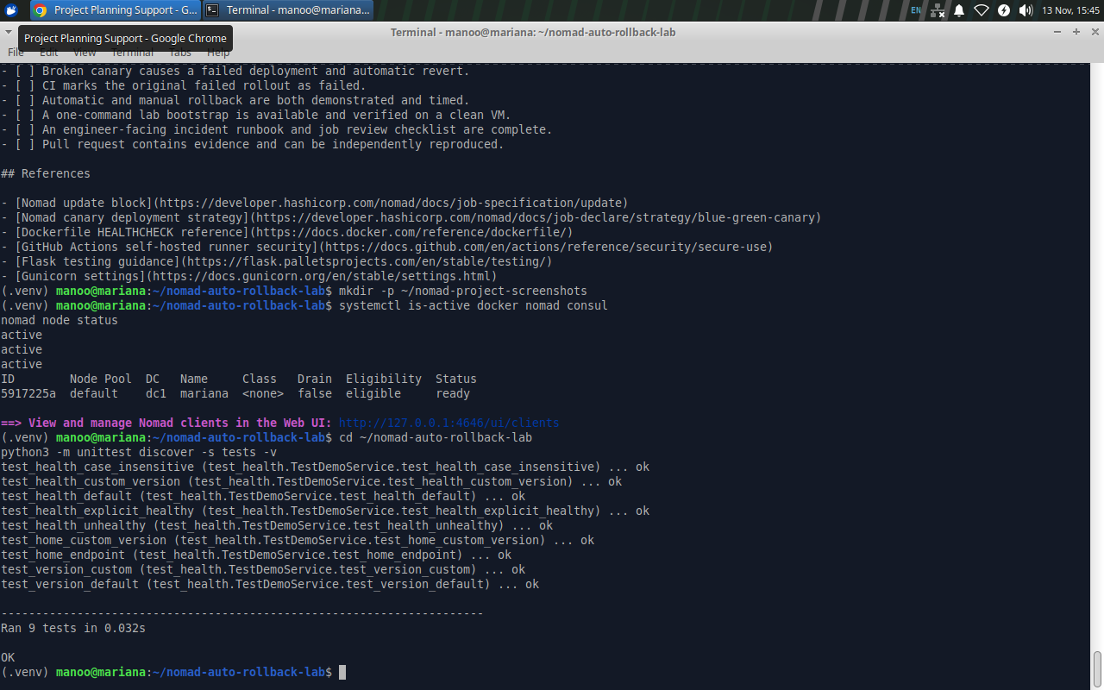
Figure 02 — Nine passing Python application unit tests in the Ubuntu VM.
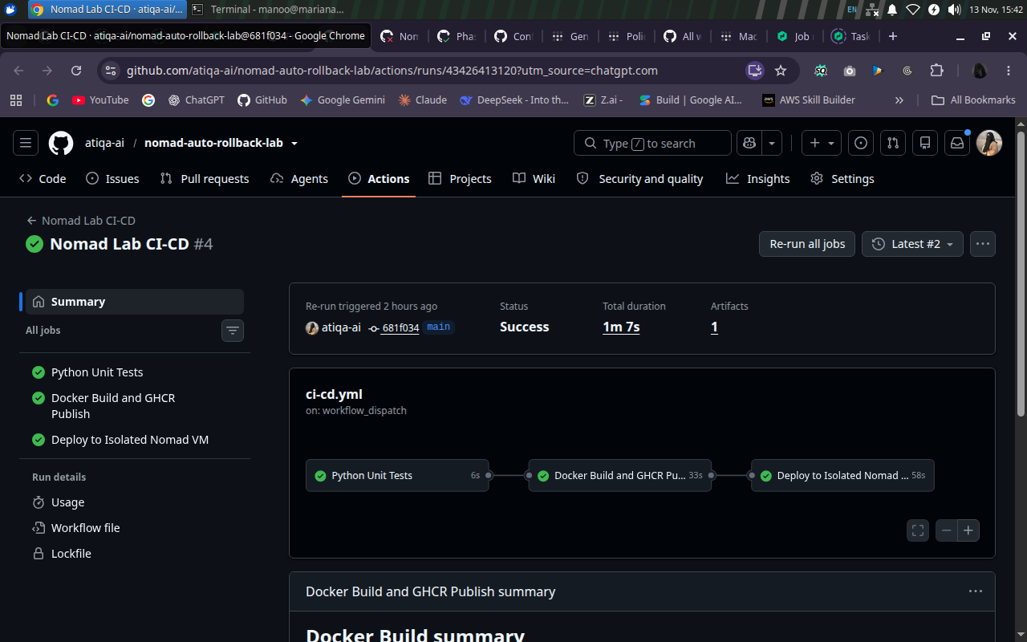
Figure 03 — Verified healthy release with passing tests, image publish and VM deployment.
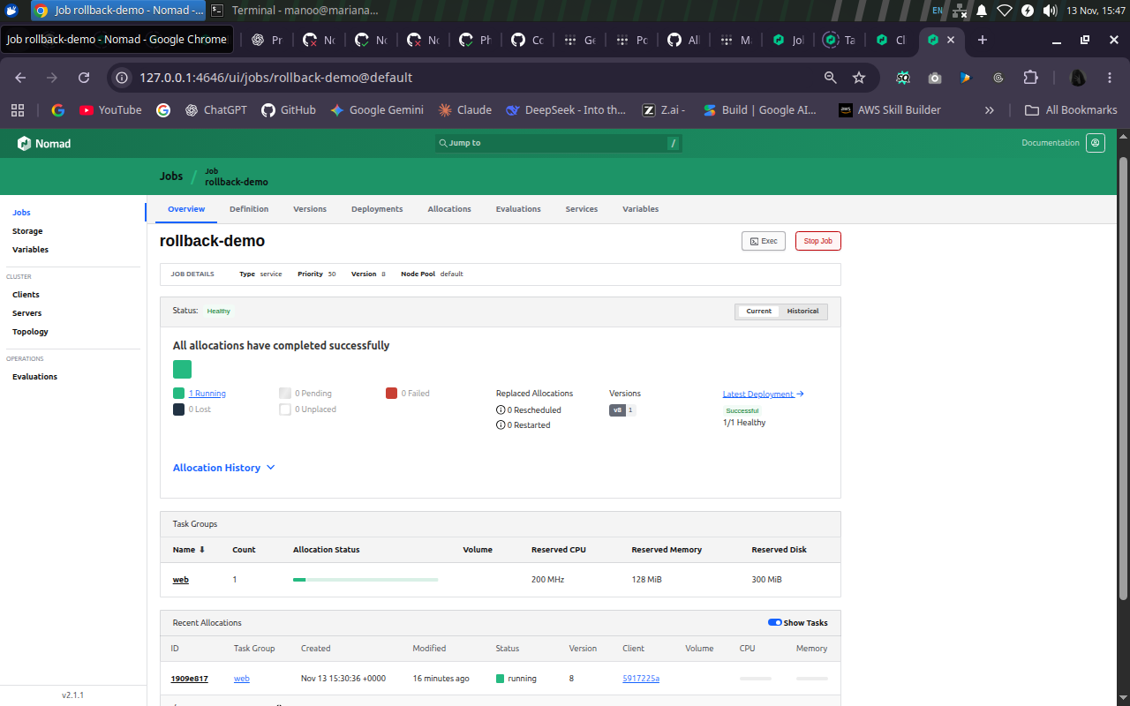
Figure 04 — Post-recovery Nomad job overview: stable version 8 and healthy allocation.
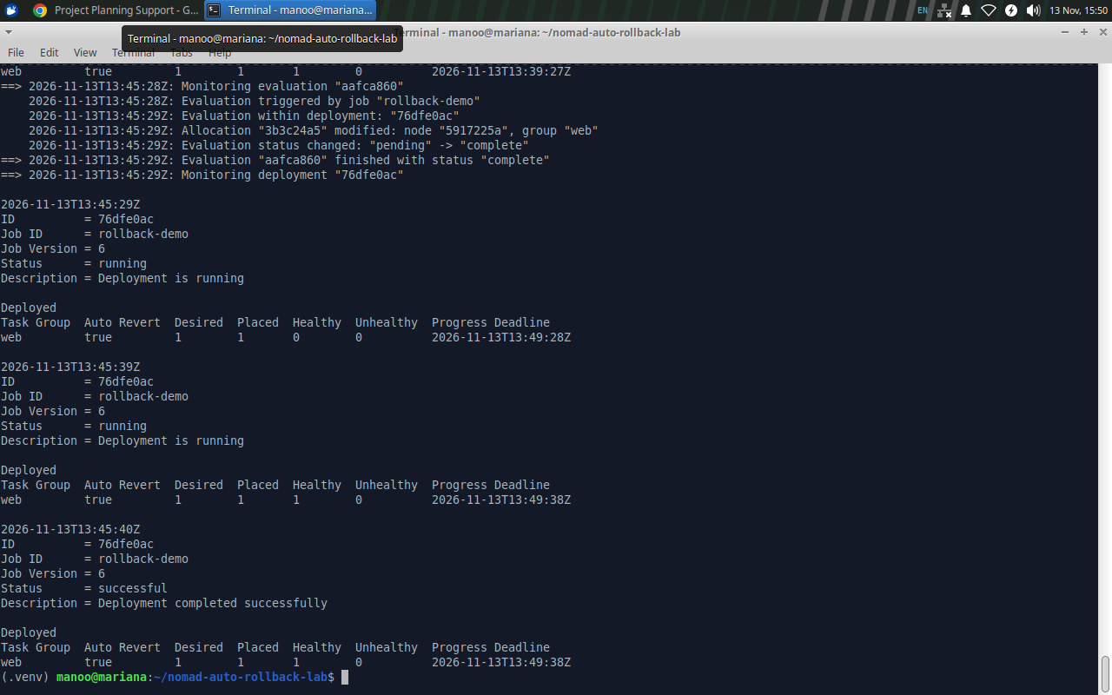
Figure 05 — Manual recovery event reaches a successful job version; original command in the saved log.
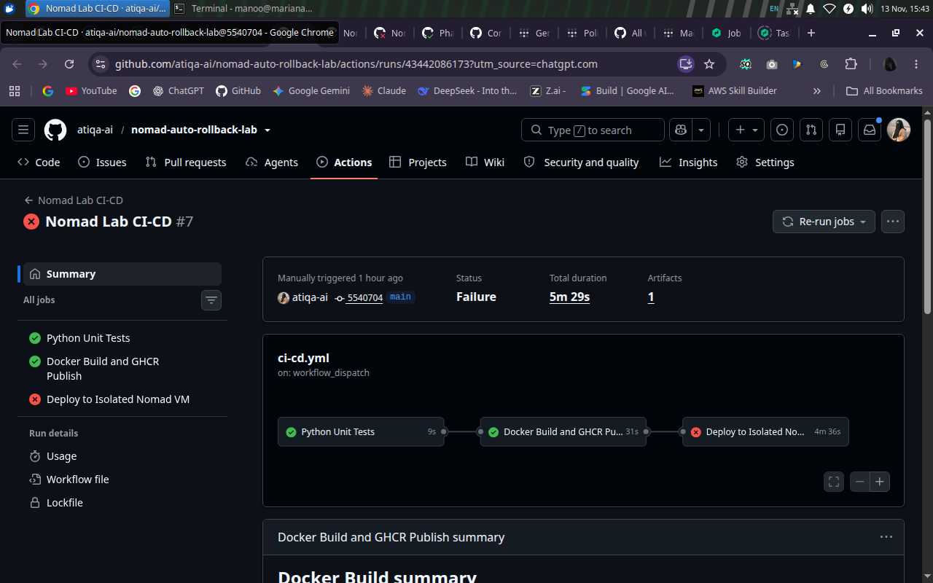
Figure 06 — Controlled unhealthy candidate: test/build jobs passed and deployment failed.
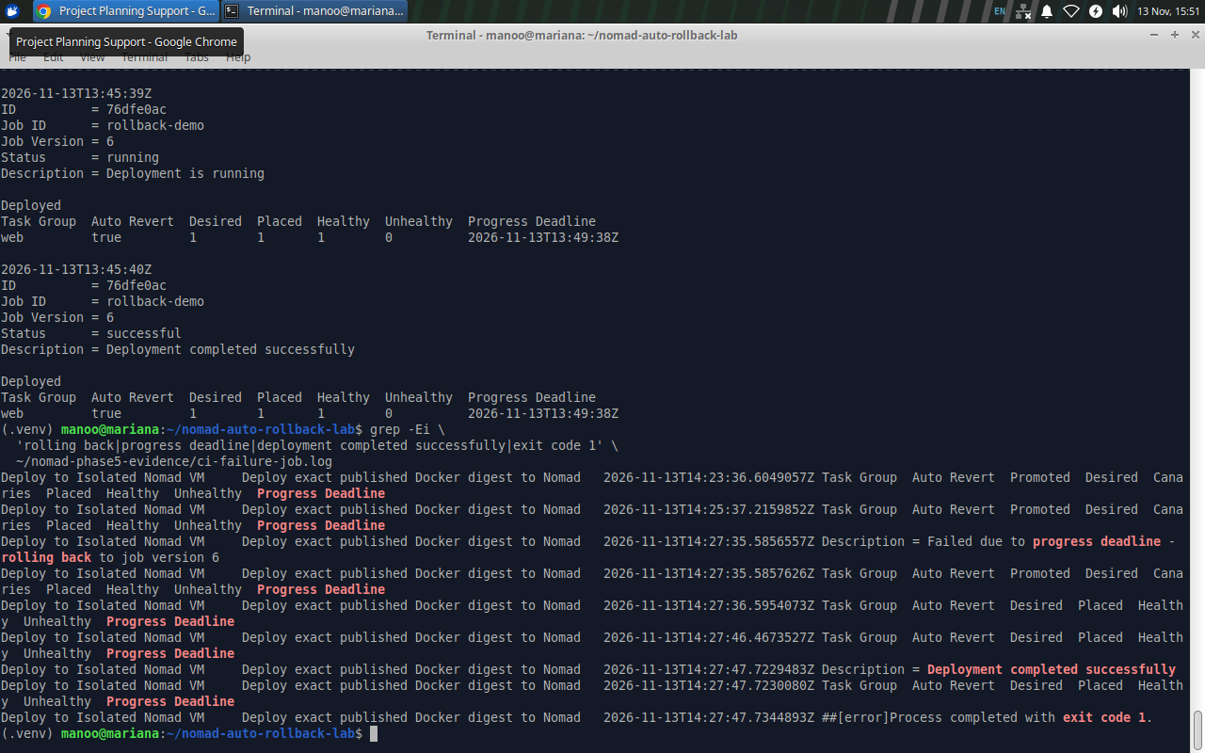
Figure 07 — Deadline failure, revert to stable configuration and CI exit code 1.
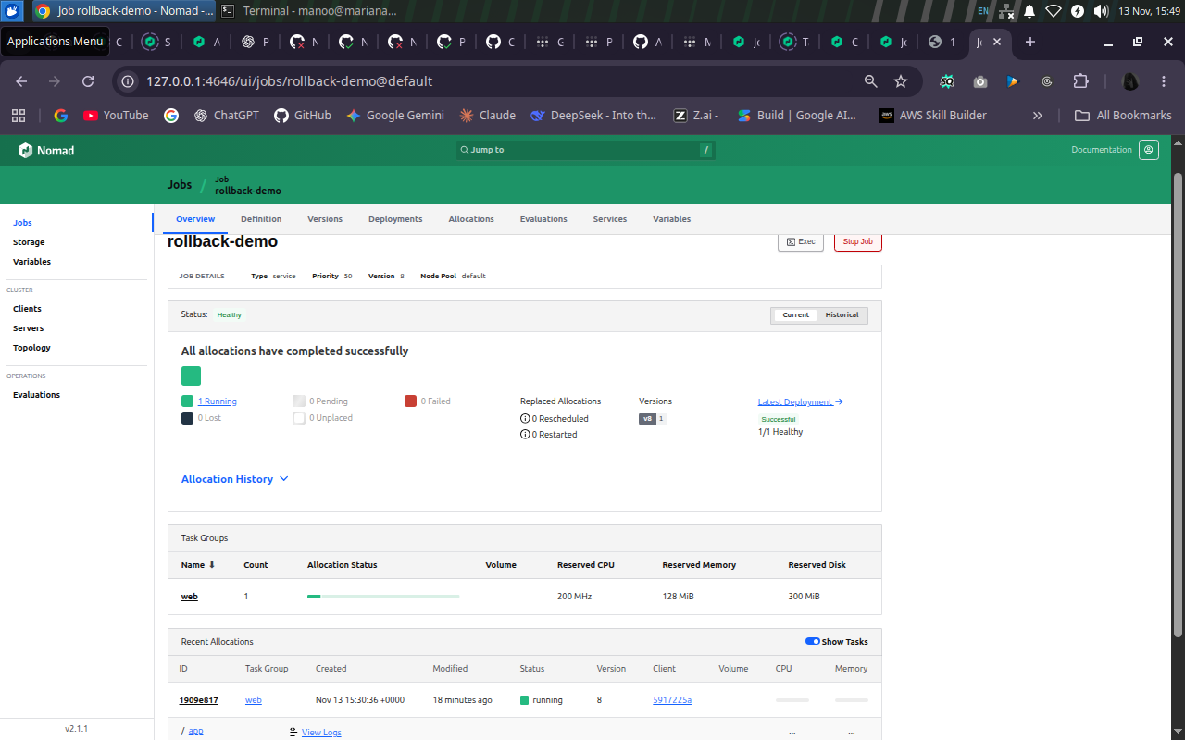
Figure 08 — Final successful Nomad deployment dashboard; independent HTTP v2 health is recorded separately.

