Input to Robot with Placing

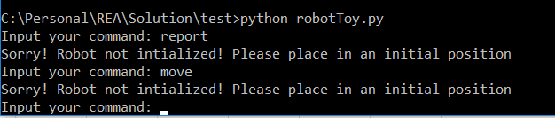

Throws error message.

Invalid direction/position in place command

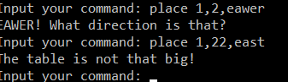

Valid Place/Move/Left/Right/Report command

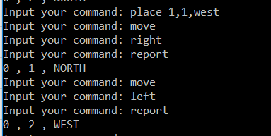

Exceeding table limit

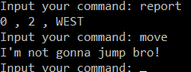

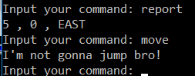

**Class Robot**

**Attributes**:

* **Location**: 2 Dimensional Array to assign Robot position
* **Direction**: Direction of the robot (north/south etc)
* **isPlaced**: Initialization flag for robot placement
* **max_X**: a class variable specifying table limit in X axis
* **max_Y**: a class variable specifying table limit in Y axis

**Methods**:

* **robotInput**: used to send input command to robot class
* **processCommand**: used by class to process the command
* **placeCommand**: used by class to process command relating to placement
* **placeRobot**: used by class to place robot with input position and direction
* **displayLocation**: to display robots position and direction
* **setPlaced**: initialize robot placement
* **getPlaced**: check in robot has been placed