* 1. **How many GADM2 regions are present in India?**

Number of GADM2 regions in India: 684

* 1. **Calculate population weighted pollution average of all years at country (GADM0) level**

● Save the country level file as a CSV.

Saved.

● What are the 10 most polluted countries in 2021?

Country pm2021

* + - Bangladesh 73.957984
    - India 58.701530
    - Nepal 51.713215
    - Pakistan 44.732405
    - Mongolia 36.039302
    - Myanmar 34.979832
    - Democratic Republic of the Congo 34.643665
    - Republic of the Congo 32.409004
    - Rwanda 32.356333
    - Burundi 31.912485
  1. **What was the most polluted GADM2 region in the world in 1998, 2005 and 2021?**

Most polluted GADM2 region in 1998:

Country: India, State: Uttar Pradesh, District: Unnao, PM2.5: 78.55 µg/m³

Most polluted GADM2 region in 2005:

Country: India, State: NCT of Delhi, District: NCT of Delhi, PM2.5: 98.75 µg/m³

Most polluted GADM2 region in 2021:

Country: India, State: NCT of Delhi, District: NCT of Delhi, PM2.5: 126.51 µg/m³

* 1. **Plot a population weighted pollution average trendline plot for Uttar Pradesh from 1998 to 2021.**

**Save this plot as a high quality PNG file.**

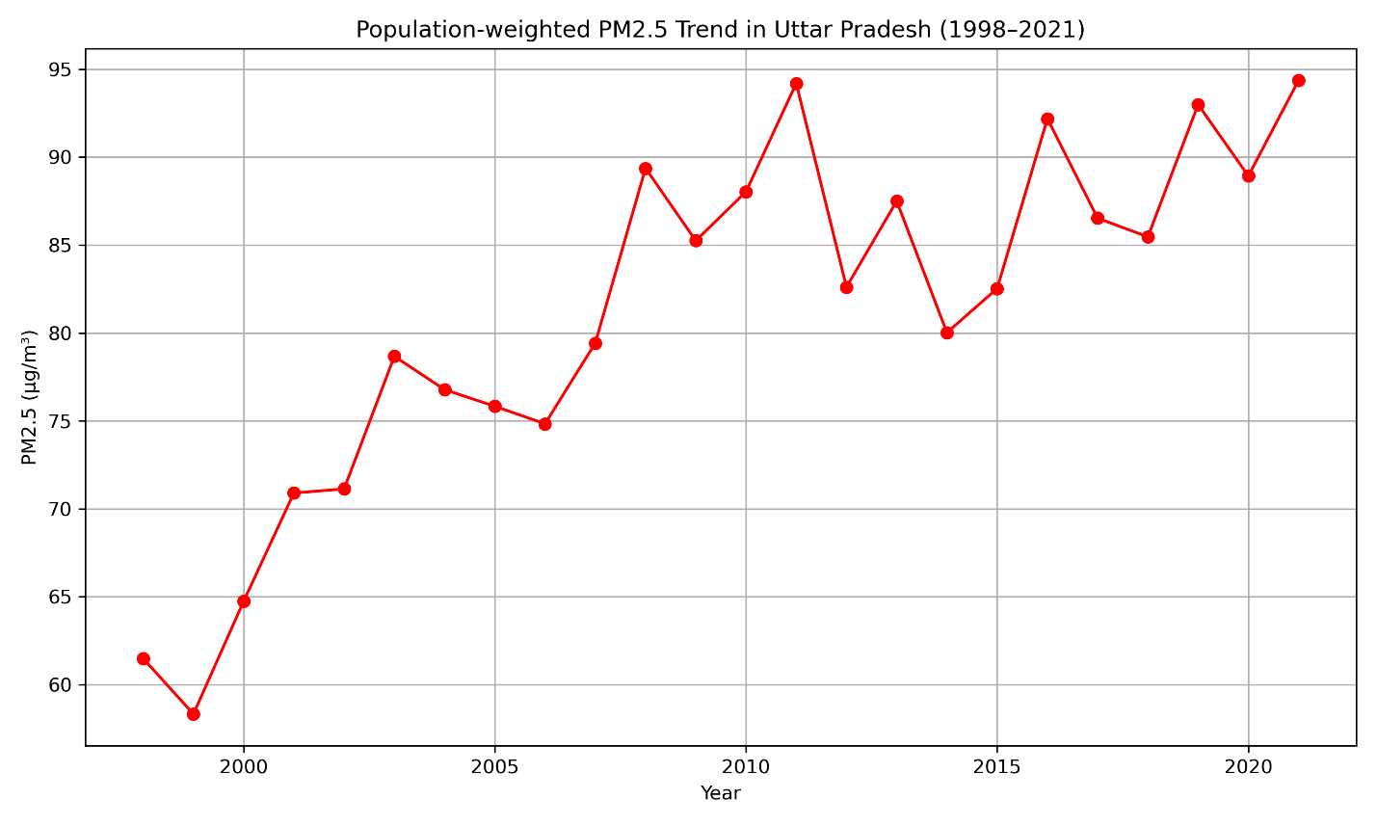

**2.1 Plot a bar graph for the life years lost relative to the WHO guideline in the 10 most**

**polluted countries in the world and also plot them on a global country level map.**

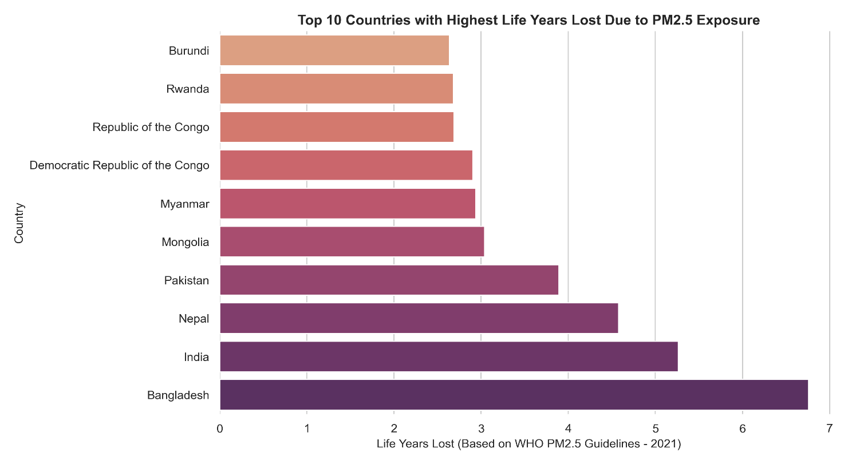

**For the map, the 10 most polluted country boundaries should be filled in with “dark red” and the**

**rest of the map should be grayed out. Save both the bar graph and the map as high**

**quality PNG files.**

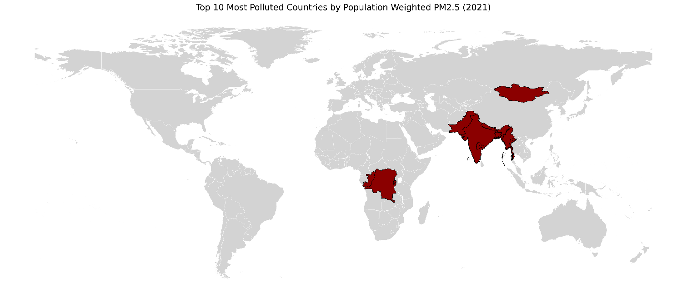

**2.2 Create a potential gain in life expectancy (relative to the WHO guideline) map of**

**eastern v/s western europe at GADM level 2 and save it as a high quality PDF.**

**● Plot should be in AQLI “Potential gain in life expectancy” color scale. Visit AQLI**

**website Index page > See legend for “Potential gain in life expectancy” and infer**

**“exact” colors from that.**

**● You can define east and west europe based on any acceptable definition online,**

**but whatever definition you use - mention the source.**

**● Feel free to add annotations/text boxes etc. to help explain the visualization.**

Saved as PDF

Easter and Western Europe Source: <https://unstats.un.org/unsd/methodology/m49/>

Potential Life Year Gained calculation: <https://aqli.epic.uchicago.edu/about/methodology/#:~:text=WHO%20Guideline%20and%20National%20Standards,95%25%20confidence.%5B1%5D>

**2.3 Look at the AQLI website > switch to Air pollution tab > plot a static version of the**

**global pollution map you see there, in those “exact” same colors. Export it as a high**

**quality (320 dpi) SVG file.**

Saved as .svg file.

**Verbal Reasoning and Writing :**

* Air, though free, is not equally clean for everyone—people living in the most polluted regions breathe air six times more polluted than those in the cleanest areas.
* Out of 252 countries and territories, 151 have no national air quality standards; and among the remaining, 33% of the population lived in areas that failed to meet their own standards in 2022.
* Air pollution, though not classified as a disease, is silently shortening lives—people in the most polluted regions lose up to 2.7 more years of life compared to those in cleaner areas.