

**Ahsanullah University of Science and Technology**

**Department of Computer Science and Engineering**

**Course No :** CSE4238

**Course Name :** Soft Computing Lab

**Assignment No :** 02

**Submitted By:**

Name : Md. Atique Ahmed Ziad

ID No. : 17.01.04.087

Session : Fall - 2020

Section : B (B2)

**The comparison between Exp_1 and Exp_2 for the first dataset is given below :**

|  |  |  |  |  |  |  |  |
| --- | --- | --- | --- | --- | --- | --- | --- |
|  | Batch  size | No of hidden  layer | No of Nodes in hidden  layer | Input  dimension | Iteration | Optimizer | Highest  Accuracy |
| Exp_1 | **20** | **6** | **200** | **28*28** | **20000** | **SGD** | **9.92** |
| Exp_2 | **128** | **2** | **200** | **28*28** | **20000** | **Adam** | **72.13** |

**Discussion:** In Experiment-1 we used 6 layers and get 9.92% accuracy. And in

Experiment-2 used 2 layers and get 72.13% accuracy.

I got less accuracy in Experiment 1 because we use 6 layers and the model trained over fitted. Then I used a fewer number of hidden layers in Experiment -2 and got a good accuracy.

**Loss vs Iteration graph of experiment 1 for First Dataset is given below:**

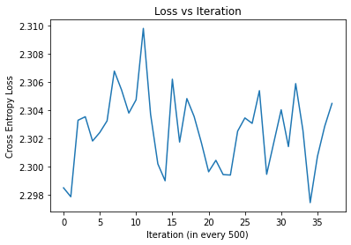

**Loss vs Iteration graph of experiment 1 for Second Dataset is given below:**

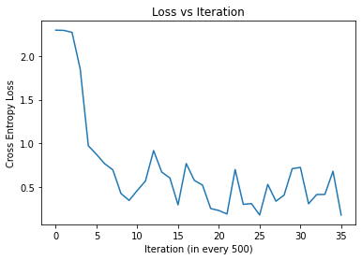

**Loss vs Iteration graph of experiment 2 for First Dataset is given below-**

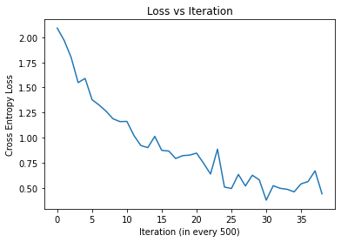

**Loss vs Iteration graph of experiment 2 for Second Dataset is given below-**

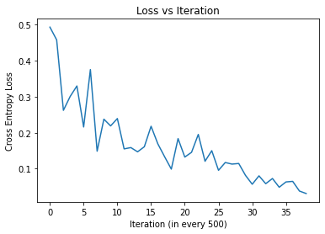

**The comparison between Experiment 1 and Experiment 2 for the first dataset and Second dataset is given below-**

|  |  |  |  |  |  |  |  |  |  |  |  |  |
| --- | --- | --- | --- | --- | --- | --- | --- | --- | --- | --- | --- | --- |
|  | Dataset 1 | | | | | | Dataset 2 | | | | | |
|  | Batch  size | No of hidden layer | Input dimens-ion | Iterati-on | Optimizer | Highest  Accuracy | Batch  size | No of hidden layer | Input dimen-sion | Itera-tion | Optimizer | Highest  Accuracy |
| Experiment1 | 20 | 6 | 28*28 | 20000 | SGD | 9.92 | 20 | 6 | 28*28 | 20000 | SGD | 87.05 |
| Experiment2 | 128 | 2 | 28*28 | 20000 | Adam | 72.13 | 128 | 2 | 28*28 | 20000 | Adam | 88.97 |

For dataset-1, In Experiment-1 we used 6 layers and get 9.92% accuracy. In Experiment-2, I used 2 layers and get 72.13% accuracy. In Experiment-1 we get less accuracy because model is overfitted.

That’s why we used a smaller number of hidden layers in Experiment -2.

For dataset-2, In Experiment-1 we used 6 layer and get 87.05 % accuracy. In Experiment-2 used 2 layers and get 88.97% accuracy. In Experiment-2 we get more accuracy than Experiment-1 because the model in experiment-2 is not overfitted (since I used smaller number of hidden layers).

**GitHub link:** https://github.com/atiqueziad/Soft-computing-Assingment-2