Department
Of
Computer Science & Engineering
Communication Engg & Coding Theory Lab manual


RCC Institute of Information Technology

Affiliated to Maulana Abul Kalam Azad University of Technology (erstwhile WBUT)

and

Approved by AICTE

Unit of an Autonomous Society of Department of Higher Education,
Govt. of West Bengal
Canal South Road, Beliaghata, Kolkata – 700015 West Bengal,India
Phone: +91 33 2323 2463 Fax: +91 33 2323 4668
www.rcciit.org


__________________________ _________________________
Course Coordinator HOD, CSE

Prepared by: | Approved & Reviewed by: | Issued by: | W.E.F Date:
Parama Bagchi  Asst. Prof,  Dept of CSE. | Dr. Minakshi Banerjee, HOD, Dept. of CSE | Program Coordinator and HOD, Department of CSE | January 2017

© Department of Computer Science & Engineering, RCCIIT, Kolkata

Department of Computer Science and Engineering

OUR MISSON:
To develop as a national level accomplished department of excellence in Computer Science and Engineering in terms of education, learning and research environment that will mould students into becoming innovative engineers, competent at solving real world problems in industry and commerce with leadership, result orientation, and high ethical standards.

OUR VISION:

We aspire to prepare world class computing professionals who can blossom into truly global leaders.

_________________________________________________________________

(In accordance with WBUT syllabus)

SUBJECT : Communication Engg & Coding Theory Lab

SUBJECT CODE : CS 491
SEMESTER : IV
STREAM : CSE

INDEX
SL. No. | CONTENT | Page No.
1 | Introduction About Lab
2 | Guidelines to Students
3 | PO and PEO of the Department
4 | Course outcome of the Lab & correlation of course outcome with PO of the department
5 | List of Lab Exercises as per University Syllabus (WBUT)
6 | List of Additional Lab Exercises to meet PO (CSE,RCCIIT)
7 | Sample solutions for Lab Exercises
8 | Sample Lab Reports
9 | Summary of Lab Reports
10 | Assessment Tools(Direct Tools and Indirect Tools)  Direct Tools  - Performance of the experiment in the lab  - Lab Report  - Programming knowledge  - Attendance  - Viva  Indirect Tools  - Team Work  - Ethics  - Punctuality  - Micro projects  - Faculty & staff satisfaction (semester exit) survey of students
11 | Rubrics on assessment Tools (Checklist and Analytical Rubrics)
12 | List of Micro projects
13 | Details of Micro projects of previous years(Last 3 years)  - Allotment details  - Award List
14 | References
_______________________________________________________

Signature of the Course Coordinator
(Parama Bagchi, Asst. Prof, Dept of CSE)

- INTRODUCTION ABOUT LAB
1. Experimental Kits:
(i) AM Modulation & Demodulation Kit
(ii) FM Modulation & Demodulation Kit
(iii) PAM Kit
(iv) PWM Kit
(v) PPM Kit
(vi) VCO PLL Kit
(Vii) Multimeter
(viii) Spectrum Analyser etc.

2. Guideline to Students:
- Equipment in the lab for the use of student community. Students need to maintain a proper decorum in the computer lab. Students must use the equipment with care. Any damage is caused is punishable.
- Students are required to carry their observation / programs book with completed exercises while entering the lab.
- Students are supposed to occupy the machines allotted to them and are not supposed to talk or make noise in the lab. The allocation is put up on the lab notice board.
- Lab can be used in free time / lunch hours by the students who need to use the systems should take prior permission from the lab in-charge.
- Lab records need to be submitted on or before date of submission.
- Students are not supposed to use pen drives and CDs/DVDs.
- All the students must wear ID cards, leave their foot wear out side the lab and must come with a formal dress code.
- Doesn’t bring bags inside the lab.

3. PO and PEO of CSE Department

PO:
PO 1. Engineering Knowledge: Apply knowledge of mathematics, science, computer engineering fundamentals and computer science specialization to the solution of complex computing engineering problems.
PO 2. Problem Analysis: Identify, formulate, research literature and analyze complex computer engineering problems using first principles of mathematics, natural sciences and computer engineering sciences for reaching advanced real life solutions.
PO 3. Design/ Development of Solutions: Design solutions for complex computer engineering problems and design system components or processes that meet specified needs with appropriate consideration for meeting socio-economic viable aspects like public health and safety, cultural, societal and environmental considerations.
PO 4. Conduct investigations of complex computer problems using research-based knowledge and research methods including design of experiments, analysis and interpretation of data and synthesis of information to provide valid conclusions and design of parts, subsystems, systems and/or processes to meet specific needs.
PO 5. Modern Tool Usage: Create, select and apply appropriate techniques, resources and modern engineering and IT tools including prediction and modeling to complex computer engineering activities with an understanding of the limitations.

PO 6. Environment and Sustainability: Understand the impact of professional engineering solutions in societal and environmental contexts utilizing contextual knowledge to assess societal, health, safety, legal and cultural issues and demonstrate knowledge of and need for sustainable development.
PO 7. Ethics: Apply ethical principles for fulfillment of professional ethics and responsibilities and norms of engineering practice. By providing a written code of conduct from the very first day of their career.
PO 8. Individual and Team Work: Function effectively as an individual, and as a member or leader in diverse teams and in multi disciplinary settings.
PO 9. Communication: Communicate effectively on complex engineering activities with the engineering community and with society at large, such as being able to comprehend and write effective reports and design documentation, make effective presentations instructions
PO 10. Project Management and Finance: Demonstrate knowledge and understanding of engineering and management principles and apply these to one’s own work, as a member and leader in a team, to manage projects and in multidisciplinary environments.
PO 11. Life-long Learning: Recognize the need for and have the preparation and ability to engage in independent and life- long learning in the broadest context of technological change.(NBA’s plus) participate and succeed in competitive examinations for PG programs & Govt. services.

PEO:

- To educate graduates to work professionally in computing profession.
- To educate graduates to analyze data, design, and conduct experiments using modern engineering tools.
- To train graduates to lead in multinational, multicultural, and multi-disciplinary teams.
- To understand the impact of Computer science & engineering solution in a global and societal context.
- To encourage graduates to pursue higher education and research.
- To develop graduates to communicate effectively with the technical fraternity and the people at large.
- To demonstrate code of conduct and ethics while performing given tasks.

4. Course outcome of the Lab & correlation of course outcome with PO of the department

CO1. Review the fundamental concepts of communication systems.
CO2. Learn to compare different analog modulation schemes.
CO3. Be familiarized with the working of PPM, PWM, PAM
CO4. Be familiarized with the design tradeoffs and performance of communications systems.

CO | PEOs |  |  |  |  |  |  | POs
CO | 1 | 2 | 3 | 4 | 5 | 6 | 7 | 1 | 2 | 3 | 4 | 5 | 6 | 7 | 8 | 9 | 10 | 11
CO1. Review the fundamental concepts of communication systems |  | S | M |  |  |  |  | S | S |  | M |  |  |  | M
CO2. Learn to compare different analog modulation schemes. |  | S | M |  |  |  |  | S | S |  | M |  |  |  | M
CO3. Be familiarized with the working of PPM, PWM, PAM |  | S | M |  |  |  |  | S | S |  | M |  |  |  | M
CO4. Be familiarized with the design tradeoffs and performance of communications systems. |  | S | M |  |  |  |  | S | S |  | M |  |  |  | M
- Strong, M=Moderate and W=Weak

5. LIST OF LAB EXERCISES:-

Sl. No | Experiment No. | Name of the program | Related COs
Day 1(Introduction)
Day 1 | Experiment 1 | Introduction about Communication Engineering and Coding Theory Laboratory And to know the different equipments (i.e. Cathode Ray - Oscilloscope, Function Generator, Communica-  tion development kits, Multimeter). | CO1,CO2,CO3
Day 2(Analog Modulation Techniques)
Day 2 | Experiment 2 | Generation of Amplitude Modulated Signal (Design using transistor or Balanced Modulator Chip) and Reconstruct the Modulating Signal by means of Demodulation. | CO2,CO4
Day 3(Analog Modulation Techniques)
Day 3 | Experiment 3 | Generation of Frequency Modulated Signal using VCO chip (to view the wave shapes) and Reconstruct the Modulating Signal by means of Demodulation. | CO2,CO4
Day 4(Digital Modulation Technique)
Day 4 | Experiment 4 | Generation of PAM Signal and Reconstruct the Modulating Signal by means of Demodulation. | CO3,CO4
Day 5(Digital Modulation Technique)
Day 5 | Experiment 5 | Generation of PWM Signal and Reconstruct the Modulating Signal by means of Demodulation. | CO3,CO4
Day 6(Digital Modulation Technique)
Day 6 | Experiment 6 | Generation of PPM Signal and Reconstruct the Modulating Signal by means of Demodulation. | CO3,CO4
Day 7 | Experiment 7 | Voltage Controlled Oscilloscope Using LM-565 chip and Record the locking frequency range (to view the change in shape). | CO3,CO4

6. List of Additional Lab Exercises to meet PO and PEO (CSE, RCCIIT):

Sl. No | Experiment No. | Name of the program | Related COs
Day-1 (Micro-Project-1)
Day 8 | Experiment 8 | Micro Project-1 | CO1, CO2, CO3, CO4

Related POs for the above mentioned micro projects are:-

CS491 (Related PO’s= PO1,PO2, PO4, PO8)
PO1 | Engineering Knowledge: Apply knowledge of mathematics, science, computer engineering fundamentals and computer science specialization to the solution of complex computing engineering problems.
PO2 | Problem Analysis: Identify, formulate, research literature and analyze complex computer engineering problems using first principles of mathematics, natural sciences and computer engineering sciences for reaching advanced real life solutions.
PO4 | Conduct investigations of complex computer problems using research-based knowledge and research methods including design of experiments, analysis and interpretation of data and synthesis of information to provide valid conclusions and design of parts, subsystems, systems and/or processes to meet specific needs.
PO8 | Individual and Team Work: Function effectively as an individual, and as a member of a team even in multidisciplinary and multi-cultural settings. Should also develop leadership capability to guide a team both in technical and administrative matters

- Sample solutions for Lab Exercises

Experiment No. 1:

Experiment Name: Introduction about Communication Engineering and Coding Theory Laboratory And to know the different equipments (i.e. Cathode Ray - Oscilloscope, Function Generator, Communication development kits, Multimeter).

Objective: Get introduced about the different equipments in Communication Engineering and Coding Theory Laboratory

Apparatus:

- Cathode Ray Oscilloscope
- Function Generator
- Communication Development Kits
- Multimeter
- Co-axial Cables
- Connecting Wires etc.

Theory: At the completion of this unit, you will be able to describe the basic principles of analog radio communications the ANALOG COMMUNICATIONS circuit board, and the balanced. A bidirectional communication system operates in opposite directions. The receiver can respond to the sender. Radio communication uses electrical energy to transmit information. Because electrical energy travels almost as fast as light, radio communication is essentially instantaneous. A radio transmitter converts audio (sound) signals to electrical signals that are sent over wires or through space. A radio receiver converts the electromagnetic waves back to sound waves so that the information can be understood.
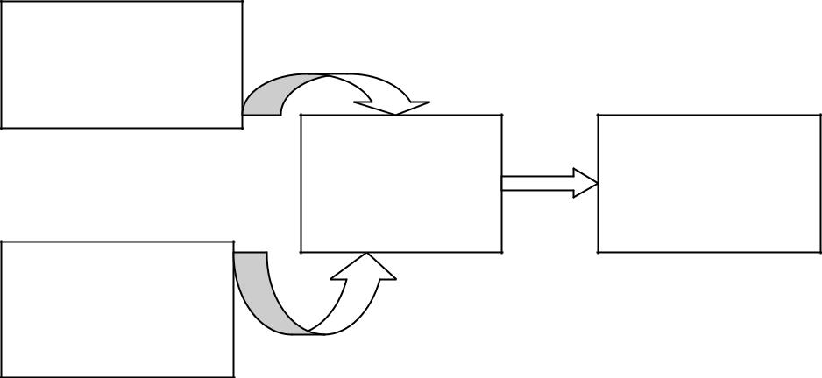

Message Signal

Transmitter
Modulator

Carrier Signal

The transmitted information is the intelligence signal or message signal In this course, the term message signal refers to the transmitted information. Message signals are in the Audio Frequency (AF) range of low frequencies from about 20 Hz to 20 kHz. The Radio Frequency (RF) is the carrier signal. Carrier signals have high frequencies that range from 10 kHz up to about 1000 GHz. A radio transmitter sends the low frequency message signal at the higher carrier signal frequency by combining the message signal with the carrier signal. Modulation is the process of changing a characteristic of the carrier signal with the message signal. In the transmitter, the message signal modulates the carrier signal. The modulated carrier signal is sent to the receiver where demodulation of the carrier occurs to recover the message signal.
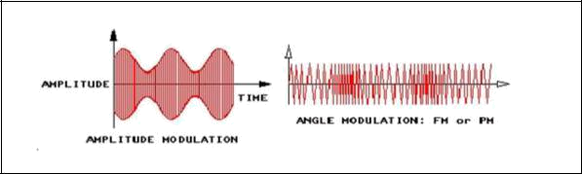

the transmitted information is the intelligence signal or message signal In this course, the term message signal refers to the transmitted information. Message signals are in the Audio Frequency (AF) range of low frequencies from about 20 Hz to 20 kHz. The Radio Frequency (RF) is the carrier signal. Carrier signals have high frequencies that range from 10 kHz up to about 1000 GHz. A radio transmitter sends the low frequency message signal at the higher carrier signal frequency by combining the message signal with the carrier signal. Modulation is the process of changing a characteristic of the carrier signal with the message signal. In the transmitter, the message signal modulates the carrier signal. The modulated carrier signal is sent to the receiver where demodulation of the carrier occurs to recover the message signal to prevent interference, every radio communication transmits at its own frequency. The designations for carrier frequency ranges are shown. The ANALOG COMMUNICATIONS circuit board contains the following circuit blocks:

    - VCO-LO
    - AM/SSB TRANSMITTER
    - PHASE MODULATOR
    - QUADRATURE DETECTOR
    - VCO-HI
    - AM/SSB RECEIVER
    - PHASE-LOCKED LOOP

These circuit blocks permit you to configure transmission and reception circuits for amplitude, frequency, and phase-modulated signals. On the ANALOG COMMUNICATIONS circuit board, a versatile Integrated Circuit (IC) called a balanced modulator performs the following functions:-

- Amplitude modulation

- Double-Sideband (DSB)modulation mixer

- Product detector phase detector

Remarks:

Experiment No. 2:

Experiment Name: Generation of Amplitude Modulated Signal (Design using transistor or Balanced Modulator Chip) and Reconstruct the Modulating Signal by means of Demodulation.

Objective: To generate the waveform for Amplitude modulation and demodulation using Amplitude modulation and Demodulation kit.

Apparatus:

- Cathode Ray Oscilloscope
- Amplitude modulation & Demodulation kit
- Co-axial Cables
- Connecting Wires etc.

Theory:
In amplitude modulation, the amplitude of a carrier signal is varied by the instantaneous value of the modulating signal, whose frequency is invariably lower than that of the carrier. In practice, the carrier may be high frequency (HF) while the modulation is audio. Let the carrier voltage vc and the modulating voltage vm be represented by:-

vc = Vc sin ωct

vm = Vm sin ωmt

The modulation index (μ) is defined by:-

μ = Vm / Vc = (Vmax – Vmin) / (Vmax + Vmin).

The instantaneous voltage of the AM wave is given by:-

v=(Vc+VmSinωmt) sin ωct

v=Vc[1+(Vm/Vc) sinωmt] sin ωct

v = Vc(1+μ sinωmt) sin ωct

Or

v = Vc sin ωct + μVc/2 cos(ωc-ωm) t – μVc/2 cos (ωc+ωm) t

Here, the first term is the un-modulated carrier and the two additional terms produced are the two side bands. The frequency of the lower side band (LSB) is fc– fm and that of the upper side band (USB) is fc + fm. The total normalized power in the modulated wave is:-

Pt= Pc (1+μ²/2) = Pc + Ps.

Where, Pc = Normalized carrier power = Vc²/2

And Ps = Total sideband power = Pcμ²/2.

The sideband power is the useful power and the carrier power is the power wasted for convenience.

Hence the power efficiency η % = (Useful power/total power) = Ps/ (Ps+Pc) =μ²/ (2+μ²)
Or η% =μ²/(2+μ²)x100% with the condition 0≤μ≤1.

Amplitude modulated signal:-

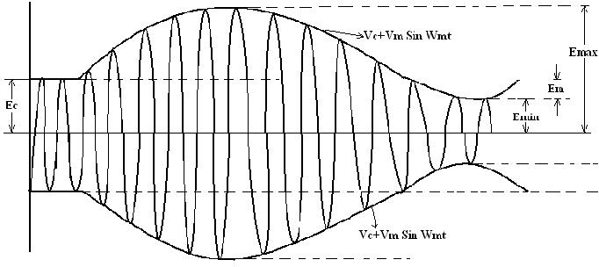

Procedure:

Step 1 : Set the amplitude and the frequency of the carrier signal by observing the signal on the CRO screen.
Step 2 : Set the amplitude and frequency of the modulating signal by observing the signal on the CRO screen.

Step 3: Observe the modulated signal on CRO screen and find Vmax and Vmin to calculate μ.

Step 4: Vary the modulating signal amplitude in steps and find the corresponding values of μ.

Step 5: Study the modulated waveform for 100% modulation and above for over modulation.

Step 6: Find Pc and calculate Pt for different values of μ.

Step 7: Calculate the power efficiency, η, for different values of μ.

Demodulation of AM signal:

An amplitude modulated signal is demodulated by rectifying (using diode) and filtering out (RC filter) the RF and DC component. In an envelope detector the output follows the envelop of the modulated carrier signal, which is nothing but the modulated signal. The circuit diagram of the envelop detector is shown below. The capacitor (C1) charges up to the peak voltage of the modulated carrier. As the signal falls below its peak value the diode is cut off, because the capacitor voltage is greater than the signal voltage at that instant thus causing the diode reverse biased. The capacitor now discharges through resistance R1 with time constant R1C1. During the next positive cycle the same things repeats. If the time is sufficiently high then the capacitor will not discharge fully and soon again charge up to the peak value of the next positive cycle. Thus the output voltage (point A) closely follows the envelop of the modulating signal with slight ripple. The frequency of the ripple signal is ωc. Ripple can be reduced by increasing the time constant R1C1. If R1C1 is too long, the output voltage does not follow the amplitude variation of the modulated signal. If it is too short the C1 will tends to discharge by an excessive amount leading to high ripple content. So,

1/ωm >> R1C1>>1/ ωc

C2 is used to eliminate DC component. R2-C3 forms a low pass filter.
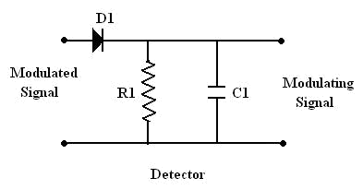

D1=1N34/0A79; R1=1M; C1= 470PF;

Procedure:

- Make the circuit connection as shown in the figure.

- Set the amplitude and Frequency of the carrier signal by observing the signal on the CRO screen.

- Set the amplitude and frequency of the modulating signal by observing the signal on the CRO screen.

- Observe the modulated signal on CRO screen and apply it to the input terminal of the detector circuit.

- The output voltage Vc(t) is observed across the capacitor C, which closely follows the envelop of the modulating signal with a ripple voltage of frequency ωc.

- The demodulated signal is observed at the output terminal after filtering the high frequency ripple voltage.

Vary the amplitude of the modulating signal and measure the corresponding amplitude of the demodulating signal

Block Diagram:

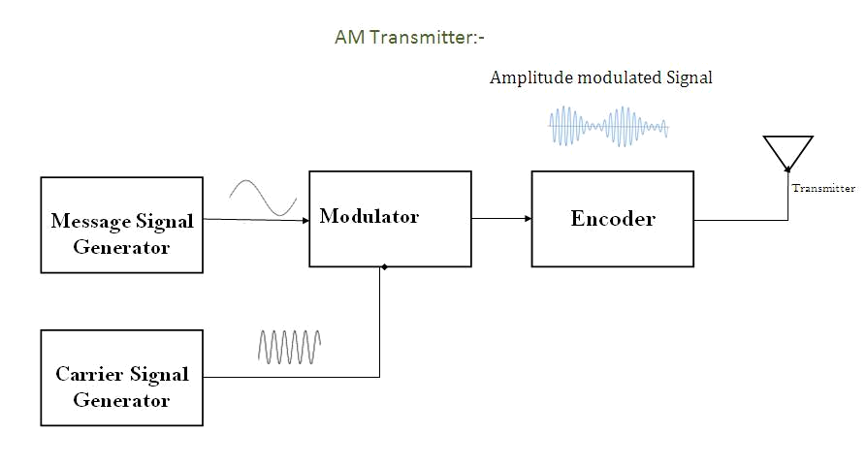

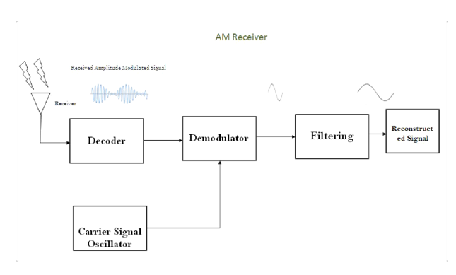

Experimental Data:-

A. To calculate the modulation index (μ):-

Vc = | ; fc = | ; fm = |  | ;
Modulating signal  amplitude  (p-p)in volts | 2Vmax |  | 2Vmin | μ = (Vmax-Vmin)/(Vmax+Vmin) | % μ
Modulating signal  amplitude  (p-p)in volts | (volts) |  | (volts)

B. To calculate the transmitted power and the efficiency:-

Pc(watt) | Values of μ | PSB(watt) | Pt(watt) | ή % | ήmax %

Plot:-

- Time vs. Amplitude for the modulating signal, carrier signal and the modulated signal for a Particular value of μ.

2 Time vs. Amplitude for the spectral components.

- Plot μ vs. Pt.

- Plot μ vs. η.

For Demodulation:-

Amplitude of the carrier signal (p-p) =
Frequency of the carrier signal=

Plot:
Amplitude of the modulating signal in Volts | Amplitude of the demodulating signal in Volts
- Time vs. Amplitude for the modulated signal.

- Time vs. Amplitude for the detected signal with ripple.

- Time vs. Amplitude for the demodulated signal.
Remarks:

Experiment No. 3:

Experiment Name: Generation of Frequency Modulated Signal using VCO chip (to view the wave shapes) and Reconstruct the Modulating Signal by means of Demodulation.

Objective: To generate the waveform for Frequency modulation and Demodulation using Frequency modulation & Demodulation kit.

Apparatus:

- Cathode Ray Oscilloscope
- Frequency modulation & Demodulation kit
- Co-axial Cables
- Connecting Wires etc.

Theory:- Frequency modulation is a system in which the amplitude of the modulated carrier is kept constant, while its frequency is varied according to the instantaneous amplitude of the modulating signal. Frequency modulation is a system in which the amplitude of the modulated carrier is kept constant, while its frequency is varied according to the instantaneous amplitude of the modulating signal.
Let the carrier signal = A Cosωct
And the modulating signal =VmCos ωmt
The instantaneous frequency f of the frequency modulated wave is given by

f = fc+kVmfc Cos ωmt; [where fc = ωc/2Π = unmodulated carrier frequency and k = proportionality constant.]

Therefore the deviation in frequency is given by ± kVmfcCos ωmt. The maximum deviation (δ) in frequency is given by:

δ = ± k Vm fc. = ± kf Vm; [where kf = k fc = frequency sensitivity of the modulator]. The modulation index mf for FM is defined as follows:-

mf = δ / fm; i.e. [max. frequency deviation / modulating frequency]. The instantaneous value of FM voltage is given by:
V = A Cos[ωct ±(δ/fm)Sinωmt]

The expansion of this equation involves the use of Bessel function. Above equation can be written as follows:-

Let V = A Cos (ωct + mf Sinωmt); where [m f = δ / fm modulation index]= A Cos ωct Cos (mf Sin ωmt) – A Sin ωct Sin (mf Sin ωmt). This function involves cosine of a sine & sine of a sine terms .These can be expanded as follows:-
Cos (x sin θ ) = J0(mf) + 2J2(mf)Cos2θ + 2J4(mf)Cos4θ +---------------------

Sin (x Sin θ ) = 2J1(mf)Sin θ + 2J3(mf)Sin 3θ +--------------------------------

V = ACosωct[J0(mf) + 2J2(mf)Cos2ωmt + 2J4(mf)Cos4ωmt + ---------------] - ASinωct[2J1(mf)Sinωmt + 2J3(mf) Sin3ωmt + -------------] =J0 (mf )ACos ωct + 2AJ2(mf) Cos ωct.Cos 2ωmt + 2AJ4 (mf) Cosωct.Cos 4ωmt + --------------
- 2AJ1(mf) Sinωct Sin ωmt – 2AJ3(mf) Sin ωct Sin3ωmt----------------------------
- J0(mf) A Cos ωct +AJ2(mf) [Cos (ωc+2ωm)t + Cos (ωc-2ωm)t] + AJ4(mf)[Cos (ωc+4ωm)t + Cos(ωc-4ωm)t] + ---

-AJ1(mf) [Cos (ωc-ωm)t – Cos(ωc+ωm)t] – AJ3(mf)[Cos(ωc-3ωm)t - Cos(ωc+3ωm)t]---------

=AJ0(mf)Cosωct + AJ1(mf)[Cos (ωc+ωm)t - Cos(ωc-ωm)t] + AJ2(mf)[Cos (ωc+2ωm)t + Cos(ωc-2ωm)t] + AJ3(mf) [Cos (ωc+3ωm)t- Cos(ωc-3ωm)t] + AJ4(mf)[ Cos (ωc+4ωm)t + Cos(ωc-4ωm)t] +--------------

FM has an infinite number of sidebands, as well as the carrier. They are separated from the carrier by ωm,2ωm,3ωm,…... The modulation index determines the number of sideband components of significant amplitude and can be obtained by consulting Bessel chart. The bandwidth of the signal is also given by Carson’s rule, B.W. = 2(δ+fm). Where, fm= highest frequency component of the modulating signal.

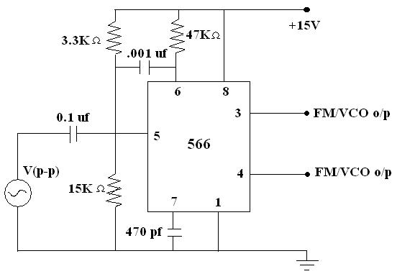

Procedure:

Step 1: Realize the circuit as shown in figure.

Step 2: Generate the carrier signal by using IC 566, without applying the input modulating signal.

Step 3: Measure the amplitude and frequency of the carrier signal either at pin 3 (for triangular Wave) or at pin 4 (for square wave) by observing on CRO screen.

Step 4: Apply the modulating signal (1KHz to 2KHz) at pin 5.

Step 5: Observe the FM waveform either at pin 3 or at pin 4 on CRO screen.

Step 6: Find the maximum and the minimum frequencies and hence find the maximum frequency deviation.

Step 7: Find the modulation index and hence find the bandwidth of the signal by consulting the Bessel chart.

Step 8: Find the bandwidth from the Carson’s formula & compare it with the result obtained from Bessel chart.

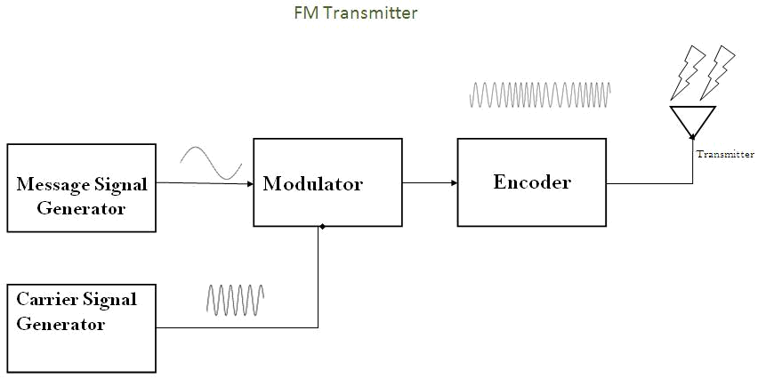
Block Diagram:

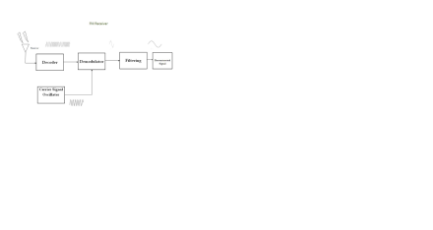

Experimental Data:-

A. To calculate the Modulation Index:

Table –1
Maximum frequency  of  the modulated signal  (fc+δ) | Minimum frequency  of the modulated  signal(fc-δ) | Maximum deviation (δ) | Modulation index  mf=δ/fm.

Plot:

  - Time vs. Amplitude for the modulating signal.

  - Time vs. Amplitude for the modulated signal.

  - Time vs. Amplitude for the demodulated signal.

Remarks:

Experiment No. 4:

Experiment Name: Generation of PAM Signal and Reconstruct the Modulating Signal by means of Demodulation.

Objective: To generate the waveform for Pulse Amplitude modulation and Demodulation using Communication Development kit.

Apparatus:

- Cathode Ray Oscilloscope

- Communication Development kit

- Co-axial Cables

- Connecting Wires etc.

Theory:

Pulse modulation may be used to transmit information, such as continuous speech or data. It is a system in which continuous speech or data. It is a system in which continuous waveforms are sampled at regular intervals. The continuous time signal g(t) is sampled and sample values are used to modify certain parameter of periodic pulse train. We may vary the amplitudes, width or positions of the pulses in proportion to the sample values of the signal g(t) Fig (1) Accordingly, we have Pulse-amplitude modulation (PAM), Pulse width modulation (PWM) or Pulse-position modulation (PPM). A continuous signal band limited to fm Hz can be completely represented by and reconstructed from the samples taken at a rate greater than or equal to 2fm Samples / Sec. This minimum sampling frequency is called the Nyquist rate i.e. for faithful reproduction of information signal fs >2fm.

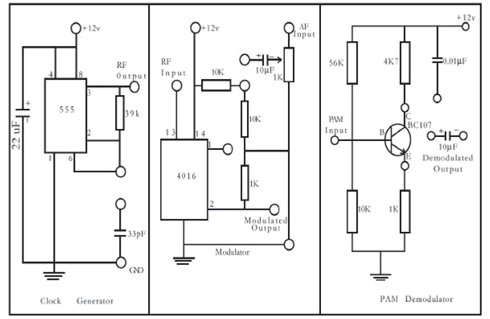

Procedure:

1 . Switch on pulse Amplitude modulation and demodulation trainer.

2 . In clock generator section connect pin 6 of 555IC to the 33pfcapacitor terminal.
3 . Check the clock generator (RF) output signal.

4 . Connect RF output of clock generator to the RF input of modulator section.

5 . Connect a 1 KHz; 2vp-p of sine wave from function generator to the AF input of modulator section.
6 . Short the 10F terminal and 10k terminal of modulator.

7 . Connect 10k terminal to pin 1 of IC 4016.

8 . Connect the CRO to modulated output of modulator section.

9. Adjust the 1k potentiometer to vary the amplitude of the modulated signal.

10. Adjust the AF signal frequency from 1KHZ-10KHZ to get stable output waveform. While increases the AF signal frequency decreases the output signal pulses.

11. During demodulation, connect the modulated output to the PAM input of Demodulator section.

12 . Connect channel 1 of CRO to modulating signal and channel-2 to demodulated output. Observe the two waveforms that they are 1800out of phase, since the transistor detector operates in CE configuration.

Block Diagram:
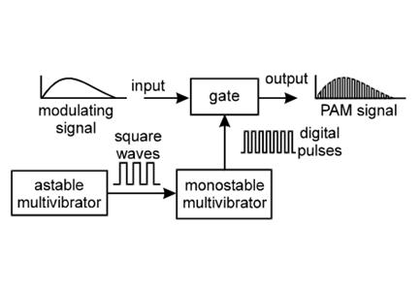

Experimental Data:

A. To study the PAM signals:

 |  |  | Table-1
 | Pulse width of the |  |  |  | Corresponding
Frequency of the | sampling signal |  |  |  | Corresponding
Frequency of the |  |  | Corresponding |  | amplitude of the
modulating |  |  |  |  | amplitude of the
modulating |  |  | frequency of the | Number of samples | PAM signal
 | On | Off | frequency of the | Number of samples | PAM signal
 | On | Off | sampling signal
signal |  |  | sampling signal
 | time | time

B. To study the demodulated signals:
 |  | Table-2
Frequency of the  Modulating signal | (p-p) amplitude of the  modulating signal |  | Frequency of the  demodulating signal | (p-p) amplitude of the  demodulating  signal

Plot:

- Time vs. Amplitude for the modulating signal.

- Time vs. Amplitude for the Sampling Pulse Train.

- Time vs. Amplitude for the pulse amplitude modulated signal.

- Time vs. Amplitude for the Demodulated signal.

Remarks:

Experiment No. 5:

Experiment Name: Generation of PWM Signal and Reconstruct the Modulating Signal by means of Demodulation.

Objective: To generate the waveform for Pulse width modulation and Demodulation using Communication Development kit.

Apparatus:

- Cathode Ray Oscilloscope

- Communication Development kit

- Co-axial Cables

- Connecting Wires etc.

Theory: In a PWM Modulator circuit base band signal is analog and carrier is pulse. Width of the trailing edge of pulse is continuously changed in accordance with modulating signal amplitude keeping height of pulse unchanged.
Pulse-width modulation (PWM), or pulse-duration modulation (PDM), is a technique used to encode a message into a pulsing signal. It is a type of modulation. Although this modulation technique can be used to encode information for transmission, its main use is to allow the control of the power supplied to electrical devices, especially to inertial loads such as motors. In addition, PWM is one of the two principal algorithms used in photovoltaic solar battery chargers, the other being MPPT. The average value of voltage (and current) fed to the load is controlled by turning the switch between supply and load on and off at a fast rate. The longer the switch is on compared to the off periods, the higher the total power supplied to the load.

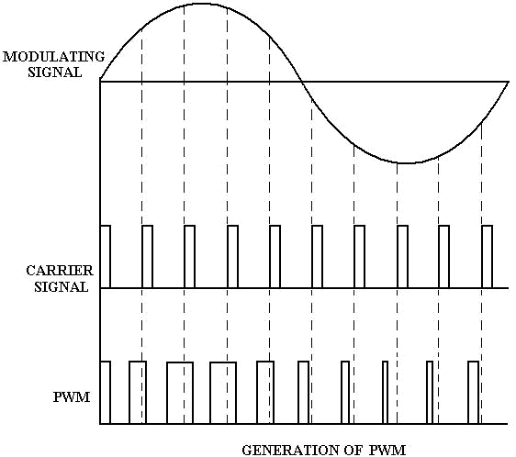

Circuit Diagram & Block Diagram:

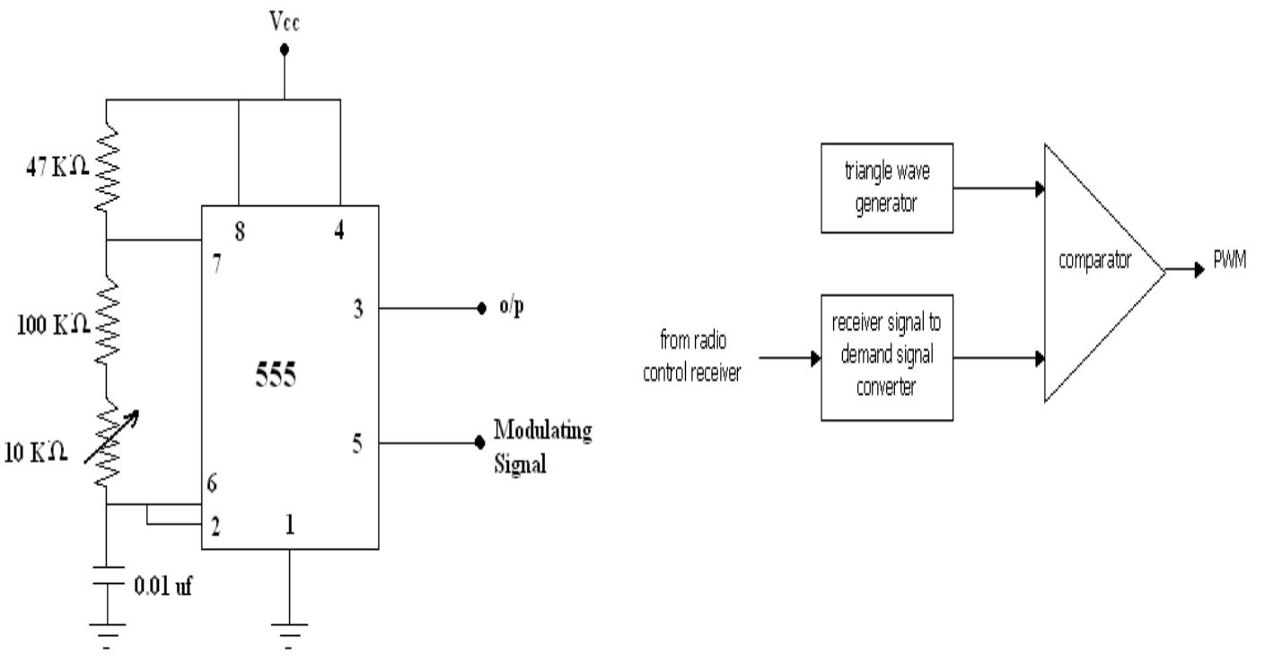

The clock signal of the desired freq. is applied is shown, from which the negative trigger pulses are derived with the help of a diode and an R1 – C1 combination which works as a differentiator. The negative trigger pulses are applied to the pin no.2 of the 555 timer which is working in the Monostable mode. They decide the starting time of the PWM pulses. The ends of the pulses depend on an R2 – C2 combination and on the signal at the pin no.5 to which the modulating signal is applied. Therefore the width of the pulses depends upon the value of modulating signal and thus the o/p at pin no-3 is the desired PWM signal.

Procedure:

- Connect both Modulator and demodulator circuit in communication development kit.

- Check the PWM o/p from pin no. 3 of 555 timers in one channel of CRO.

- Observe the Modulating signal in another channel of CRO.

- Vary the amplitude of Modulating signal.

- Observe change in o/p in CRO.

Experimental Data:

- To study The PWM Signals:-

Sl. No. | p-p Amplitude of | T(On) | T(Off)
 | Modulating signal(v)

- To study the Demodulated Signals:-

Frequency of the Modulating Signal | Amplitude of the  Modulating Signal | Frequency of the Demodulating Signal | Amplitude of the Demodulating Signal

Plot:

  - Time vs. Amplitude for the modulating signal.

  - Time vs. Amplitude for the Sampling Pulse Train.

  - Time vs. Amplitude for the pulse width modulated signal.

  - Time vs. Amplitude for the Demodulated signal.

Observe the following waveforms on CRO and plot it on the tracing paper.

Remarks:

Experiment No. 6:

Experiment Name: Generation of PPM Signal and Reconstruct the Modulating Signal by means of Demodulation.

Objective: To generate the waveform for Pulse Position modulation and Demodulation using Communication Development kit.

Apparatus:

- Cathode Ray Oscilloscope

- Communication Development kit

- Co-axial Cables

- Connecting Wires etc.

Theory: Pulse modulation may be used to transmit information, such as continuous speech or data. It is a system in which continuous speech or data. It is a system in which continuous waveforms are sampled at regular intervals. The continuous time signal g(t) is sampled and sample values are used to modify certain parameter of periodic pulse train. We may vary the amplitudes, width or positions of the pulses in proportion to the sample values of the signal g(t) Fig (1) Accordingly, we have Pulse-amplitude modulation (PAM), Pulse width modulation (PWM) or Pulse-position modulation (PPM).
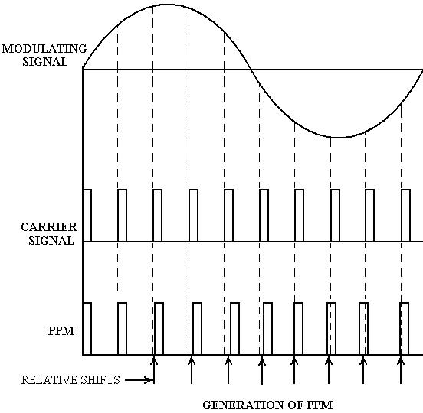

Circuit Diagram:

RA= RB = 100KΩ, C = 0.1µF

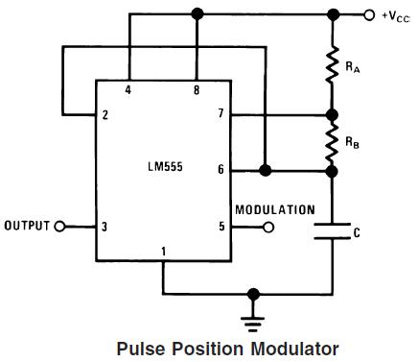

Procedure:

- Connect both Modulator and demodulator Circuit in communication development kit.

- Check the PPM o/p from pin no. 3 of 555 timers in one channel of CRO.

- Observe the Modulating signal in another channel of CRO.

- Vary the amplitude of Modulating signal.

- Observe change in o/p in CRO.

Experimental Data:

- To study the PPM signals:-

Table-1:
Sl. No | Amplitude of the Modulating Signal | Frequency of the Modulating Signal | Maximum Deviation

B. To study the demodulated signals:-

Table-2:

Frequency of the  Modulating signal | (p-p) Amplitude of the  modulating signal | Frequency of the  demodulating signal | (p-p) amplitude of the  demodulating  signal

Plot:

- Time vs. Amplitude for the modulating signal.

- Time vs. Amplitude for the Sampling Pulse Train.

- Time vs. Amplitude for the pulse position modulated signal.

- Time vs. Amplitude for the Demodulated signal.

Remarks:

Experiment No. 7:

Experiment Name: Voltage Controlled Oscilloscope Using LM-565 chip and Record the locking frequency range (to view the change in shape).

Objective:

To generate the waveform and calculate the locking frequency Range (Difference between Minimum and Maximum locking frequency) using VCO-PLL Trainer kit.

Apparatus:

- Cathode Ray Oscilloscope

- LM-565

- Registers

- Capacitors

- Co-axial Cables

- Connecting Wires etc.

Theory: A phase locked loop, PLL, is basically of form of servo loop. Although a PLL performs its actions on a radio frequency signal, all the basic criteria for loop stability and other parameters are the same.A basic phase locked loop, PLL, consists of three basic elements:-

- Phase comparator / detector: As the name implies, this circuit block within the PLL compares the phase of two signals and generates a voltage according to the phase difference between the two signals.

- Loop filter: This filter is used to filter the output from the phase comparator in the PLL. It is used to remove any components of the signals of which the phase is being compared from the VCO line. It also governs many of the characteristics of the loop and its stability.

- Voltage controlled oscillator (VCO): The voltage controlled oscillator is the circuit block that generates the output radio frequency signal. Its frequency can be controlled and swung over the operational frequency band for the loop.
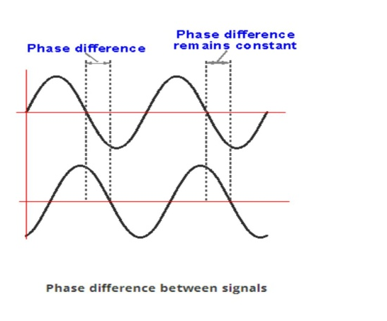

A phase-locked loop or phase lock loop (PLL) is a control system that generates an output signal whose phase is related to the phase of an input signal. While there are several differing types, it is easy to initially visualize as an electronic circuit consisting of a variable frequency oscillator and a phase detector. The oscillator generates a periodic signal. The phase detector compares the phase of that signal with the phase of the input periodic signal and adjusts the oscillator to keep the phases matched. Bringing the output signal back toward the input signal for comparison is called a feedback loop since the output is 'fed back' toward the input forming a loop. Keeping the input and output phase in lock step also implies keeping the input and output frequencies the same. Consequently, in addition to synchronizing signals, a phase-locked loop can track an input frequency, or it can generate a frequency that is a multiple of the input frequency. These properties are used for computer clock synchronization, demodulation, and frequency synthesis.

Circuit Diagram and Block Diagram:-
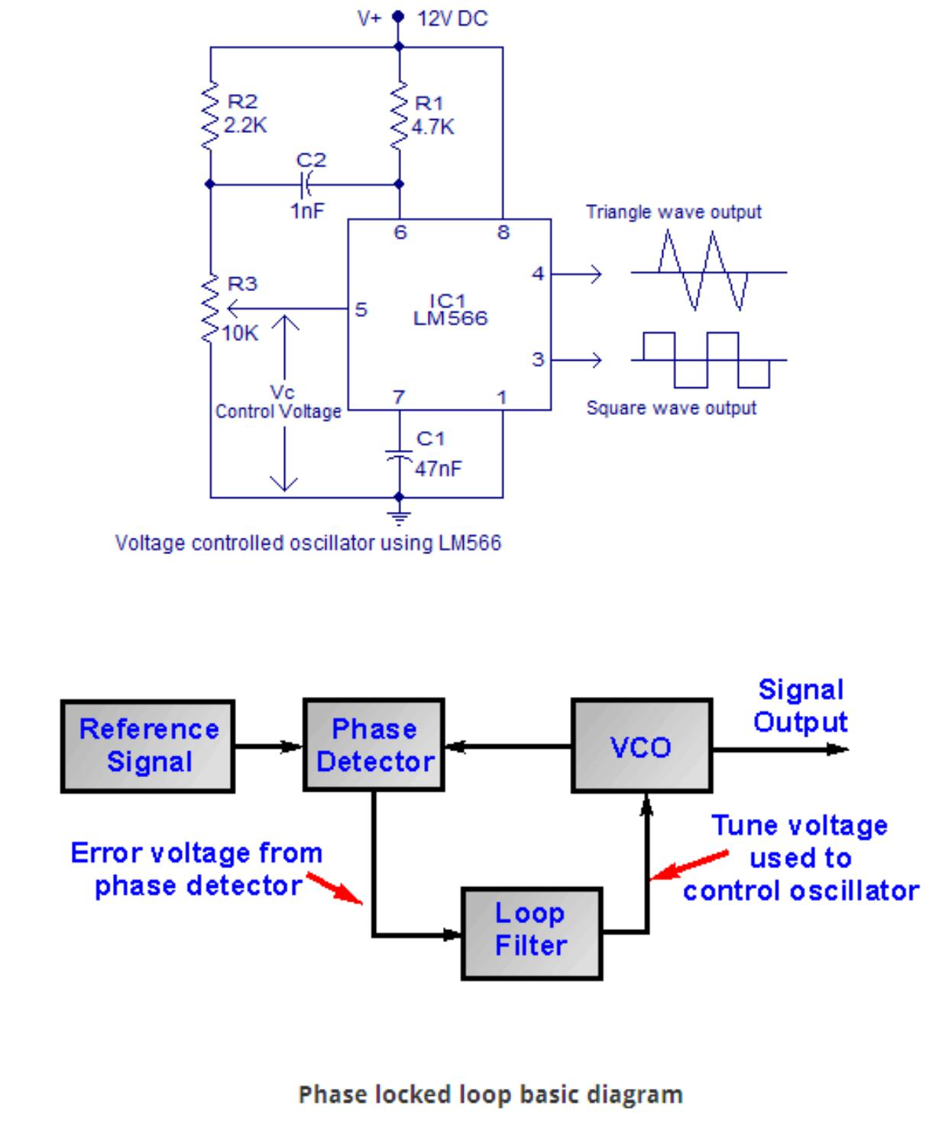

Procedure:

- Connect both Modulator and demodulator Circuit in VCO-PLL Trainer kit.

- Check the o/p as shown in circuit in one channel of CRO.

- Then vary the frequency of the input and check the point Minimum Frequency.

- Vary the frequency of the input and check the point Maximum Frequency.

- Observe change in o/p in CRO for more frequency ranges.

Experimental Data:

Locking Frequency  of the  Unknown Signal  KHz | Amplitude(P-P) of | Minimum locking | Maximum locking | Locking Range
Locking Frequency  of the  Unknown Signal  KHz | the | Frequency | Frequency | F=(Fmin-Fmax)
Locking Frequency  of the  Unknown Signal  KHz | Unknown Signal | Fmin | Fmax | KHz
Locking Frequency  of the  Unknown Signal  KHz | Volts | KHz | KHz

Plot:

- Time vs. Amplitude for Phase Locked signal.

Remarks:

8. Additional Lab Exercises to meet PO and PEO (Micro projects)

Sl. No |  | Name of the program | Related COs
1 |  | Micro project | CO1,CO2,CO3,CO4

After completion of all these exercise, the following micro-projects are assigned to the students in different groups in various domains according to their choice.

8. Sample Lab Reports

Sample Lab reports are available in Lab

9. Summary of Lab Reports (For Academic Year 2017-2018)

- Regular submission of report :
Lab reports will be evaluated according to the general and detailed marking criteria. We strongly encourage student to submit lab report within the original due date. For reports submitted by the original due date, we will endeavor to provide marks.

Analysis: On the next lab class 95% student submit a fair lab report. Submission implies that the work is original and does not copy from others student.

- Write all the required point in the report: Lab reports are the most frequent kind of document written in Lab. The goal of lab reports is to document the findings and communicate their significance. A good lab report does more than present data; it demonstrates the writer's comprehension of the concepts behind the data. Simply recording the expected and observed results is not sufficient; students should also identify how and why differences occurred, explain how they affected the experiment and show the understanding of the principles of the experiment which was designed to examine. The Title Page needs to contain the name of the experiment, the names of lab partners and the lab completion date. The title of the lab should be straight forward and informative. Experimental Procedure Page describes the experimental process in chronological order and Data & Results Page is usually dominated by calculations, tables and figures.
Analysis: Most of the student like 80% student mentions the above point in their respective lab report.
- Details of all the point described by student :
It is extremely important that to understand the need for, and format of a good report. Scientific work of any sort is useless unless its results can be communicated to others. First of all, a report should have a title. If it is in the style of a scientific article, it should have an abstract. In addition student describes the details of the points below:
1) Introduction: Include a statement of the problem to be investigated, why the work was carried out, history and theoretical background of the problem, a brief statement of the general method of approach to the problem, and expected results.

2) Methods: This section tells the reader how and with what the work was done.

3) Results: Here is the real meat of a report. In this section you should describe the important qualitative and quantitative observations is your work. Data should be tabulated and/or graphed and described. One of the common errors in report-writing is to say, "The data are plotted in Fig. 1" without saying something like, "As can be seen from the graph, absorbance at 260nm is relatively constant up to about 80°C, after which a sharp rise is noted." Be aware that tables and graphs are not self-explanatory, and must be summarized for the reader. All graphs and tables should be numbered and provided with a title. Additional information which makes the data more comprehensible should be provided as needed.

4) Discussion and conclusions: This section serves two functions. First, it provides a place where the data may be fully discussed and interpreted, and second, it allows the author to delve into the realms of speculation

Analysis: Most of the student like 70% student mentions the above points in their respective lab report.

10. Assessment Tools (Direct Tools and Indirect Tools)

CS491 (Related PO’s= PO1,PO2, PO4, PO8)
PO1 | Engineering Knowledge: Apply knowledge of mathematics, science, computer engineering fundamentals and computer science specialization to the solution of complex computing engineering problems.
PO2 | Problem Analysis: Identify, formulate, research literature and analyze complex computer engineering problems using first principles of mathematics, natural sciences and computer engineering sciences for reaching advanced real life solutions.
PO4 | Conduct investigations of complex computer problems using research-based knowledge and research methods including design of experiments, analysis and interpretation of data and synthesis of information to provide valid conclusions and design of parts, subsystems, systems and/or processes to meet specific needs.
PO8 | Individual and Team Work: Function effectively as an individual, and as a member of a team even in multidisciplinary and multi-cultural settings. Should also develop leadership capability to guide a team both in technical and administrative matters

Assessment Components and Tools : CS491 |  |  | Program Outcome
 | Tools | Details description of Tools/Methods | 1 | 2 | 4 | 8
1.Direct assessment tools | 1.1Performance of the experiment in the lab | 1.1.1 Theoretical Knowledge  1.1.2 Experimental Design  1.1.3 Procedure  1.1.4 Testing  1.1.5 Graphs and Charts  1.1.6 Analyze and Interpret Results | S | S | S | M
1.Direct assessment tools | 1.2 Lab Report/Assignment | 1.2.1 Abstract  1.2.2 Introduction  1.2.3 Materials and Methods(or Calculations)  1.2.4 Data  1.2.5 Discussion  1.2.6 Writing Style | S | S | S | M
1.Direct assessment tools | 1.3 Attendance | 1.3.1 Regularity in attending classes | - | - | M | M
1.Direct assessment tools | 1.4 Viva | 1.4.1 Viva voce on the Lab experiment | S | S | S | -
2.Indirect assessment tools | 2.1 Team Work | 2.1.1 Attending  2.1.2 Participating  2.1.3 Problem-solving  2.1.4 Contributions  2.1.5 Team Member Support  2.1.6 Attitude  2.1.7 Focus on the task | - | - | S | S
2.Indirect assessment tools | 2.2 Ethics | 2.2.1Ethical Self-Awareness  2.2.2Understanding Different Ethical Perspectives/Concepts  2.2.3Ethical Issue Recognition  2.2.4Application of Ethical Perspectives/Concepts  2.2.5Evaluation of Different Ethical Perspectives/Concepts | - | - | - | M
2.Indirect assessment tools | 2.3 Punctuality | 2.3 .1 Present in class on time  2.3.2 Completes work on time  2.3.3 Is Prepare to learn | - | - | - | M
2.Indirect assessment tools | 2.4 Micro Projects | 2.4.1 Understanding of Background Theory  2.4.2 Analytical Ability  2.4.3 Engineering Drawings  2.4.4 Following Task Guidelines and Directions  2.4.5 Effort  2.4.6 Interaction with group members  2.4.7 Correctness  2.4.8 Creativity  2.4.9 Clarity  2.4.10 Modification/Testing  2.4.11 Overall Document presentation  2.4.12 Professional Ethics  2.4.13 Knowledge Acquisition and application | S | S | S | S
 | 2.5 Faculty & staff satisfaction (semester exit) survey of students | 2.5.1 How much student have developed his/her skill | S | S | S | S

Rubrics for Performance Of The Experiment In The Lab (Related to PO1, PO2,PO4,PO8) |  |  | Weighted Evaluation of POs  (S=1 || M= 0.6 || W = 0.2)
 |  |  | PO1*1 |  | PO2*1 | PO4*1 |  | PO8*0.6
Analytics | Poor  1 pts | Good  2 pts |  | Very Good  3 pts |  |  | Excellent  4 pts
Checklist
Theoretical Knowledge | Background study is not included in the introduction. Sources are not cited. The significance of the problem is not stated. | Background study is included in the introduction. Sources are cited. The significance of the problem is stated. |  | Background study has been thoroughly conducted. Sources are appropriately cited. The significance of the problem is stated. |  |  | Background study has been thoroughly conducted using at least two original sources. Sources are all appropriately cited. The significance of the problem is clearly stated.
Experimental  Design | Does not identify, describe or control any variables. Does not evaluate the procedure and/or set up. Does not attempt to describe bias in the design. | Identifies, describes and controls some relevant variables. Evaluates the procedure and/or set up.  Attempts to describe bias in the design. |  | Identifies, describes and controls most relevant variables. Evaluates the procedure and/or set up. Clearly describes bias in the design. |  |  | Identifies, describes and controls all relevant variables. Thoughtfully evaluates the procedure and/or set up. Clearly describes bias in the design.
Procedure | Several serious errors in technique were observed during the lab procedure. Procedures were not well planned and were carried out in a disorganized fashion. | Only minor errors in technique were observed during the lab procedure. Procedures were carried out well but may have been slightly disorganized. |  | No errors in technique were observed during the lab procedure. Procedures were well-planned and were carried out in an organized fashion. |  |  | Excellent technique was used throughout the lab procedure. Procedures were well-planned and  Well-executed.
Testing | Collects data in a non reliable and/or invalid manner. Does not present data or presents data that is not relevant to the problem. Does not generate tables, charts and graphs. | Collects data in a reliable and  Valid manner. Presents data that is consistent with the problem. Generates tables, charts and graphs with data |  | Collects data in a reliable and  valid manner. Present relevant data that is consistent with the problem. Generates appropriate tables, charts and graphs with data and/or makes appropriate calculations. |  |  | Collects data in a reliable and valid manner. Presents relevant data that is consistent with the problem. Generates appropriate tables, charts and graphs with data and makes appropriate calculations.
Graphs and  Charts | Graphs or charts are not utilized where they would clearly be desirable to emphasize or clarify results. | Graphs and charts are used where appropriate. |  | Graphs and charts are used to support the description of progress where appropriate. These are labeled and organized so it is easy for the reader to follow |  |  | Graphs and charts are used to support the description of progress where appropriate. These are labeled and organized so it is easy for the reader to follow.
Analyze and Interpret  Results | Draws no conclusions or draws conclusions that are not supported by the data. Does not attempt to relate conclusions to original question. Does not describe sources of error or does not attempt to describe their effects on the data. | Draws conclusions that are partially supported by the data. Attempts to relate conclusions to original question. Describes sources of error and attempts to describe their effects on the data. |  | Draws conclusions that are supported by the data. Relates conclusions to original question. Describes several sources of error and their effects on the data. |  |  | Draws thoughtful conclusions that are supported by the data.  Relates conclusions to original question. Thoroughly describes sources of error and their effects on the data.
11. Rubrics on Direct Assessment Tools:-
Rubrics for Lab Report/Assignment (Related to PO1, PO2,PO4,PO8) |  |  |  |  | Weighted Evaluation of POs  (S=1 || M= 0.6 || W = 0.2)
 |  |  | PO1*1 |  |  | PO2*1 | PO4*1 |  | PO8*0.6
Analytics | 1  Unacceptable | 2  Acceptable |  | 3  Good |  |  |  | 4  Exemplary
Checklist
Abstract | Abstract is missing or contains no specific information. | Insufficient summary of what was done. Few specific results resented. |  | Most information is presented, but some items may be missing. |  |  |  | Summarizes goal of project and results concisely. Specific Information provided.
Introduction | Provides little or no information on why the study was done. No background information given. | Some information on the purpose of the study is given, but no background or references provided. |  | Gives general description of the purpose of the study, but some relevant background information may be missing. |  |  |  | Discusses why the study was done, and expected behaviour. Presents background information, with references, relevant to the study.
Materials and  Methods  (or Calculations) | Most key pieces of information are missing. References to methods aren’t provided. | Methods may be insufficiently explained, or may be described in too much detail. Large gaps in information. |  | Methods generally are well described or referenced, but some items may be insufficiently de-  scribed or left out. |  |  |  | Concisely describes methods or gives references to sources of methods used. Assumptions well described.
Data | Raw data are missing. Reported counts are calculated incorrectly. No text to present the results. No figures or alternative methods of data presentation. | Insufficient data are presented, or several errors in calculations are present and distract from the results. Text and/or figures may be missing. |  | Data tables are presented, but some calculations may be in error, some data may be missing, or figures may be insufficient. |  |  |  | Data are presented in one or more tables, with accompanying text to introduce the tables. Figures are used to illustrate key comparisons or trends. No errors in calculations.
Discussion | Reader can gain very little information about why the project was done and what theresults may mean. No reference to other studies. | Limited discussion of results and conclusions. Little or no reference to published standards or other reports. |  | Generally clear discussion of results and conclusions, but may miss some points. Some use of references and published standards. |  |  |  | Clearly discusses what results mean and what conclusions may be drawn from them. Cites published standards or other related reports.
Writing Style | Errors are frequent and distracting, so that it is hard to determine meaning. No logical connection of ideas or flow of sentences. Journal paper style is not followed. | Writing has some errors but these are not too distracting. Voice may change randomly. Flow is not consistently smooth; appears disjointed. Style is not followed consistently. |  | Writing is generally error-free and in active voice. Sentence flow is generally smooth and logical.  Standard style is generally followed. Minor errors may be present. |  |  |  | Writing is free of errors in grammar, punctuation, capitalization, and spelling. Uses active voice. Flows smoothly.  Logical connection of points. Follows standard organizational style.

Gradation rubrics for Attendance (Related to PO4 & PO8) |  |  |  |  | Weighted Evaluation of POs  (S=1 || M= 0.6 || W = 0.2)
 |  |  | PO4*0.6 |  |  |  | PO8*0.6
ATTENDANCE | Excellent(4)  Student was present for every class. | Good(3)  Student was absent for 1 to 2 classes but provided instructor with a reasonable excuse. |  | Moderate (2)  Student was absent for more than 2 classes and/or did not provide instructor with reasonable excuses. |  | Poor(1)  Student was absent for more than 5 classes and/or did not provide instructor with reasonable excuses.

Grading rubrics for the VIVA (Related to PO1,PO2,PO4) |  |  | Weighted Evaluation of POs  (S=1 || M= 0.6 || W = 0.2)
 |  |  | PO1*1 |  | PO2*1 | PO4*1
Assessment Tools

Grading Criteria

Method/Element | Poor  (Score – 1) | Developing  (Score – 2) |  | Good  (Score – 3) |  |  | Excellent  (Score – 4)
Viva | Poor subject knowledge;  can’t understand simple questions | Moderate subject knowledge, some good explanation; unable to answer harder questions |  | Good subject knowledge, mostly good explanation; attempts some harder  questions |  |  | Sound subject knowledge, precise  explanations; correctly answers most of the harder questions

11. Rubrics on Indirect Assessment Tools:
Rubrics for Team Work (Related to PO4,PO8) |  |  |  | Weighted Evaluation of POs  (S=1 || M= 0.6 || W = 0.2)
 |  |  |  | PO4*1 |  | PO8*1
Analytics | Exceptional  (4) | Acceptable  (3) | Amateur  (2) |  | Unsatisfactory  (1)
Checklist
Attending | Most, if not all, group members attend all classes. | Most members are present at most classes. When members have to be absent, they inform the team. | Some of the members frequently miss classes and do not inform the team. |  | Many members frequently miss classes and do not inform the team.
Participating | There is a clear definition of tasks to be accomplished, anticipating future needs. All members take an active role. Tasks are defined by the group and assigned to all members. The team engages in follow-up activities to monitor progress. | Tasks are defined informally, and most but not all members understand them. Most members contribute. Follow-up is sporadic. | Tasks are defined, and few members participate actively.  There is no follow-up. |  | Tasks are not defined, and few members participate actively.  There is no follow-up.
Problem-solving | Actively looks for and suggests solutions to problems. | Refines solutions suggested by others. | Does not suggest or refine solutions, but is willing to try out solutions suggested by others. |  | Does not try to solve problems or help others solve problems. Lets others do the work.
Contributions | Routinely provides useful ideas when participating in the group and in classroom discussion. A leader who contributes a lot of effort. | Usually provides useful ideas when participating in the group and in classroom discussion. A strong group member who tries hard. | Sometimes provides useful ideas when participating in the group and in classroom discussion. A satisfactory group member who does what is required. |  | Rarely provides useful ideas when participating in the group and in classroom discussion. May refuse to participate.
Team Member  Support | Every team member is treated with respect. All members listen to all  ideas. The work of each person is acknowledged. Members feel free to seek assistance from others or to ask questions. | There is a general atmosphere of respect for team members, but some members may not be heard as much as others. Acknowledging others’ work is serendipitous rather than planned. Some members may not feel free to turn to others for help. | There is a general atmosphere of respect for team members but individualistic rather than cooperative and supportive. |  | The team atmosphere is competitive and individualistic rather than cooperative and supportive.
Attitude | Is never publicly critical of the project or the work of others. Always has a positive attitude about the task(s). | Is rarely publicly critical of the project or the work of others. Often has a positive attitude about the task(s). | Is occasionally publicly critical of the project or the work of other members of the group. Usually has a positive attitude about the task(s). |  | Is often publicly critical of the project or the work of other members of the group. Is often negative about the task(s).
Focus on the  task | Consistently stays focused on the task and what needs to be done. Very self-directed. | Focuses on the task and what needs to be done most of the time. Other group members can count on this person. | Focuses on the task and what needs to be done some of the time. Other group members must sometimes nag, prod, and remind to keep this person on task. |  | Rarely focuses on the task and what needs to be done. Lets others do the work.

Rubrics on Ethics (Related to PO8) |  |  | Weighted Evaluation of POs  (S=1 || M= 0.6 || W = 0.2)
 |  |  |  | PO8*0.6
Analytics | Excellent  4 pts | Very-Good  3 pts |  |  | Satisfactory  2pts | Poor  1pt
Checklist
Ethical Self-Awareness | Student discusses in detail/analyzes both core  beliefs and the origins of the core beliefs and  discussion has greater depth and clarity. | Student discusses in detail/analyzes both core  beliefs and the origins of the core beliefs. |  |  | Student states both core beliefs and the origins  of the core beliefs. | Student states either their core beliefs or  articulates the origins of the core beliefs but  not both.
Understanding Different Ethical  Perspectives/Concepts | Student names the theory or theories, can  present the gist of said theory or theories, and  accurately explains the details of the theory or  theories used. | Student can name the major theory or theories  she/he uses, can present the gist of said  theory or theories, and attempts to explain the  details of the theory or theories used, but has  some inaccuracies. |  |  | Student can name the major theory she/he  uses, and is only able to present the gist of the  named theory. | Student only names the major theory she/he  uses.
Ethical Issue Recognition | Student can recognize ethical issues when  presented in a complex, multilayered (gray)  context AND can recognize cross-  relationships among the issues. | Student can recognize ethical issues when  issues are presented in a complex, multilayered  (gray) context OR can grasp cross-  relationships among the issues. |  |  | Student can recognize basic and obvious  ethical issues and grasp (incompletely) the  complexities or interrelationships among the  issues. | Student can recognize basic and obvious  ethical issues but fails to grasp complexity or  inter relationships.
Application of Ethical  Perspectives/Concepts | Student can independently apply ethical  perspectives/concepts to an ethical question,  accurately, and is able to consider full  implications of the application. | Student can independently (to a new example)  apply ethical perspectives/concepts to an  ethical question, accurately, but does not  consider the specific implications of the  application. |  |  | Student can apply ethical  perspectives/concepts to an ethical question,  independently (to a new example) and the  application is inaccurate. | Student can apply ethical  perspectives/concepts to an ethical question  with support (using examples, in a class, in a  group, or a fixed-choice setting) but is unable  to apply ethical perspectives/concepts  independently (to a new example.).
Evaluation of Different Ethical  Perspectives/Concepts | Student states a position and can state the  objections to, assumptions and implications of  and can reasonably defend against the  objections to, assumptions and implications of  different ethical perspectives/concepts, and  the student's defense is adequate and effective. | Student states a position and can state the  objections to, assumptions and implications  of, and respond to the objections to,  assumptions and implications of different  ethical perspectives/concepts, but the  student's response is inadequate. |  |  | Student states a position and can state the  objections to, assumptions and implications of  different ethical perspectives/concepts but  does not respond to them (and ultimately  objections, assumptions, and implications are  compartmentalized by student and do not  affect student's position.) | Student states a position but cannot state the  objections to and assumptions and limitations  of the different perspectives/concepts.

Grading Rubric for Punctuality (Related to PO8) |  |  | Weighted Evaluation of POs  (S=1 || M= 0.6 || W = 0.2)
Analytics -> |  |  | PO8*0.6
Checklist / Assessment tools | Consistently exceeds expectations (4) | consistently meets expectations (3) | Inconsistently meets expectations (2) | Does not meet expectations (1)
Present in class on time  (Punctuality) | Student was always on time for class and often arrived early. | Student was usually on time or early for class (was tardy to class only 1 to 4 times). | Student was rarely on time or early (was tardy to class 5 or more times). | Student was never on time or early (was tardy to class 5 or more times).
Completes work  (Punctuality Neatness  Makes up work) | Is punctual or early turning in assignments and goes beyond the stated requirements relative to neatness and adherence to conventions. | Is punctual in turning in assignments and meets the stated requirements relative to neatness and adherence to conventions. | Is not punctual in turning in assignments and does not meets the stated requirements relative to neatness and adherence to conventions. | Is not punctual in turning in assignments and does not meets the stated requirements relative to neatness and adherence to conventions.
Is prepared to learn  (On time  Has materials) | Always in class on time. Brings needed materials to class and is always ready to work. | Very few tardier. Almost always brings needed materials to class and is ready to work. | Some tardier. Usually Brings needed materials but sometimes needs reminders and redirection. | Frequent tardier. Often forgets materials and is rarely ready to get to work. often does not accept redirection.

Rubrics for Micro Project (Related to PO1,PO2,PO4,PO8) |  |  | Weighted Evaluation of POs  (S=1 || M= 0.6 || W = 0.2)
 |  |  | PO1*1 | PO2*1 |  | PO4*1 |  | PO8*1
Analytics | Excellent  4 pts | Very Good  3 pts |  |  | Satisfactory  2pts |  | Poor  1pt
Checklist
Understanding of Background Theory | Can develop on and combine the course material | Can apply class material on the problem |  |  | Show some understanding of the background topics and theory |  | Do not show understanding
Analytical Ability | Execution of methodology is correct | The methodology used is mathematical and sound |  |  | Shows understanding of the problem |  | Does not show understanding of the problem
Engineering Drawings | Easy to follow ‰ Used standard diagram shapes | Did not use abstraction to present the material at different levels of detail |  |  | Hard to follow ‰ Incomplete ‰ Inconsistent use of symbols |  | None included ‰ Incorrect
Following Task Guidelines and Directions | Student has completed all requirements of project on time .Followed all directions | Forgot something or added to , but followed most of the directions of the project |  |  | Late work or missing project was a problem . And /or followed very few directions |  | Did not follow directions
Effort | Project’s appearance show a great deal of time and effort spent. | Project’ s appearance show a considerable amount of time and effort spent |  |  | Project’s appearance shows satisfactory amount of time and effort spent |  | Project’s appearance suggests more time and effort needed to be spent.
Interaction with group members | All group members worked cooperatively with excellent team effort to achieve the goals of the challenge. | Most group members worked cooperatively with strong effort to achieve goals of the challenge |  |  | Some group members worked cooperatively with good effort to achieve goals of the challenge |  | Some group members worked cooperatively with minor effort to achieve goals of the challenge
Correctness | Very good and impressive suggestion | Correct and typically understand the problem |  |  | Correct but rare understand the problem |  | Do not show the correctness
Creativity | Use a researched solution  Totally solution | Use a researched solution |  |  | Use the solution existing in the book |  | Use the solution existing in the book
Clarity | Clear language, no grammar mistakes | Clear language, some grammar mistakes |  |  | A lot of language errors, concepts are not clearly expressed |  | Unintelligible tex
Modification/Testing | Clear evidence of testing , and refinements made on project | Some evidence of testing and refinements made on project |  |  | Little evidence of testing and refinements made on project |  | No evidence of testing and refinements made on project
Overall Document presentation | All tables and figures include captions and are referred to in the text  No errors detected in the use of template | Special case formatting applied manually rather than through the use of styles  Only minor errors detected |  |  | Inconsistent or inappropriate application of template styles |  | Template not used ‰ Front matter incorrect
Professional Ethics | Attend lab on time.  Submit report on a same day practical work done. | Attend lab within 30 minutes class start.  Submit report a day after |  |  | Attend lab after 1 hour class start.  Submit report after a week. |  | Absent class.  Didn’t submit report.
Knowledge Acquisition and application | Proficient in demonstrating knowledge | Sufficiency in demonstrating knowledge in field of study |  |  | Borderline knowledge through research & inquiry |  | Deficiency or lack of knowledge in the field of study

Grading rubrics for the Faculty & staff satisfaction (semester exit) survey of students (Related to PO1,PO2,PO4,PO8) |  |  |  |  | Weighted Evaluation of POs  (S=1 || M= 0.6 || W = 0.2)
 |  |  | PO1*1 | PO2*1 |  |  | PO4*1 | PO8*1
Assessment Tools

Grading Criteria

Method/Element | Poor  (Score – 1) | Developing  (Score – 2) |  |  |  | Good  (Score – 3) |  |  | Excellent  (Score – 4)
Faculty & staff satisfaction (semester exit) survey of students | Overall unimpressive | Encouraging effort |  |  |  | Impressive performance |  |  | Highly impressive – near perfect

12. List of Micro projects:-

Students chose the Micro project Topics. The list is being given in Section 13.

13. Details of Micro projects of previous years (Last 2 years)

Allotment details

For Academic session January, 2015 - June, 2015: -

Micro Project: 1: Voltage Controlled Oscilloscope Using LM-565 chip and Record the locking Frequency range (to view the change in shape).

Micro Project: 2: Time Division Multiplexing and Reconstruct the signal.

For Academic session January, 2015 - June, 2015: -

Details of Micro projects of previous years (Last 3 years)

Allotment details:

CSE 2nd yr, Sec - A & SEC - B

Group no. | Name | Roll |  | PROJECT TOPIC
Section A Group 1
Group1 | - ARINDAM KUNDU | CSE2013/01 |  | Micro Project -1/2
Group1 | - PROLAY KUMAR SAHA | CSE2013/02 |  | Micro Project -1/2
Group1 | - SAIKAT MONDAL | CSE2013/03 |  | Micro Project -1/2
Group1 | - SOHAM ADHIKARI | CSE2013/04 |  | Micro Project -1/2
Group1 | - PAYEL SAMANTA | CSE2013/05 |  | Micro Project -1/2
GROUP 2 | - ARGHYA BHATTACHARYYA | CSE2013/06 |  | Micro Project -1/2
GROUP 2 | - SOHAM DEV | CSE2013/07 |  | Micro Project -1/2
GROUP 2 | - SHROUTI GANGOPADHYAY | CSE2013/08 |  | Micro Project -1/2
GROUP 2 | - MEGHA SARDAR | CSE2013/09 |  | Micro Project -1/2
GROUP 2 | - MOUMITA BASAK | CSE2013/10 |  | Micro Project -1/2
GROUP 3 | - ABHRADITA GHOSH | CSE2013/11
GROUP 3 | - PAYAL GHOSH | CSE2013/12
GROUP 3 | - SUDESHNA ADHIKARY | CSE2013/13
GROUP 3 | - PAULAMI BAKSHI | CSE2013/14 |  | Micro Project -1/2
GROUP 3 | - RASHID HASHMI | CSE2013/15 |  | Micro Project -1/2
GROUP 4 | - GOURAB SAMANTA | CSE2013/18
GROUP 4 | - SUMAN KUNDU | CSE2013/19
GROUP 4 | - SAYAN MUKHERJEE | CSE2013/20
GROUP 4 | - BISWAJIT ORAON | CSE2013/21 |  | Micro Project -1/2
GROUP 4 | - ANTRA VERMA | CSE2013/22 |  | Micro Project -1/2
GROUP 4 | - DEVMALA MUKHERJEE | CSE2013/23 |  | Micro Project -1/2
GROUP 5 | - PRITHA BAG | CSE2013/26 |  | Micro Project -1/2
GROUP 5 | - SUBHASIS CHAKRABORTY | CSE2013/27 |  | Micro Project -1/2
GROUP 5 | - DIPTARGHYA SENSARMA | CSE2013/28 |  | Micro Project -1/2
GROUP 5 | - AVIJIT DAS | CSE2013/29 |  | Micro Project -1/2
GROUP 5 | - PARNAB SANYAL | CSE2013/24
GROUP 5 | - SAYAN KUMAR DAS | CSE2013/25
Section A Group 2
GROUP 1 | - NIRUPAMA SHAW | CSE2013/31 |  | Micro Project -1/2
GROUP 1 | - RITWIKA PALIT | CSE2013/32 |  | Micro Project -1/2
GROUP 1 | - SOMA MAITY | CSE2013/ 33 |  | Micro Project -1/2
GROUP 1 | - SHUVAM NASKAR | CSE2013/34 |  | Micro Project -1/2
GROUP 1 | - SOUMEN DAS | CSE2013/35 |  | Micro Project -1/2
GROUP 2 | - RAKESH KUMAR HALDER | CSE2013/36 |  | Micro Project -1/2
GROUP 2 | - BIKASH SINGH | CSE2013/37 |  | Micro Project -1/2
GROUP 2 | - SHUBHAM KUMAR KARNA | CSE2013/38 |  | Micro Project -1/2
GROUP 2 | - SHANSHANK SHANKAR JHA | CSE2013/39 |  | Micro Project -1/2
GROUP 2 | - SWARUP GURIA | CSE2013/40 |  | Micro Project -1/2
GROUP 3 | - DHEERAJ SINGH | CSE2013/41 |  | Micro Project -1/2
GROUP 3 | - INDRANI GANGULY | CSE2013/42 |  | Micro Project -1/2
GROUP 3 | - RAJIB MONDAL | CSE2013/43 |  | Micro Project -1/2
GROUP 3 | - ANURAN MONDAL | CSE2013/44 |  | Micro Project -1/2
GROUP 3 | - NILOY BOSE | CSE2013/45 |  | Micro Project -1/2
GROUP 4 | - NILOY BOSE | CSE2013/46 |  | Micro Project -1/2
GROUP 4 | - ANIK BISWAS | CSE2013/47 |  | Micro Project -1/2
GROUP 4 | - ROHIT KUMAR SHAW | CSE2013/48 |  | Micro Project -1/2
GROUP 4 | - NIKHAT PARVEEN | CSE2013/49 |  | Micro Project -1/2
GROUP 4 | - SOURAV PAUL | CSE2013/50 |  | Micro Project -1/2
GROUP 5 | - PALLAB SADHUKAN | CSE2013/51 |  | Micro Project -1/2
GROUP 5 | - DIPAYAN MONDAL | CSE2013/53 |  | Micro Project -1/2
GROUP 5 | - AMARTYA GHOSH | CSE2013/54 |  | Micro Project -1/2
GROUP 5 | - SOURAV BARAI | CSE2013/55 |  | Micro Project -1/2
GROUP 6 | - ABHISHEK KUMAR | CSE2013/56 |  | Micro Project -1/2
GROUP 6 | - SANDIPAN SARKAR | CSE2013/57 |  | Micro Project -1/2
GROUP 6 | - ASHISH ABHINAV | CSE2013/58 |  | Micro Project -1/2
Section B Group 1
GROUP 1 | - ANIT CHAKRABORTY | CSE2013/061 |  | Micro Project -1/2
GROUP 1 | - SHREYA DASGUPTA | CSE2013/062 |  | Micro Project -1/2
GROUP 1 | - PUNAM KARJEE | CSE2013/064 |  | Micro Project -1/2
GROUP 1 | - SOUDEEP BHATTACHARJEE | CSE2013/065 |  | Micro Project -1/2
GROUP 1 | - ROUNAQ CHAUDHURI | CSE2013/066 |  | Micro Project -1/2
GROUP 2 | - ANWESHA PAUL | CSE2013/068 |  | Micro Project -1/2
GROUP 2 | - SATADAL CHAKRAVARTY | CSE2013/070 |  | Micro Project -1/2
GROUP 2 | - TANUSHREE SAHA | CSE2013/071 |  | Micro Project -1/2
GROUP 2 | - DIPAK GUPTA | CSE2013/072 |  | Micro Project -1/2
GROUP 2 | - AMRITA SAHA | CSE2013/074 |  | Micro Project -1/2
GROUP 3 | - DEEKSHA SINHA | CSE2013/075 |  | Micro Project -1/2
GROUP 3 | - SHUBHAM KUMAR | CSE2013/076 |  | Micro Project -1/2
GROUP 3 | - SHUBHAM SNEH | CSE2013/077 |  | Micro Project -1/2
GROUP 3 | - PROJJAL SAHA | CSE2013/078 |  | Micro Project -1/2
GROUP 3 | - RISHAV SAIGAL | CSE2013/079 |  | Micro Project -1/2
GROUP 3 | - SHASHANK SHEKHAR | CSE2013/080 |  | Micro Project -1/2
GROUP 4 | - RANJAN KUMAR | CSE2013/081 |  | Micro Project -1/2
GROUP 4 | - SNEHA GUPTA | CSE2013/082 |  | Micro Project -1/2
GROUP 4 | - MANISH PASI | CSE2013/083 |  | Micro Project -1/2
GROUP 4 | - MEGHDEEP BISWAS | CSE2013/084 |  | Micro Project -1/2
GROUP 4 | - SOUTAM DUTTA | CSE2013/085 |  | Micro Project -1/2
GROUP 5 | - AVINASH SINGH CHAUHAN | CSE2013/086 |  | Micro Project -1/2
GROUP 5 | - GURUPADA CHAKRABORTY | CSE2013/087 |  | Micro Project -1/2
GROUP 5 | - SIKIM CHAKRABORTY | CSE2013/088 |  | Micro Project -1/2
GROUP 5 | - FAIZAAN AHMED KHAN | CSE2013/089 |  | Micro Project -1/2
GROUP 5 | - RAKESH KUMAR SHAW | CSE2013/090 |  | Micro Project -1/2
Sec B Group 2
GROUP 6 | - SANJEEV GUPTA | CSE2013/091 | Micro Project -1/2
GROUP 6 | - ADRESHA GHOSH | CSE2013/092
GROUP 6 | - AYUSHI GHOSH | CSE2013/093
GROUP 6 | - DEBAYAN MITRA | CSE2013/094
GROUP 6 | - ARNAB DAS | CSE2013/095
GROUP 7 | - SUDIP KUMAR MONDAL | CSE2014/L01 | Micro Project -1/2
GROUP 7 | - KOUSHIK KHAN | CSE2014/L02
GROUP 7 | - SUMAN DEBNATH | CSE2014/L03
GROUP 7 | - SANJUKTA SAHA | CSE2014/L04
GROUP 7 | - MADHURIMA BASU | CSE2014/L05
GROUP 8 | - SOUNAK ROY | CSE2014/L06 | Micro Project -1/2
GROUP 8 | - SWATI ROY | CSE2014/L07
GROUP 8 | - PUJA DINDA | CSE2014/L08
GROUP 8 | - DIPANWITA PODDAR | CSE2014/L09
GROUP 8 | - DIBYANDA DAS | CSE2014/L10
GROUP 9 | 1.SRIJIT CHOWDHURY | CSE2014/L11 | Micro Project -1/2
GROUP 9 | 2. AMITA PATRA | CSE2014/L12
GROUP 9 | 3. UDAYAN PODDAR | CSE2014/L13
GROUP 9 | 4.SUVRADIP DAS | CSE2014/L14
GROUP 9 | 5.SHUBHAYAN SAHA | CSE2014/B01
GROUP 10 | 1.ABHIPSA CHAKRABORTY | CSE2014/B02 | Micro Project -1/2
 | 2.GIRI SWAGARIKA JAHARLAL | CSE2014/B03
 | 3.PALLABI CHOUDHURY | CSE2014/B04
 | 4.SHREYA DAS | CSE2014/B05
 | 5.AHINDRILA DUTTA | CSE2014/B06

For Academic session January, 2016 - June 2016: -

CSE 2nd Yr, Sec-A, Grp-1

Sl .no. | Team members | Roll no. |  | Group leader | Micro project name
1. | Riya Roy  Swagata Kundu  Ashwini Dharewa  Orchi Saha | CSE/2014/001  CSE/2014/005  CSE/2014/013  CSE/2014/028 |  | Ashwini Dherewa | Portable charger
2. | Dhrubajoyti Bhuiya  Supriti Paul  Sana khan Bano | CSE/2014/003  CSE/2014/029  CSE/2014/024 |  | Dhrubajoyti Bhuiya | Clap on Clap off switch
3. | Anasuya Majumder  Sanchari Das  Urmi Halder  Sangita Jana | CSE/2014/021  CSE/2014/002  CSE/2014/007  CSE/2014/025 |  | Anasuya Majumder | Rain detector
4. | Kishan Ojha  Pritam Bhattacharjee  Harshit Dhwan  Disha Roy | CSE/2014/014  CSE/2014/018  CSE/2014/026  CSE/2014/027 |  | Disha Roy | FM transmitter
5. | Bidit Roy  Sourik Barman  Tonmoy Patra  Jhilik Guha | CSE/2014/012  CSE/2014/006  CSE/2014/015  CSE/2014/017 |  | Bidit Roy | Metal detector.
6. | Biswadeep Roy  Angshuman Midya  Swarup Banerjee  Sayan Pal | CSE/2014/016  CSE/2014/022  CSE/2014/023  CSE/2014/030 |  | Swarup Banerjee | Dark Sensor
7. | Hillol Ghosh  Arkadipta Biswas  Tithankar Ghosh  Subham Misra | CSE/2014/009  CSE/2014/010  CSE/2014/011  CSE/2014/008 |  | Tithankar Ghosh | Wireless mobile charger
8. | Sourjali Das  Surajit Das  Auropriya Sinha | CSE/2014/019  CSE/2014/004  CSE/2014/020 |  | Surajit Das | Transmission of signal through optical fibre: a brief study
9. | Alfaiz Ullah  Tanmoy Saha  Arnab Mondal | CSE/2014/039  CSE/2014/040  CSE/2014/043 |  | Alfaiz Ullah
10. | Kuheli Pratihar  Rituparna Das  Sarmistha Bhattacharya  Tanusree roy | CSE/2014/051  CSE/2014/058  CSE/2014/036  CSE/2014/035 |  | Kuheli Pratihar | Electronic eye as Door alarm
11. | Arkadeb Saha  Sourish Sengupta  Koustav Biswas | CSE/2014/048  CSE/2014/049  CSE/2014/032 |  | Arkadeb Saha | IR Remote tester Circuit
12. | Anasuya Dhara  Shubham Das  Debkrishna Roy | CSE/2014/041  CSE/2014/054  CSE/2014/052 |  | Debkrishna Roy | AM Radio Transmitter
13. | Rajarshi Barui  Sanchari Das  Subhamoy Sarkar | CSE/2014/047  CSE/2014/034  CSE/2014/038 |  | Rajarshi Barui | Sound amplifier
14. | Arpan Pathak  Arpan Roy  Aritra Das  Arindam Prasad | CSE/2014/044  CSE/2014/053  CSE/2014/057  CSE/2014/056 |  | Arpan Pathak | RF Remote Based Home Automation System(very good)
15. | Arkav Paul  Sohan Dutta  Arnab Choudhury | CSE/2014/046  CSE/2014/042  CSE/2014/055 |  | Arnab Choudhury | Mobile phone detector
16. | Tirthamouli Baidya  Subhadhriti Maikap  Pranit Bose | CSE/2014/045  CSE/2014/059  CSE/2014/060 |  | Subhadhriti Maikap
Group No. | Leader |  |  |  | Project Topic
Grp1 | Abhimanshu  Srivastava  CSE/2014/063 | Subham  Kothari  CSE/2014/065 | Satyam  Garodia  CSE/2014/080 | Richa  Sinha  CSE/2014/083 | Sound  Communication
Grp2 | Amit  Chandra  CSE/2014/075 | Sourin  Ghatak  CSE/2014/062 | Sachin  Kumar  CSE/2014/086 | MD Aquib  Jawed  CSE/2014/088 | Anti-Theft Alarm
Grp3 | Chayan  Maity  CSE/2014/079 | Shalu  Bhagat  CSE/2014/064 | Tamalika  Halder  CSE/2014/078 | Dipayita  Basu  CSE/2014/089 | Mobile Phone  Activity  Detector
Grp4 | Soumyabrata  Maity  CSE/2014/066 | Kumajit  Ghosh  CSE/2014/070 | Subham  Karmakar  CSE/2014/082 | Sudipta  Ray  CSE/2014/085 | DC Motor  Control  Using PWM
Grp5 | Mehul  Sengupta  CSE/2014/084 | Mudassar  Uddin  CSE/2014/076 | Sagar  Mukherjee  CSE/2014/077 | Nishan Singh  Shekhon  CSE/2014/068 | AM Radio/Opamp tester
Grp6 | SK MD  Sohail  CSE/2014/087 | Saikat  Debnath  CSE/2014/071 | Debjit  Dutta  CSE/2014/072 | Raunak  Kar  CSE/2014/067 | TV Remote  Controller  Jammer
Grp7 | Rohit  Jaiswal  CSE/2014/061 | Debanjan  Biswas  CSE/2014/074 | Souvik  Mondal  CSE/2014/081 | Soumya  Pramanik  CSE/2014/090 | Portable  Battery Charger

Award List:

For Academic session January, 2016 - June, 2016:

Sl. No | Team Member’s Name | Team Member’s Roll No. | Project Topic | Position Held
1. | Anasuya Dhara | CSE/2014/041 | AM Radio Transmitter | 1st
2. | Shubham Das | CSE/2014/054 | AM Radio Transmitter | 1st
3. | Debkrishna Roy | CSE/2014/052 | AM Radio Transmitter | 1st

Sl. No | Team Member’s Name | Team Member’s Roll No. | Project Topic | Position Held
1. | Soumyabrata Maity | CSE/2014/066 | DC Motor Control Using PWM | 3rd
2. | Kumarjit Ghosh | CSE/2014/070 | DC Motor Control Using PWM | 3rd
3. | Shubham Karmakar | CSE/2014/082 | DC Motor Control Using PWM | 3rd
4. | Sudipta Ray | CSE/2014/085 | DC Motor Control Using PWM | 3rd

Sl. No | Team Member’s Name | Team Member’s Roll No. | Project Topic | Position Held
1. | Arpan Pathak | CSE/2014/044 | RF Remote Based Home Automation System(very good) | 2nd
2. | Arpan Roy | CSE/2014/053 | RF Remote Based Home Automation System(very good) | 2nd
3. | Aritra Das | CSE/2014/057 | RF Remote Based Home Automation System(very good) | 2nd
4. | Arindam Prasad | CSE/2014/056 | RF Remote Based Home Automation System(very good) | 2nd

For Academic session January, 2017 - June 2017: -

Group no. | Name | Roll | PROJECT TOPIC
Section A Group 1
Group1 | ANIRUDHH SADHUKAN (GL) | CSE2015/004 | WIRELESS AUDIO TRANSMISSION USING FM TECHNIQUE
Group1 | DEVPRATIM DAS | CSE2015/003 | WIRELESS AUDIO TRANSMISSION USING FM TECHNIQUE
Group1 | SOUMYADEEP BISWAS | CSE2015/010 | WIRELESS AUDIO TRANSMISSION USING FM TECHNIQUE
Group1 | SUVADITYA SUR | CSE2015/028 | WIRELESS AUDIO TRANSMISSION USING FM TECHNIQUE
GROUP 2 | PRASUN MAJHI | CSE2015/005 | LIGHT DETECTOR WITH 555 TIMER AND LDR
GROUP 2 | BIDISHA BANERJEE | CSE2015/008 | LIGHT DETECTOR WITH 555 TIMER AND LDR
GROUP 2 | ARANYA AKASH MONDAL | CSE2015/009 | LIGHT DETECTOR WITH 555 TIMER AND LDR
GROUP 2 | RANA MONDAL (GL) | CSE2015/015 | LIGHT DETECTOR WITH 555 TIMER AND LDR
GROUP 3 | ANISHA ROY | CSE2015/019 | MOBILE  SIGNAL DETECTOR
GROUP 3 | ARPITA BASAK | CSE2015/023 | MOBILE  SIGNAL DETECTOR
GROUP 3 | ZENITH ROY (GL) | CSE2015/025 | MOBILE  SIGNAL DETECTOR
GROUP 3 | ARNAB MONDAL | CSE2015/029 | MOBILE  SIGNAL DETECTOR
GROUP 4 | APU SARKAR (GL) | CSE2015/002 | WIRELESS COMMUNICATION USING RADIO FREQUENCY
GROUP 4 | KSHITIZ RAJ | CSE2015/007 | WIRELESS COMMUNICATION USING RADIO FREQUENCY
GROUP 4 | ASTHA MISHRA | CSE2015/011 | WIRELESS COMMUNICATION USING RADIO FREQUENCY
GROUP 4 | RAVI PRAKASH | CSE2015/022 | WIRELESS COMMUNICATION USING RADIO FREQUENCY
GROUP 5 | ASHISH KUMAR RAI | CSE2015/014 | CELL PHONE  DETECTOR
GROUP 5 | SOUVIK DAS | CSE2015/017 | CELL PHONE  DETECTOR
GROUP 5 | SOUMAJIT BOSE (GL) | CSE2015/018 | CELL PHONE  DETECTOR
GROUP 5 | JEET MUKHERJEE | CSE2015/027 | CELL PHONE  DETECTOR
GROUP 6 | PORTRET MALLICK | CSE2015/012 | ARDUINO BASED HEART BEAT MONITORING
GROUP 6 | ARKADEEP DEY (GL) | CSE2015/030 | ARDUINO BASED HEART BEAT MONITORING
GROUP 6 | SWARNA KAMAL MITRA | CSE2015/026 | ARDUINO BASED HEART BEAT MONITORING
GROUP 6 | KAUSTAV MONDAL | CSE2015/016 | ARDUINO BASED HEART BEAT MONITORING
GROUP 7 | SUMITA BASU (GL) | CSE2015/001 | WIRELESS DOORBELL WITH IR PROXIMITY SENSOR
GROUP 7 | AVIK SARKAR | CSE2015/024 | WIRELESS DOORBELL WITH IR PROXIMITY SENSOR
GROUP 7 | SHATABHISA DEY | CSE2015/006 | WIRELESS DOORBELL WITH IR PROXIMITY SENSOR
GROUP 8 | ARIJIT ROY | CSE2015/013 | NA
GROUP 8 | SATYAKI DAS (GL) | CSE2015/020 | NA
GROUP 8 | SOUMYADEEP MONDAL | CSE2015/021 | NA
GROUP 9 | SOURAV MONDAL | CSE2015/034 | PROPELLER CLOCK
GROUP 9 | SOUVIK PAL | CSE2015/040 | PROPELLER CLOCK
GROUP 9 | SOURAV SADHU | CSE2015/046 | PROPELLER CLOCK
GROUP 9 | SAIKAT DEBNATH (GL) | CSE2015/041 | PROPELLER CLOCK
GROUP 10 | CHANDRADAYA CHAKRABORTY | CSE2015/035 | LOCKER SECURITY SYSTEM
GROUP 10 | S TUSHAR | CSE2015/042 | LOCKER SECURITY SYSTEM
GROUP 10 | AKSHAY KUMAR DAS | CSE2015/045 | LOCKER SECURITY SYSTEM
GROUP 10 | SOMSUBHRO MAITY (GL) | CSE2015/059 | LOCKER SECURITY SYSTEM
GROUP 11 | ANKITA BHARTI (GL) | CSE2015/055 | TRAFFIC LIGHT SIGNAL USING 555 TIMER AND 4017B IC.
GROUP 11 | RAKHI KUMARI | CSE2015/056 | TRAFFIC LIGHT SIGNAL USING 555 TIMER AND 4017B IC.
GROUP 11 | PREETI SAGAR | CSE2015/057 | TRAFFIC LIGHT SIGNAL USING 555 TIMER AND 4017B IC.
SECTION A GROUP 2
GROUP 1 | SAGAR SAW | CSE2015/032 | MOBILE PHONE DETECTOR
GROUP 1 | VIKASH HELA | CSE2015/044 | MOBILE PHONE DETECTOR
GROUP 1 | AKSHAY KUMAR | CSE2015/052 | MOBILE PHONE DETECTOR
GROUP 1 | AMAR KUMAR GUPTA | CSE2015/053 | MOBILE PHONE DETECTOR
GROUP 2 | SOURAV MONDAL | CSE2015/034 | PROPELLER CLOCK
GROUP 2 | SOUVIK PAL | CSE2015/040 | PROPELLER CLOCK
GROUP 2 | SAIKAT DEBNATH | CSE2015/041 | PROPELLER CLOCK
GROUP 2 | SOURAV SADHU | CSE2015/046 | PROPELLER CLOCK
GROUP 3 | APURVA JYOTI | CSE2015/031 | WATER LEVEL DETECTOR
GROUP 3 | ALTAMASH GHAUS | CSE2015/048 | WATER LEVEL DETECTOR
GROUP 3 | PRITAM MONDAL | CSE2015/049 | WATER LEVEL DETECTOR
GROUP 3 | AKHIL MISHRA | CSE2015/060 | WATER LEVEL DETECTOR
GROUP 4 | NISHITA TIWARY | CSE2015/037 | WIRELESS REMOTE CONTROLLED CAR
GROUP 4 | SANTANU PAUL | CSE2015/038 | WIRELESS REMOTE CONTROLLED CAR
GROUP 4 | MUSKAAN JAIN | CSE2015/051 | WIRELESS REMOTE CONTROLLED CAR
GROUP 4 | SUDIPTA SARKAR | CSE2015/058 | WIRELESS REMOTE CONTROLLED CAR
GROUP 5 | ANIK BAIN | CSE2015/033 | RF REMOTE CONTROL CIRCUIT
GROUP 5 | SUBHADRA SUNDAR CHAKRABORTY | CSE2015/043 | RF REMOTE CONTROL CIRCUIT
GROUP 5 | SOURAV SARKAR | CSE2015/050 | RF REMOTE CONTROL CIRCUIT
GROUP 5 | SATYAM KUMAR | CSE2015/054 | RF REMOTE CONTROL CIRCUIT
SECTION B GROUP 1
GROUP 1 | AVISHEK SAHA(LEADER) | CSE2015/078 | GENERATION OF PWM MODULATED WAVE USING 555 TIMER IC
GROUP 1 | RUPESH KUMAR JHA | CSE2015/089 | GENERATION OF PWM MODULATED WAVE USING 555 TIMER IC
GROUP 1 | RAHUL KUMAR SHARMA | CSE2015/082 | GENERATION OF PWM MODULATED WAVE USING 555 TIMER IC
GROUP 1 | RAJA KUMAR BHAGAT | CSE2015/086 | GENERATION OF PWM MODULATED WAVE USING 555 TIMER IC
GROUP 2 | AYUSHI (76) (LEADER) | CSE2015/076 | SPEED CONTROL OF A DC MOTOR USING PWM
GROUP 2 | NAVNEET BHARDWAJ | CSE2015/077 | SPEED CONTROL OF A DC MOTOR USING PWM
GROUP 2 | SADIQUE BUKSHI | CSE2015/073 | SPEED CONTROL OF A DC MOTOR USING PWM
GROUP 2 | SUSHANT KUMAR | CSE2015/079 | SPEED CONTROL OF A DC MOTOR USING PWM
GROUP 2 | RITIKA KGERIA | CSE2015/084 | SPEED CONTROL OF A DC MOTOR USING PWM
GROUP 3 | HABIBUR RAHAMAN (LEADER ) | CSE2015/088 | RFID BASED AUTOMATED LIBRARY MANAGEMENT SYSTEM
GROUP 3 | AKANKSHA KUMARI | CSE2015/072 | RFID BASED AUTOMATED LIBRARY MANAGEMENT SYSTEM
GROUP 3 | SOURABH KESHRI | CSE2015/061 | RFID BASED AUTOMATED LIBRARY MANAGEMENT SYSTEM
GROUP 3 | IRFAN MASOOK MOLLAH | CSE2015/090 | RFID BASED AUTOMATED LIBRARY MANAGEMENT SYSTEM
GROUP 3 | SUDIPTA PAUL | CSE2015/080 | RFID BASED AUTOMATED LIBRARY MANAGEMENT SYSTEM
GROUP 4 | SUSHANT KUMAR (70) (LEADER ) | CSE2015/070 | BLUETOOTH RGB LED CONTROLLER
GROUP 4 | RANIT DAS | CSE2015/068 | BLUETOOTH RGB LED CONTROLLER
GROUP 4 | RAHUL TIWARY | CSE2015/081 | BLUETOOTH RGB LED CONTROLLER
GROUP 4 | SAUMYADIP PACKRAY | CSE2015/066 | BLUETOOTH RGB LED CONTROLLER
GROUP 5 | ADITYA DAS(67) (GL) | CSE2015/067 | IMPLEMENTATION OF LIFI USING ARDUINO (THIRD)
GROUP 5 | BAIBHAB KUNDU | CSE2015/062 | IMPLEMENTATION OF LIFI USING ARDUINO (THIRD)
GROUP 5 | SANGRAM SHARMA | CSE2015/071 | IMPLEMENTATION OF LIFI USING ARDUINO (THIRD)
GROUP 5 | GUNJAN DUTTA BHOWMICK(69) | CSE2015/069 | IMPLEMENTATION OF LIFI USING ARDUINO (THIRD)
GROUP 6 | RITIKA DAS (63) (LEADER) | CSE2015/063 | SIMPLE WIRELESS POWER TRANSMISSION
GROUP 6 | MEGHA SARKAR (64) (LEADER) | CSE2015/064 | SIMPLE WIRELESS POWER TRANSMISSION
GROUP 6 | DEBLINA DUTTA(74) | CSE2015/074 | SIMPLE WIRELESS POWER TRANSMISSION
GROUP 7 | SUSOVAN MANDAL (83) (GL) | CSE2015/083 | MOBILE PHONE DETECTOR
GROUP 7 | PRANAV KUMAR | CSE2015/065 | MOBILE PHONE DETECTOR
GROUP 7 | SHIBAM DAS | CSE2015/075 | MOBILE PHONE DETECTOR
GROUP 7 | RAJDEEP SAHA | CSE2015/087 | MOBILE PHONE DETECTOR
SECTION B GR 2 |  |  | SIMPLE WIRELESS POWER TRANSMISSION
GROUP 8 | RITIKA DAS |  | SIMPLE WIRELESS POWER TRANSMISSION
 | DEBLINA DUTTA |  | SIMPLE WIRELESS POWER TRANSMISSION
 | MEGHA SARKAR |  | SIMPLE WIRELESS POWER TRANSMISSION
GROUP 9 | GITABITAN PATI (LEADER) | CSE2015/L11 | DESIGN A CLAP SWITCH USING IC555 TIMER
 | SUDESHNA GUHA | CSE2015/L04 | DESIGN A CLAP SWITCH USING IC555 TIMER
 | SAHELI SAHA | CSE2015/L07 | DESIGN A CLAP SWITCH USING IC555 TIMER
 | ANKESHA SINGHA | CSE2015/L12 | DESIGN A CLAP SWITCH USING IC555 TIMER
 | ANKANA PAL | CSE2015/L09 | DESIGN A CLAP SWITCH USING IC555 TIMER
GROUP 10 | KAUSTUV GUPTA | CSE2015/93 | SMS BASED LOAD CONTROL SYSTEM
 | TRIDISHA KHASHNOBISH | CSE2015/91 | SMS BASED LOAD CONTROL SYSTEM
 | PRATIP CHANDRA | CSE2015/95 | SMS BASED LOAD CONTROL SYSTEM
 | ARCHANA KUMARI SINGH | CSE2015/92 | SMS BASED LOAD CONTROL SYSTEM
GROUP 11 | AINDRILA BAKSHI | CSE2015/B02 | TOUCH SENSOR USING TRANSISTORS BASED ON DARLINGTON PAIR.
 | SAMPREETI DAS | CSE2015/094 | TOUCH SENSOR USING TRANSISTORS BASED ON DARLINGTON PAIR.
 | PUJA KUMARI | CSE2015/B03 | TOUCH SENSOR USING TRANSISTORS BASED ON DARLINGTON PAIR.
 | SAHIN PRAVEEN | CSE2015/L16 | TOUCH SENSOR USING TRANSISTORS BASED ON DARLINGTON PAIR.
GROUP 12 | MAITRY RAKSHIT | CSE2015/L02 | DTMF DECODER CONNECTED TO CELL PHONE MOBILE
 | SARMILA BAR | CSE2015/L01 | DTMF DECODER CONNECTED TO CELL PHONE MOBILE
 | SUBHASREE DAS | CSE2015/L06 | DTMF DECODER CONNECTED TO CELL PHONE MOBILE
 | DIPA SARKAR | CSE2015/L10 | DTMF DECODER CONNECTED TO CELL PHONE MOBILE
GROUP 13 | ADITYA GUPTA | CSE2015/L17 | CELL PHONE JAMMER
 | PARTHA MONDAL | CSE2015/L03 | CELL PHONE JAMMER
 | PRANAB MONDAL | CSE2015/L05 | CELL PHONE JAMMER
 | BIDHAN CHAKRABORTY | CSE2015/L13 | CELL PHONE JAMMER
GROUP 14 | SACHIN SHAW | CSE2015/B01 | FM TRANSMITTER
 | BIDHAN CHANDRA PAL | CSE2015/L15 | FM TRANSMITTER
 | MRIDUL DEBNATH | CSE2015/L08 | FM TRANSMITTER
 | HEMANT SHARMA | CSE2015/L14 | FM TRANSMITTER
 | BISWAJIT SAHA | CSE2015/L18 | FM TRANSMITTER

Award List:-

FIRST - HABIBUR RAHAMAN (CSE2015/88), AKANKSHA KUMARI (CSE2015/72), SOURABH KESHRI (CSE2015/61), IRFAN MASOOK MOLLAH (CSE2015/90) AND SUDIPTA PAUL (CSE2015/80) FOR “RFID BASED AUTOMATED LIBRARY MANAGEMENT SYSTEM”.
SECOND:-KAUSTUV GUPTA (CSE2015/93), TRIDISHA KHASHNOBISH (CSE2015/91), PRATIP CHANDRA (CSE2015/95), SAMPREETI DAS CSE2015/94), ARCHANA KUMARI SINGH (CSE2015/92) FOR “SMS BASED LOAD CONTROL SYSTEM”.

THIRD: - ANIK BAIN (33), SUBHADRA SUNDAR CHAKRABORTY (43), SATYAM KUMAR (54) - RF REMOTE CONTROL CIRCUIT

14. References:-

- “Communication Systems” by A.B. Carlson
- “Modern Digital and Analog Communication System”, by B.P.Lathi.

