Assignment 4 Report

-Atish Telang Patil; 20793593

**Accuracy Table:**

|  |  |  |  |
| --- | --- | --- | --- |
| Activation | Accuracy(Training Set) | Accuracy (validation set) | Accuracy (test set) |
| Relu | 83.22% | 80.38% | 80.11% |
| Tanh | 84.81 | 81.64% | 81.43% |
| Sigmoid | 83.45% | 80.83% | 80.41% |

**Hyperparameters:**

* EMBEDDING_DIM = 300
* BATCH_SIZE = 512
* N_EPOCHS = 5
* Optimizer = Adam
* Loss = binary_crossentropy

**Model Summary:**

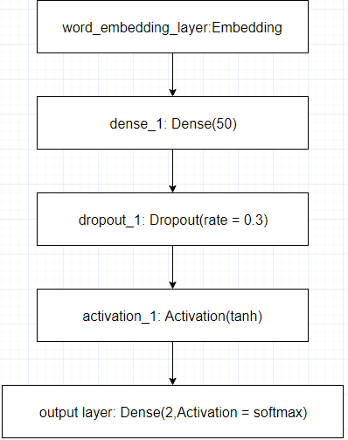

* “Tanh” activation function gave the best result when compared to “Relu” and “Sigmoid”.
* The Neural Network is a shallow network with only one hidden layer comprising of 50 nodes.
* If there were multiple hidden layers than “Relu” activation function would have given better result as it rectifies all the value below 0(<0) to 0.
* Sigmoid function is better for predicting probability as the output. For classification Tanh is the better. This can be observed in the above accuracy table.
* Adding dropout to the sigmoid and relu activation reduces the testing accuracy, as the model is a shallow network.
* But in contrary dropout of 0.3 is giving a good result in case of tanh activation.
* L2 Regularizer does not have a positive effect on the testing accuracy.
* By adding L2 regularizer the training accuracy does not sky rocket to 99%, but it reduces the validation and testing accuracy.
* The Neural Network created does not remember, if we were to use LSTM we would have gotten much better results. As in LSTM the previous words are remembered.
* I have used tokens without stop words, as they perform better when compared to words with stop words. The reason for this being the stop words are frequently occurring in a sentence due to which the nodes get penalized and the accuracy is drpped.
* In the pre-processing part, I have removed “not” and “no” from the stop words list as it helps in increased test accuracy