1) [AccessNow.me](http://AccessNow.me/)

This portal shows the places with accessibility information for the user with disabilities. But it lacks the other informations like parking, entrance etc. No categories is mentioned for quick access to the website

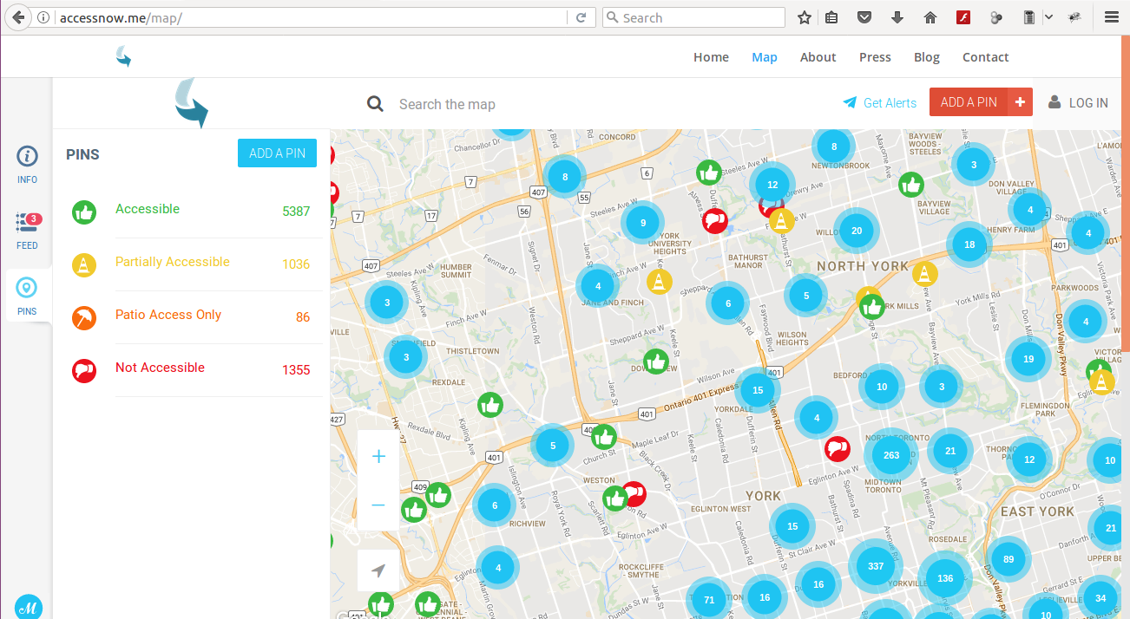

2) Wheelmap.org

It has all the good UI with nformation needed to the user with disabilities. It has categories for quick access to the type of services like Education, Health, Food etc. So that we can access the specific categories without wasting too much time. Again this website does not provides the other information on accessibility for example Public areas, bathrooms and amenities etc.

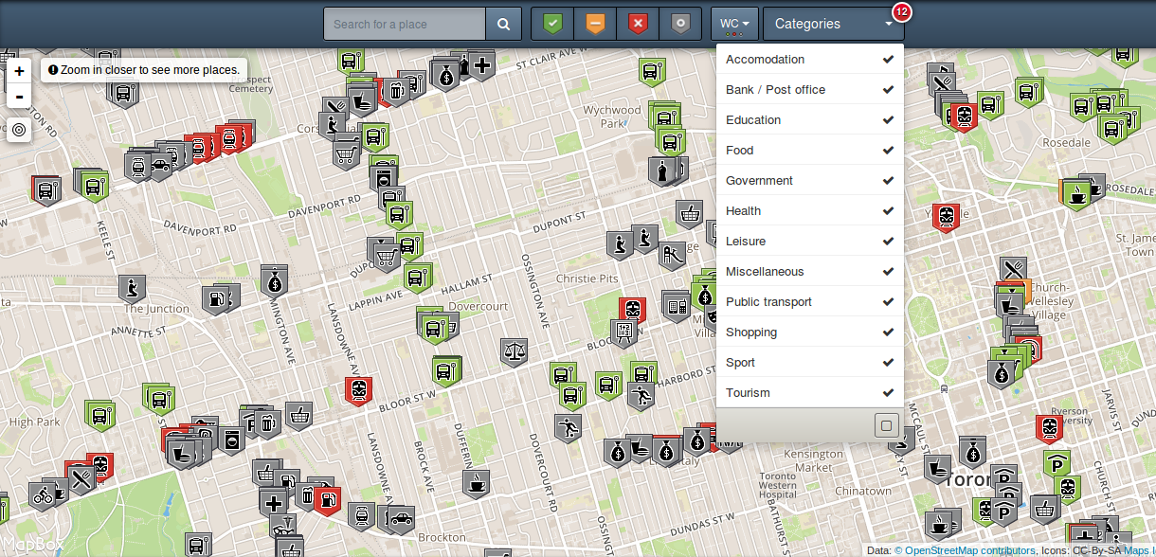

3) [Planat.com](http://Planat.com/)

This portal is like anyother website with the basic information. It is not user friendly and hard to understand whether particular place is suitable for the people with disabilities. Like in our website we tried to give maximum information of particular place with all the other possible areas like parking, entrance, public areas, bathrooms and amenities ,whether this bulding surounding is suitable for the user with the disabilities or not.

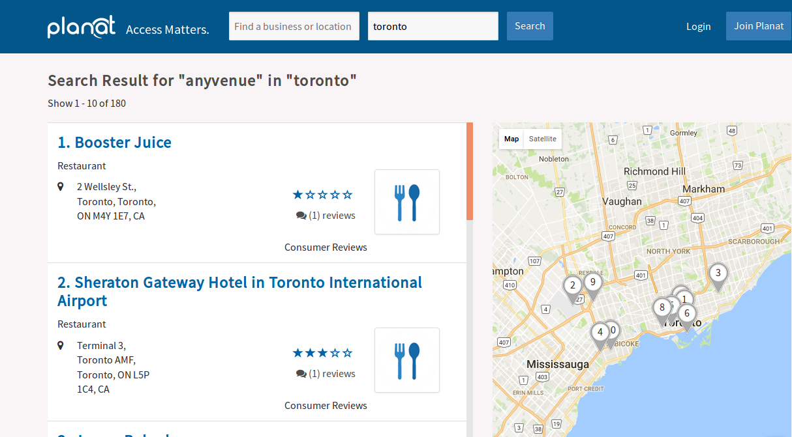

4) [AxsMap.com](http://AxsMap.com/)

Again this website is quite useful for the people with disabilities, it indeed provides the ratings for the accessibility on buildings to the user with disabilities but again it does not have the other options like parking, entrance, public areas, bathrooms and amenities listed in the front page associated with the particular place.

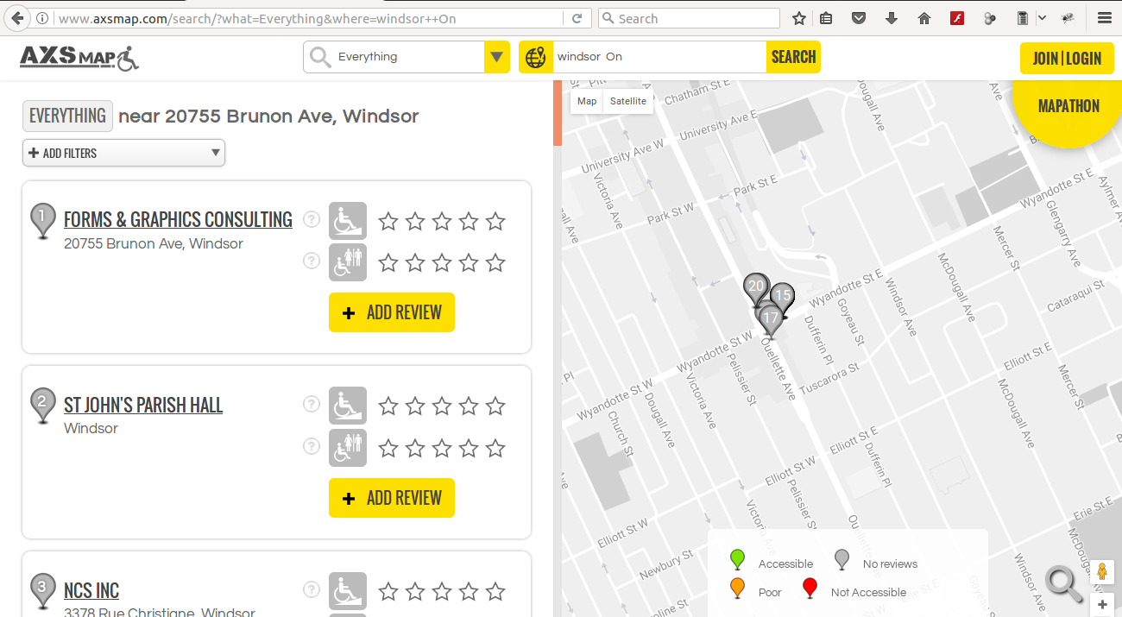

5) [Jaccede.com](https://www.jaccede.com/)

This portal provides the all the information associated with the user with disabilities, however we need to click the particular place to get all the information. It would be better if we could see the information in first page itself and again it would provide the other options like parking, entrance, public areas, bathrooms and amenities at the map itself.

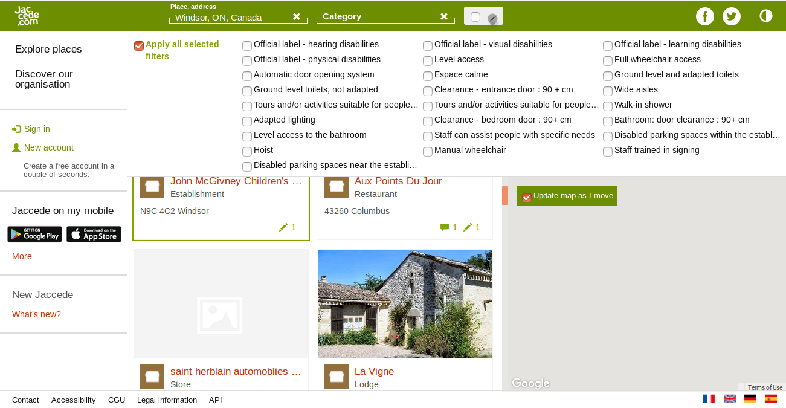

6) [AbleRoad.com](http://AbleRoad.com/)

The UI of the website is not that much appealing, but it provide the ratings for the place with the accessibility information for the user with disabilities however all this information is available after clicking on the particular place link. All the information is not present in the first page like in our website all the required information is mentioned in the first page itself which makes website more user friendly and time efficient.

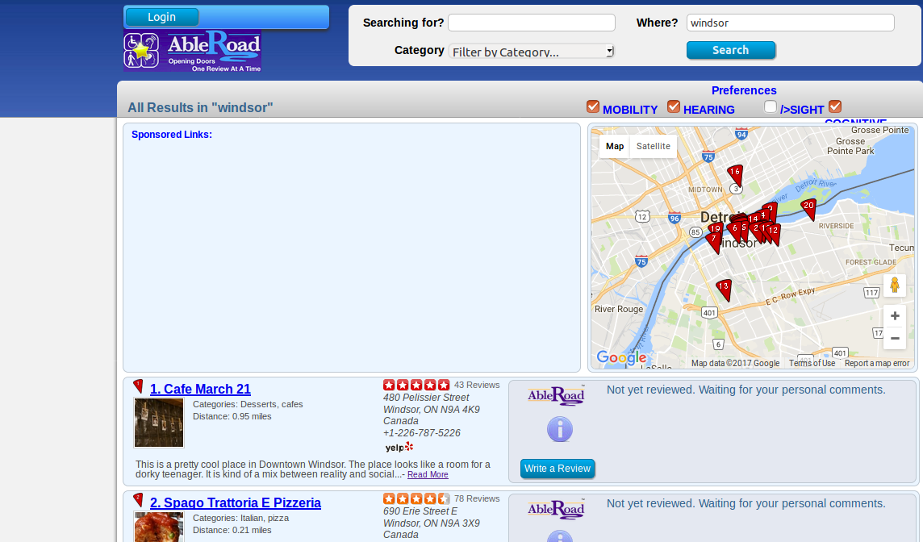

**7)** [accesslocator.com](http://accesslocator.com/)

In our website has maximum information in the front page for the accessibility on buildings to the user with disabilities. When we compare with the other websites, our website is providing more information in the main page itself which is user friendly and easy to use. Any user wants all the information in the same page so that he or she can avoid searching the pages. This website is giving all the possible options for the building like parking, entrance, public areas atc in the same page which is not present in the other websites.

