Sentiment Analysis using R: Batman Vs Superman
In this project, I have analyzed sentiments using 1000 tweets for each Batman and Superman.
The code for this analysis resides in two files Batman.R and Superman.R.
How to execute:
All the execution instructions are included in code itself in BLOCK LETTERS.
1. Perform twitter authentication.
2. Change the necessary paths in both the files.
3. Execute block of codes enclosed in block of ##################################.

PART 1:
The flow execution for each file is as follows:
1. Get 1000 tweets for #Batman and #Superman using case insensitive comparison.
2. Form a dataframe using twListToDF and store it in .csv file.
3. Load the positive and negative words list and few words which are missing and needed for sentiment analysis.
4. For every tweet in .csv file:
a. Remove unnecessary characters such as RT and http.
b. Calculate sum using - score = sum(pos.matches) - sum(neg.matches)
c. Store the scores of each tweet accordingly.
5. Plot the bar plot using ‘qplot’ to compare positive and negative sentiments for batman and superman.
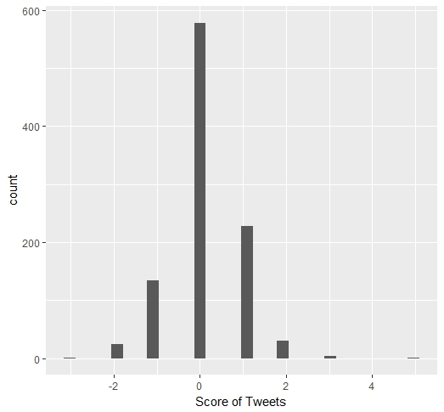
Fig. Batman sentiments graph

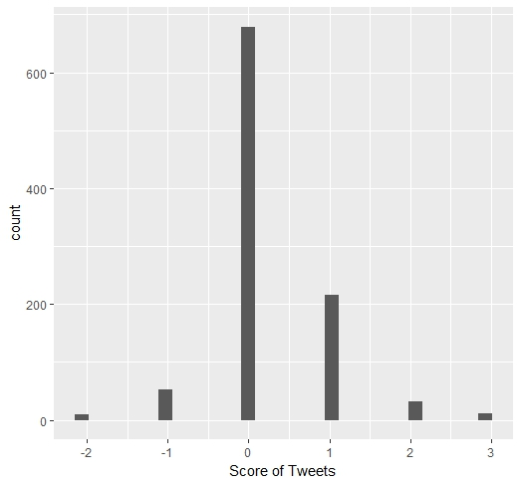
Fig. Superman sentiments graph

PART 2:
The next part of the analysis is to find out what other topics people like to talk about along with Batman and Superman. This is done using wordcloud.
- Remove all the white spaces and unnecessary words.
- Remove words from other languages and keep tweets in English language.
- Form the wordcloud using –
wordcloud(d1$word,d1$freq,max.words="200",colors = dark2)
Following are the resulting wordclouds:
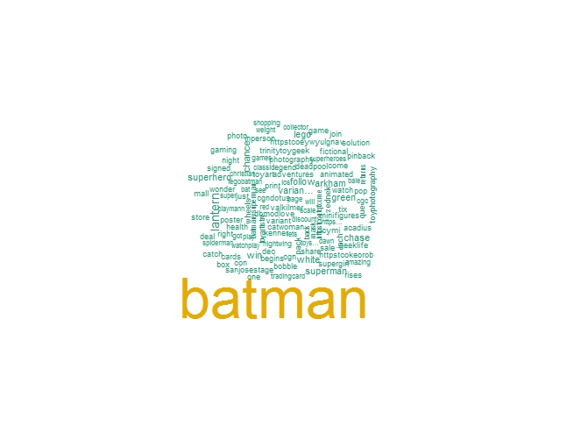
Fig. Wordcloud for #Batman
We can see ‘Batman’ occurs most frequently. Along with batman, people also talk about green lantern, lego batman, toys, arkham.
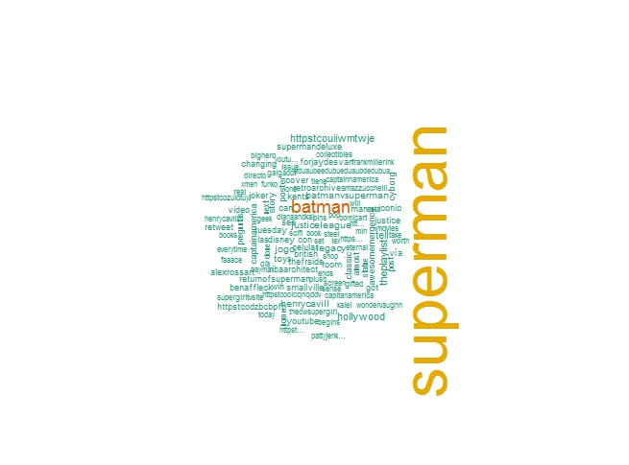
Fig. Wordcloud for #Superman
We can see ‘Superman’ occurs most frequently. Along with superman, people also talk about batman, henry cavill, toys, Hollywood, supergirl, etc.

PART 3:
In this analysis, we are going to calculate the word frequency accurately and draw a conclusion.
- Calculate the frequency of words using document term matrix.
- Plot the graph of word frequency accordingly.

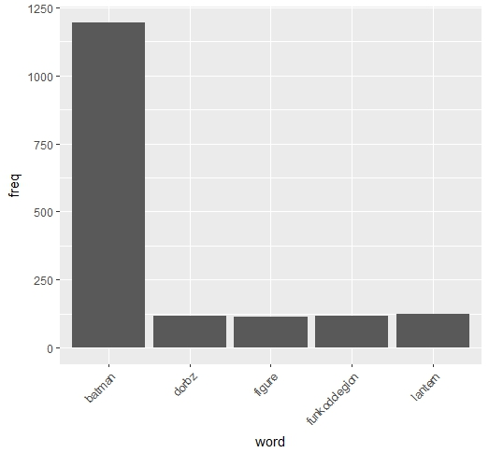
Fig. Word frequency for batman
We can see that, people also discuss about dorbs action figures along with batman.

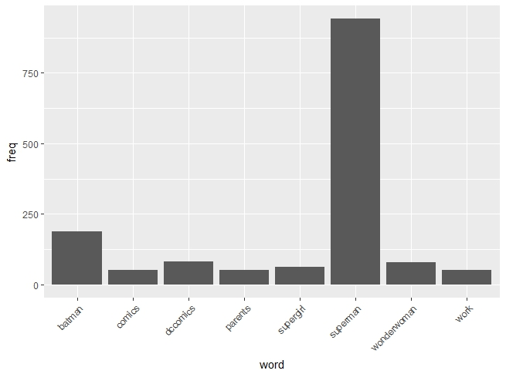
Fig. Word frequency for Superman
We can see that along with superman, people also talk about batman, dc comics, supergirl, wonderwoman, parents and work.

Conclusion:
From the analyzed tweets, following conclusions are made:
1. Both Batman and Superman got high volume of neutral sentiment, and moderate positive response. Negative response for Batman was more than Superman.
2. When people talk about Batman, they also talk about superman, green lantern, lego, legobatman, spiderman, gaming, catwoman, superhero, etc.
3. When people talk about Superman, they also talk about HenryCavill, Justice League, toys, supergirl, captain America, etc.
4. According word frequency in batman tweets, batman being highest discussed figure, people are also interested in Dordz Action figures.
5. According word frequency in batman tweets, batman being highest discussed figure, people are also interested in dccomics, comics, batman, supergirl, wonderwoman.

