Project Synopsis

On

**Right to Education: Data-Driven Analysis for Reducing Dropout Rates**

**(PCS 26-31)**

Submitted as a part of course curriculum for

**Bachelor of Technology**

in

**Computer Science**



**Submitted by**

Atithi Singh (2200290120056)

Anushka Mishra (2200290120046)

Amrita Geetam (2200290120027)

Anushika Prajapati (2200290120044)

**Under the Supervision of**

Dr. Raj Kumar

Associate Professor & Additional HOD (CS)

**KIET Group of Institutions, Ghaziabad**

**Department of Computer Science**

**Dr. A.P.J. Abdul Kalam Technical University**

**2024-2025**

**ABSTRACT**

Many students, especially in rural areas, drop out of school due to challenges such as poverty, lack of resources, and limited access to quality education. These issues make it difficult to achieve the goals of the Right to Education (RTE) Act, which aims to ensure that every child gets a proper education. The lack of tools to track trends and take timely actions makes it harder to address this issue effectively.

This project proposes a simple yet powerful solution: a website designed to help reduce student dropout rates using data-driven insights. The website will include features like predictive analysis of dropout rates, interactive charts to display data in a clear and easy way, and maps to highlight areas that need immediate attention. Additionally, it will showcase motivational success stories from organizations that have successfully tackled dropout challenges.

By providing actionable insights and sharing effective strategies, the platform will help governments and NGOs, make better decisions, use resources efficiently, and focus on areas that need the most help. This tool will support the RTE Act’s mission by encouraging long-term educational success and ensuring more children stay in school.

**INTRODUCTION**

Education is one of the most important tools for shaping a person’s life and building the future of a country. It helps reduce poverty, improve living conditions, and create a better society. Education provides people with the knowledge and skills they need to get jobs and contribute to their communities. For countries, it drives economic growth and progress. Despite its importance, many students face problems that stop them from completing their education. One of the biggest challenges is student dropout, where students leave school or college before finishing their studies.

Student dropout is a global issue that affects both rich and poor countries. For individuals, dropping out means missing opportunities for good jobs and higher income. For society, it results in fewer skilled workers, higher unemployment, and more poverty. Students who drop out are often from poor or disadvantaged backgrounds, which makes their challenges even harder to overcome. Key findings indicate that dropout rates are influenced by factors such as previous knowledge and examination results.[1]

Many factors cause students to drop out of school. Common reasons include poverty, lack of access to quality education, gender inequality, and cultural traditions. For example, in countries like Nepal, India, and Bangladesh, poverty is a major reason students leave school. Families with low incomes often cannot afford school fees, books, or uniforms. Some children are forced to work and support their families instead of continuing their education. Students who attended vocational schools (except commercial schools) had higher dropout rates, especially after the first and second year of study.[5]

In rural areas, dropout rates are often higher because schools and learning resources are harder to access. Gender inequality is another challenge, especially for girls, who may face societal pressure to prioritize household duties over their education. In some communities, parents may not value education due to their own lack of schooling. To address this issue, many countries and schools are turning to data-driven solutions. Financial problems, lack of parental support, poor school infrastructure and environment, and security issues for girls are major causes of student dropouts across different countries.[6] Student dropouts have significant economic costs for countries in terms of lost productivity and tax revenue.[6]

Technology like machine learning (ML) can predict which students are likely to drop out. These methods analyze data such as attendance and family background to find patterns that indicate a higher risk of dropping out. With these predictions, schools can intervene early to help at-risk students. Decision tree and naive Bayes classifiers were able to accurately predict whether a student would drop out of the computer science major with 98.14% and 96.86% accuracy, respectively.[1]

Machine learning uses data to make accurate predictions. It helpful for understanding the reasons behind student dropouts and for designing strategies to keep students in school. However, these tools also face challenges.

This project aims to use data to understand why students drop out and to develop models that predict dropout risks. The study will analyze data such as gender, caste, age and region to evaluate dropout rates. The goal is to create a framework that schools can use to identify and support at-risk students.

The project will also explore ways to reduce dropout rates. The project will map different NGOs and government bodies using intervention mapping that can help to reduce the dropout rates.

This project could help government bodies and NGOs understand the dropout problem better and take effective action. By identifying students at risk and providing timely support, this study aims to reduce dropout rates and ensure more students complete their education. This will not only benefit individual students but also strengthen society by creating a more skilled and educated workforce.

In conclusion, student dropout is a serious problem that requires urgent attention. While the reasons for dropout are complex, data-driven approach like machine learning offer promising solutions.

**PROBLEM STATEMENT**

Student dropout rates are a significant challenge to achieving universal education, especially in rural and economically disadvantaged areas. Despite efforts like the Right to Education (RTE) Act, many children leave school due to financial difficulties, limited resources, and cultural pressures. Factors, such as agricultural demands and festivals, further increase dropout rates, disrupting education.

One major issue is the lack of a centralized, data-driven platform to analyze trends, map interventions, and share successful strategies. Without actionable insights, governments, NGOs, and schools struggle to identify underserved areas and implement effective solutions. Current efforts are often uncoordinated and rely on incomplete data, limiting their impact.

There is an urgent need for a comprehensive solution that uses data to understand dropout patterns, predict risks, and support timely interventions. By addressing these issues, a systematic approach can significantly reduce dropout rates and ensure that more students, regardless of their background, have access to continuous and quality education.

**OBJECTIVES**

1. **Analyze Dropout Trends**:  
   Use past and real-time data to predict dropout rates on basis of age, gender and caste.
2. **Visualize Dropout Hotspots**:  
   Develop dynamic charts and graphs to highlight dropout hotspot regions through google maps, providing an easy-to-understand overview of areas needing immediate attention.
3. **Enable Targeted Interventions**:  
   Use intervention mapping to identify underserved regions and connect them with local NGOs, government bodies, and support programs.
4. **Highlights of Progress:**  
   Present success stories from schools and organizations that have reduced dropout rates.
5. **Raise Awareness and Engagement**:  
   Highlight the causes of dropout rates and promote involvement among stakeholders to offer better and more sustainable solutions.

**PROPOSED METHODOLOGY**

1. **Data Collection and Preprocessing:**

Scrape dropout data from governmental records and educational institutions. Clean and preprocess the data to handle missing values, remove inconsistencies, and standardize formats.

1. **Predictive Analytics for Dropout Trends:**

Use machine learning techniques to predict dropout trends. Model training will incorporate parameters like socioeconomic conditions, geographical locations, and previous trends.

1. **Data Visualization:**

Use interactive resources like trend lines, pie charts and bar charts to visualize dropout rates.

1. **Intervention Mapping:**

Utilize GIS to map interventions implemented by NGOs and government bodies. Identify underprivileged areas needing urgent attention based on dropout rates and available support.

1. **Compilation of Success Stories:**

Create success stories by extracting key findings from intervention data and dropout trends, automating motivational case studies.

1. **Testing and Deployment of website:**

Conduct unit and system testing to ensure accurate data reporting, efficient algorithms, and platform usability. Deploy the platform on cloud services.

**Diagram for the Proposed Methodology**

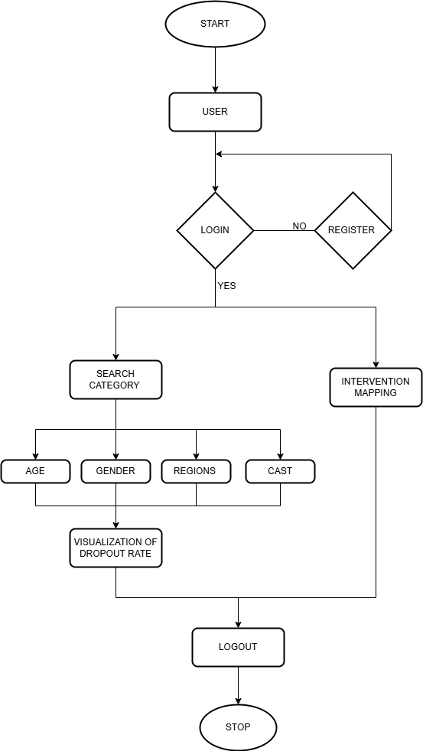

Fig 1: Methodology for the proposed system

**ER DIAGRAM**

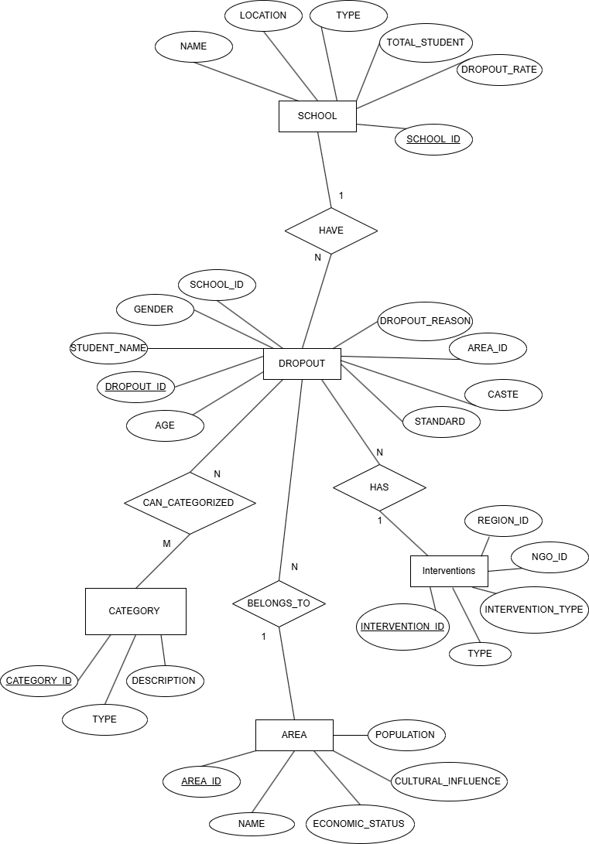

Fig 2: ER Diagram for the proposed system

**TECHNOLOGY USED**

1. Development Tools and Frameworks:
   1. Frontend Development:
      1. React.js: For building a dynamic, interactive, and responsive user interface.
      2. HTML, CSS, JavaScript: Core technologies for web design and styling.
   2. Backend Development:
      1. Node.js: For server-side logic, API development, and database integration.
2. Database and Data Management:
   1. Database:
      1. MySQL: For structured data storage and relational database management.
      2. MongoDB: For unstructured or semi-structured data (if needed).
   2. Data Processing Tools:
      1. Pandas, NumPy (Python): For data preprocessing and analysis.
3. Machine Learning and AI Tools:
   1. Scikit-learn: For building predictive models to analyze dropout trends.
   2. TensorFlow: For implementing models, if required.
4. Data Visualization:
   1. Matplotlib: For creating interactive charts and visualizations such as heat maps, trend lines, and bar charts.
   2. Google Maps API: For mapping dropout hotspots and interventions.
5. Deployment and Hosting
   1. Version Control:
      1. Git: For source code management.
      2. GitHub/GitLab: For collaborative development and repository hosting.

**EXPECTED OUTCOMES**

The proposed system would be set to achieve measurable and impactful change regarding the reduction of student dropout levels in furthering the Right to Education initiative. It is anticipated that key outcomes will include the following:

* 1. **Accurate Dropout Prediction**

Facilitate stakeholders in providing seasonal forecasts of dropouts using predictive analytics, with timely intervention and resource allocation.

* 1. **Identification of High-Risk Areas**

Generate precise visualizations through heat maps and trend charts as a simple way to delineate those areas showing the highest dropout rates, thus focusing efforts there.

* 1. **Targeted Interventions:**

Mapping and deploying interventions into needy areas by supporting NGOs and government bodies to ensure they utilize resources in the right places.

* 1. **Motivational Success Story**

Automate success stories using data analysis to publicize best practices in order to inspire communities and stakeholders to emulate proven strategies.

* 1. **Improved Awareness and Involvement:**

Emphasize root causes of dropout rates that involve integrated solutions for economic, social, and cultural barriers to education.

**CONCLUSION**

This project combines data analysis, intervention mapping, and motivational success story generation to support the Right to Education campaign. By using predictive analysis, it identifies issues such as dropout rates and provides quick, targeted solutions to address these challenges.

Intervention mapping give us an overview of NGOs and government agencies that can help to identify and work on areas with high dropout rates, ensuring that resources are allocated effectively. This approach maximizes the impact of their efforts and creates opportunities to reach more children and families. Sharing stories of success not only inspires communities but also spreads good practices, motivating others to adopt positive approaches and fostering a shared sense of purpose in tackling educational challenges.

The platform is designed to break down barriers to education and ensure that every child can complete their studies without interruptions. By supporting effective interventions, actively involving NGOs, government bodies and sharing inspiring success stories will works toward long-term solutions. This initiative reduces dropout rates and strengthens collaboration among governments and organizations to address these issues in a sustainable, scalable, and inclusive way, ultimately contributing to a future where education is accessible to all.

**REFERENCES**

1. G. S. Abu-Oda and A. M. El-Halees, "Data mining in higher education: University student dropout case study," International Journal of Data Mining & Knowledge Management Process, 2015
2. K. K. and R. P., "Predicting Student Dropout: A Machine Learning Approach," in Proceedings of the Conference on Smart Technologies, 2023.
3. S. Ameri, R. B. Chinnam, M. J. Fard, and C. K. Reddy, "Survival analysis-based framework for early prediction of student dropouts," Proc. of the 25th ACM International Conference on Information and Knowledge Management (CIKM '16), Indianapolis, IN, USA, Oct. 24–28, 2016.
4. N. Lagun and R. P. Shah, "Evaluating variation in school dropout rates in rural Nepal: A statistical study," Int. J. Sci. Res. Archive, vol. 12, no. 1, pp. 1063–1073, 2024.
5. M. Jadrić, Ž. Garača, and M. Ćukušić, "Student dropout analysis with application of data mining methods," Manag., vol. 15, no. 1, pp. 31–46, 2010.
6. A. Latif, A. I. Choudhary, and A. A. Hammayun, "Economic effects of student dropouts: A comparative study," J. Glob. Econ., vol. 3, no. 2, pp. 137, Apr. 2015.