**PATENT**

**PROJECT ID: PCS 26-31**

**DEPARTMENT: CS**

**Title of your invention**

Right to Education: Data-Driven Analysis for Reducing Dropout Rates**.**

**Type of Invention**

This invention is a software-based data -driven intervention tool that uses machine learning to analyze and visualize the dropout rates on basis of age, gender, caste etc.

**Brief Description of your invention**

Our invention uses machine learning models to visualize the dropout rates. This invention takes into account diverse demographic and academic data, such as age, gender, caste, and socio-economic status, to look into the patterns and risk factors leading to dropout. The interactive visualizations through graphs and dashboards enable a more informed approach to NGOs and government bodies. It aims at improvement in retention rates as well as facilitating fair education by looking into the root causes of student dropout.

**Objective of your invention**

The main goal of our invention is to develop a website that provides actionable insights into student dropout rate:

* Predict and address different dropout reasons, and visualize them.
* Create an interactive map to identify and support underserved areas through NGO and government intervention.
* Share success stories, showcasing effective dropout reduction strategies.
* Empower governments, NGOs, and communities to drive targeted interventions and promote student retention through data-driven analysis.

**How to use the invention**

* Access the Platform: Users (school administrators, educators) log on to the Internet-enabled platform using their credentials.
* Review Results: Results are presented as: The list of students ranked by dropout risk level (low, medium, high). Graphical representation provides trends such as risk distribution by grade or region.
* Intervention Planning: Users invoke the tab entitled "Intervention Suggestions" whereby the system lists NGOs and other government bodies in specific areas.
* Compiling Success Stories: The user can access the functionality named "Success Stories" to view reports about students who benefited from the intervention.

**Problem your invention is solving**

There is insufficient understanding of local challenges affecting dropout rates. Our invention addresses these challenges by:

* Systematically analyse the trends of the dropouts.
* Identify underserved areas and at-risk students.
* Effectively map interventions.
* Share action strategies among stakeholders such as governments, NGOs, and educational institutions.

**Purpose and object of Invention**

Our purpose is to reduce student dropout rates through a platform that is:

* User-Friendly: Accessible for educators, parents, and administrators.
* Data-Driven: Predicts dropouts and provides actionable insights using advanced analytics.
* Scalable: Suitable for implementation in schools, districts, and organizations.

**Discuss potential commercial application of the invention**

* Educational Institutions: The website can be used to identified students by schools, colleges, and universities.
* Government Agencies: The education departments can use the tool at the national or regional level to implement dropout reduction programs.
* Non-Profit and NGOs: It will also be used by organizations promoting education to identify dropout-prone areas and understand intervention outcomes.
* Research Organizations: Researchers may use the system to study dropout pattern trends and test educational strategy interventions.
* International Organizations: Agencies like UNESCO and UNICEF could use the tool in global education improvement projects**.**

**Flowchart**

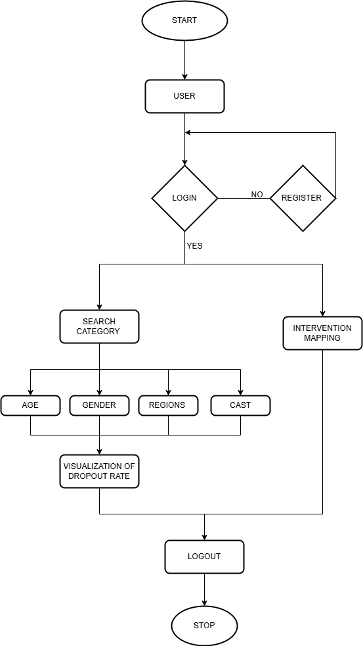

Fig 1: Flowchart depicting the process for predicting and managing student dropout rates.

**Abstract**

The invention will aid government, educational organizations and NGOs, in factoring dropout trends, forecasting spikes in dropout rates and carrying out targeted interventions, especially in rural areas. Highlights include predicting dropout rates, interactive visualizations of dropout rates, and mapping of underserved areas. It also features the stories of successful organizations as motivational case studies, using artificial intelligence.

**Summary of the invention**

This platform combines data analysis, feedback incorporation, intervention mapping, and automated success story generation to address student dropout rates, particularly in rural areas. By predicting trends and involving community feedback, it provides targeted interventions, highlights effective practices, and shares motivational success stories. Its goal is to eliminate educational barriers, ensuring every child can complete their education, while aiding governments and NGOs in creating sustainable, data-driven educational strategies.

**Detail description of invention with methodology**

* Data Upload and Processing: Processing the data, applying machine learning algorithms to forecast dropout risks.
* Predictive Analysis and Review: Predictive insights, ranking students by dropout risk levels and displaying trends through interactive charts.
* Intervention Planning and Implementation: Based on the analysis, users access suggested interventions and select appropriate region for at-risk students or groups.
* Success Story Compilation: The success stories from schools and NGOs that have effectively reduced dropout rates. These stories are showcased on the platform, serving as motivational case studies for other regions and institutions.
* Results Compilation

**Applicant and inventor details:**

* **Applicant:** Anushika Prajapati, Anushka Mishra, Atithi Singh, Amrita Geetam
* **Institution:** KIET Group of Institutions