Machine Learning Assignment 7

Alice Tivarovsky

3/5/2020

## Setup

## Number 1

Cleaning and tidying the Cleveland Heart Disease dataset.

heart.data <- read.csv("/Users/AliceTivarovsky/Documents/Grad School/Spring 2020/Machine Learning/processed.cleveland.data", header = FALSE)  
  
var.names <- c("age", "sex", "pain_type", "resting_sysbp", "chol", "fast_blsugar_gt120", "rest_ecg", "max_hr", "exerc_angina", "ST_depression", "ST_slope", "vessels_colorflu", "defect", "heart_disease_present")  
  
colnames(heart.data) <- var.names  
str(heart.data)

## 'data.frame': 303 obs. of 14 variables:  
## $ age : num 63 67 67 37 41 56 62 57 63 53 ...  
## $ sex : num 1 1 1 1 0 1 0 0 1 1 ...  
## $ pain_type : num 1 4 4 3 2 2 4 4 4 4 ...  
## $ resting_sysbp : num 145 160 120 130 130 120 140 120 130 140 ...  
## $ chol : num 233 286 229 250 204 236 268 354 254 203 ...  
## $ fast_blsugar_gt120 : num 1 0 0 0 0 0 0 0 0 1 ...  
## $ rest_ecg : num 2 2 2 0 2 0 2 0 2 2 ...  
## $ max_hr : num 150 108 129 187 172 178 160 163 147 155 ...  
## $ exerc_angina : num 0 1 1 0 0 0 0 1 0 1 ...  
## $ ST_depression : num 2.3 1.5 2.6 3.5 1.4 0.8 3.6 0.6 1.4 3.1 ...  
## $ ST_slope : num 3 2 2 3 1 1 3 1 2 3 ...  
## $ vessels_colorflu : Factor w/ 5 levels "?","0.0","1.0",..: 2 5 4 2 2 2 4 2 3 2 ...  
## $ defect : Factor w/ 4 levels "?","3.0","6.0",..: 3 2 4 2 2 2 2 2 4 4 ...  
## $ heart_disease_present: int 0 2 1 0 0 0 3 0 2 1 ...

heart.data[heart.data == "?"] <- NA  
  
heart.data$defect <- as.numeric(factor(heart.data$defect))  
heart.data$vessels_colorflu <- as.numeric(factor(heart.data$vessels_colorflu))  
  
heart.data$outcome <- ifelse(heart.data$heart_disease_present == 0, 0,1)  
heart.data$heart_disease_present <- NULL  
heart.data$outcome <- factor(heart.data$outcome)  
levels(heart.data$outcome) <- c("HD Not Present", "HD Present")  
str(heart.data)

## 'data.frame': 303 obs. of 14 variables:  
## $ age : num 63 67 67 37 41 56 62 57 63 53 ...  
## $ sex : num 1 1 1 1 0 1 0 0 1 1 ...  
## $ pain_type : num 1 4 4 3 2 2 4 4 4 4 ...  
## $ resting_sysbp : num 145 160 120 130 130 120 140 120 130 140 ...  
## $ chol : num 233 286 229 250 204 236 268 354 254 203 ...  
## $ fast_blsugar_gt120: num 1 0 0 0 0 0 0 0 0 1 ...  
## $ rest_ecg : num 2 2 2 0 2 0 2 0 2 2 ...  
## $ max_hr : num 150 108 129 187 172 178 160 163 147 155 ...  
## $ exerc_angina : num 0 1 1 0 0 0 0 1 0 1 ...  
## $ ST_depression : num 2.3 1.5 2.6 3.5 1.4 0.8 3.6 0.6 1.4 3.1 ...  
## $ ST_slope : num 3 2 2 3 1 1 3 1 2 3 ...  
## $ vessels_colorflu : num 1 4 3 1 1 1 3 1 2 1 ...  
## $ defect : num 2 1 3 1 1 1 1 1 3 3 ...  
## $ outcome : Factor w/ 2 levels "HD Not Present",..: 1 2 2 1 1 1 2 1 2 2 ...

summary(heart.data)

## age sex pain_type resting_sysbp   
## Min. :29.00 Min. :0.0000 Min. :1.000 Min. : 94.0   
## 1st Qu.:48.00 1st Qu.:0.0000 1st Qu.:3.000 1st Qu.:120.0   
## Median :56.00 Median :1.0000 Median :3.000 Median :130.0   
## Mean :54.44 Mean :0.6799 Mean :3.158 Mean :131.7   
## 3rd Qu.:61.00 3rd Qu.:1.0000 3rd Qu.:4.000 3rd Qu.:140.0   
## Max. :77.00 Max. :1.0000 Max. :4.000 Max. :200.0   
##   
## chol fast_blsugar_gt120 rest_ecg max_hr   
## Min. :126.0 Min. :0.0000 Min. :0.0000 Min. : 71.0   
## 1st Qu.:211.0 1st Qu.:0.0000 1st Qu.:0.0000 1st Qu.:133.5   
## Median :241.0 Median :0.0000 Median :1.0000 Median :153.0   
## Mean :246.7 Mean :0.1485 Mean :0.9901 Mean :149.6   
## 3rd Qu.:275.0 3rd Qu.:0.0000 3rd Qu.:2.0000 3rd Qu.:166.0   
## Max. :564.0 Max. :1.0000 Max. :2.0000 Max. :202.0   
##   
## exerc_angina ST_depression ST_slope vessels_colorflu  
## Min. :0.0000 Min. :0.00 Min. :1.000 Min. :1.000   
## 1st Qu.:0.0000 1st Qu.:0.00 1st Qu.:1.000 1st Qu.:1.000   
## Median :0.0000 Median :0.80 Median :2.000 Median :1.000   
## Mean :0.3267 Mean :1.04 Mean :1.601 Mean :1.672   
## 3rd Qu.:1.0000 3rd Qu.:1.60 3rd Qu.:2.000 3rd Qu.:2.000   
## Max. :1.0000 Max. :6.20 Max. :3.000 Max. :4.000   
## NA's :4   
## defect outcome   
## Min. :1.000 HD Not Present:164   
## 1st Qu.:1.000 HD Present :139   
## Median :1.000   
## Mean :1.837   
## 3rd Qu.:3.000   
## Max. :3.000   
## NA's :2

#Remove the missings  
heart.data.nomiss <- na.omit(heart.data)  
  
#Set No Heart Disease as Reference Level  
heart.data.nomiss$outcome <- relevel(heart.data.nomiss$outcome, ref = "HD Not Present")  
  
str(heart.data.nomiss)

## 'data.frame': 297 obs. of 14 variables:  
## $ age : num 63 67 67 37 41 56 62 57 63 53 ...  
## $ sex : num 1 1 1 1 0 1 0 0 1 1 ...  
## $ pain_type : num 1 4 4 3 2 2 4 4 4 4 ...  
## $ resting_sysbp : num 145 160 120 130 130 120 140 120 130 140 ...  
## $ chol : num 233 286 229 250 204 236 268 354 254 203 ...  
## $ fast_blsugar_gt120: num 1 0 0 0 0 0 0 0 0 1 ...  
## $ rest_ecg : num 2 2 2 0 2 0 2 0 2 2 ...  
## $ max_hr : num 150 108 129 187 172 178 160 163 147 155 ...  
## $ exerc_angina : num 0 1 1 0 0 0 0 1 0 1 ...  
## $ ST_depression : num 2.3 1.5 2.6 3.5 1.4 0.8 3.6 0.6 1.4 3.1 ...  
## $ ST_slope : num 3 2 2 3 1 1 3 1 2 3 ...  
## $ vessels_colorflu : num 1 4 3 1 1 1 3 1 2 1 ...  
## $ defect : num 2 1 3 1 1 1 1 1 3 3 ...  
## $ outcome : Factor w/ 2 levels "HD Not Present",..: 1 2 2 1 1 1 2 1 2 2 ...  
## - attr(*, "na.action")= 'omit' Named int 88 167 193 267 288 303  
## ..- attr(*, "names")= chr "88" "167" "193" "267" ...

## Number 2

Run a single classification tree using all of the features available in the dataset. Calculate evaluation metrics and output the variable importance metrics.

training.data <- heart.data.nomiss$outcome %>% createDataPartition(p = 0.7, list = F)  
train.data <- heart.data.nomiss[training.data, ]  
test.data <- heart.data.nomiss[-training.data, ]

train.control <- trainControl(method = "cv", number = 10)  
grid.2 <- expand.grid(cp = seq(0.001, 0.3, by = 0.01))  
hd.tree <- train(outcome~., data = train.data, method = "rpart",trControl = train.control, tuneGrid = grid.2)  
hd.tree$bestTune

## cp  
## 4 0.031

# variable importance  
varImp(hd.tree)

## rpart variable importance  
##   
## Overall  
## vessels_colorflu 100.000  
## defect 94.153  
## pain_type 65.901  
## max_hr 52.781  
## exerc_angina 45.005  
## ST_slope 30.227  
## ST_depression 27.920  
## chol 8.085  
## age 7.605  
## resting_sysbp 0.000  
## rest_ecg 0.000  
## sex 0.000  
## fast_blsugar_gt120 0.000

# tree plot  
rpart.plot(hd.tree$finalModel)

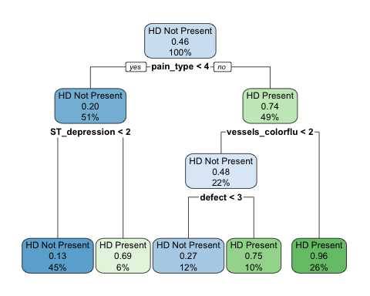

accuracy.train.singletree <- hd.tree$results[which.max(hd.tree$results[,"Accuracy"]), "Accuracy"]

The variables vessels_colorflu, pain_type, max_hr, defect and exerc_angina have the highest variable importance. The accuracy of the model is 81.76%.

## Number 3

Use random forest to classify heart disease. Set up a pipeline to try different values of mtry and different numbers of trees to obtain your optimal model. Again, calculate appropriate evaluation metrics and output the variable importance metrics.

set.seed(100)  
  
possible_predictors = heart.data.nomiss %>% select(-"outcome")  
  
## using tuneRF to find optimal mtry  
bestMtry=tuneRF(x = possible_predictors, y = heart.data.nomiss$outcome, ntreeTry = 50, stepFactor = 1, improve=0.0001, trace=FALSE, plot=FALSE, doBest=FALSE)   
  
# running random forest with 50 trees  
rf.heart.tune = randomForest(outcome ~., data = train.data, mtry = bestMtry, importance = TRUE, ntree = 50)  
  
print(rf.heart.tune)

##   
## Call:  
## randomForest(formula = outcome ~ ., data = train.data, mtry = bestMtry, importance = TRUE, ntree = 50)   
## Type of random forest: classification  
## Number of trees: 50  
## No. of variables tried at each split: 1  
##   
## OOB estimate of error rate: 18.27%  
## Confusion matrix:  
## HD Not Present HD Present class.error  
## HD Not Present 97 15 0.1339286  
## HD Present 23 73 0.2395833

plot(1-rf.heart.tune$err.rate[,1])

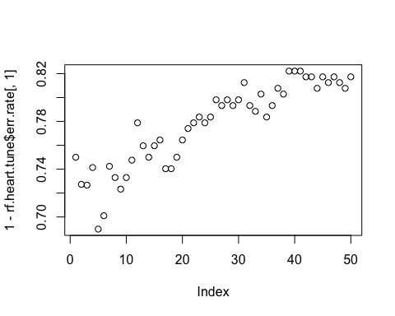

# running random forest with 100 trees  
rf.heart.tune = randomForest(outcome ~., data = train.data, mtry = bestMtry, importance = TRUE, ntree = 100)  
  
print(rf.heart.tune)

##   
## Call:  
## randomForest(formula = outcome ~ ., data = train.data, mtry = bestMtry, importance = TRUE, ntree = 100)   
## Type of random forest: classification  
## Number of trees: 100  
## No. of variables tried at each split: 1  
##   
## OOB estimate of error rate: 16.83%  
## Confusion matrix:  
## HD Not Present HD Present class.error  
## HD Not Present 101 11 0.09821429  
## HD Present 24 72 0.25000000

plot(1-rf.heart.tune$err.rate[,1])

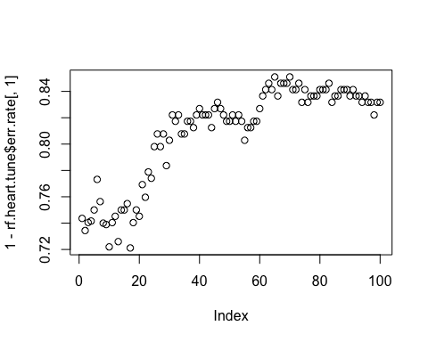

varImpPlot(rf.heart.tune)

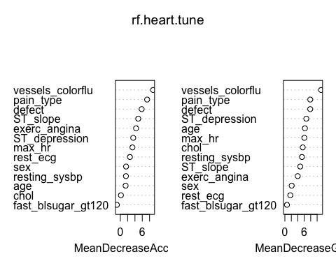

Out of bag error rate with 50 trees = 12.98% Error rate with 100 trees = 16.35%

We see from the plots that the error rate does not improve after about 50 trees. Looking at the variable importance plots, vessels_colorflu, defect, pain_type, and max_hr are the most important variables.

## Number 4

Answer the questions: Are there differences in variable importance that you see between a single tree and an ensemble metric? Are there differences observed across the different variable importance metrics output from the ensemble? How do you interpret those differences?

## Number 5