Static Analysis Report

Asal Tiwari
ITIS 4221
July 29, 2026

1. Overview
This report documents a static analysis exercise on AssignmentServlet.java, an intentionally vulnerable Java servlet. Two custom Semgrep taint-mode rules were written to detect three vulnerabilities: two instances of reflected Cross-Site Scripting (XSS) and one instance of SQL Injection (SQLi). After confirming detection, each vulnerability was patched and the scan was re-run to confirm zero remaining findings. Three endpoints were in scope:
- /asmt/comment - reflected XSS
- /asmt/search - reflected XSS
- /asmt/userByEmail - SQL injection

2. Vulnerable Code
2.1 Reflected XSS - /asmt/comment
The submitComment method reads the author and text request parameters and inserts them directly into the HTML response without encoding. The heading string concatenates the raw author value, and the raw text value is passed straight into Views.thankYouSections(), which flows into Views.layout(). Because neither value is HTML-escaped, an attacker-supplied payload such as <script>alert(1)</script> in either parameter would execute in the victim’s browser.
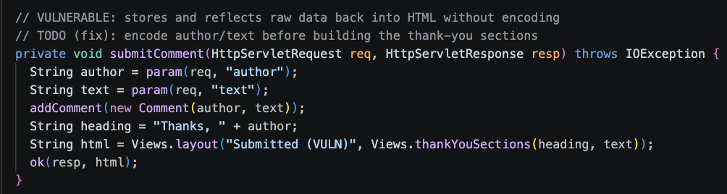

2.2 Reflected XSS - /asmt/search
The search method reads the q parameter and passes it, unescaped, into Views.searchSections() and Views.renderItems(), both of which embed the raw string into HTML. The result is written back via ok() with no sanitization, giving an attacker the same reflected-XSS primitive as above.
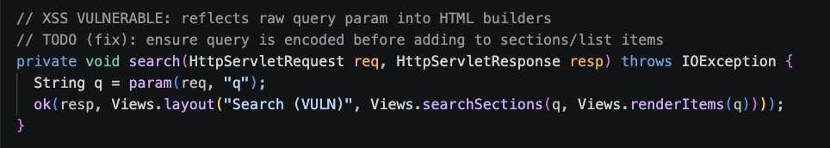

2.3 SQL Injection - /asmt/userByEmail
The userByEmail method reads the email parameter and passes it to SqlTemplates.lookupByEmail(), which builds a SQL string via plain concatenation ("email = '" + value + "'"). The resulting string is executed directly with Statement.executeQuery(). Because the email value is never separated from the SQL syntax, an attacker can break out of the intended query; e.g. supplying ' OR '1'='1; to alter the query's logic or exfiltrate data.
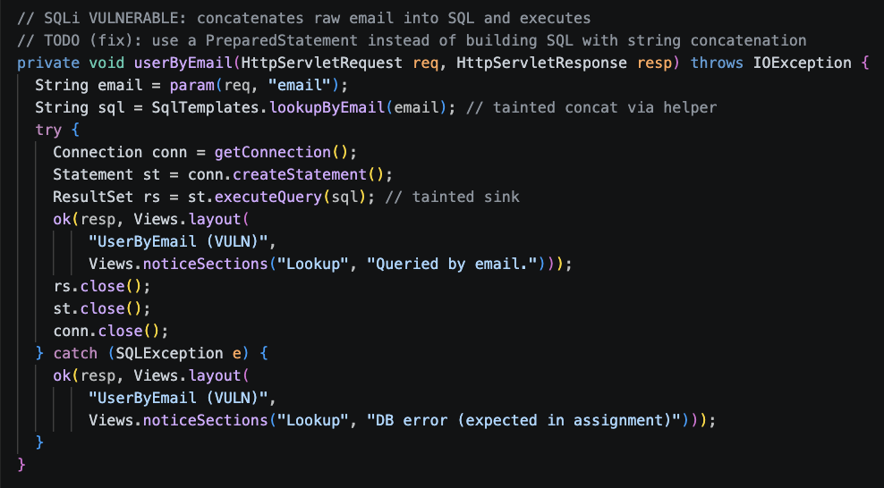

3. Semgrep Detection Rules
Two custom taint-mode rules were written in assignment_rules_starter.yaml: one for reflected XSS (asmt-java-xss) and one for SQL injection (asmt-java-sqli). Both rules use request.getParameter(...) / the project's param(req, ...) wrapper as taint sources. Because taint does not automatically cross helper-method boundaries in Semgrep's taint engine, pattern-propagators were added to explicitly track taint through the project's own helper methods (Views.thankYouSections, Views.searchSections, Views.layout, and SqlTemplates.lookupByEmail). The XSS rule treats out.println, response.getWriter().println/print, and the project's ok(), bad(), and writeHtml() wrappers as sinks and recognizes StringEscapeUtils.escapeHtml4 (and the project's local escape() wrapper) as sanitizers. The SQLi rule treats Statement.executeQuery/executeUpdate/execute and Connection.prepareStatement as sinks.

3.1 Scan on Vulnerable Code
Running semgrep --dataflow-traces --config assignment_rules_starter.yaml assignment against the original code produced 3 findings (3 blocking): two asmt-java-xss findings (comment endpoint at line 90, search endpoint at line 227) and one asmt-java-sqli finding (userByEmail endpoint at line 238), each with a full dataflow trace from the tainted param(req, ...) source to the sink.
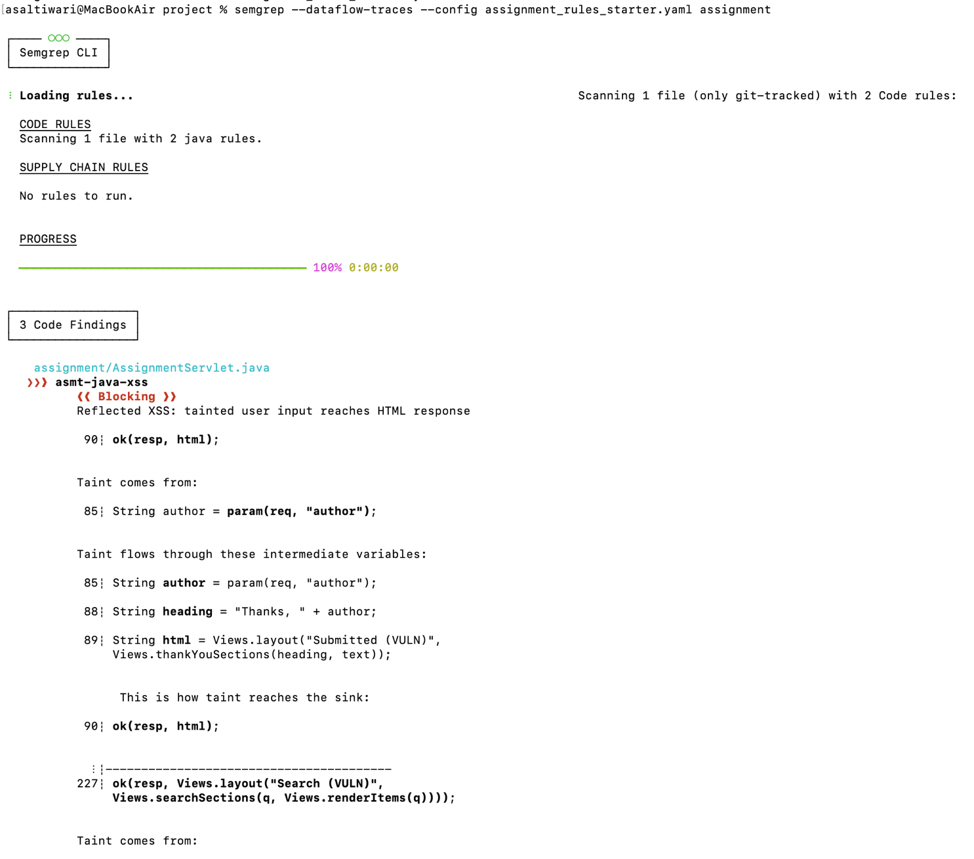
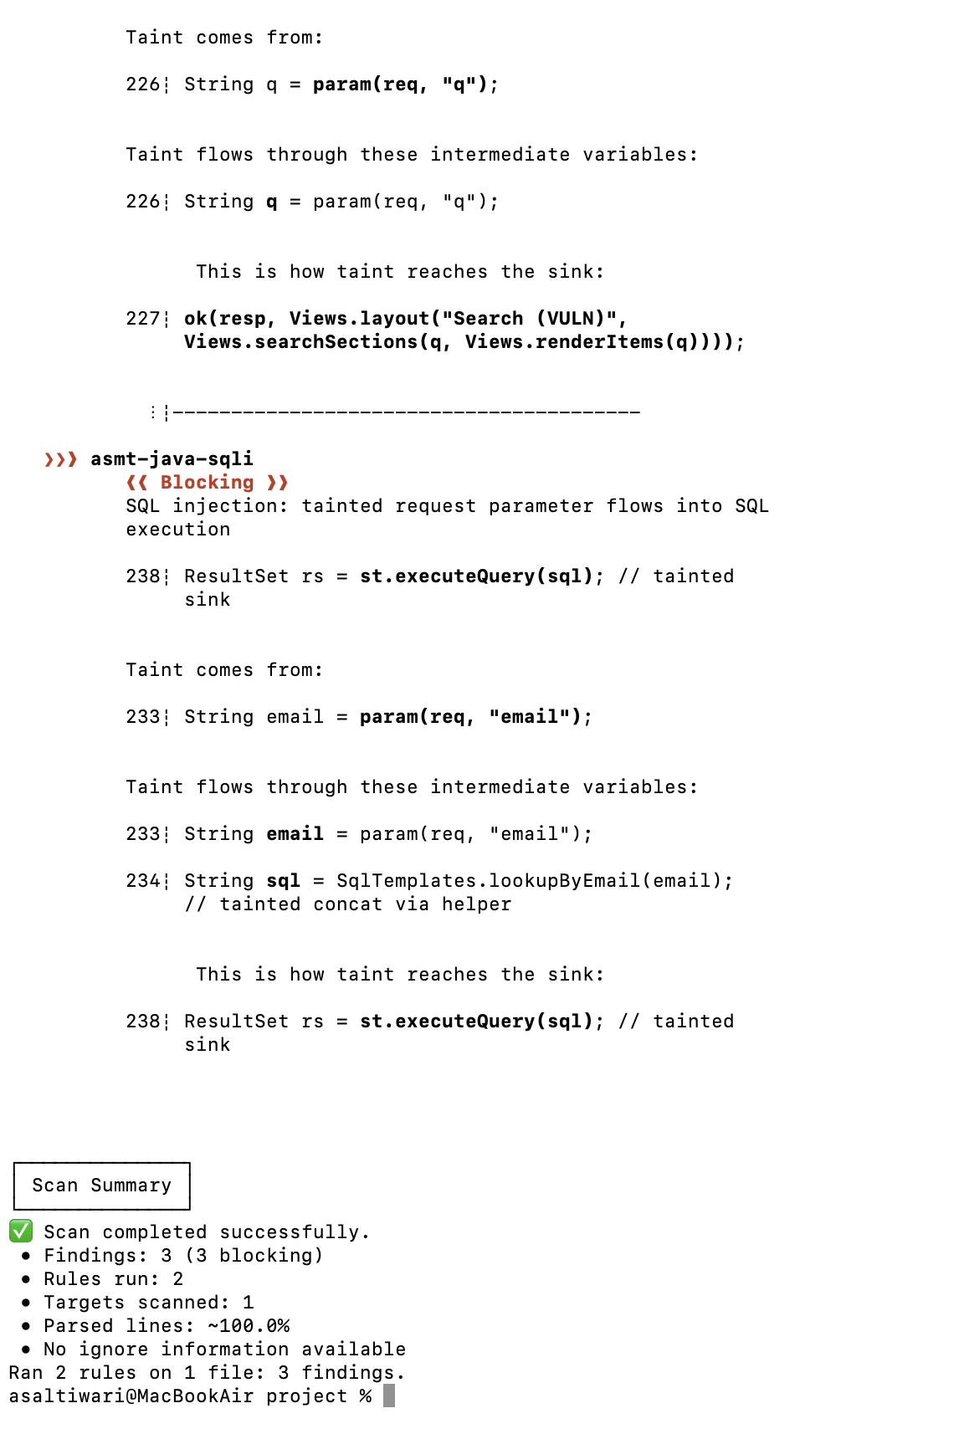
4. Fixed Code
4.1 /asmt/comment
Both author and text are now passed through the project's escape() helper before being placed into the response markup. This HTML-encodes special characters (e.g. <, >, &) so any injected markup is rendered as inert text rather than executed as HTML/JavaScript.
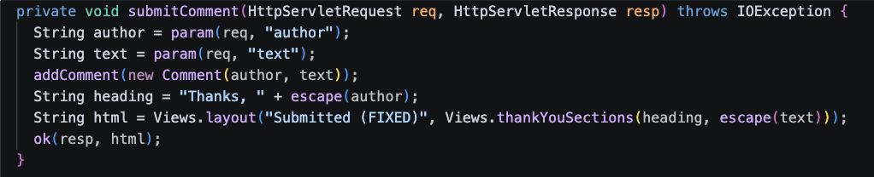

4.2 /asmt/search
The query parameter escaped once into safeQ immediately after being read, and the escaped value is reused for both the heading and the rendered result items, ensuring no raw user input reaches the HTML output.
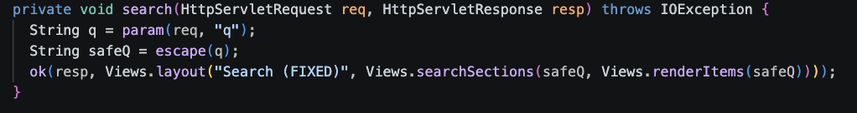

4.3 /asmt/userByEmail
The vulnerable string-concatenation helper (SqlTemplates.lookupByEmail) was replaced with a parameterized PreparedStatement. The SQL text now uses a literal ? placeholder ("SELECT id, email FROM users WHERE email = ?"), and the user-supplied email is bound separately via ps.setString(1, email). This guarantees the database driver treats the email strictly as data, never as part of the SQL syntax, eliminating the injection vector regardless of what characters the value contains.
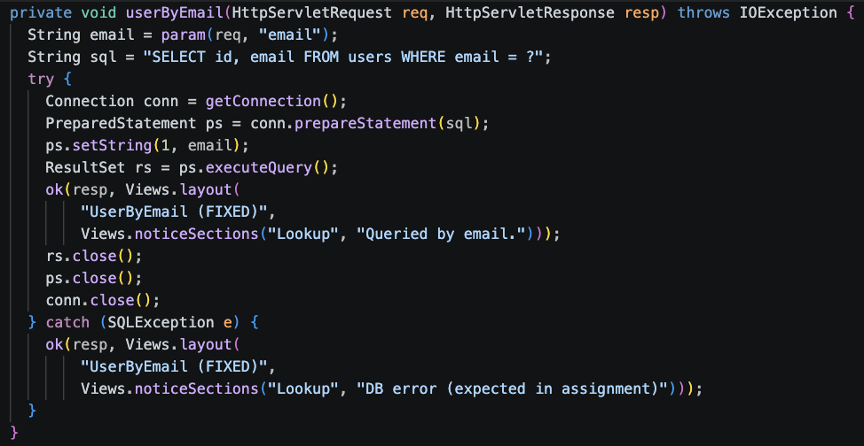

5. Verification - Rescan After Fix
The same command was re-run against the patched file: semgrep --dataflow-traces --config assignment_rules_starter.yaml assignment. The scan reported 0 findings (0 blocking) across both rules, confirming that the sanitizer (escape()) now sits between every taint source and the HTML sinks for the XSS rule, and that the SQLi rule no longer detects any tainted data reaching a SQL execution sink, since the query is fully parameterized.
