Front-End (React) Coding Challenge

(Duration 3 hours)

Create a React Application that manages a doctors information. Implement the following requirements in React Application:

1. Provide the following navigations from the home page:
   1. Home
   2. Doctors
   3. About Us
   4. Contact Us
   5. Login
2. Home Page: It should provide navigation links, Banner, Footer, Some Information about the website.
3. Doctors Page:
   1. Each doctor should have the following attributes:
      * Doctor Id, Doctor Name, Contact Number, E-mail, Speciality, Degree
   2. Allows Display all doctors details, Add a doctor, (Delete – Optional)
   3. Try to display doctors details in cards format
   4. Data should exchange between Express API and React App
   5. It is protected page, user can access this page only after login with proper credentials.
4. Login Page:
   1. Verify the credentials in client application and use some static value as token
   2. No need to communicate with server
5. About and Contact Page:
   1. Provide the required information in these pages and add some images suitable to this requirement.

Points to be considered while implement the above Requirements:

* Use Express JS for back-end REST API.
* Should implement service in Front-end Application to communicate with server
* Optionally: Apply styles where ever it is required
* Should follow the proper coding standards in components, service development
* Should implement not found route also

HomePage:



Doctos Page:

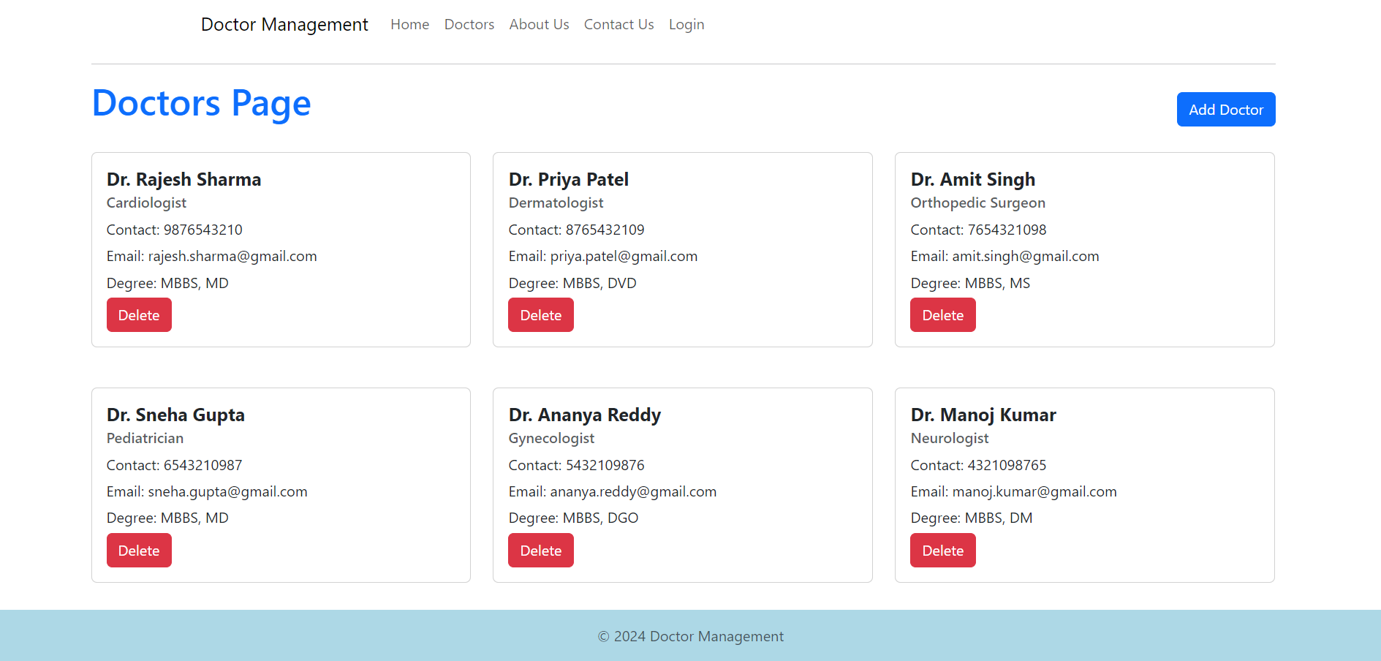

Login page

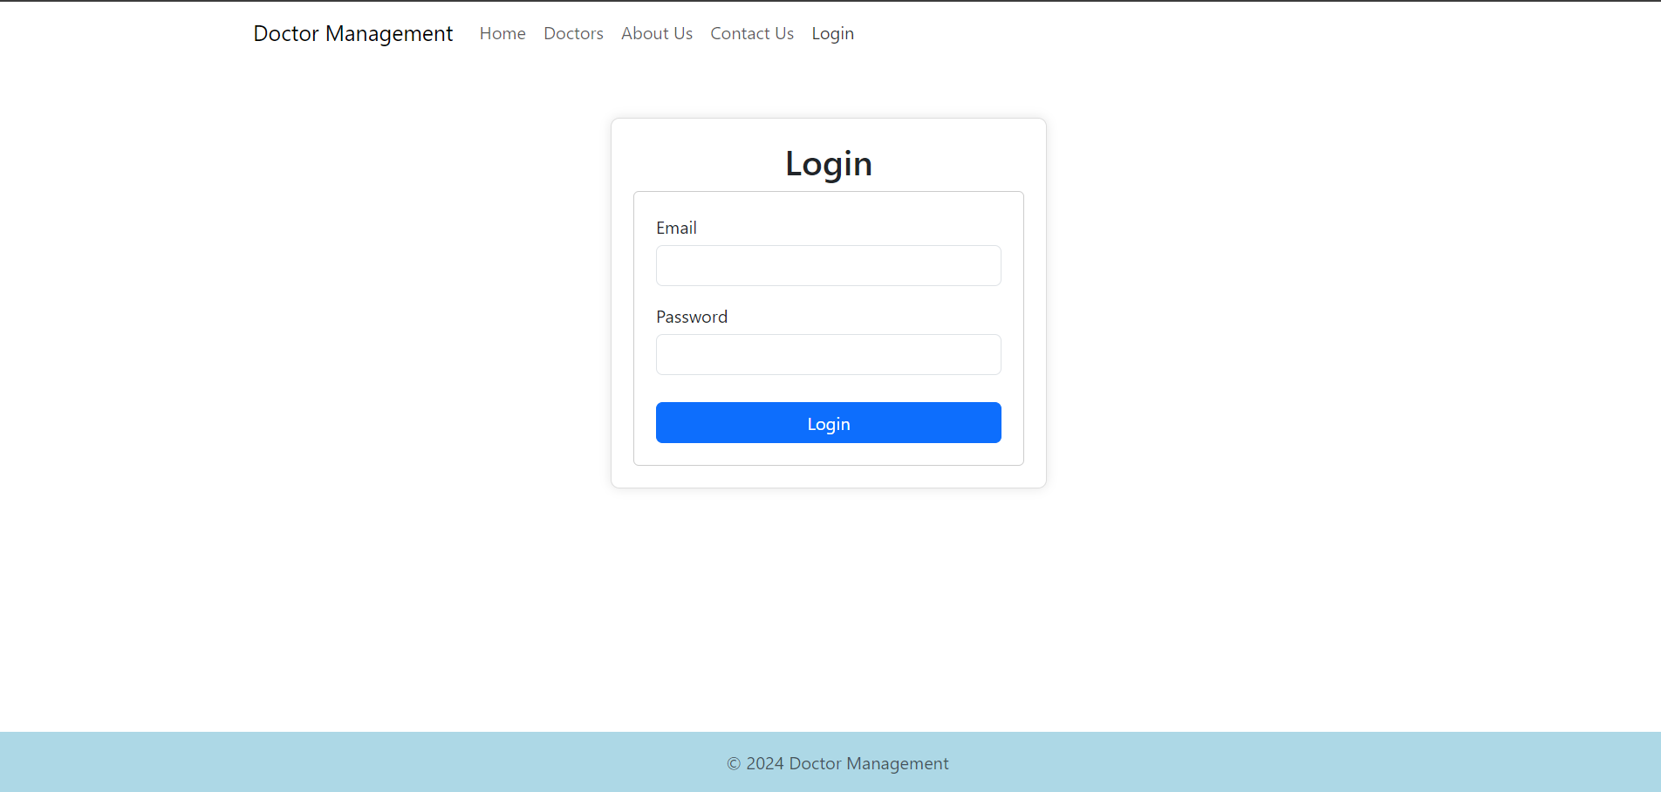

About Page



Contact Us Page

