Object: To determine the time domain responses by using matlab.

1. For impulse response:

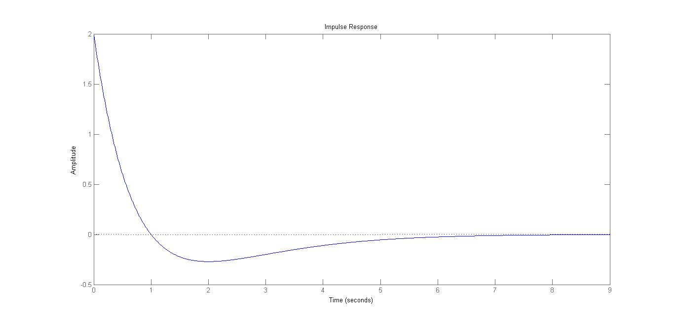

2. For unit step input:

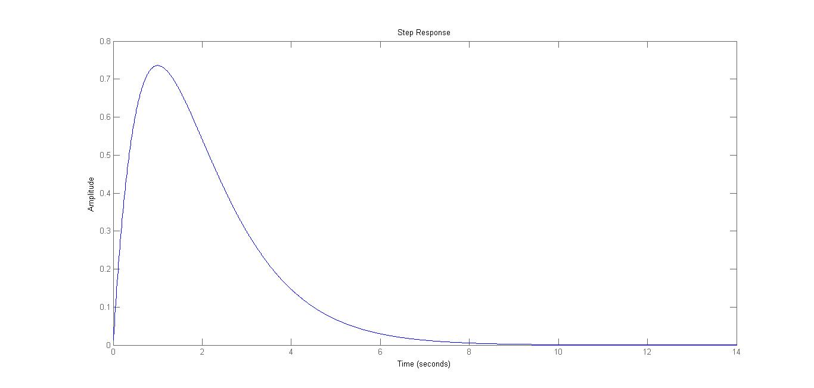

1. For parabolic Response:

