TASK NO:01

OBJECTIVE: To find out the temperature value in different scale.

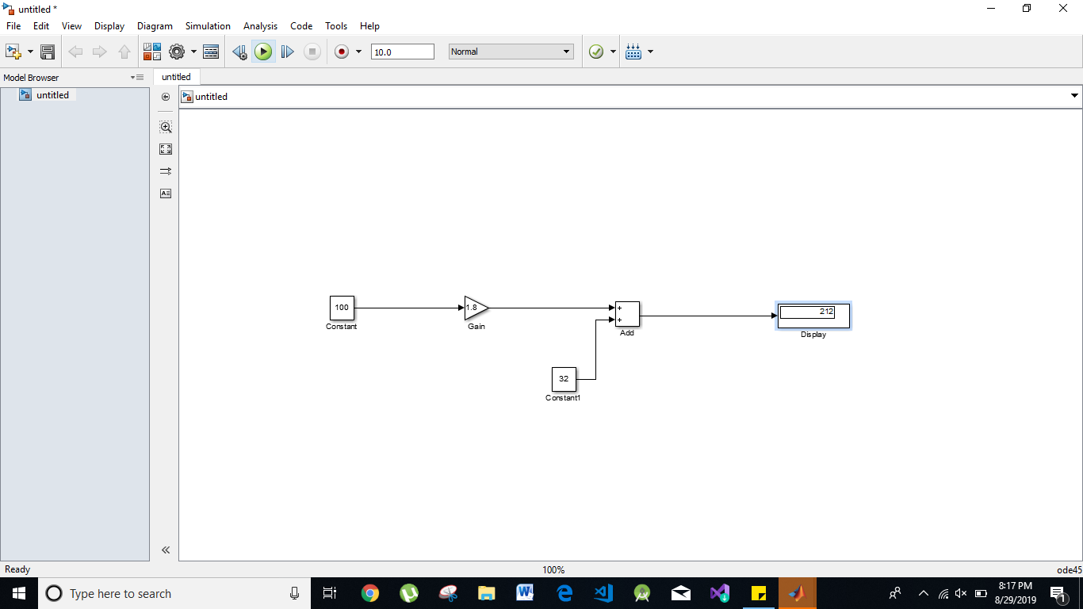

1.Determining the derivative of ramp input.

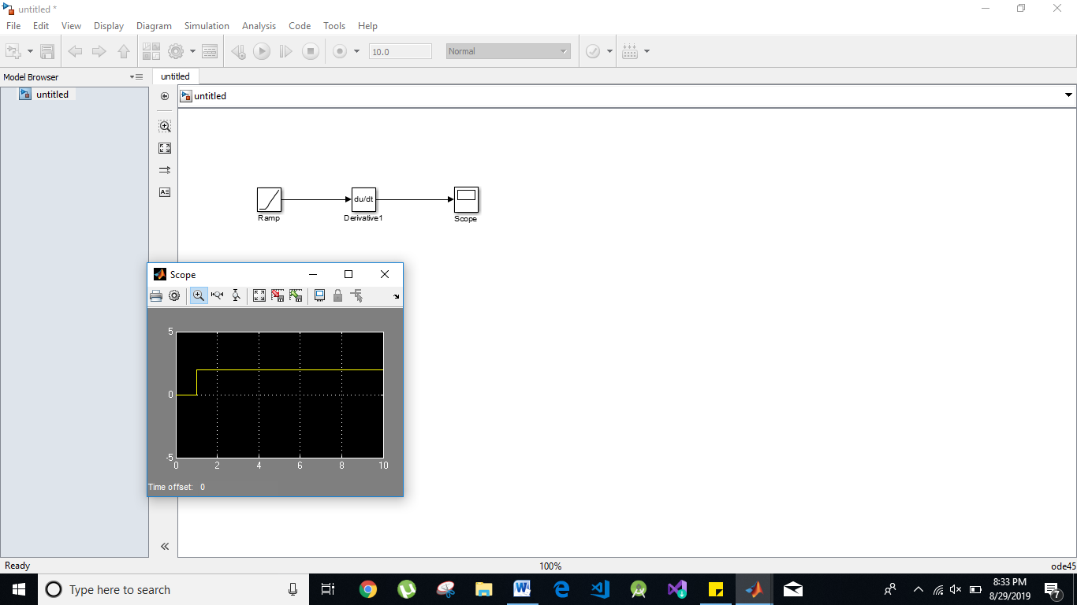

2. Observe the output of sinewave.

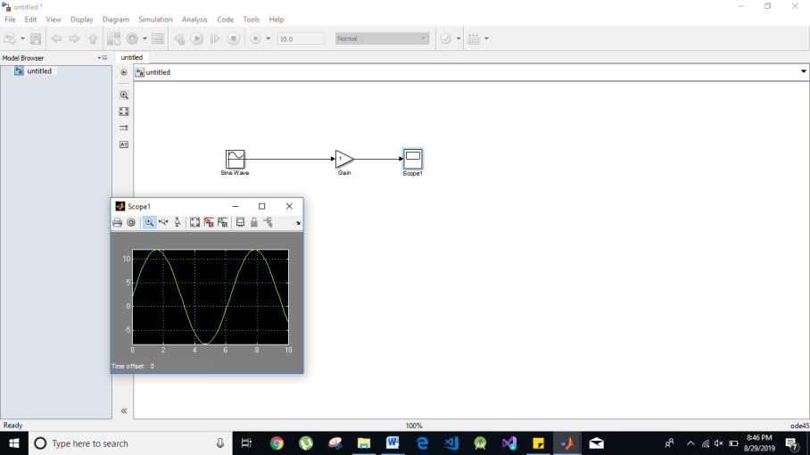

3. Determine the integrative of step input.

.0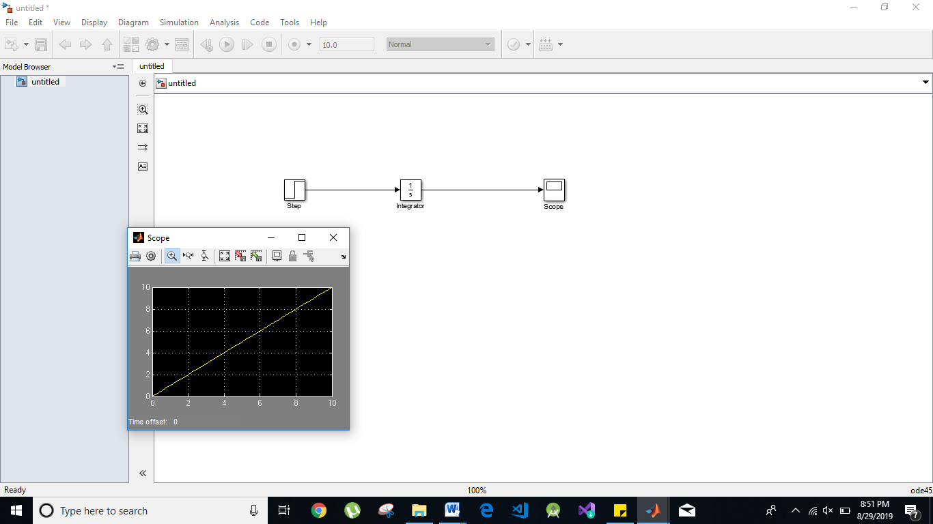

4. Determine the response of integration of ramp input.

