Assignment 1

1.Print Assignment 1
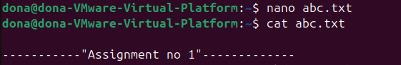
2.Folder with Roll no

3.Change directory


4.Create SelfIntroduction.txt

5.print Self Introduction via cpp
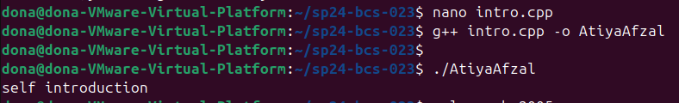

6.Exe file name Atiya Afzal

7.Print contents of SelfIntriduction.txt
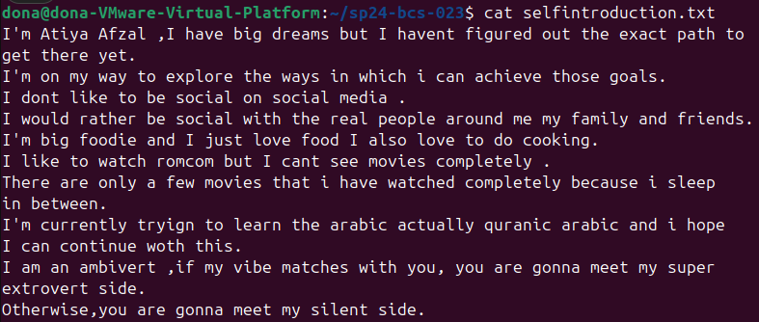

8.Calender of birthday month

