Q1
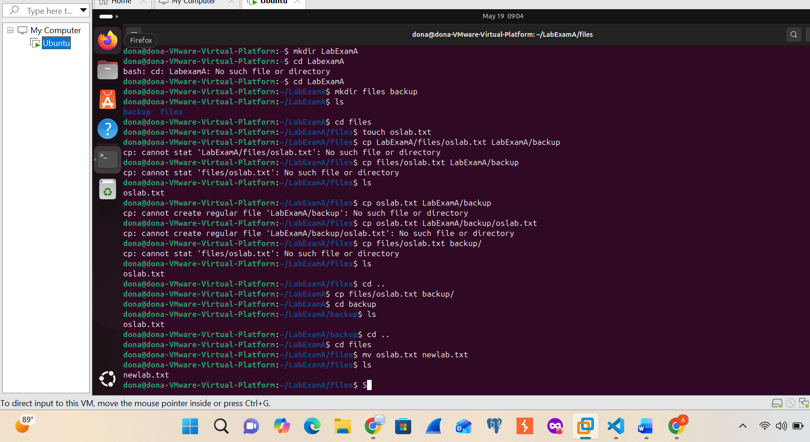
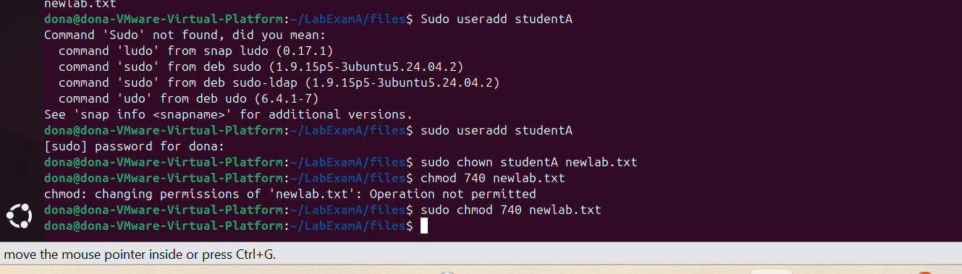
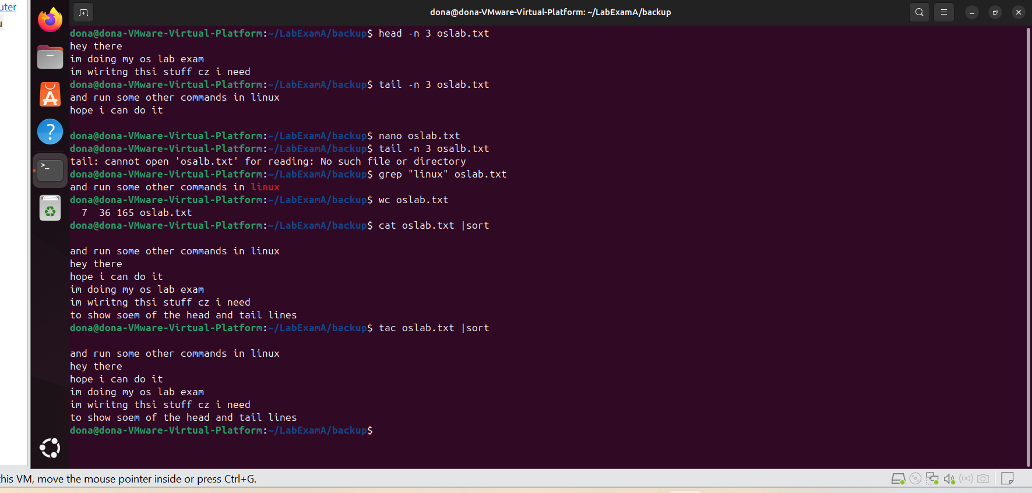

Q2
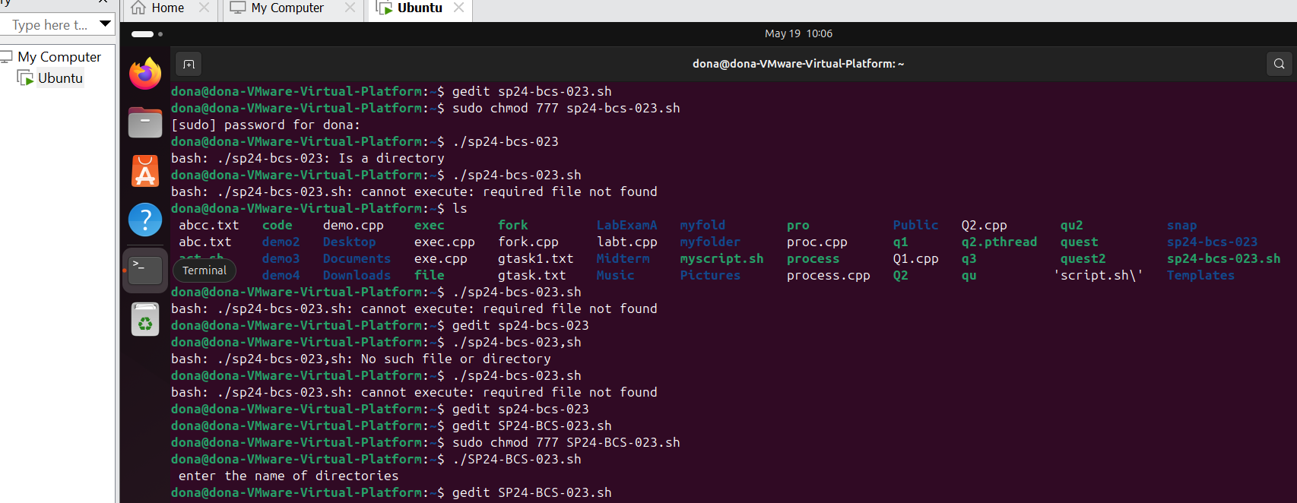
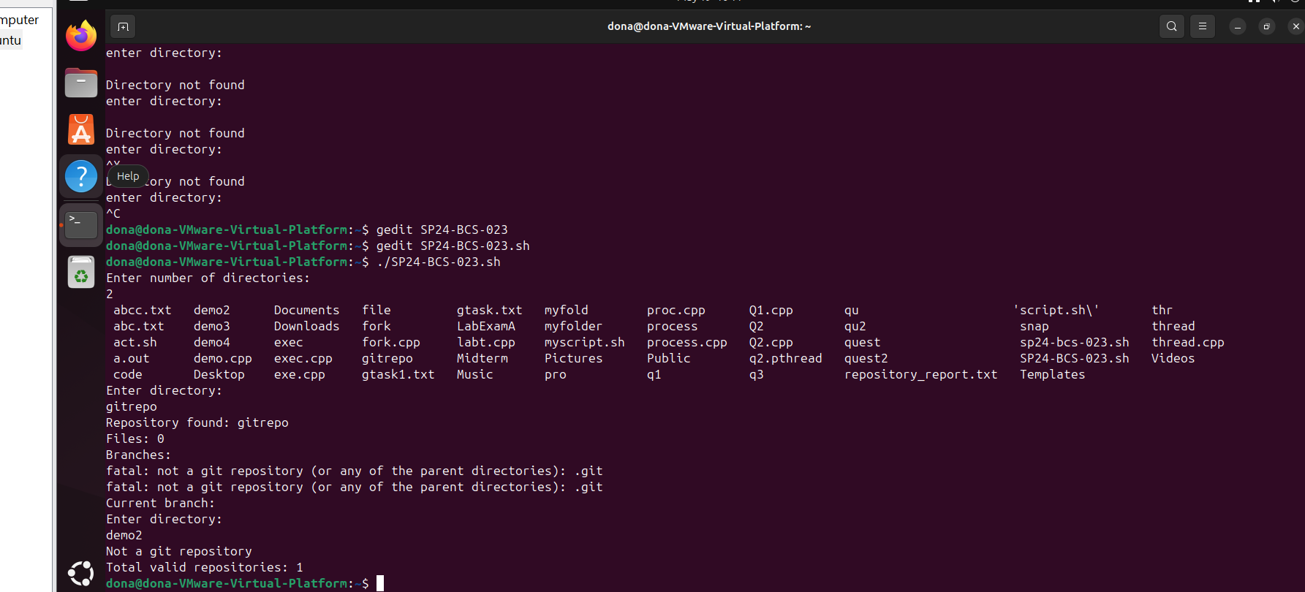
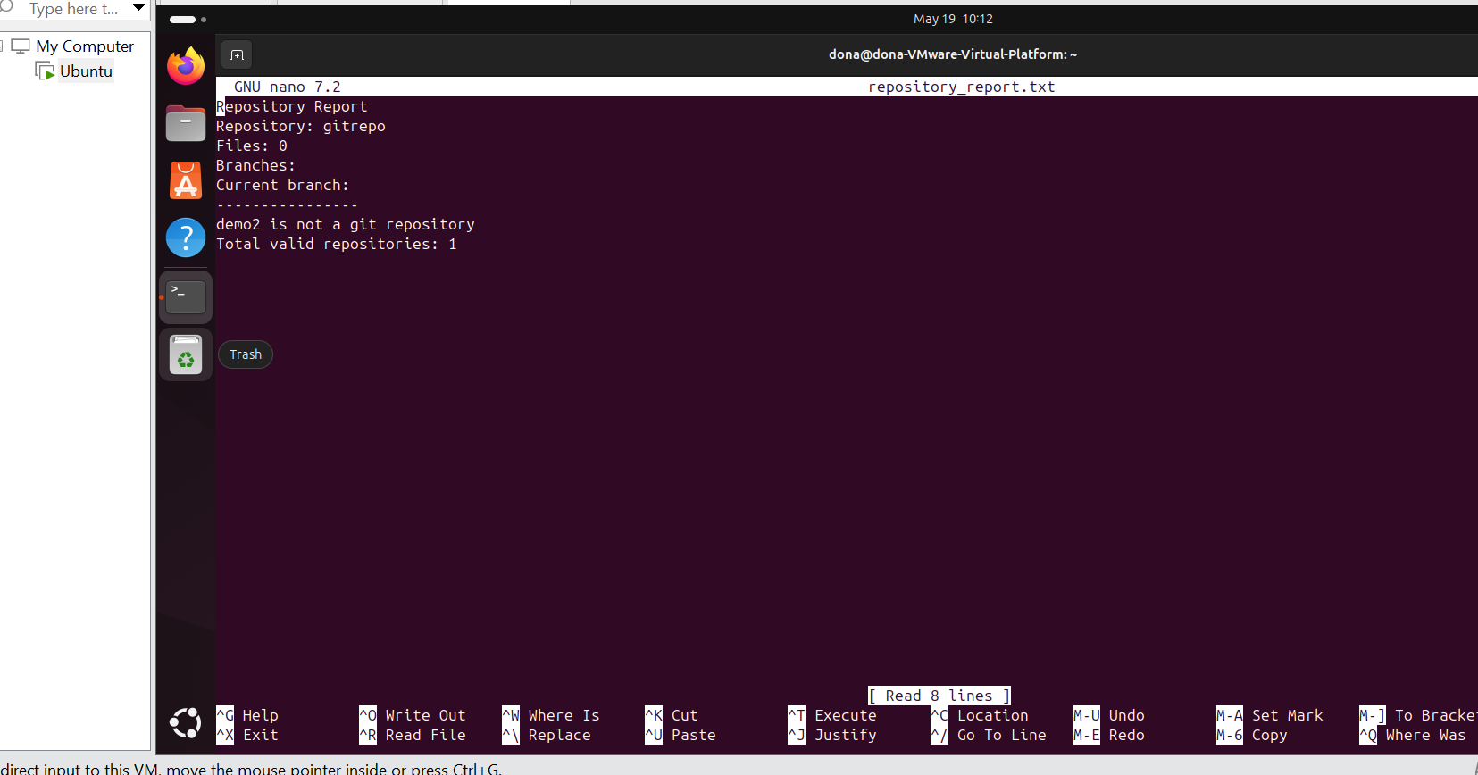
#!/bin/bash

echo "Repository Report" > repository_report.txt

valid=0

echo "Enter number of directories:"
read n

i=1
ls
while [ $i -le $n ]
do
echo "Enter directory:"
read dir

if [ -d "$dir" ]
then
if [ -d "$dir/.git" ]
then
echo "Repository found: $dir"
echo "Repository: $dir" >> repository_report.txt

files=$(find "$dir" -type f | wc -l)
echo "Files: $files"
echo "Files: $files" >> repository_report.txt

echo "Branches:"
echo "Branches:" >> repository_report.txt
git -C "$dir" branch | tee -a repository_report.txt

branch=$(git -C "$dir" branch --show-current)
echo "Current branch: $branch"
echo "Current branch: $branch" >> repository_report.txt

echo "----------------" >> repository_report.txt
valid=$((valid + 1))
else
echo "Not a git repository"
echo "$dir is not a git repository" >> repository_report.txt
fi
else
echo "Directory not found"
echo "$dir does not exist" >> repository_report.txt
fi

i=$((i + 1))
done

echo "Total valid repositories: $valid"
echo "Total valid repositories: $valid" >> repository_report.txt

Q3
Part A
#include <iostream>
#include <unistd.h>
#include <sys/wait.h>
#include <cstdlib>
#include <ctime>

using namespace std;

bool isPrime(int n) {
if (n < 2)
return false;

for (int i = 2; i * i <= n; i++) {
if (n % i == 0)
return false;
}

return true;
}

int main() {

int arr[1000];

srand(time(0));

for (int i = 0; i < 1000; i++) {
arr[i] = rand() % 100 + 1;
}

pid_t child1 = fork();

if (child1 == 0) {

int primeCount = 0;

for (int i = 0; i < 500; i++) {
if (isPrime(arr[i])) {
primeCount++;
}
}

cout << "Prime number in first 500 (by child 1): "
<< primeCount << endl;

exit(0);
}

pid_t child2 = fork();

if (child2 == 0) {

int primeCount = 0;

for (int i = 500; i < 1000; i++) {
if (isPrime(arr[i])) {
primeCount++;
}
}

cout << "Prime number in second 500 (by child 2): "
<< primeCount << endl;

exit(0);
}

wait(NULL);
wait(NULL);

return 0;
}
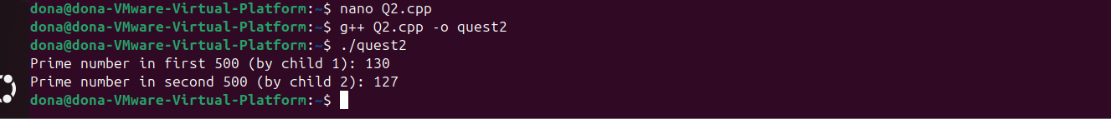
Part B
#include <iostream>
#include <thread>
#include <mutex>

using namespace std;

int var = 0;
mutex m;

void increment() {
for (int i = 0; i < 100000; i++) {
m.lock();
var++;
m.unlock();
}
}

int main() {
thread t1(increment);
thread t2(increment);

t1.join();
t2.join();

cout << var << endl;
}
