- Press “.” to open a web editor in github
- git clone … (copy the github link in the green button naming code in github to clone the project in the src folder of the workspace)

Github commands to push in the terminal:
- git status
- git add . → if there several files which are red
- git commit -m “diff_control”

For the two_driven_wheeled robot:
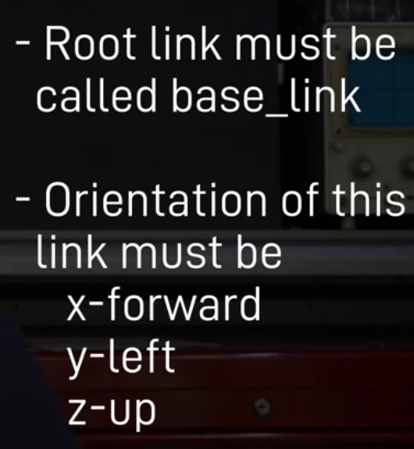

odom → is the odom world origin → robot start position
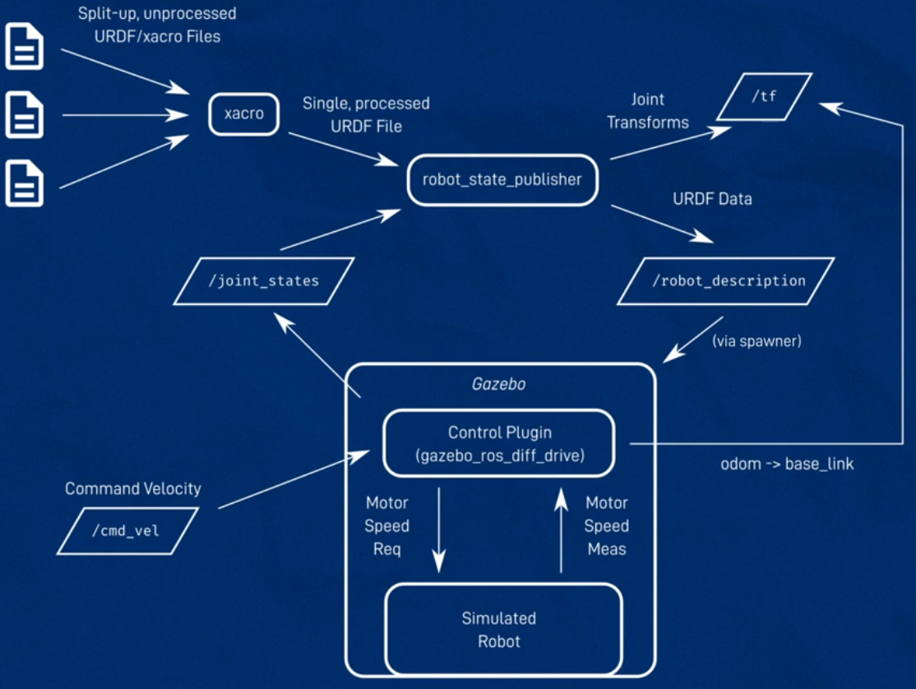

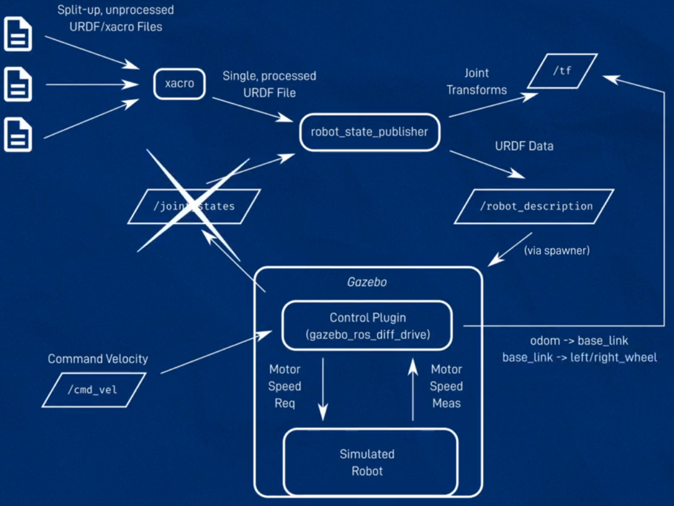

To move the robot around:
- ros2 run teleop_twist_keyboard teleop_twist_keyboard
For controlling the robot with joy stick:
- teleop_twist_joy – teleop_node
- from the joy – joy_node
Power
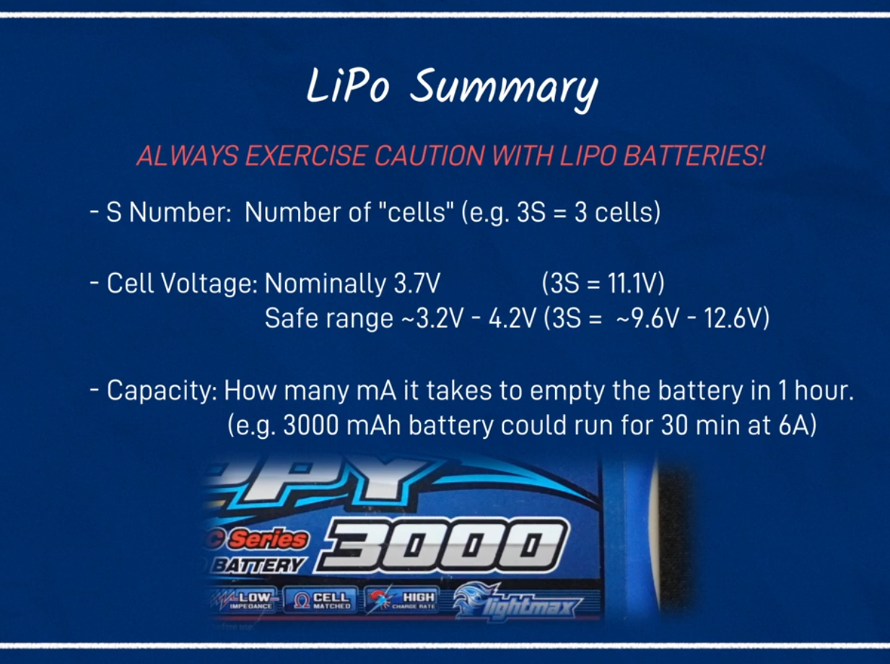

To find the connected usbs:
- ls /dev/serial/by-id -→(maybe working in raspberry pi!)
- lsusb → it gets the usb devices id. So, to read from the lidar connected to the comuter by the usb port we can: ros2 run rplidar_ros rplidar_composition –ros-args -p serial_port:=(input_the_id)

to load compressed images of cameras:
- ros2 run rqt_image_view rqt_image_view

check what image formats are available:
- ros2 run image_transport list_transports

to uncompressed the compressed image:
- ros2 run image_transport republish compressed raw –ros-args -r in/compressed:=/camera/mage_raw/compressed -r out:=/camera/image_raw/uncompressed
- using for compression, sending over a network, and then uncompression.

to see whether a ros2 package is installed or not:
- ros2 pkg prefix image_transport_plugins → if yes the path of that package will be shown.

To check if the raspberry pi is under voltage:
- vcgencmd get_throttled

To check if the raspberry pie is searching for a monitor or not:
- if we type journalctl -fe:
  - every few seconds RPI restarts the display manager (extra cpu usage when we do not use monitor)
- But if we have no monitor we can disable it (disable lightdm.service)
- systemctl get-default → if it gets back graphical.target --> the current default level is graphical
- sudo systemctl set-default multi-user.target
- to swap back: sudo systemctl set-default graphical.target

To interacting with ros2_control (after defining yaml file):
- ros2 control list_hardware_interfaces
- ros2 control list_controllers
- start our controller → ros2 run controller_manager spawner diff_cont

Odom and map topics:

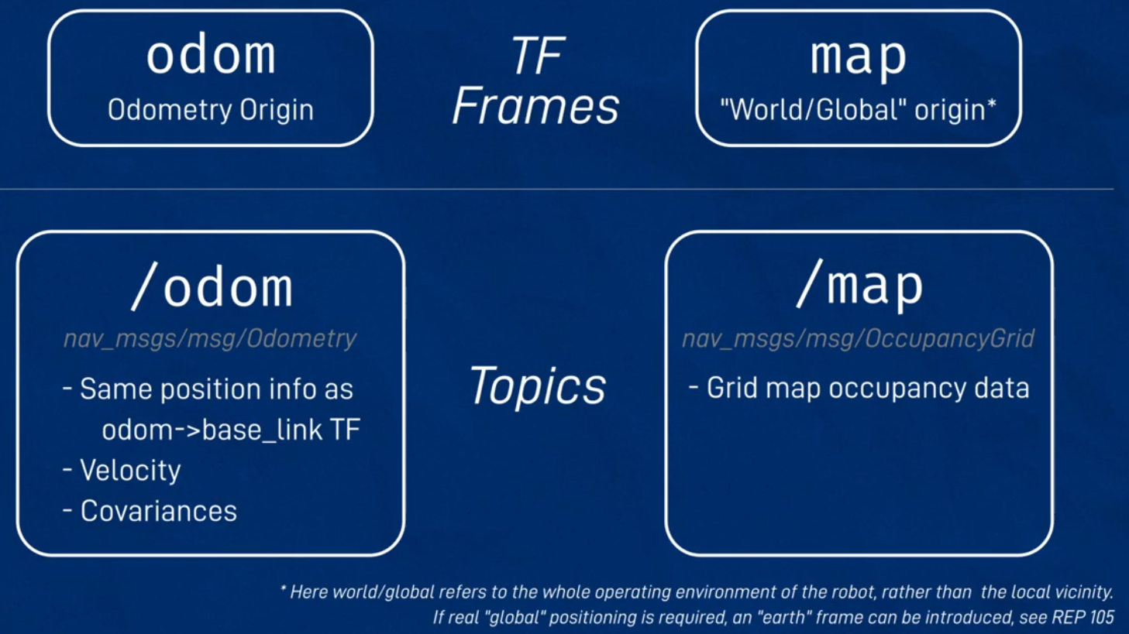

More info about Tfs:
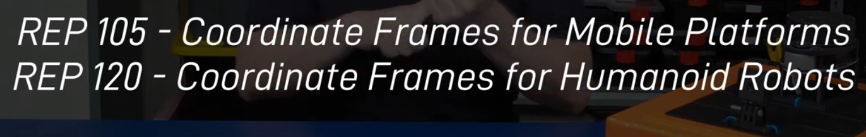

To run the slam_toolbox:
- ros2 launch slam_toolbox online_async_launch.py params_file:=./src/my_bot/config/mapper_params_online_async.yam; use_sim_time:=true

To load map with map_server and run amcl:
- AMCL implements the server for taking a static map and localizing the robot within it using an Adaptive Monte-Carlo Localizer.
- First the gazebo sim node should be run.
- Second, rviz2 should be run along with teleop (optional)
- Third, the loadmap.launch.py should be loaded using:
  - ros2 launch my_bot loadmap.launch.py
- if the map tf is not loaded, it can be published by the command:
  - ros2 run tf2_ros static_transform_publisher 0 0 0 0 0 0 map odom
  - it should be set as map to odom. Otherwise an error may be raised complaining: a loop in tf free is found.
- Finally, amcl node should be run using the commands:
  - run nav2_amcl amcl --ros-args -p use_sim_time:=true
  - ros2 run nav2_util lifecycle_bringup amcl
- After that, the initial pose should be set in rviz (or initial pose topic should be published)

Using twist_mux to gather together to different twist commands:
- ros2 run twist_mux twist_mux --ros-args -r /cmd_vel_out:=/diff_cont/cmd_vel_unstamped --params-file ./src/my_bot/config/twist_mux.yaml

To use amcl instead of slam_toolbox with nav2:
- load gazebo, rviz2, joy, twist_mux
- remove previous map in the left panel and add a new one
- after that we shoud run the command:
  - ros2 launch nav2_bringup localization_launch.py map:=./my_map_save.yaml
- if the map tf is not displayed, run the following static_tf as always:
  - ros2 run tf2_ros static_transform_publisher 0 0 0 0 0 0 map odom

