Database Design Documentation

Relational Database Schema & Entity-Relationship Diagram

KIFAYAT AUTO PARTS

ATIZAZ SHAH & HOORISH KIYANI

Submitted: April 25, 2026

1. Entity-Relationship Diagram
The following ERD illustrates the complete database structure for the Kifayat Auto Parts e-commerce system, including all entities, attributes, primary keys (PK), foreign keys (FK), and relationships. The data source is the Kifayat Auto Parts daily sales ledger (2019–2023), containing 978 transaction records, 519 unique products, 69 daily orders, and 10 customer accounts.

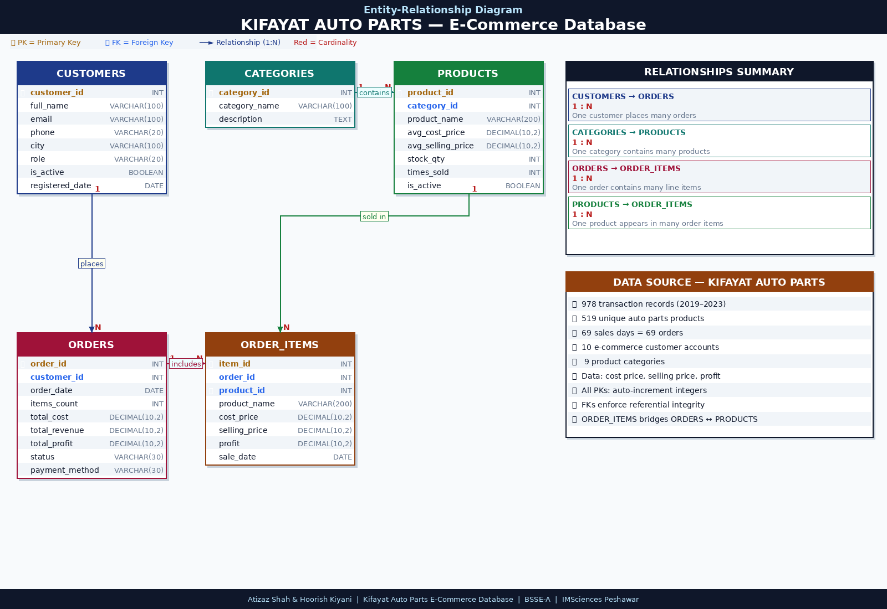
Figure 1. Entity-Relationship Diagram — Kifayat Auto Parts E-Commerce Database (5 Entities, 4 Relationships)

2. Relational Database Schema
The database consists of 5 core tables derived directly from the Kifayat Auto Parts sales dataset. Each table is described below with its attributes, data types, primary keys (PK), and foreign keys (FK).

2.1 CUSTOMERS
Attribute | Data Type | Constraint | Description
customer_id | INT | PRIMARY KEY | Unique identifier for each customer account
full_name | VARCHAR(100) | NOT NULL | Customer's full name
email | VARCHAR(100) | UNIQUE | Login email address
phone | VARCHAR(20) | NULL | Contact phone number
city | VARCHAR(100) | NULL | Customer city / delivery location
role | VARCHAR(20) | NOT NULL | Account role: customer or admin
is_active | BOOLEAN | NOT NULL | Account active status flag
registered_date | DATE | NOT NULL | Date the customer account was created

2.2 CATEGORIES
Attribute | Data Type | Constraint | Description
category_id | INT | PRIMARY KEY | Unique identifier for each product category
category_name | VARCHAR(100) | NOT NULL | Name of the category (e.g., Wheels, Paint & Spray)
description | TEXT | NULL | Optional description of the category

2.3 PRODUCTS
Attribute | Data Type | Constraint | Description
product_id | INT | PRIMARY KEY | Unique identifier for each product
category_id | INT | FOREIGN KEY | References CATEGORIES(category_id)
product_name | VARCHAR(200) | NOT NULL | Product name as recorded in Kifayat sales data
avg_cost_price | DECIMAL(10,2) | NULL | Average purchase/cost price in PKR
avg_selling_price | DECIMAL(10,2) | NOT NULL | Average selling price in PKR
stock_qty | INT | NOT NULL | Current available stock quantity
times_sold | INT | NOT NULL | Total number of times this product was sold
is_active | BOOLEAN | NOT NULL | Whether the product is visible in the store

2.4 ORDERS
Attribute | Data Type | Constraint | Description
order_id | INT | PRIMARY KEY | Unique order identifier (one per sales day)
customer_id | INT | FOREIGN KEY | References CUSTOMERS(customer_id)
order_date | DATE | NOT NULL | Date of the sales transaction
items_count | INT | NOT NULL | Total number of individual items in this order
total_cost | DECIMAL(10,2) | NOT NULL | Sum of all cost prices in the order (PKR)
total_revenue | DECIMAL(10,2) | NOT NULL | Sum of all selling prices in the order (PKR)
total_profit | DECIMAL(10,2) | NOT NULL | Total profit earned on this order (PKR)
status | VARCHAR(30) | NOT NULL | Order status: pending / confirmed / delivered
payment_method | VARCHAR(30) | NOT NULL | Payment method: cash_on_delivery / bank_transfer

2.5 ORDER_ITEMS
Attribute | Data Type | Constraint | Description
item_id | INT | PRIMARY KEY | Unique identifier for each order line item
order_id | INT | FOREIGN KEY | References ORDERS(order_id)
product_id | INT | FOREIGN KEY | References PRODUCTS(product_id)
product_name | VARCHAR(200) | NOT NULL | Product name captured at time of sale
cost_price | DECIMAL(10,2) | NULL | Purchase cost recorded for this item (PKR)
selling_price | DECIMAL(10,2) | NOT NULL | Price at which the item was sold (PKR)
profit | DECIMAL(10,2) | NULL | Profit on this line item (selling − cost)
sale_date | DATE | NOT NULL | Date of this individual sale transaction

3. Relationships Summary

Relationship | Type | FK Column | Description
CUSTOMERS → ORDERS | 1 : N | orders.customer_id | One customer places many orders
CATEGORIES → PRODUCTS | 1 : N | products.category_id | One category contains many products
ORDERS → ORDER_ITEMS | 1 : N | order_items.order_id | One order contains many line items
PRODUCTS → ORDER_ITEMS | 1 : N | order_items.product_id | One product appears in many order items

4. Design Notes & Constraints

• All primary keys use auto-increment integers (SERIAL / INT AUTO_INCREMENT).
• Foreign keys enforce referential integrity at the database level — no orphan records can exist.
• ORDER_ITEMS resolves the many-to-many relationship between ORDERS and PRODUCTS, acting as a bridge table. Every individual sale from the Kifayat ledger is stored as one row in ORDER_ITEMS.
• selling_price in ORDER_ITEMS is captured at the time of sale to preserve historical accuracy — it is never overwritten even if the product price changes later.
• profit = selling_price − cost_price. This is stored as a column (not computed at query time) to match the original Kifayat ledger format and allow reporting without recalculation.
• stock_qty in PRODUCTS is reduced when orders are confirmed, preventing overselling.
• The CATEGORIES table uses 9 categories derived from the product names in the Kifayat dataset: Accessories, Cleaning, Electrical, Exterior, General Auto Parts, Interior, Mechanical, Paint & Spray, Wheels.
• The ERD was produced using a professional digital drawing tool — no hand-drawn elements are present.
• The complete normalized dataset is available in KIFAYAT_Database_Dataset.xlsx with sheets: CUSTOMERS, CATEGORIES, PRODUCTS, ORDERS, ORDER_ITEMS.

