

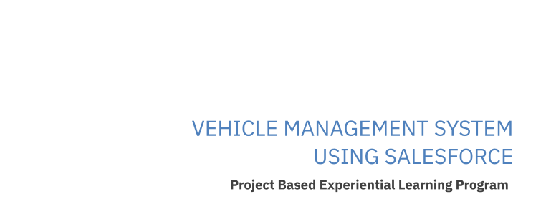

1. INTRODUCTION:

1.1)Overview

Vehicle Management is an application where a customer Details are stored in order to choose cars,bikes and commercial vehicles for travel with in the city.The data which is stored here is further used to remind them if any offers are provided during the seasons and any updates regarding vehicles are sent to them in the form of messages and mails.

1.2)Purpose

**To create** Vehicle Management is an application where a customer Details are stored in order to choose cars,bikes and commercial vehicles for travel with in the city.The data which is stored here is further used to remind them if any offers are provided during the seasons and any updates regarding vehicles are sent to them in the form of messages and mails.

1. **PROBLEM DEFINITION & DESIGN THINKING:**

**2.1)Empathy Map**

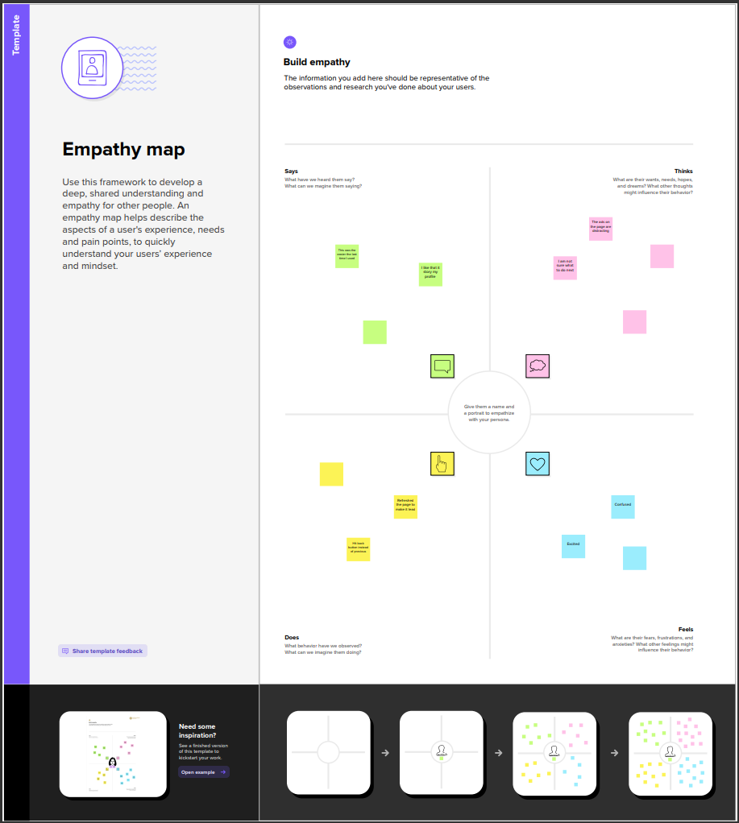

**2.2)Ideation & Brainstoming Map**

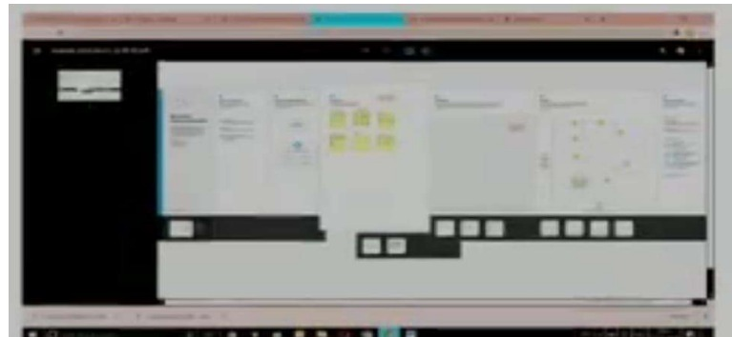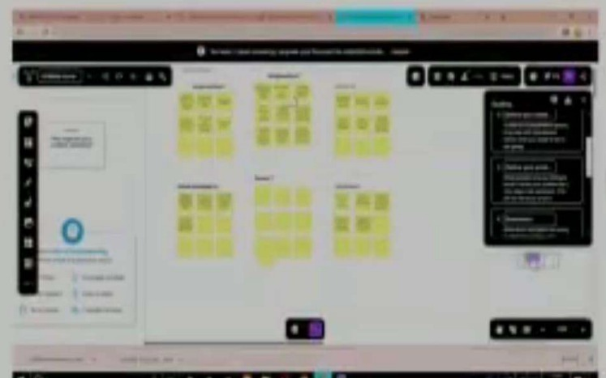

1. **RESULT:**

**3.1)Data Model**

**Object1: Vehicle**

|  |  |  |
| --- | --- | --- |
| S NO. | Field Names | Data Types |
| 1. | Customer Name | Text |
| 2 | Customer Mobile No | Number |
| 3 | Vehicle Type  i)2 wheeler ii)4 wheeler | Picklist |
| 4. | 2WHEELERS  i) HERO ii)HONDA iii)BAJAJ iv)ROYAL ENFIELD v)TVS vi)KINETIC vii)OLA viii)JAWA ix)SD  x)BATTERY | Picklist |
| 5 | 4WHEELERS  i) RENAULT ii)SKODA iii) HONDA iv)HYUNDAI v)SUZUKI | Picklist |

|  |  |  |
| --- | --- | --- |
|  | vi)MAHINDRA vii)VOLKSWAGEN viii)BENZ ix)AUDI  x)VOLVO |  |
| 6. | Vehicle Name | Text |
| 7. | Vehicle No | Text |
| 8. | Chassic No | Text |
| 9. | Colour | Text |
| 10. | Body Type | Text |
| 11. | Vehicle Includes  i)Fire Extenuation ii)First Aid Kit iii)Multi Charger kit  iv)Stepney v)Stereo vi)Tool Kit vii)Tracking Device viii)Tyre Jack | Multi Picklist |
| 12. | Condition  i)Good  ii)Medium  iii)Least | Picklist |
| 13 | Mileage | Text |
| 14 | Seats | Number |
| 15 | Start Date | Date/Time |
| 16 | End Date | Date/Time |
| 17 | Opportunity | Lookup(opportunities) |

**Object2: Driver**

|  |  |  |
| --- | --- | --- |
| S No | Field | Data Type |
| 1 | Driver Name | Text |
| 2 | Licence No | Text |
| 3 | Mobile No | Number |
| 4 | Fair Per Hour | Text |
| 5 | Vehicle | Lookup(Vehicle) |

**3.2) Activity & Screenshot**

**Creation of Salesforce ORG**

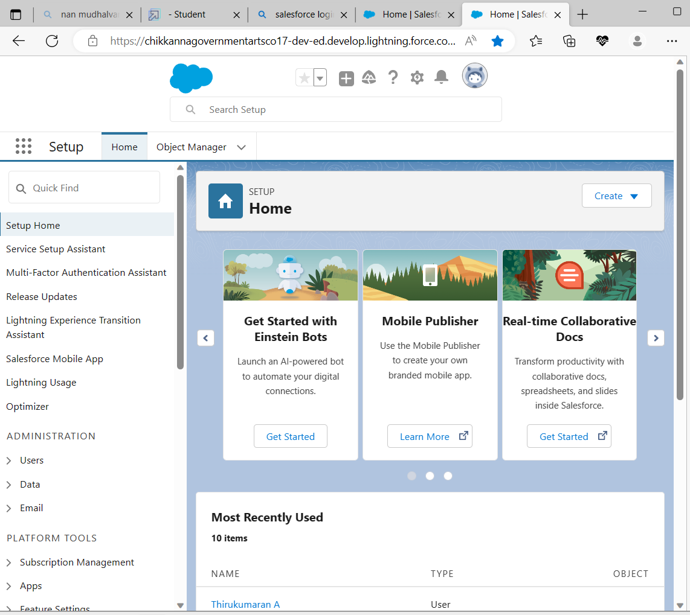

**We have created a developer account for salesforce account. Salesforce is your customer success platform.**

**Our mail id and name are given to get developer account.**

**Create an Object**

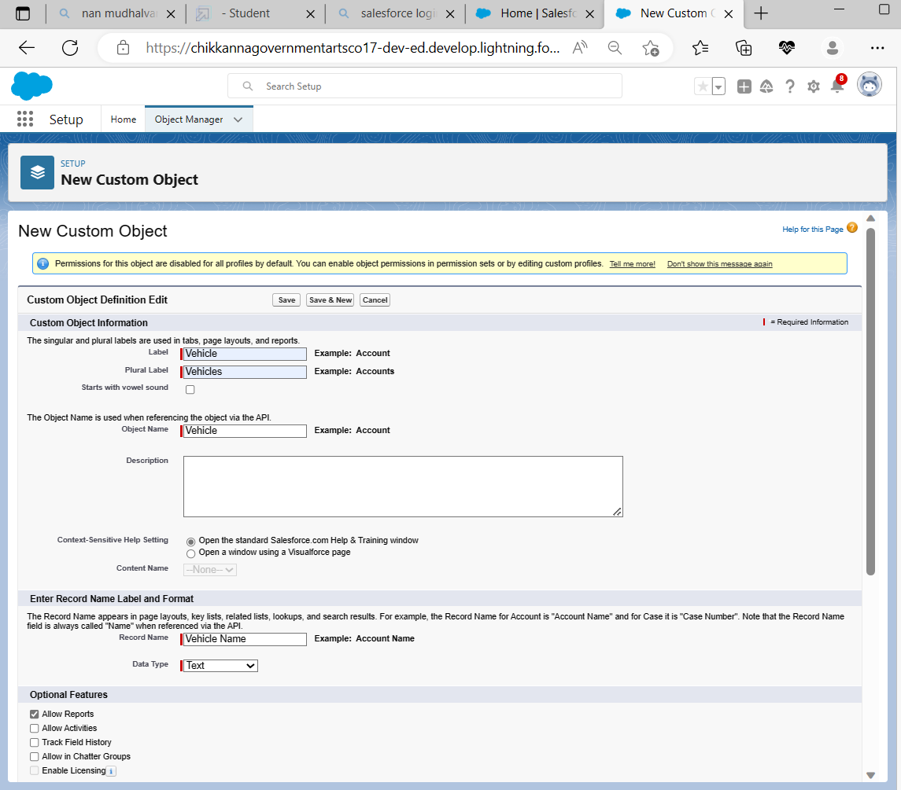

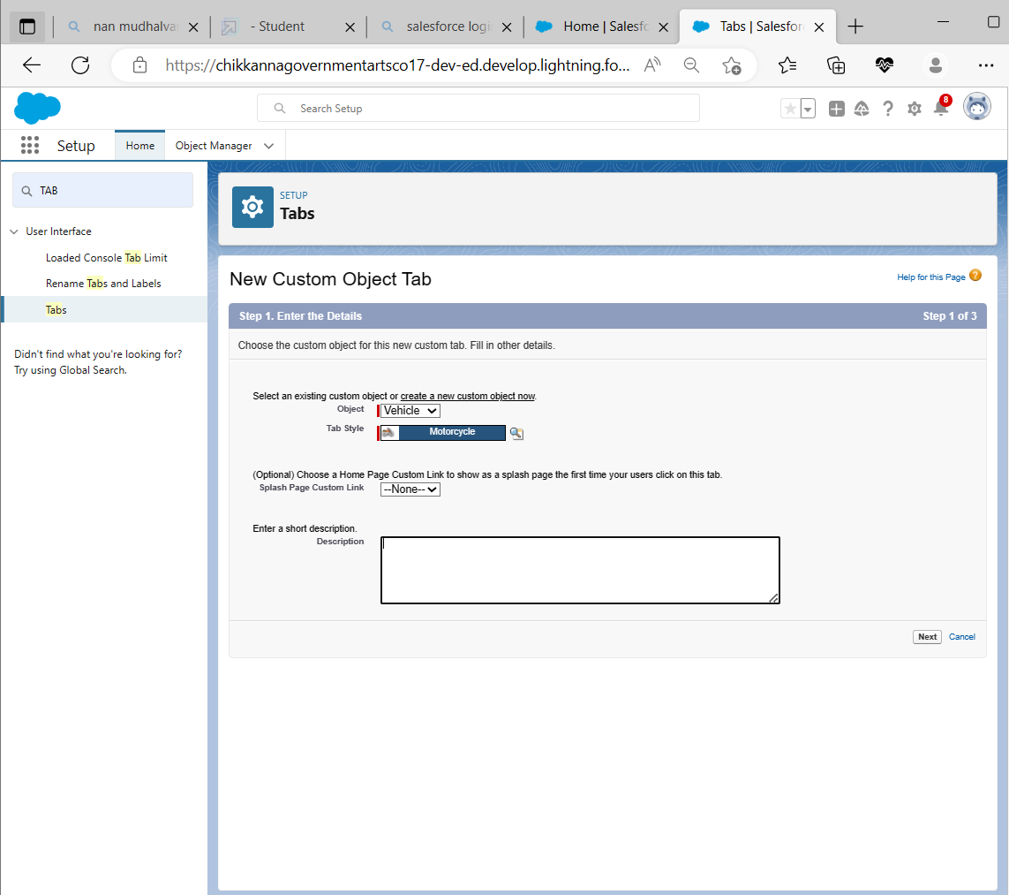

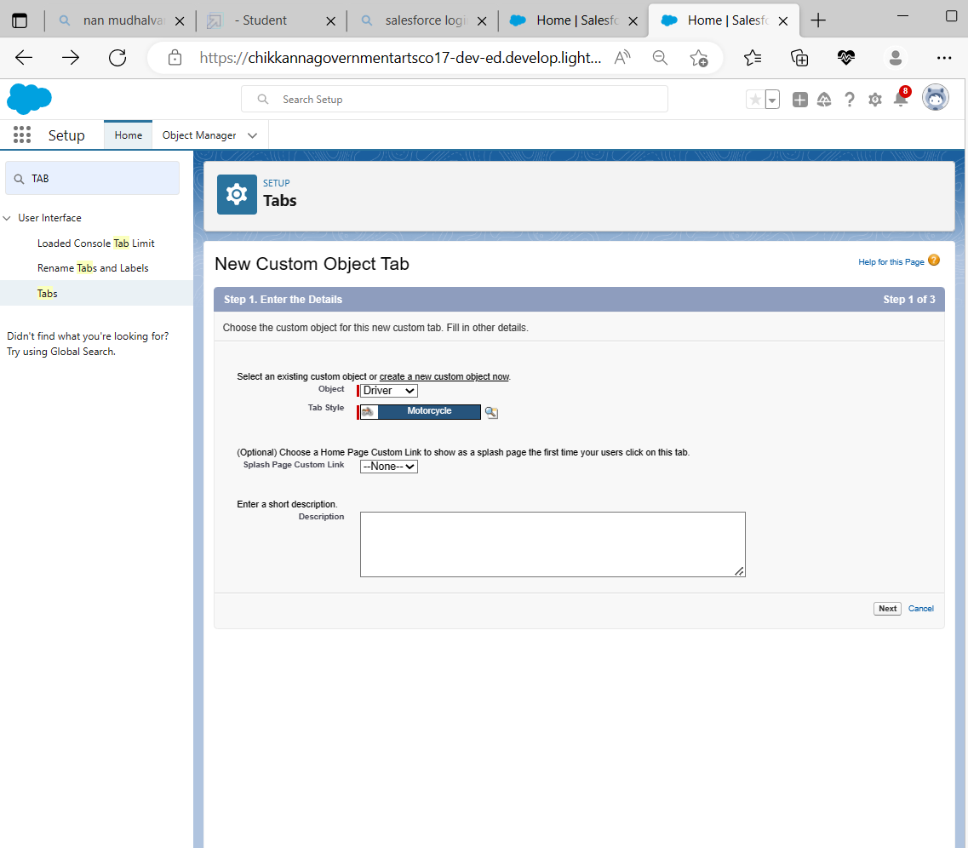

Creation of Objects for Vehicle Management, For this Vehicle Management we need to create 2 objects i.eVehicles,Driver

**Creation of Fields**

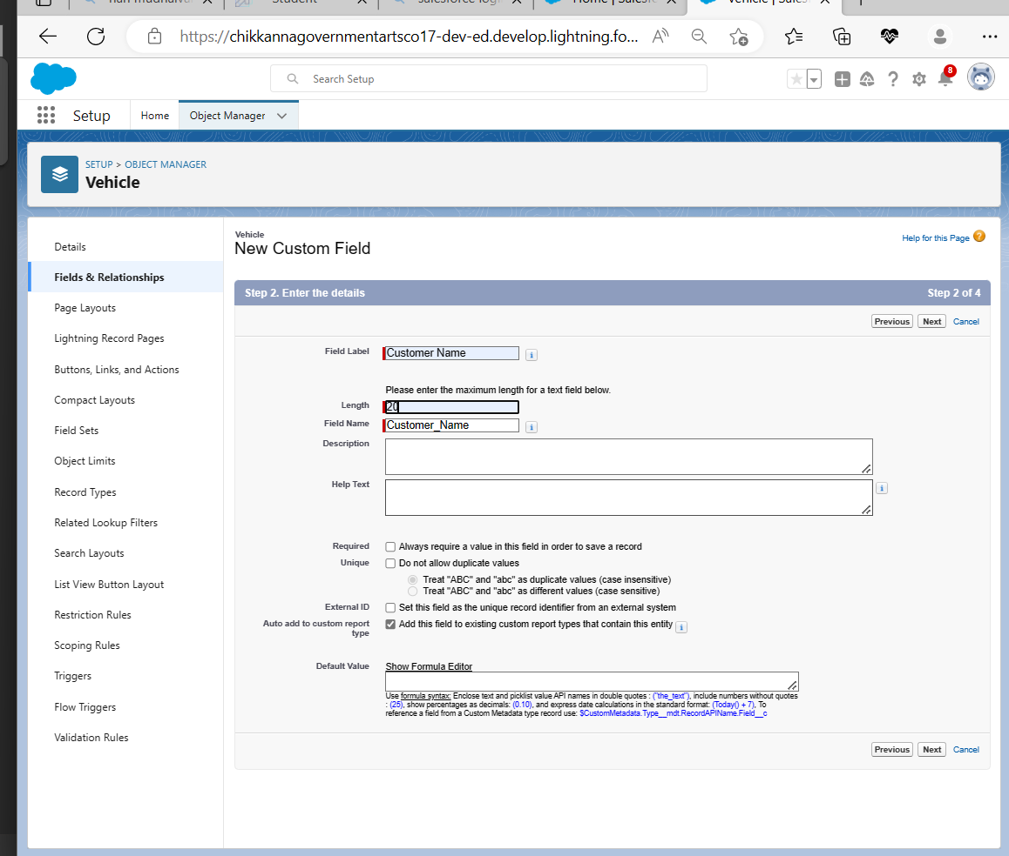

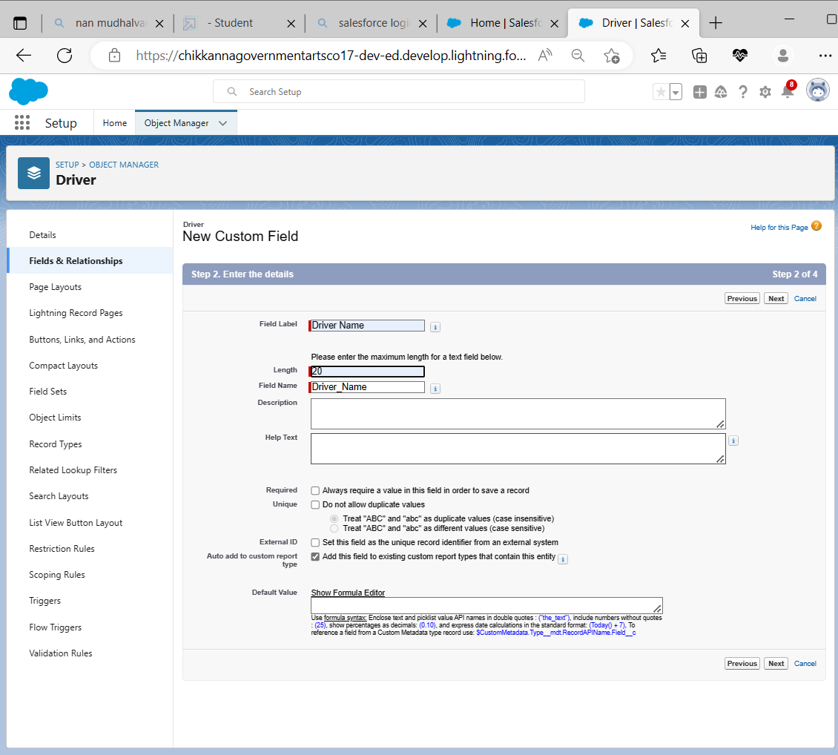

An object relationship in Salesforce is a two-way association between two objects.

Relationships are created by creating custom relationship fields on an object. This is done so that when users view records, they can also see and access related data.

**Fields in Driver Object**

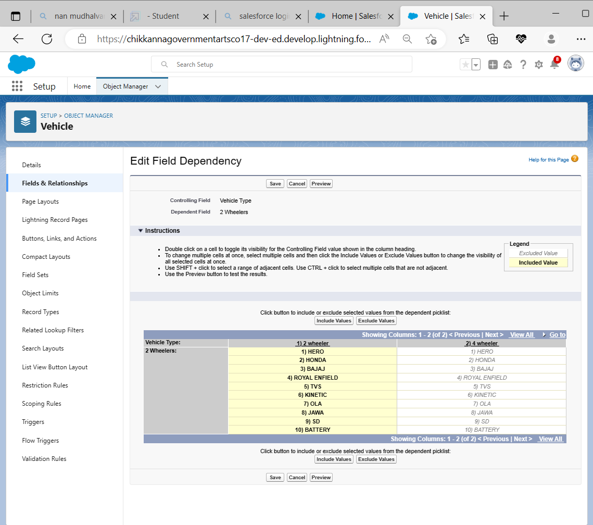

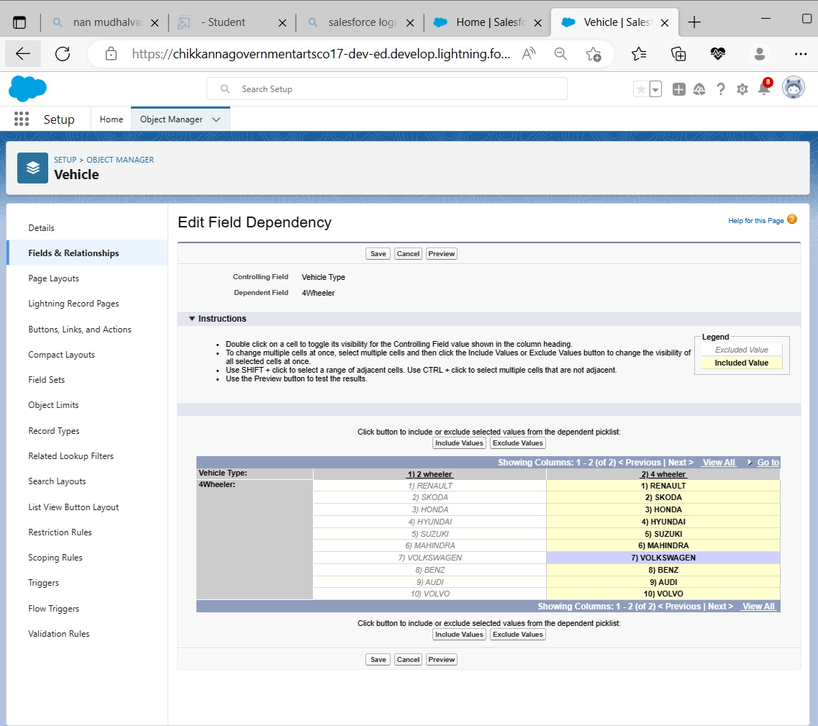

Create a dependency between these two picklists, so that when a Vehicle type is selected, only respective 2Wheeler Brands are available in the 2Wheeler field, Similarly for 4 wheelers

**Lightning App**

**Create the Vehicle Management Constraction App**

Apps in Salesforce are a group of tabs that help the application function by working together as a unit. It has a name, a logo, and a particular set of tabs. The simplest app usually has just two tabs.

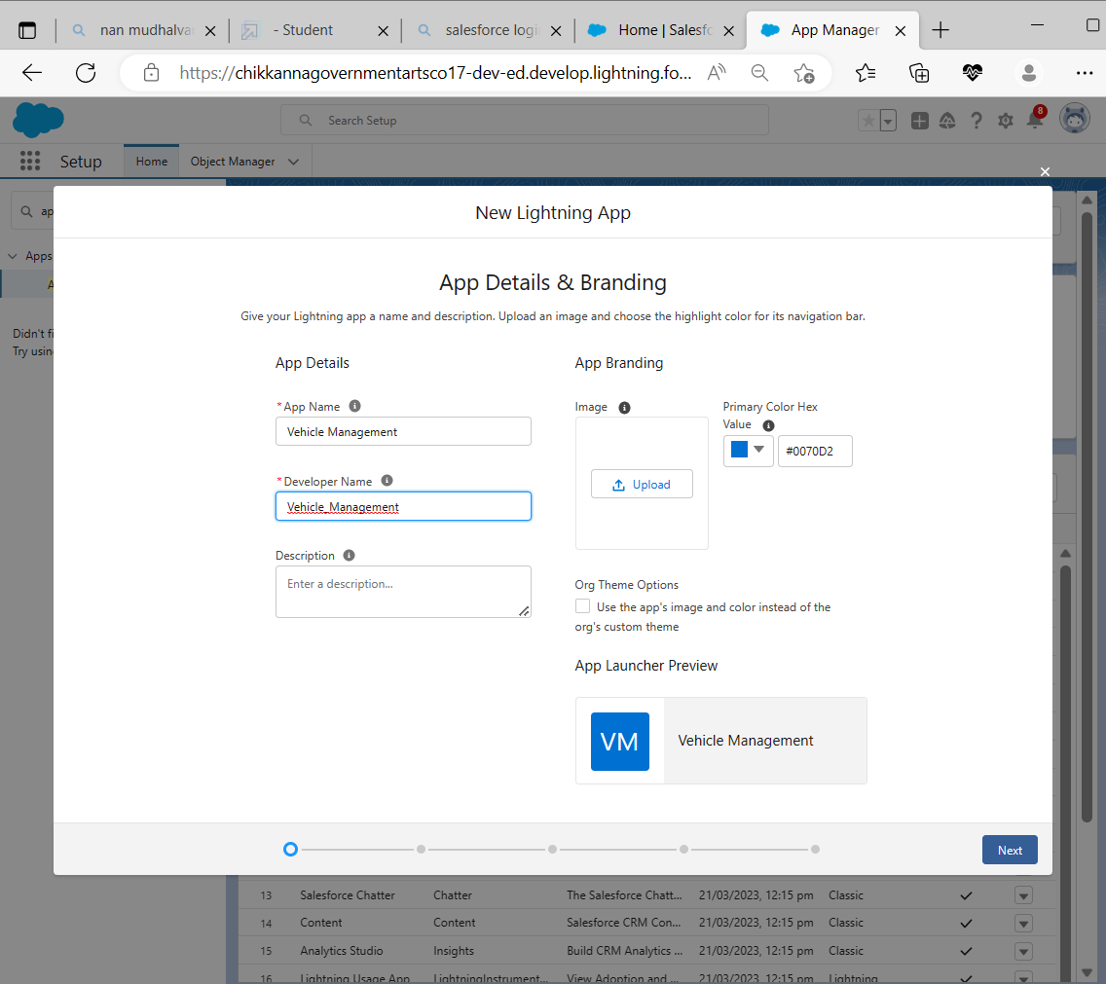

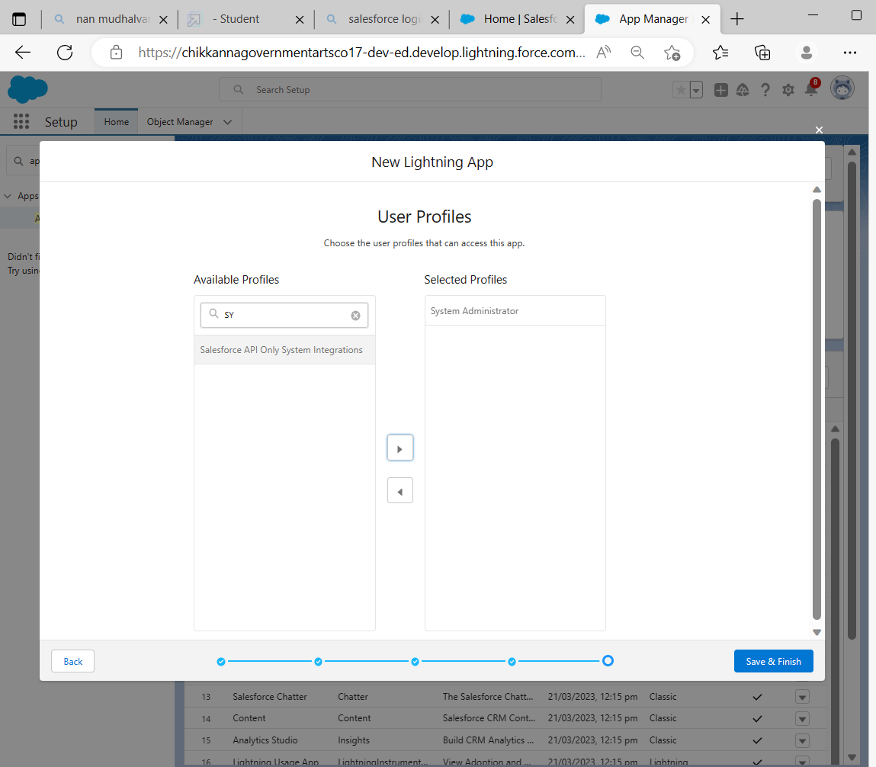

**Creating a Profiles**

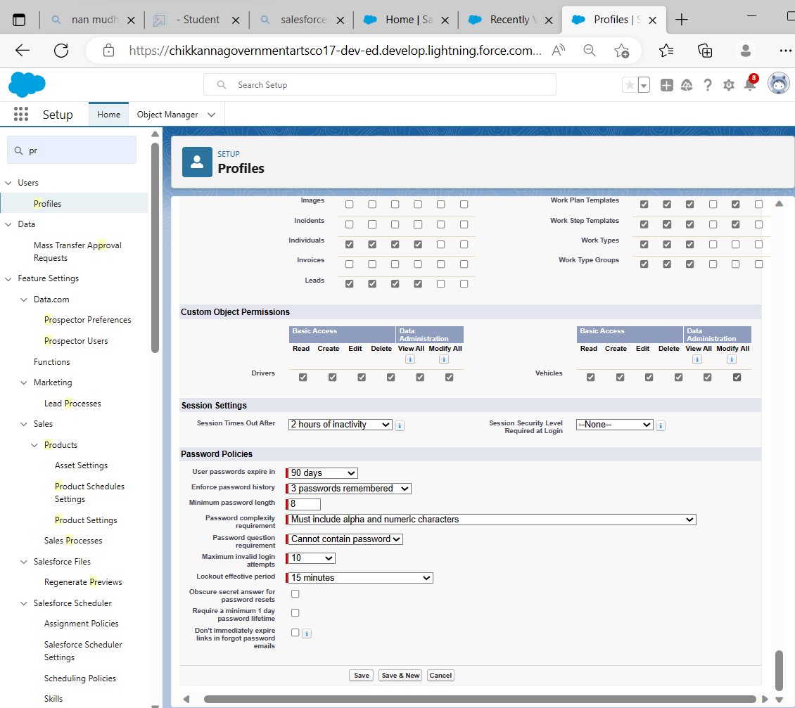

A profile is a group/collection of settings and permissions that define what a user can do in salesforce. A profile controls “Object permissions, Field permissions, User permissions, Tab settings, App settings, Apex class access, Visualforce page access, Page layouts, Record Types, Login hours & Login IP ranges

**Setup Roles**

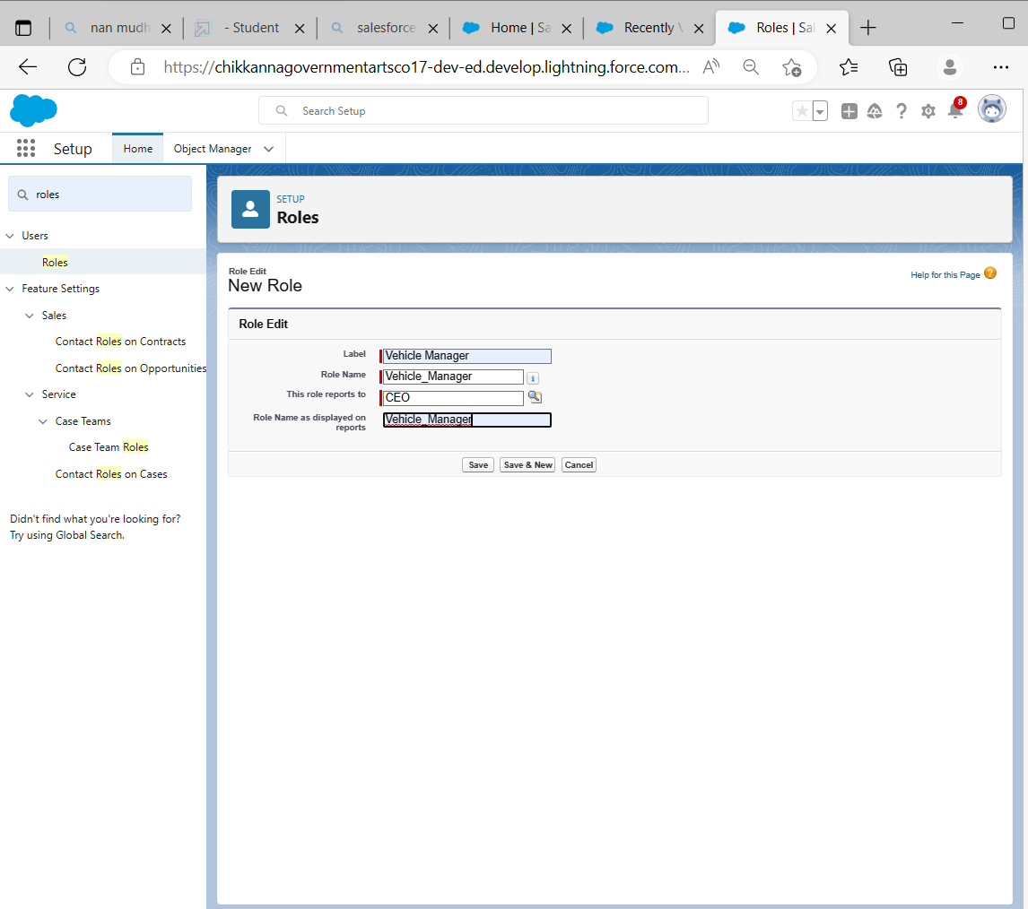

**Creating a Users**

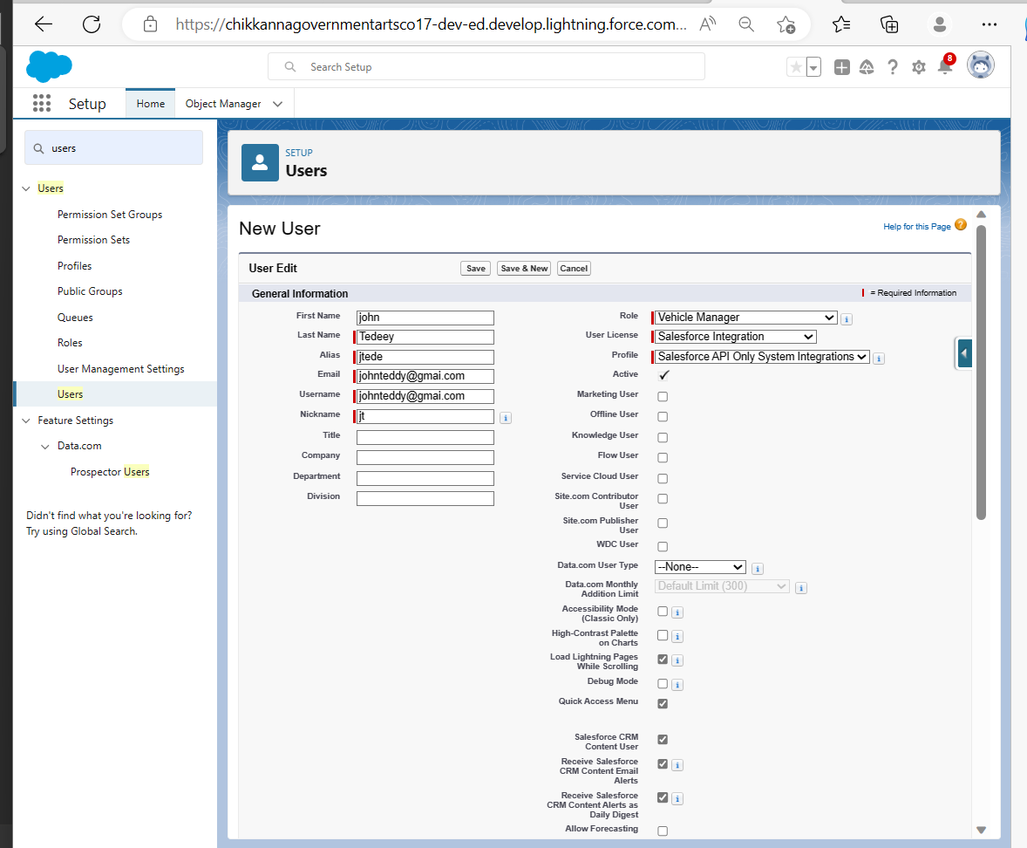

A user is **anyone who logs in to Salesforce**. Users are employees at your company, such as sales reps, managers, and IT specialists, who need access to the company's records. Every user in Salesforce has a user account.

**Reports and Dashboards**

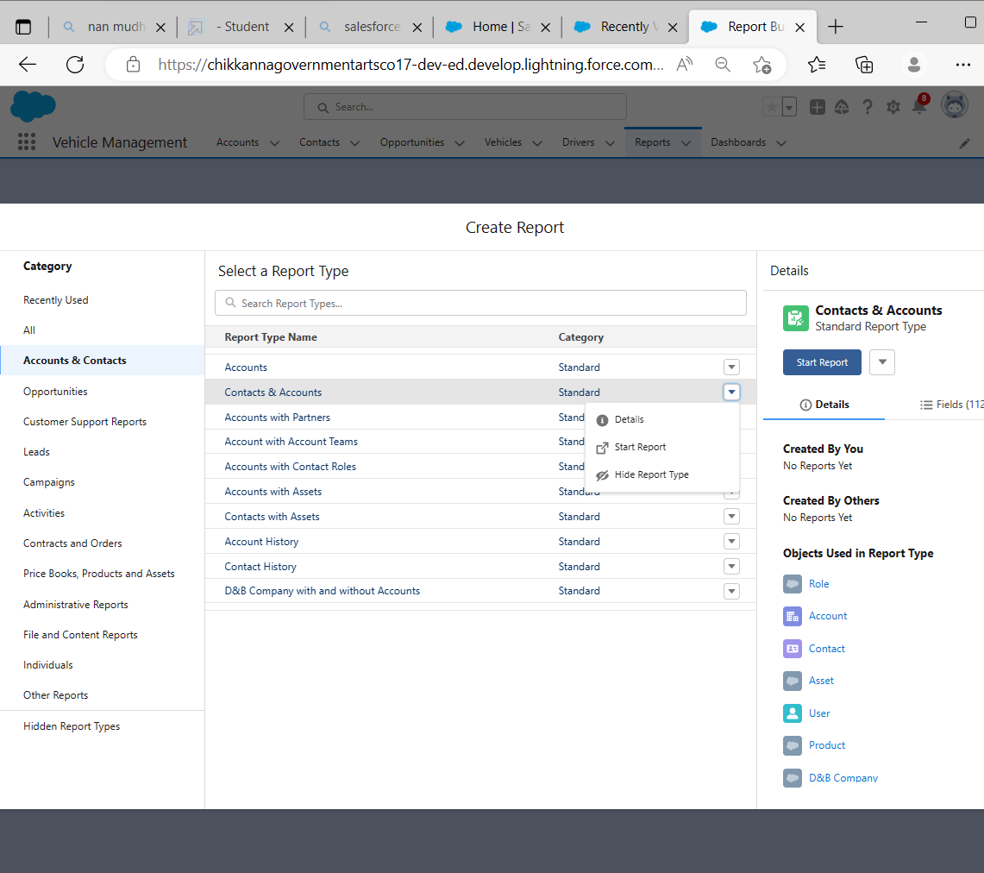

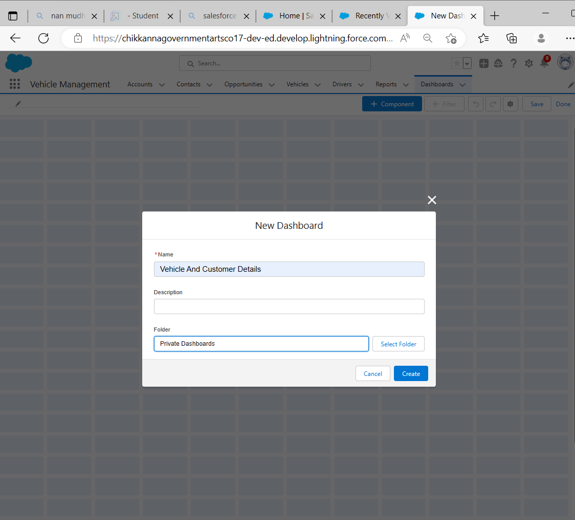

A report is a list of records that meet the criteria you define. It's displayed in Salesforce in rows and columns, and can be filtered, grouped, or displayed in a graphical chart. Every report is stored in a folder. Folders can be public, hidden, or shared, and can be set to read-only or read/write.

1. **Trailhead Profile Public URL**

**Team Leader :** <https://trailblazer.me/id/thiru95>

**Team member1:** <https://trailblazer.me/id/gsekaran13>

**Team member2:** <https://trailblazer.me/id/aruns202>

**Team member3:** <https://trailblazer.me/id/vijat16>

1. **ADVANTAGES & DISADVANTAGES**

**Advantages:**

Vehicle Management is a simple and effective tool that makes a deep impact on the operations of LSPs.

Know the FABs of using Vehicle Management by WebXpress.

WebXpress is an IT and Solutions company that offers services in the domain of Logistics.

Founded in 2004 the company has a presence in India, Saudi Arabia, East Africa, and South Asia.

Our idea is to connect all stakeholders in supply chain and provide visibility

**Disadvantages:**

It is difficult track the occupancy

Jis todos to track the details of cobs provided by third party

There is lity to track the approvals of requests

No co-ordination between various departments

1. **Applications :**

• To manage the best reporting system

• To trace all over regular and irregular expenses.

• To apply an organized inventory management system with regular income and expenses.

• To have an automatic stock register.

• To get an easy traceable stock and product system

• Expense reports are particular and time frame based.

• Custom reports are also available based on user request.

1. **Conclusion:**

**Efficiency in fleet operations relies on utilising vehicle management software in daily operations**. With a fleet management system, a manager can monitor daily operations from the routes, vehicle status and health to fuel costs and driver performance.

1. **Future Scope:**

This software eliminates manual labor and any associated issues. It is a simple

approach to learning more about the many products that are available at supermarkets. Well

my team and I have been working hard to provide a website that is better than the current one

in terms of information on the different activities. However, we discovered that the job might

be carried out more effectively.

The company, product id, product name, and the number of quantities available are the only information that is often provided when we seek information on a certain product. After

receiving the information, we may reach the product firm's website by simply clicking on the

name of the product. The option for searching is the next improvement we can make. From

this website, we may easily search for a certain product firm. These two improvements are

the best we can come up with for now