



1) INTRODUCTION:

# 1.1)Overview

Vehicle Management is an applica on where a customer Details are stored in order to choose cars,bikes and commercial vehicles for travel with in the city.The data which is stored here is further used to remind them if any offers are provided during the seasons and any updates regarding vehicles are sent to them in the form of messages and mails.

# 1.2)Purpose

To create Vehicle Management is an applica on where a customer Details are stored in order to choose cars,bikes and commercial vehicles for travel with in the city.The data which is stored here is further used to remind them if any offers are provided during the seasons and any updates regarding vehicles are sent to them in the form of messages and mails.

2) PROBLEM DEFINITION & DESIGN THINKING:

# 2.1)Empathy Map

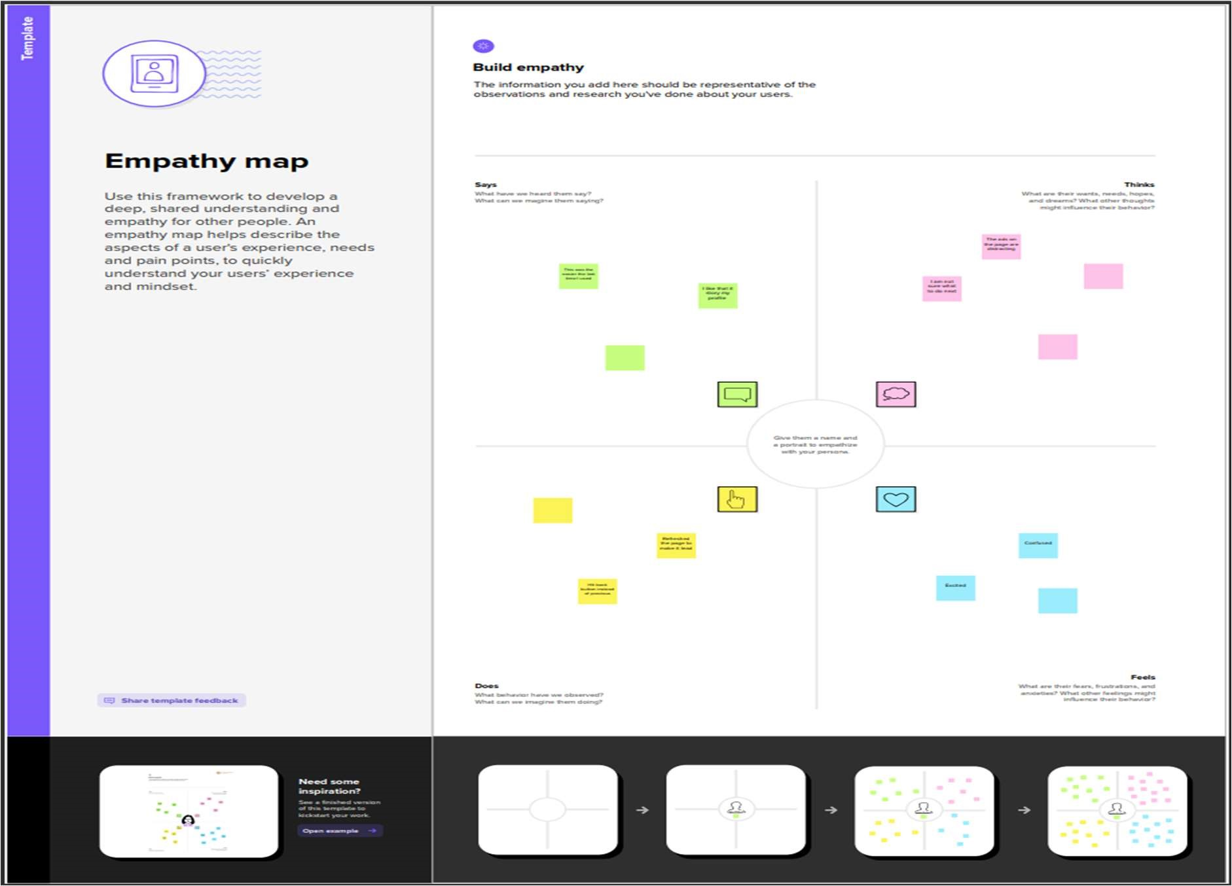

# 2.2)Idea on & Brainstoming Map

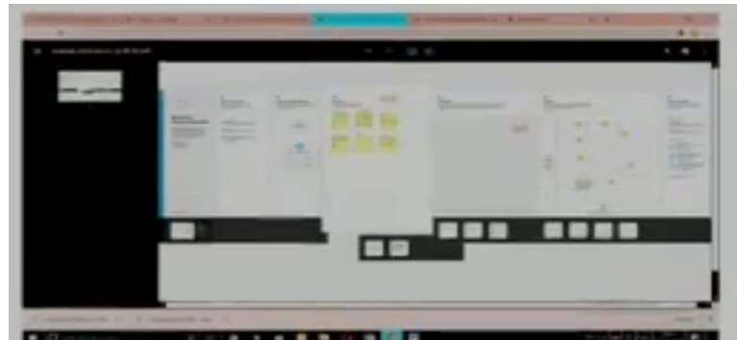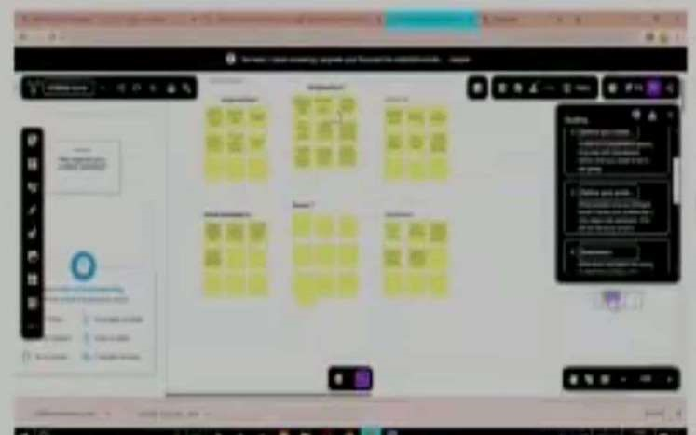

3) RESULT:

# 3.1)Data Model

Object1: Vehicle

|  |  |  |
| --- | --- | --- |
| S NO. | Field Names | Data Types |
| 1. | Customer Name | Text |
| 2 | Customer Mobile No | Number |
| 3 | Vehicle Type  i)2 wheeler ii)4 wheeler | Picklist |
| 4. | 2WHEELERS  i) HERO ii)HONDA iii)BAJAJ iv)ROYAL  ENFIELD v)TVS vi)KINETIC vii)OLA  viii)JAWA ix)SD x)BATTERY | Picklist |
| 5 | 4WHEELERS  i) RENAULT  ii)SKODA iii)  HONDA  iv)HYUNDAI v)SUZUKI | Picklist |

|  |  |  |
| --- | --- | --- |
|  | vi)MAHINDRA  vii)VOLKSWAGEN viii)BENZ ix)AUDI x)VOLVO |  |
| 6. | Vehicle Name | Text |
| 7. | Vehicle No | Text |
| 8. | Chassic No | Text |
| 9. | Colour | Text |
| 10. | Body Type | Text |
| 11. | Vehicle Includes  i)Fire Extenuation ii)First Aid Kit iii)Multi Charger kit  iv)Stepney v)Stereo vi)Tool Kit vii)Tracking Device viii)Tyre Jack | Multi Picklist |
| 12. | Condition  i)Good  ii)Medium  iii)Least | Picklist |
| 13 | Mileage | Text |
| 14 | Seats | Number |
| 15 | Start Date | Date/Time |
| 16 | End Date | Date/Time |
| 17 | Opportunity | Lookup(opportunities) |

## Object2: Driver

|  |  |  |
| --- | --- | --- |
| S No | Field | Data Type |
| 1 | Driver Name | Text |
| 2 | Licence No | Text |
| 3 | Mobile No | Number |
| 4 | Fair Per Hour | Text |
| 5 | Vehicle | Lookup(Vehicle) |

3.2) Ac vity & Screenshot

# Crea on of Salesforce ORG

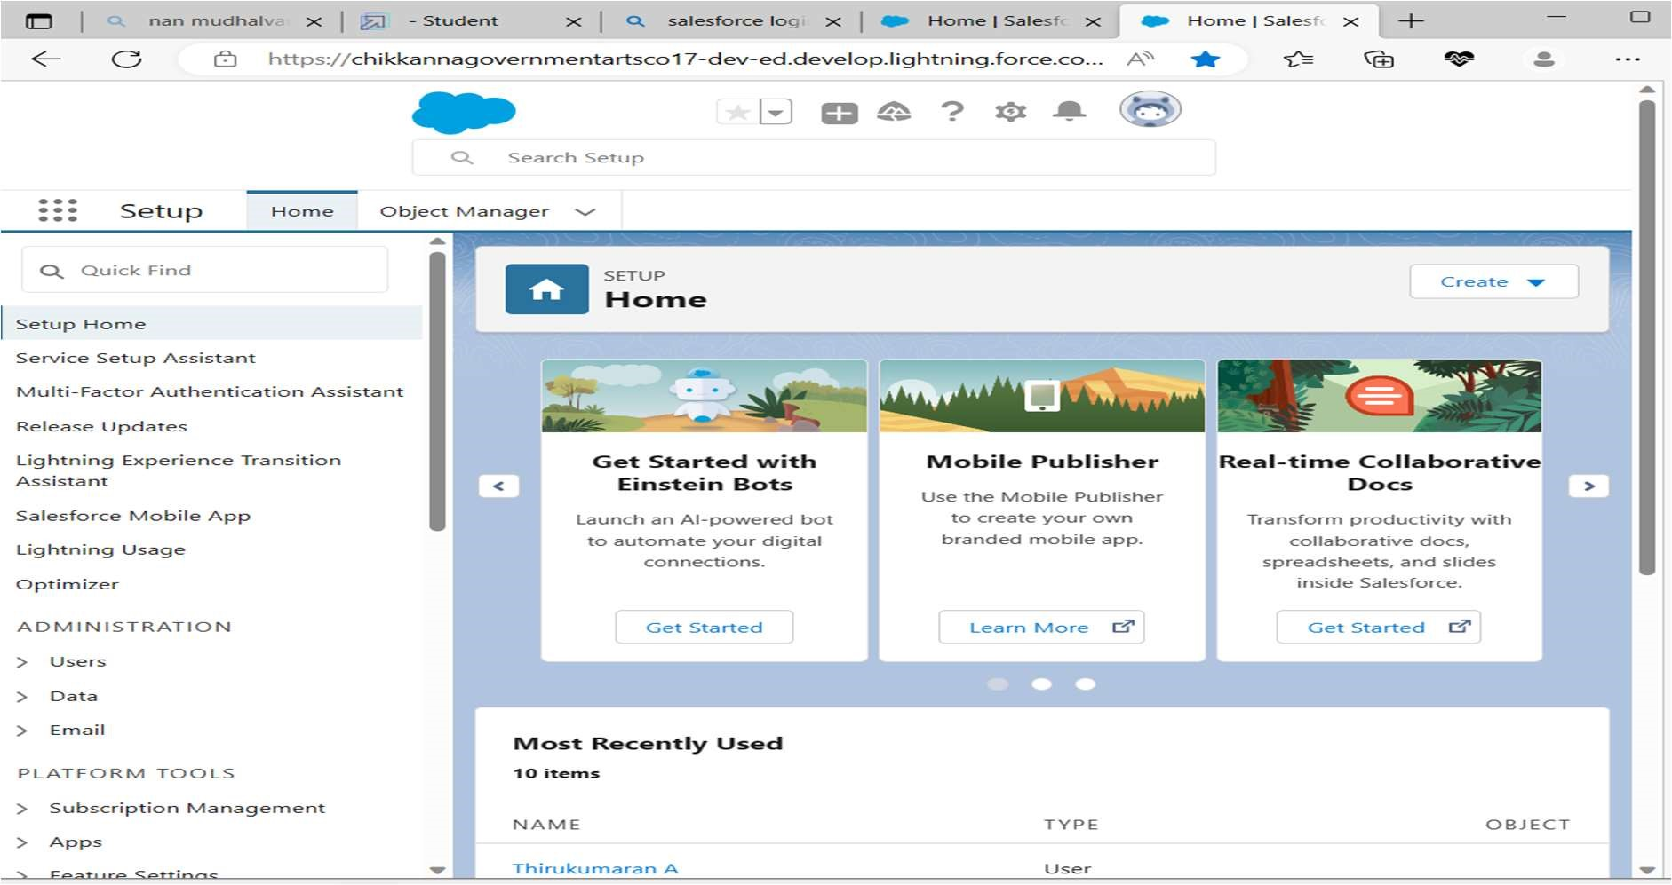

We have created a developer account for salesforce account. Salesforce is your customer success pla orm.

Our mail id and name are given to get developer account.

# Create an Object

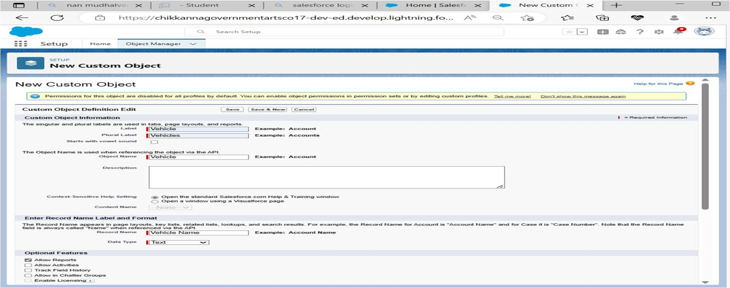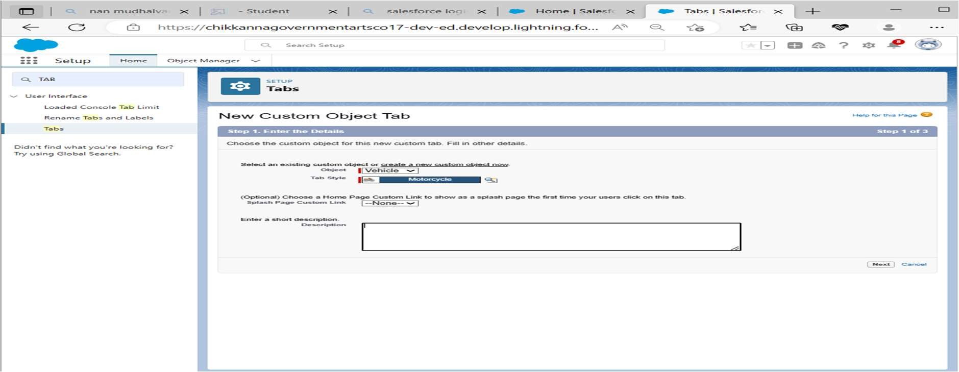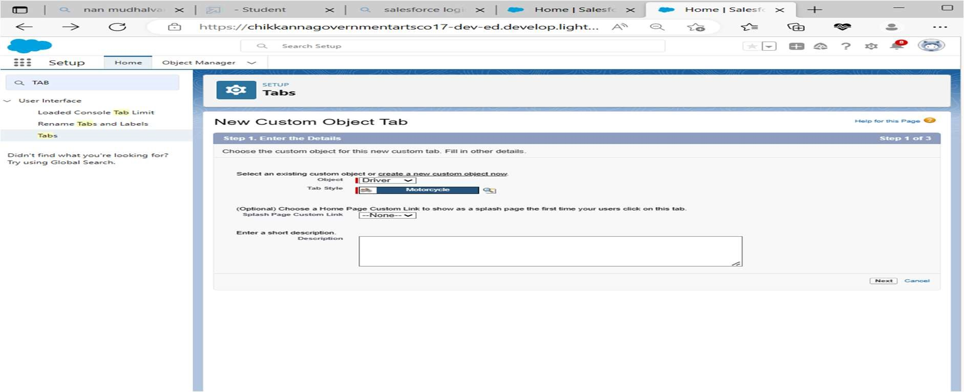

Crea on of Objects for Vehicle Management, For this Vehicle Management we need to create 2 objects i.eVehicles,Driver

# Crea on of Fields

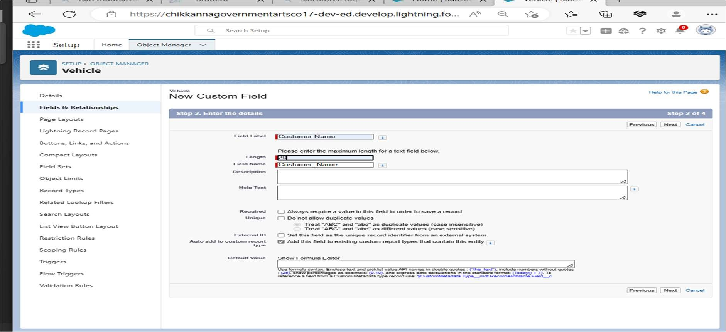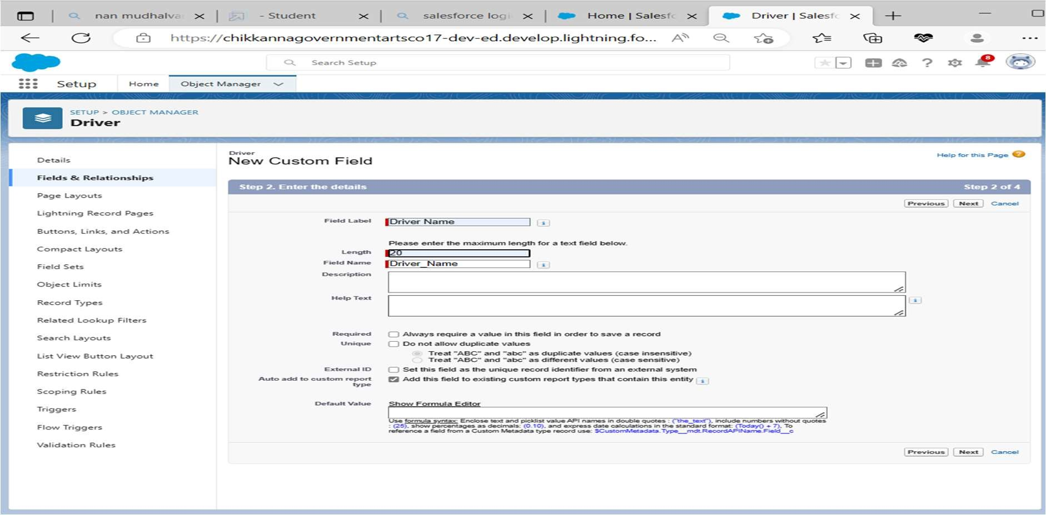

An object rela onship in Salesforce is a two-way associa on between two objects.

Rela onships are created by crea ng custom rela onship fields on an object. This is done so that when users view records, they can also see and access related data.

## Fields in Driver Object

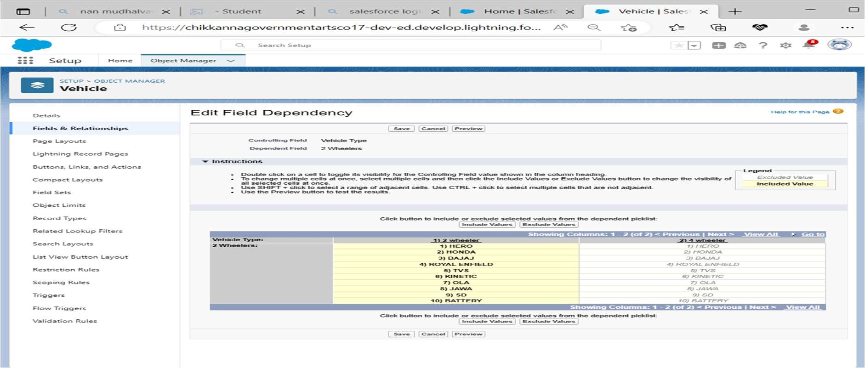

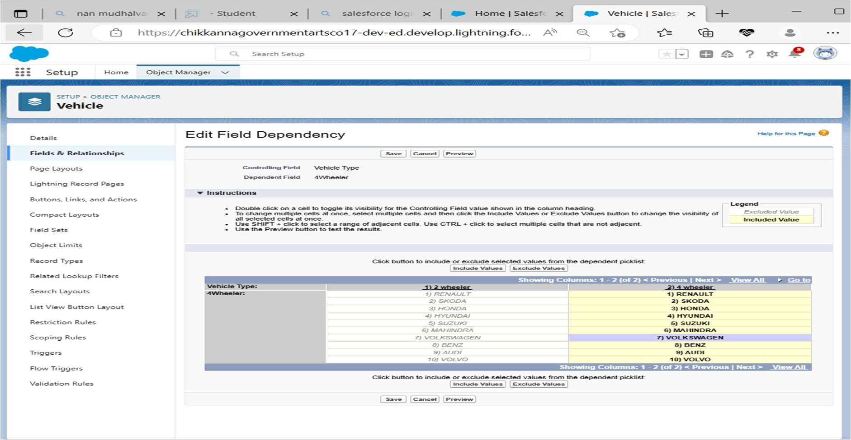

Create a dependency between these two picklists, so that when a Vehicle type is selected, only respec ve 2Wheeler Brands are available in the 2Wheeler field, Similarly for 4 wheelers

# Lightning App

Create the Vehicle Management Constrac on App

Apps in Salesforce are a group of tabs that help the applica on func on by working together as a unit. It has a name, a logo, and a par cular set of tabs. The simplest app usually has just two tabs.

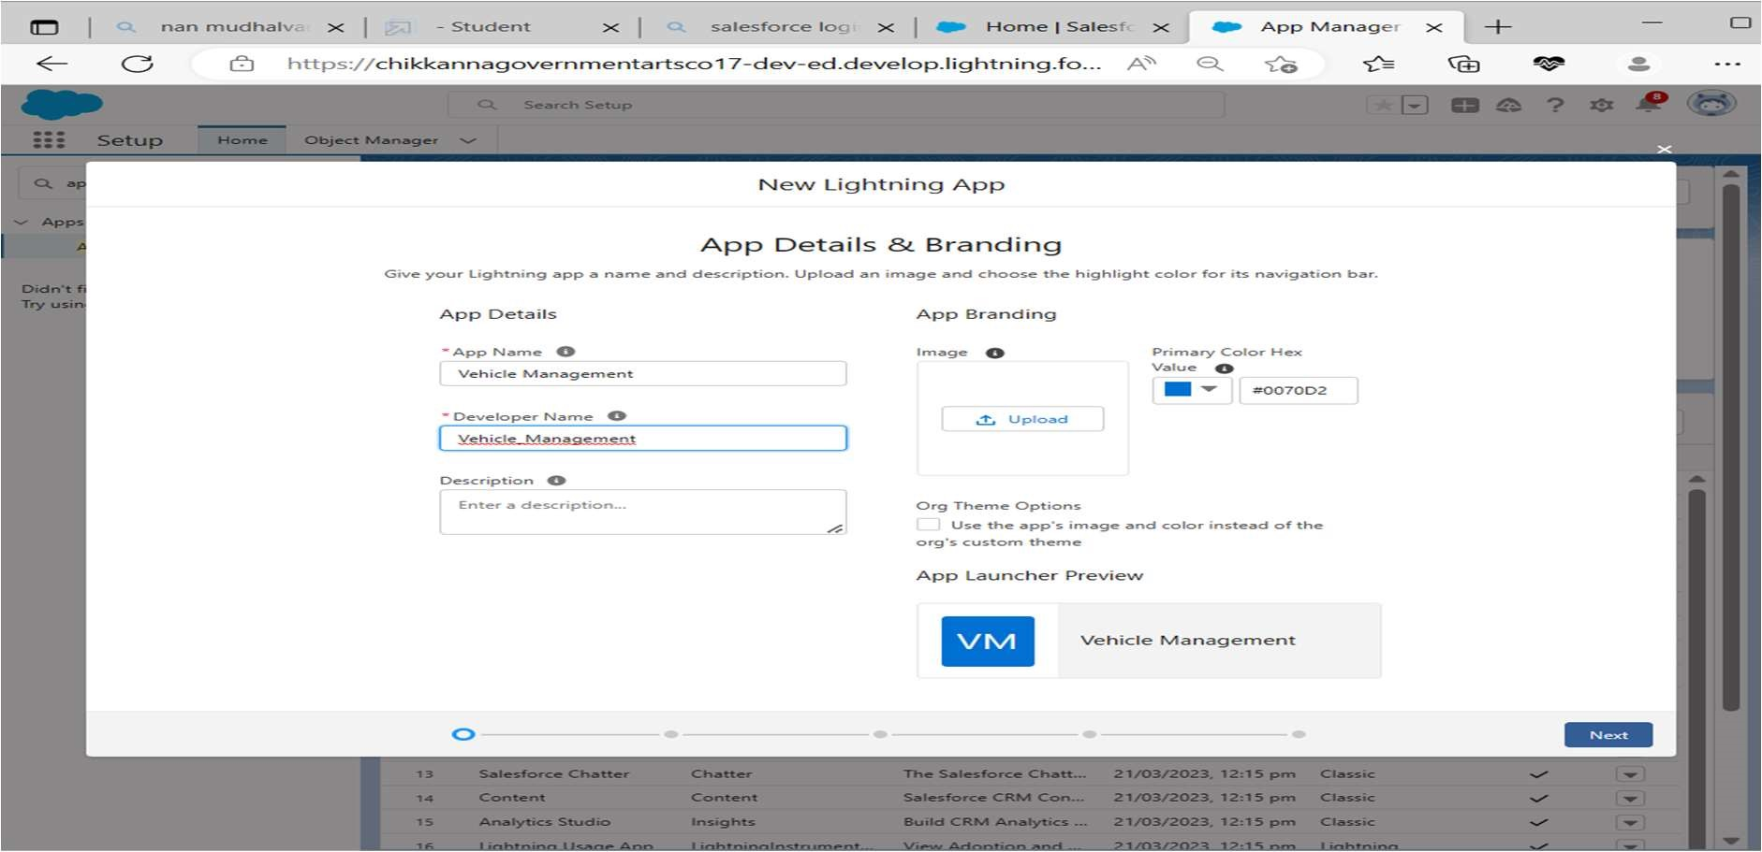

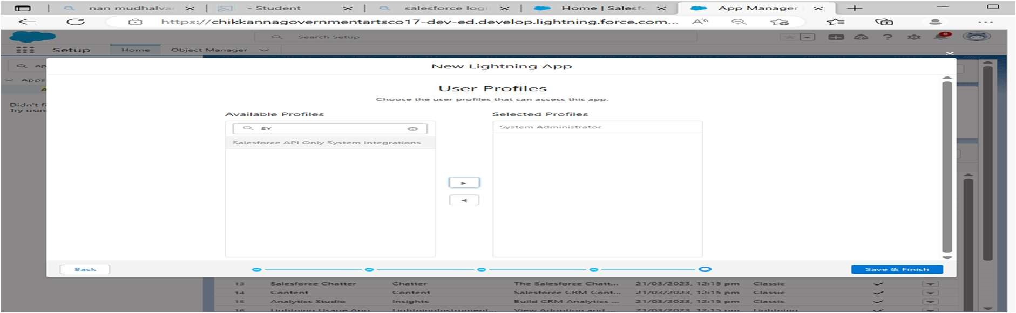

Crea ng a Profiles

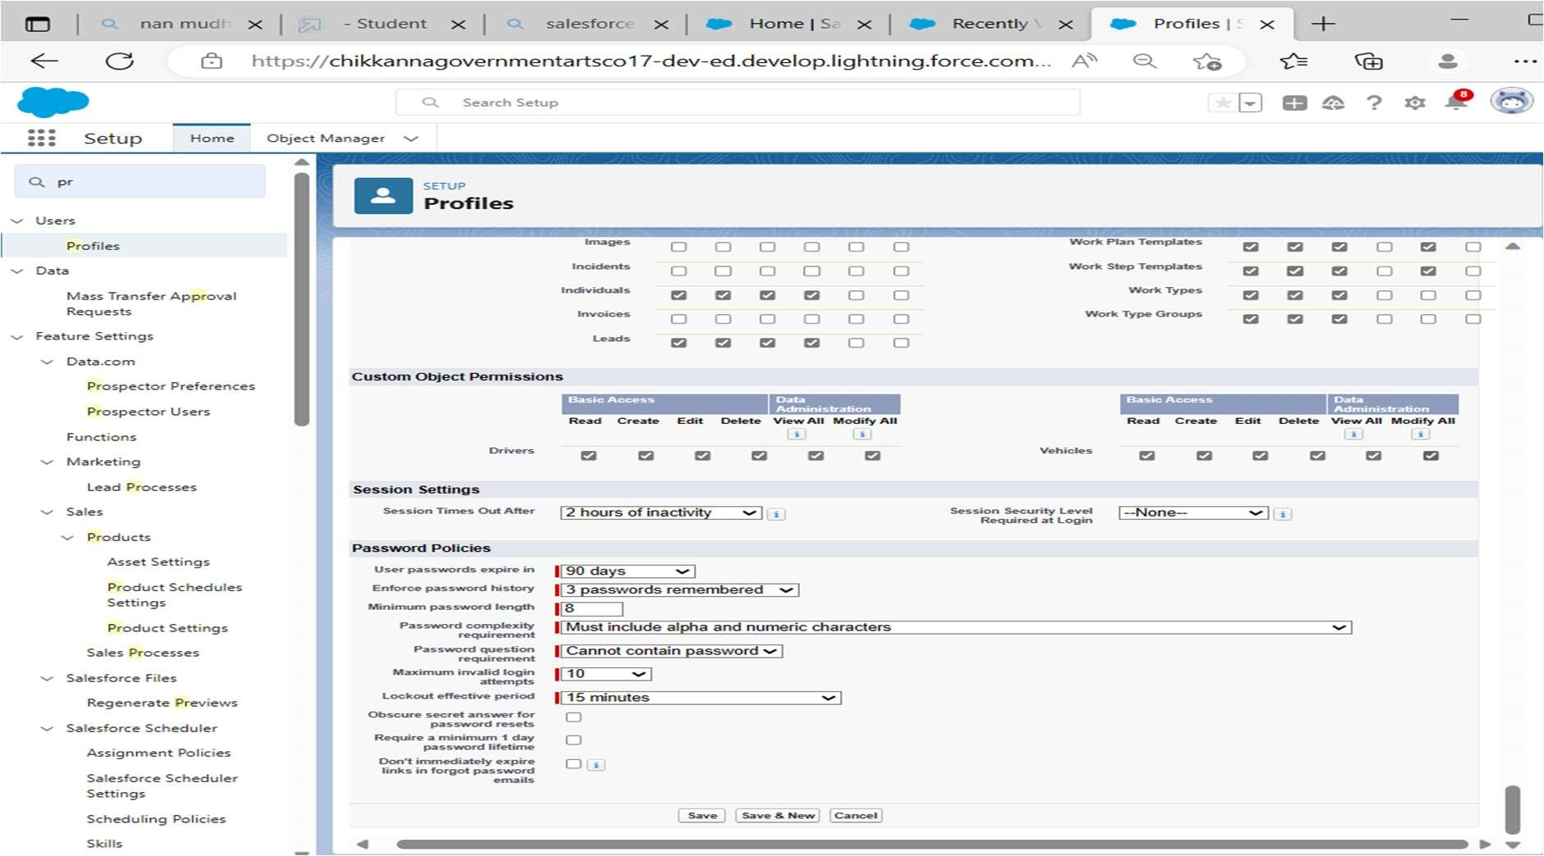

A profile is a group/collec on of se ngs and permissions that define what a user can do in salesforce. A profile controls “Object permissions, Field permissions, User permissions, Tab se ngs, App se ngs, Apex class access, Visualforce page access, Page layouts, Record Types, Login hours & Login IP ranges

## Setup Roles

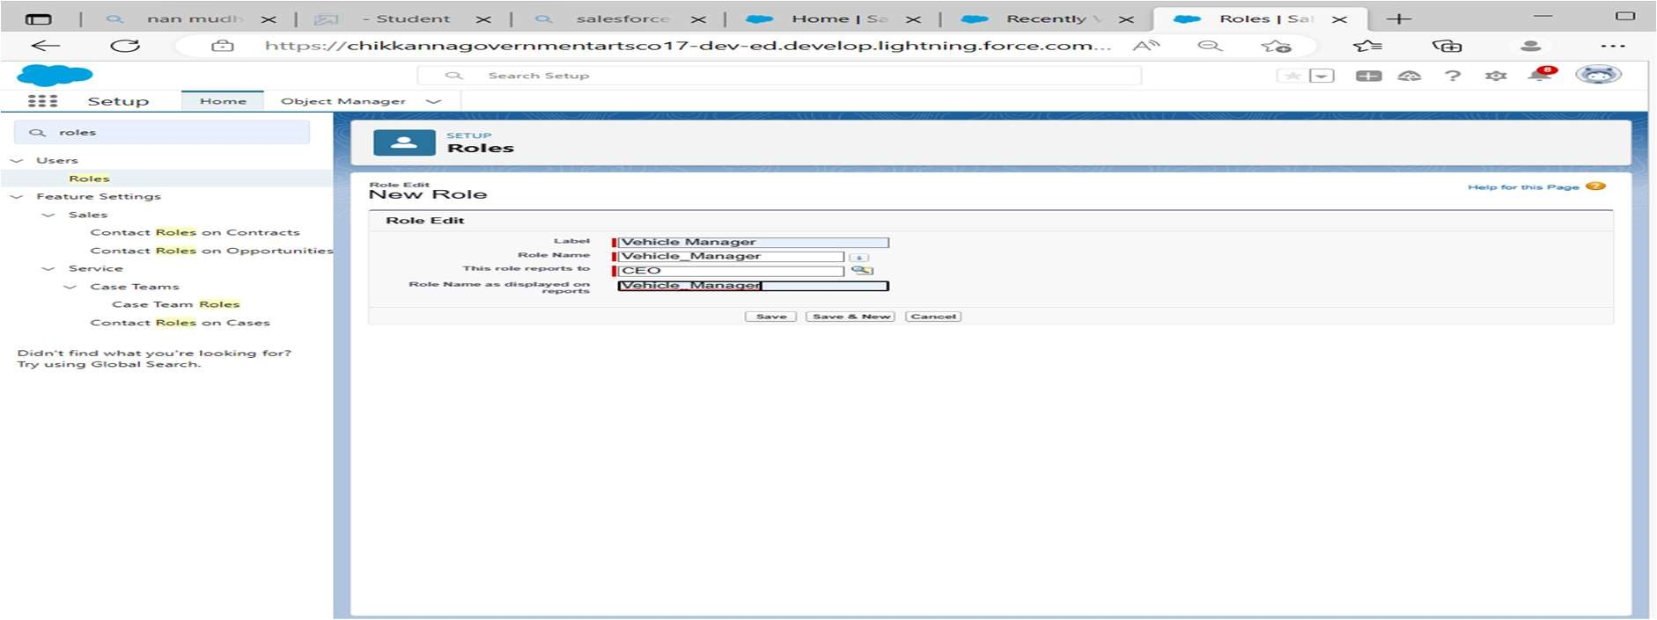

Crea ng a Users

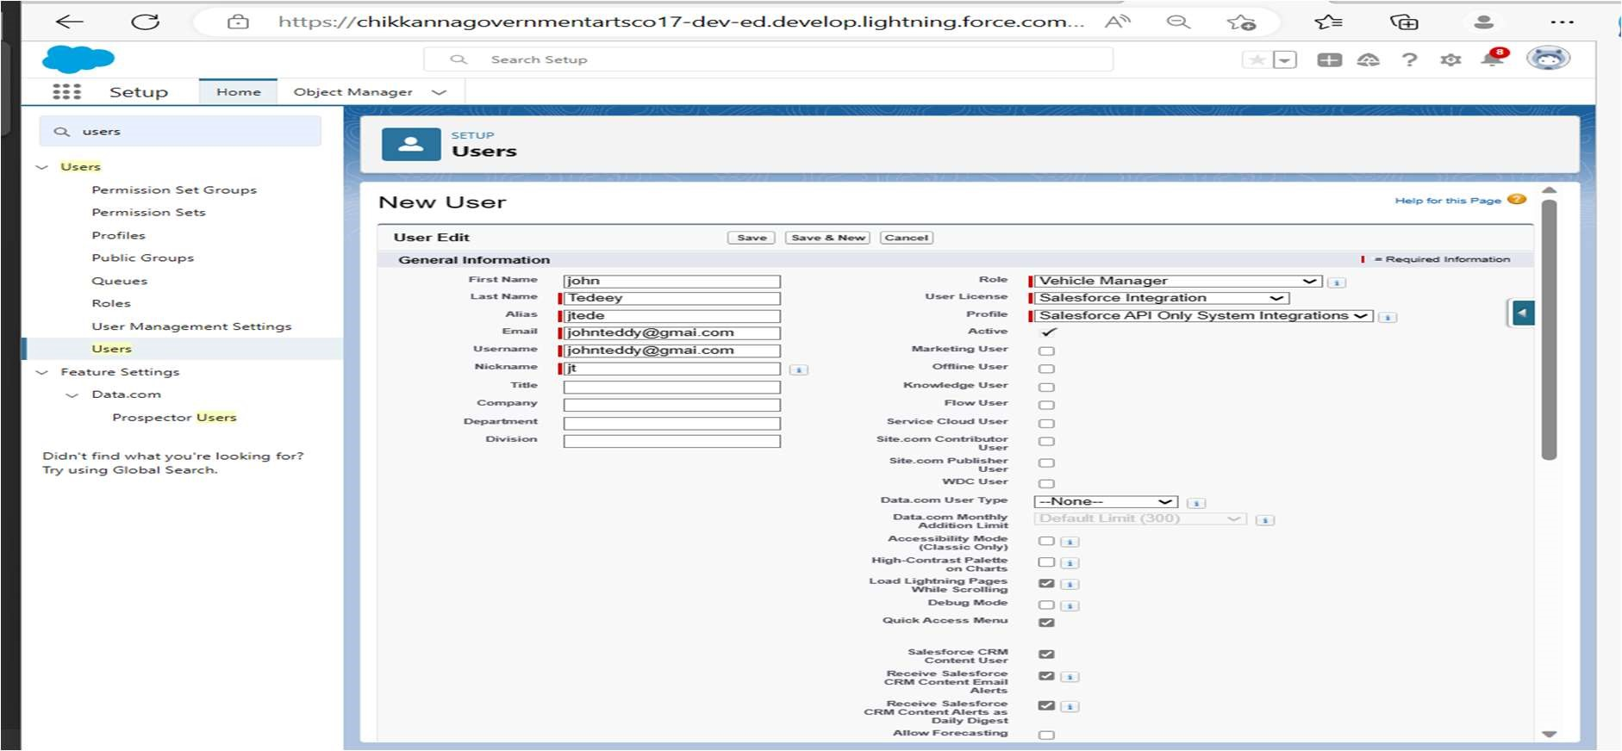

A user is anyone who logs in to Salesforce. Users are employees at your company, such as sales reps, managers, and IT specialists, who need access to the company's records. Every user in Salesforce has a user account.

## Reports and Dashboards

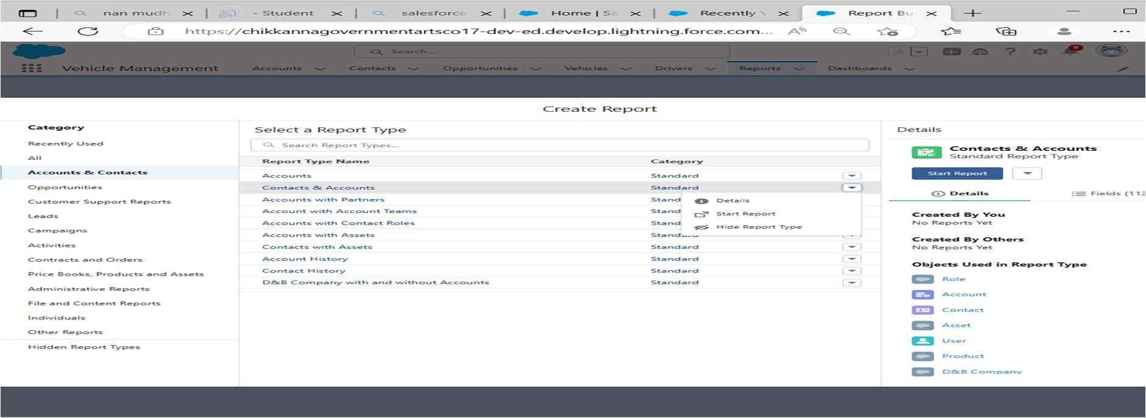

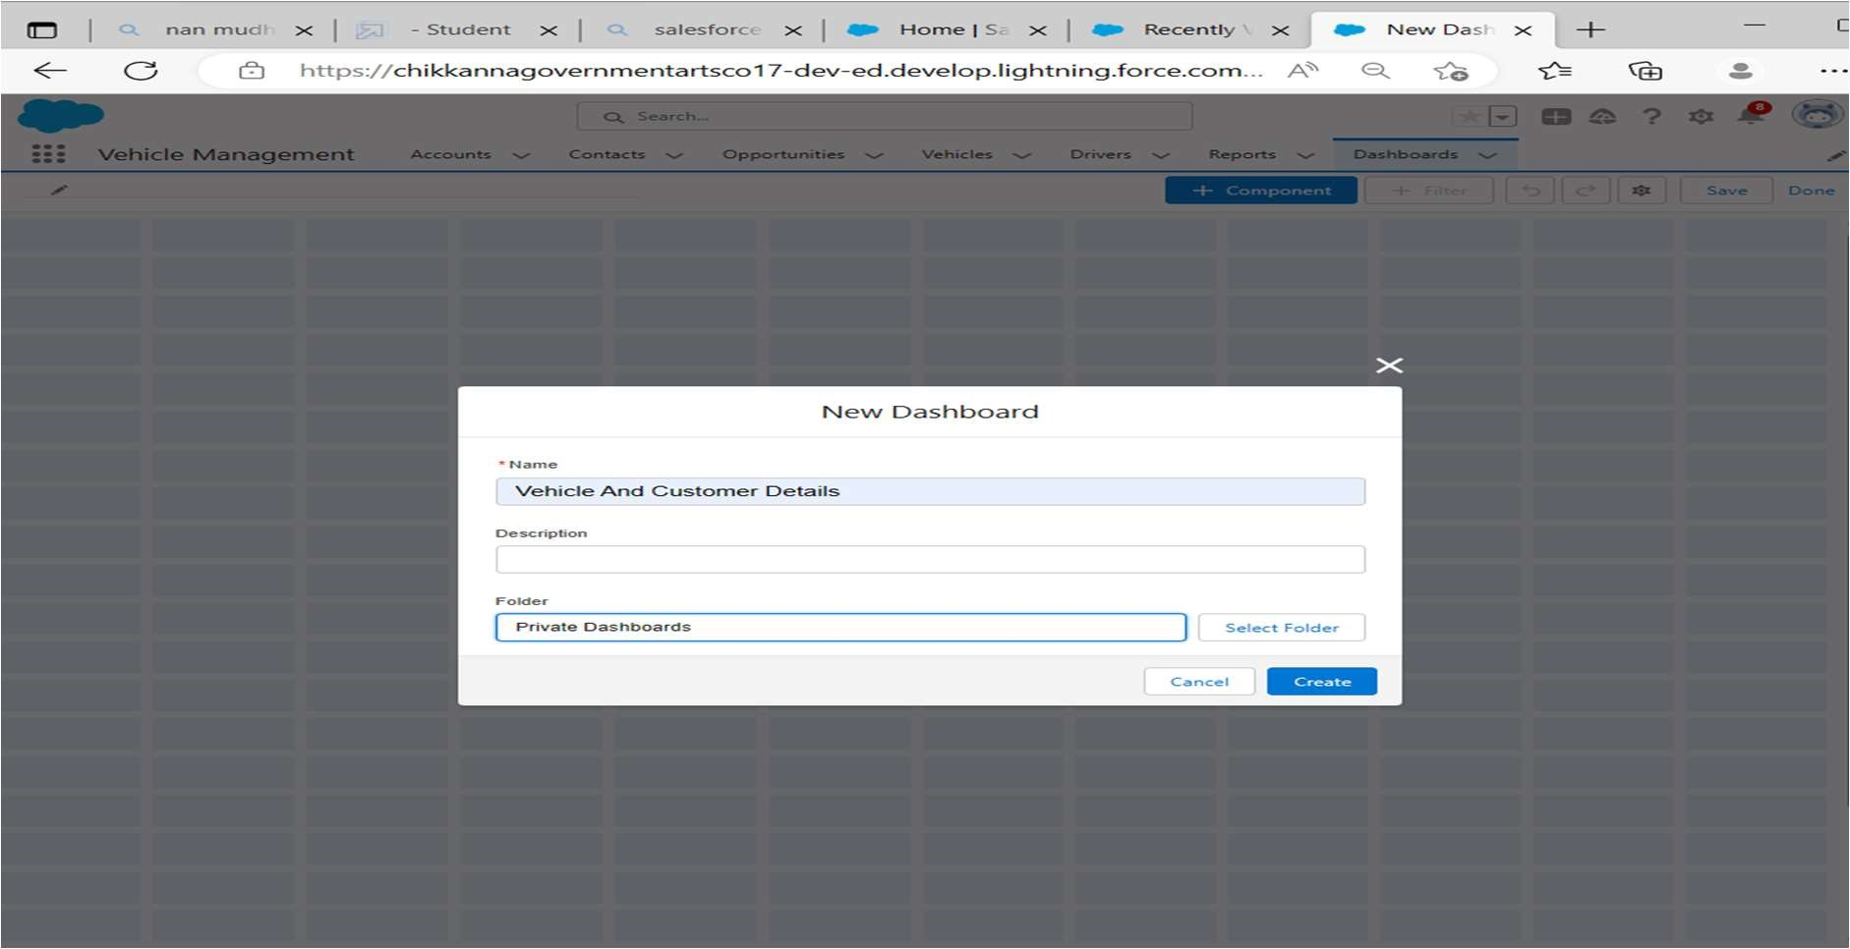

A report is a list of records that meet the criteria you define. It's displayed in Salesforce in rows and columns, and can be filtered, grouped, or displayed in a graphical chart. Every report is stored in a folder. Folders can be public, hidden, or shared, and can be set to read-only or read/write.

# 4) Trailhead Profile Public URL

Team Leader : h ps://trailblazer.me/id/thiru95

Team member1: h ps://trailblazer.me/id/gsekaran13

Team member2: h ps://trailblazer.me/id/aruns202

Team member3: h ps://trailblazer.me/id/vijat16

# 5) ADVANTAGES & DISADVANTAGES

Advantages:

Vehicle Management is a simple and effec ve tool that makes a deep impact on the opera ons of LSPs.

Know the FABs of using Vehicle Management by WebXpress.

WebXpress is an IT and Solu ons company that offers services in the domain of Logis cs. Founded in 2004 the company has a presence in India, Saudi Arabia, East Africa, and South Asia.

Our idea is to connect all stakeholders in supply chain and provide visibility

Disadvantages:

It is difficult track the occupancy

Jis todos to track the details of cobs provided by third party

There is lity to track the approvals of requests

No co-ordina on between various departments

1. Applications :

* + To manage the best reporting system
  + To trace all over regular and irregular expenses.
  + To apply an organized inventory management system with regular income and expenses.
  + To have an automatic stock register.
  + To get an easy traceable stock and product system • Expense reports are particular and time frame based.
  + Custom reports are also available based on user request.

1. Conclusion:

Efficiency in fleet operations relies on utilising vehicle management software in daily operations. With a fleet management system, a manager can monitor daily operations from the routes, vehicle status and health to fuel costs and driver performance.

1. Future Scope:

This software eliminates manual labor and any associated issues. It is a simple approach to learning more about the many products that are available at supermarkets. Well my team and I have been working hard to provide a website that is better than the current one in terms of information on the different activities. However, we discovered that the job might be carried out more effectively.

The company, product id, product name, and the number of quantities available are the only information that is often provided when we seek information on a certain product. After receiving the information, we may reach the product firm's website by simply clicking on the name of the product. The option for searching is the next improvement we can make. From this website, we may easily search for a certain product firm. These two improvements are the best we can come up with for now