Kuwaiba Open Network Inventory
Version 0.1 [19.08.2010]
User Manual

Please visit http://kuwaiba.sourceforge.net for documentation, latests updates and upcoming events

Change History
Responsible | Description | Date | Reviewed by
Charles Bedón  charles.bedon@zoho.com | First version shipped with version 0.1.1 | 19th August 2010

License
This document is published under the terms of a license Creative Commons by-nc-sa. You can find details about it at
http://creativecommons.org/licenses/by-nc-sa/2.0/
 | Kuwaiba Server and Client are licensed under EPL v1. You can find the whole text of this license at  http://www.eclipse.org/legal/epl-v10.html

Disclaimer
- Netbeans and Java are registered trademarks of Oracle and/or its affiliates. Other names may be trademarks of their respective owners. The Kuwaiba project is not endorsed in any way with any of them.

- This document is provided “as is”, with no warranty at all. Install the software and follow the instructions included at your own risk.

Chapter 1. Network Inventory Management in a nutshell
When you have a lot of things is easy to lose some of them and it's even easier to end up with a monumental mess if you're not organized enough. As a result, you will find yourself buying something you already have but you haven't managed to find, or wasting precious resources (money or space) storing stuff you barely know what is for.
The same happens to the IT and telecommunications infrastructure (actually in nearly every business handling assets [1]). It tends to be complex and its components lose visibility as the base of users/suscribers/customers increases. So it's common to see servers, workstations, antennas and equipment of all species piled in some dark room. In the mean time, sysadmin or technical guy's mind apart, it's not possible to find the updated information about the operative elements configuration or even location, the rack space is wasted and the patch panels are a land of no one, so how will anyone know which cable to pull?.
They say you can't manage what you can't control, and you can't control what you don't measure, and that's more or less the point of all this inventory thing. If you have under control what you have and the way everything is related will be more likely to achieve the goals of the Operations Deparment or the IT Staff, if they use this information to attend the incidents effectively and plan the capacity the more accurately way possible, among other things.
Having said this, three possible types of resources may be identified:
- Physcal: These are the equipment, pipes, cables, fiber optics, facilities, parts and in general every physical asset from a port to a building.
- Logical: These are all the resources related to non-tangible technology assets. In this group fits timeslots, virtual circuits, VLANs, disk space, available bandwidths, etc.
- Administrative: These are all those related to administrative tasks, human resources or services. Here you can find customers, services associated to those customers, SLAs (and related parameters like availability or throughput), account managers, technical staff assigned to those services, vendors, brands. In short, all not-operational resources related to a given service management workflow.
As you may guess (or have experienced), to have all this information updated and complete at a single point is a hard task. Mostly because IT and telecommunications are ever changing environments and your network configuration layout can shift overnight. Updating all the data manually is almost impossible, but fortunately, you can grab a good part of it from the network elements if the have proper management interfaces.
From an ITIL perspective [2], within the Service Transition process there's a key concept called “CMDB”. In short, is a place where you have Configuration Items (CIs, any IT asset that can be configure or have configuration information) and their relationships. Yes, not only the objects. Indeed, multiplexors, radios, routers are not islands. They're connected physically or logically, and people may be related to them as well. A network inventory system is CMDB but may extend its functionality in order to provide workflow management, network designing features, etc. But the core of it is a Configuration Management Database.
But one thing is different from other scenarios is that technology assets may not be physical. If you have a core using SDH you need to know what VCs are free, which ones are protected and what kind of protections they have, but if you manage switches you may want to now the bit rate configured for a given port or how the VLANs are set up. At application level, you'd like to know what DNS are configured for a given Web Servers or where are the Domain Servers...
Kuwaiba Open Network Inventory aims to be a solution for this scenario. It is completely Object Oriented, so you can model your network according to your needs, no matter if you're an ISP, a carrier or just a guy with a large IT infrastructure. Remember, Kuwaiba is under active development and new models are added every release. Please request the ones you consider as top priority in this thread [3].

Chapter 2. The login window
Since version 0.1.1 was added a basic user authentication. The default user/password is admin/kuwaiba. When you execute the binary at $CLIENTPATH/bin/kuwaibainventory (Unix-like systems) or $CLIENTPATH/bin/kuwaibainventory.exe (MS Windows systems) youl'll get a window like this (remember, you need JRE1.6 or superior to run the client. Check here [4] for details):
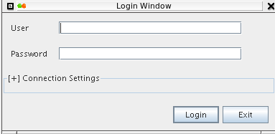

Figure 1. Login window with the Connection Settings panel collapsed
Pressing “Exit” will close the application, and pressing “Login” will attempt to log into the system using the default connection values. This is, localhost as server, 8080 as server port and “/KuwaibaServer-war/KuwaibaWebserviceService” as WSDL location. If you deployed the server with the default settings in the same box as the client, this should be enough.

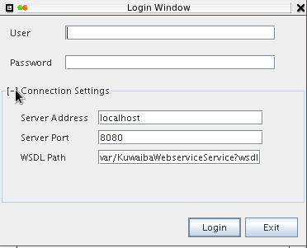

Figure 2. Login window with the Connection Settings panel expanded
You can expand the Connection Settings in case you want to change those defaults.
- Server address: Name or IP address where the server is running
- Server port: Port where the applications erver is listening at.
- WSDL Path: Path to be appended to the server address and port to form the valid URL to access the WSDL expose the methods to be consumed. It's important to point out that Kuwaiba client has a webservice client within, and that's the interface used to communicate with the server. If you're unsure, try typing in web browser an URL like this:
http://<server_address>:<server_port><wsdl_location>
A XML document must be displayed
If you were able to login successfully, the first thing you will see is an empty window with only a toolbar at the top.


Figure 3. Default toolbar layout
Query Builder (Chapter 8)
Graphical Views for a given object (Not operational yet, expected by version 0.2)
User and Group management (Chapter 9)
Attribute Manager (Chapter 3)
Class Customizer (Chapter 4)
Container Hierarchy (Chapter 5)
List Manager (Chapter 7)
Navigation Tree (Chapter 6)
Refreshes the current focused module (Not operational yet)

Chapter 3. The Attribute Customizer
One of the key features in Kuwaiba is that it is completely object oriented. That means that every business element (Router, City, Port) is actually treated as an object within the application. As such, every attribute is a Field into a Class [5]. You can customize how these attributes are displayed in module called “Attribute Editor” as shown in the figure 4:
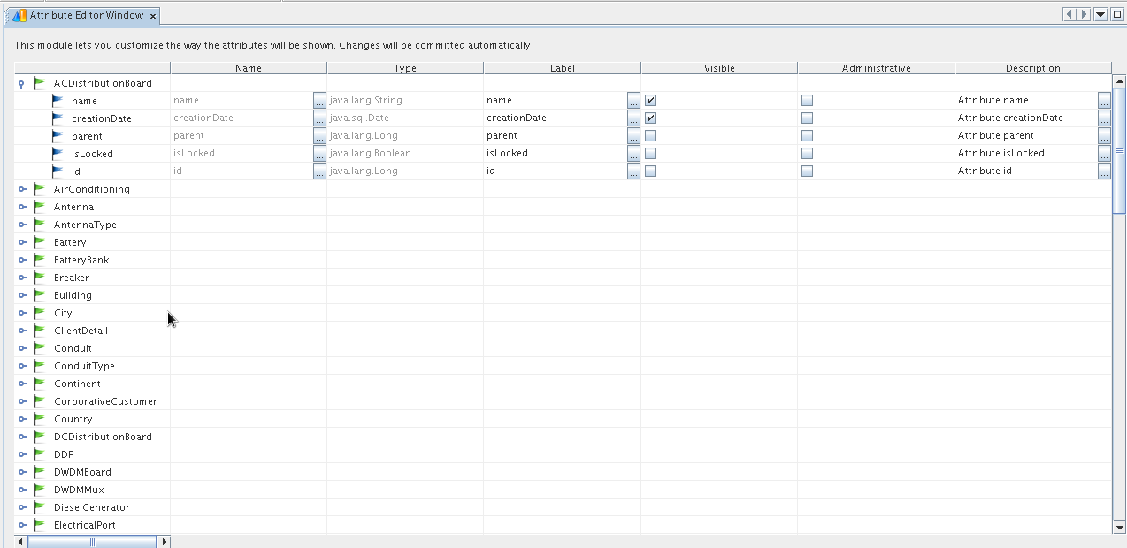
Figure 4. Attribute Editor main window
The first column (unlabeled) contains the available classes for the current release. Every row can be expanded to show the attributes related to each one.
The second, is a readonly field showing the real name of the attribute, this is, the name used internally to reference it.
The third is read only too and shows the attribute's type. It can be a native one like Integer, String, Boolean, Float or Date, a list type attribute (those where you can pick the value from a list) or even a multichoice type (those where you can pick multiple values at a time from a list). It's only for information purposes.
The fourth shows the attribute's display label. This label will be used in the properties window. You should edit it in order to show a friendly text instead of the default attributes real name (ie.: real name: “rackUnits” suggested display label: “Rack Units”).
The fifth marks the attribute as “Visible”. Useful for those attribute you don't want to show to the end user. By default “id” and “parent” are hidden for all classes.
The sixth marks an attribute as “Administrative”, this means it will be shown in a separated category in the Properties window (by default all attributes are in the category “General”). This is useful to differenciate between “operative” attributes (name, color, bandwidth) from those administrative (serial, responsible, etc).
The seventh is intended for documentation purposes. In the description field you can place a small explanation about a given attribute (no more than 255 characters). This will be shown at the bottom of the Properties window when the attribute is selected. You can click the button to get a bigger space to write as shown in the figure 5.

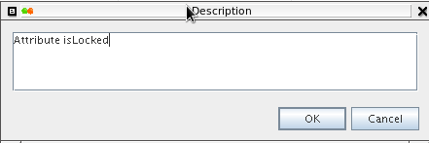

Figure 5. Custom editor for field “Description”

Note: If you don't find the attribute or class you need, you may wish to request it at this forum thread [3]. Next versions of Kuwaiba will support a dynamic datamodel, when you will be able to add classes and attributes on the fly.

Shortcut: CTRL+A

Hint: Selecting any node in the tree and writing a text string will attempt to search for a class or attribute starting with such string. If there are several matches, F3 will jump to the next one.

Chapter 4. The Class Customizer
Just the same way you can customize the way the attributes are shown in the Properties window, you can change the display preferences for classes (and their respective instances) themselves.
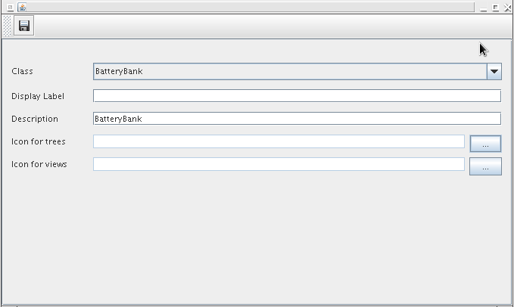
Figure 6. Class Customizer maiin window
The Class combo box lets you choose the class to be customized.
Display Label is intented to change the way the class name is shown in the navigation tree and similars. This is particularly useful for internationalization purposes, ie.: Changing “Country” for “País” if you want it in Spanish language.
The field Description, let you annotate that class, so people can now what is that about. For example, “IDU” may not be as clear as “Country” for some users. This will take special importance
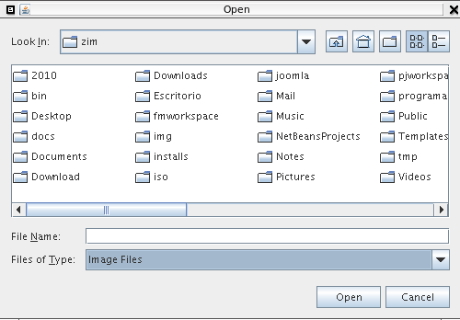

Shortcut: CTRL+M

Chapter 5. The Containment hierarchy
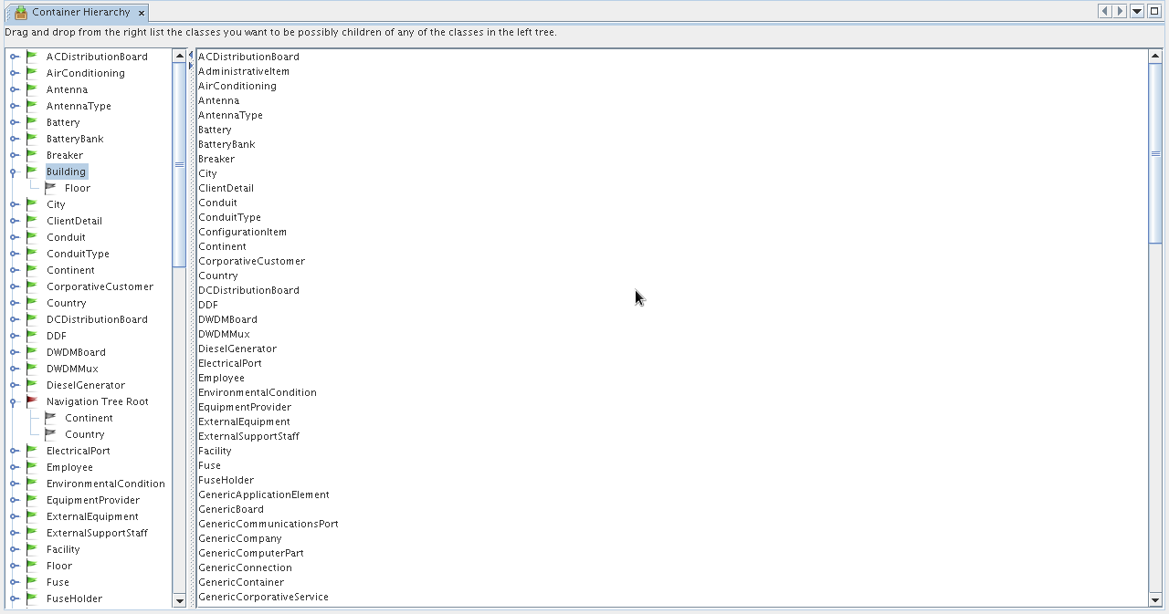

Chapter 6. The Navigation Tree
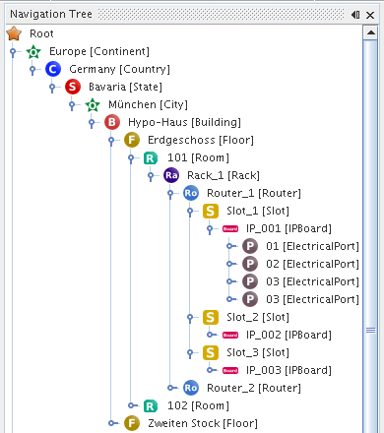

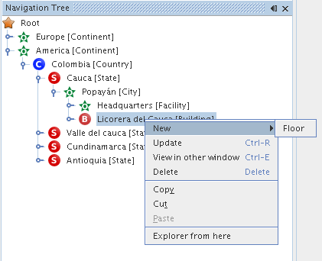

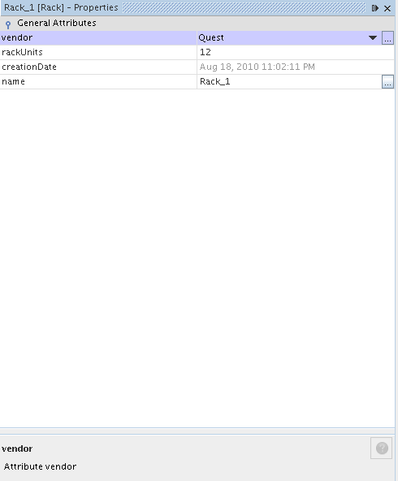

Chapter 7. List Manager
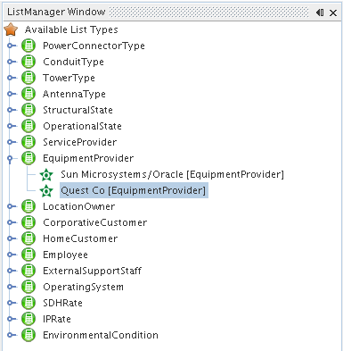

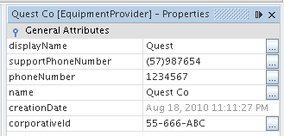

Chapter 8. Querying
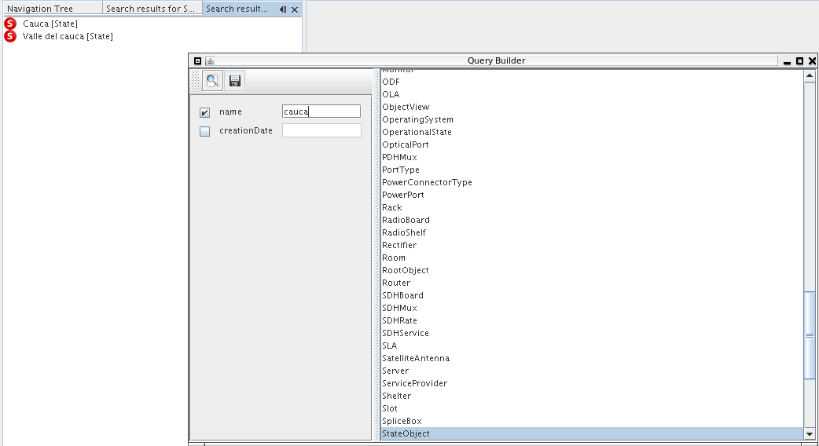

Chapter 9. User and Group Management

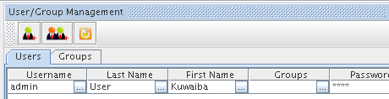

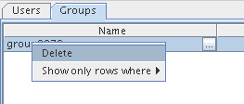

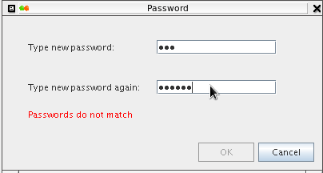

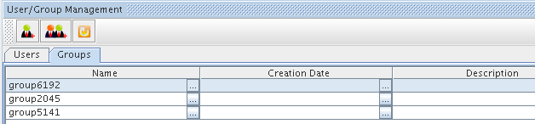

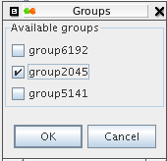

Resources
[1] Definition of Asset. http://en.wikipedia.org/wiki/Asset
[2 ] Overview of ITIL. http://en.wikipedia.org/wiki/ITIL
[3] Thread to request https://sourceforge.net/projects/kuwaiba/forums/forum/1129209/topic/3734242
[4] Client installation instructions http://kuwaiba.sourceforge.net/index.php?option=com_content&view=article&id=58:client-instructions&catid=38:user-documentation&Itemid=55
[5]

