Kuwaiba Open Network Inventory
Version 0.1 [11.09.2013]
Mobile Networks Model (GSM, UMTS and LTE)

Please visit http://kuwaiba.org for documentation, latest updates and upcoming events

Change History
Responsible | Description | Date | Reviewed by
Andrés Arboleda  andresarboleda@gmail.com | First version | September 11th 2013 | Charles Bedón  charles.bedon@kuwaiba.org

License
This document is published under the terms of a license Creative Commons by-nc-sa. You can find details about it at
http://creativecommons.org/licenses/by-nc-sa/2.0/
 | Kuwaiba Server and Client are licensed under EPL v1. You can find the whole text of this license at  http://www.eclipse.org/legal/epl-v10.html

Chapter 1. Introduction
You can find a lot of information about the architecture of mobile networks on the internet, so we're not going to talk about such technicalities here. The present document shows the main components included into the data model, explaining the design decisions. It's important to clarify that this model does not deal with CDMA networks, only GSM/EDGE, UMTS and LTE.
The following figure depicts a generic 2G/3G network based on 3GPP Release 4 standard [1]. The components are contained in three main groups: GERAN which is the 2G Radio Access Network, UTRAN which is the 3G Radio Access Network and the Network Core. Usually, telecommunications providers own hybrid networks because they're constantly upgrading to new, high capacity equipment, and that's exactly how this model is organized. There's no a separate class set for every generation, but instead, all possible components considered belong to the same branch.
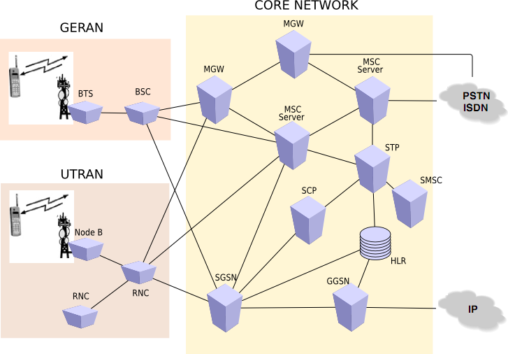Figure 1: Network Architecture of a 3GPP Release 4, 2G/3G Mobile Network.

For informational purposes, we present here what every acronym stands for:
GERAN (GSM EDGE Radio Access Network)
BTS: Base Transceiver Station
BSC: Base Station Controller
UTRAN (UMTS Terrestrial Radio Access Network)
Node B: Replaces the 2G BTS in 3G networks
RNC: Radio Network Controller
Core Network
MGW: Media Gateway
MSC Server: Mobile Switching Center Server
STP: Signaling Transfer Point
SMSC: Short Message Service Center, is one of the Value Added Services platforms.
SCP: Signaling Control Point
SGSN: Serving GPRS Support Node
GGSN: Gateway GPRS Support Node
The following figure shows the main components of a 4G (LTE) network contained in two groups: EUTRAN which is the 4G Radio Access Network and EPC which is the Network Core [2]. As you can see, the architecture has been simplified significantly and most of it relies on IP.

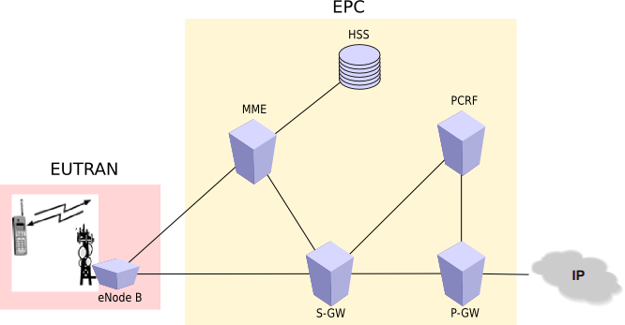Figure 2: Network Architecture of a 3GPP Release 8 4G Mobile Network.

And this is the meaning of the acronyms:
EUTRAN (Evolved UMTS Terrestrial Radio Access Network)
eNode B: Evolved Node B, for these Node B’s there is no need of a controller like an RNC.
EPC (Evolved Packet Core)
MME: Mobility Management Entity
HSS: Home Subscriber Server, replaces the HLR of 2G and 3G networks
PCRF: Policy Charging and Rules Function, this node manages all the Prepaid charging with service differentiation.
S-GW: Serving Gateway
P-GW: Packet Data Network Gateway

Chapter 2. Data Model
In this chapter, we will explore in detail the data model conceived in order to represent the elements of a mobile network in Kuwaiba, considering the scenario already described.
In the figure above, we can see the class hierarchy directly related to a mobile networks model. Most classes inherit from GenericMobileNetworkElement. Under it, you can see a class per every main node defined in a standard UMTS 3GPP Release 4/LTE 3GPP Release 8 network like BTS, BSC, MGW, MSCServer, STP, SCP, HLR, SGSN, GGSN, RNC and NodeB. For VAS (Value Added Services) only SMSC is defined as a specific element, but there is also a generic type of element called ValueAddedPlatformElement that can be used for any VAS platform not defined in the model. The type of service can be managed by creating new instances of ValueAddedPlatformType, which behaves as a regular list type. This kind of equipment might contain boards. For this purpose, a generic type of board was created: MobileNetworkElementBoard, whose instances can be used to represent the boards inside a BTS, for example (or in general, inside any other element in the mobile network).
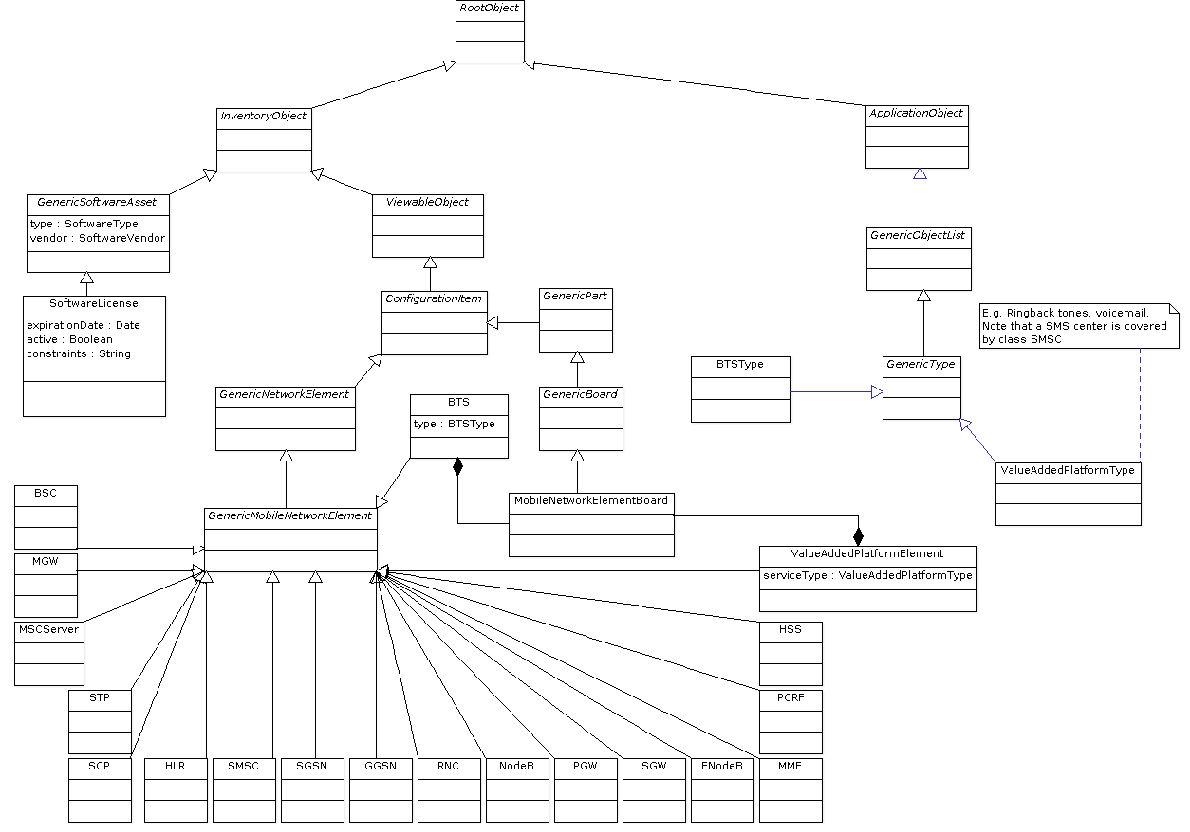Figure 3: Class diagram (zoom in to see details)

Some equipment requires special software licenses to run. These licenses specify constraints particular to the vendor and/or function, for example amount of users or time.
By default, most of the classes have only the attributes inherited from their superclasses. It's up to the implementator to customize this according to his particular needs.

Resources
[1] http://www.3gpp.org/specifications/Releases/article/release-4
[2] http://www.3gpp.org/Release-8

