Kuwaiba Open Network Inventory
Version 0.1 [07.02.2012]
Network Layer Model

Please visit http://kuwaiba.sourceforge.net for documentation, latest updates and upcoming events

Change History
Responsible | Description | Date | Reviewed by
Charles Bedón  charles.bedon@kuwaiba.org | First version aimed to be the base for the 0.4.x series network layer elements support | February 7th 2012 | Adrián Martínez  adrián.martinez@kuwaiba.org

License
This document is published under the terms of a license Creative Commons by-nc-sa. You can find details about it at
http://creativecommons.org/licenses/by-nc-sa/2.0/
 | Kuwaiba Server and Client are licensed under EPL v1. You can find the whole text of this license at  http://www.eclipse.org/legal/epl-v10.html

Disclaimer
Some brands are mentioned as example for different types of equipment. This project is not endorsed to any of the related companies and they're the sole owners of such brands.

Chapter 1. Network Layer in a nutshell
Kuwaiba uses the OSI model [1] as a base to define its different data models. The first tier included in such model is precisely the Physical Layer. It deals with the hardware and physical stuff necessary to transport information in a telecommunications network. It includes all specifications regarding to the way the information is represented via a data carrier over a transmission medium, and how such information is received at the other side to be interpreted or broadcast.
Here, we can identify three types of elements:
- Connection elements: These are, basically, the links. This is, the means by which the information can be transported. Nowadays, there are three kinds of transmission media: Electrical, using wires as conduits and electricity as data carrier. Optical, which uses light as carrier, modulating its wave length to provide different transmission channels (the conduits are fiber optics). And Radio, which uses electromagnetic fields at fixed bands (radio-frequency) to transport data, having “nothing” as conduit but the space or air itself.
Sometimes the wires/fibers are grouped in order to use a common protection or to keep the core lines together before to go into the distribution network. In structured cabling is also important to organize the wires to provide connectivity to offices and datacenters. Different methods are used to do it: cable racks, conduits, pipes, cable ditches, etc. In the present document we'll take a look on how to manage the transmission medium as well as the container used to group/protect it from the data model perspective.
- Nodes: A node is not an equipment. It is a termination point to a container conduit. I.e, one can have a pipe with many fibers in it between two buildings. The termination point to that pipe is not a router or a port, it's the building itself. However the termination point to the fiber is a port within an ODF or a board. It can be even disconnected at all.
- Endpoints: These are the actual points where a connection ends. Most of the cases these are ports, but in the case of a radio/satellite link, it's just a virtual representation of a port.
Note: Power connections won't be addressed in this document, since they will be tackled later as they belong to the electrical subsystem rather than data transport/transmission infrastructure.

Chapter 2. Data Model
In this chapter, we'll explore the Class data model conceived in order to implement the physical layer considering a scenario as described in the past chapter.

Endpoints
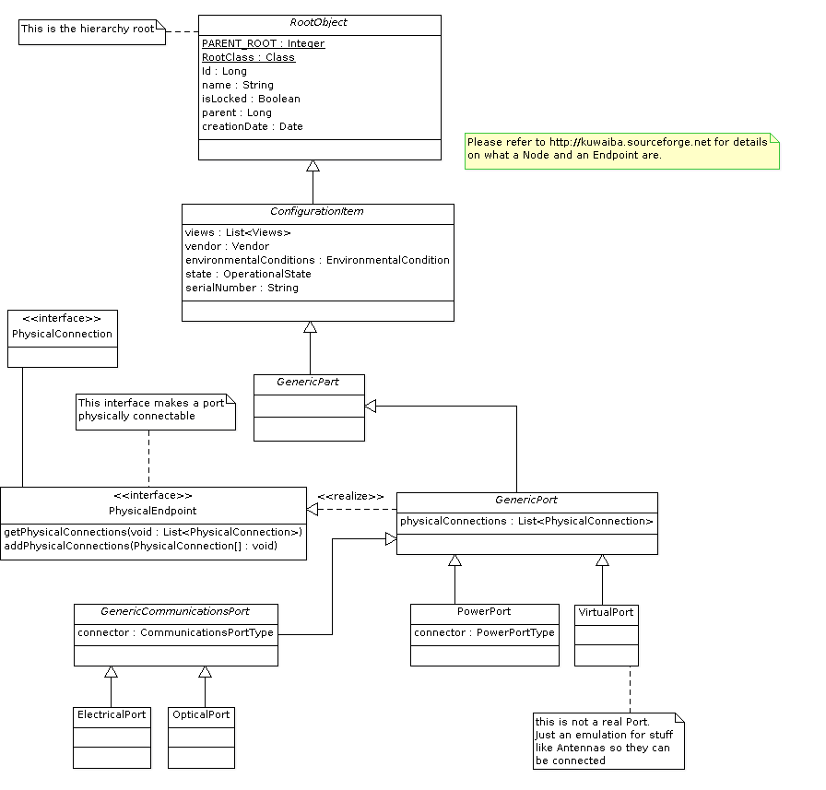
Figure 1. Class Diagram related to the endpoints
In the figure 1, we can see the class hierarchy directly related to the endpoints. As you can see, there are the types of ports: ElectricalPort, OpticalPort and VirtualPort (PowerPort is not used for data transmission). Since VirtualPort is not a real port, doesn't inherit from GenericCommunicationPort and has no type. What makes these classes eligible to be connected using a PhysicalConnection (as we'll see later, this means to be connected to radio, electrical and optical links) is to implement the PhysicalEndpoint interface by means of their superclass GenericPort.
Note that all classes using the prefix “Generic” are abstract (however not all methods within them are abstract).

Nodes
In the figure 2 is shown the class structure to support connection of wire/fiber containers between nodes (buildings, rooms, towers,etc). The general idea is simple: by implementing the PhysicalNode interface, these elements are capable to provide methods to add and remove PhysicalContainers. It's important to point out that since Rooms and Floors are very specific locations, they don't inherit from GenericLocation, but from RootObject and they have to implement that interface directly.

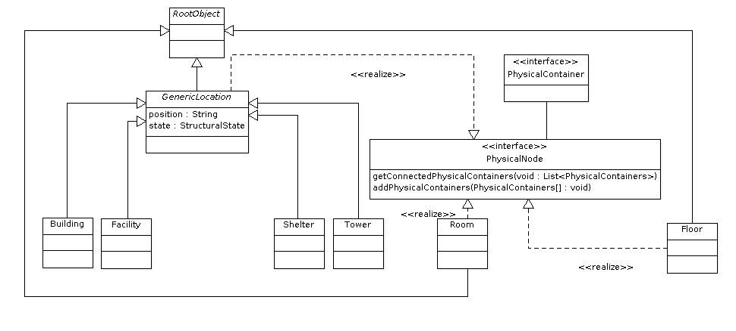

Figure 2. Class diagram with the classes related to the so called “nodes”

Containers

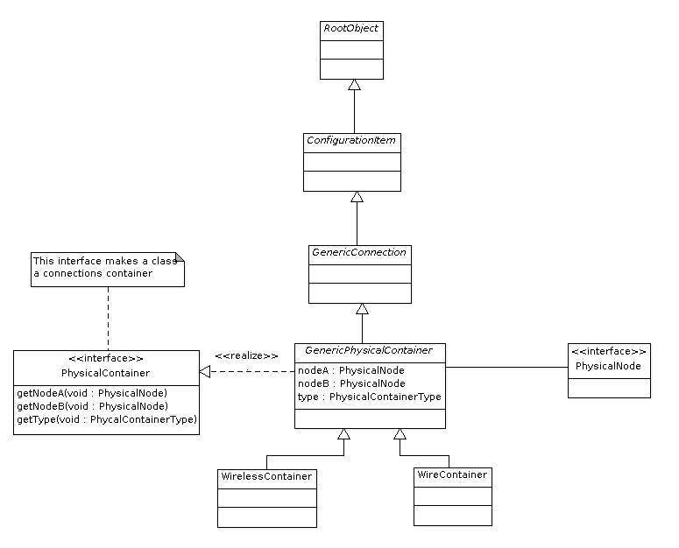
Figure 4. Class diagram showing the classes related to connections containers
Just like the past diagram, there is an interface (PhysicalContainer) that has to be implemented in order to be a connections container. They have two endpoints which are actually nodes (the endpoints of a pipe are offices, buildings, etc).

Connections
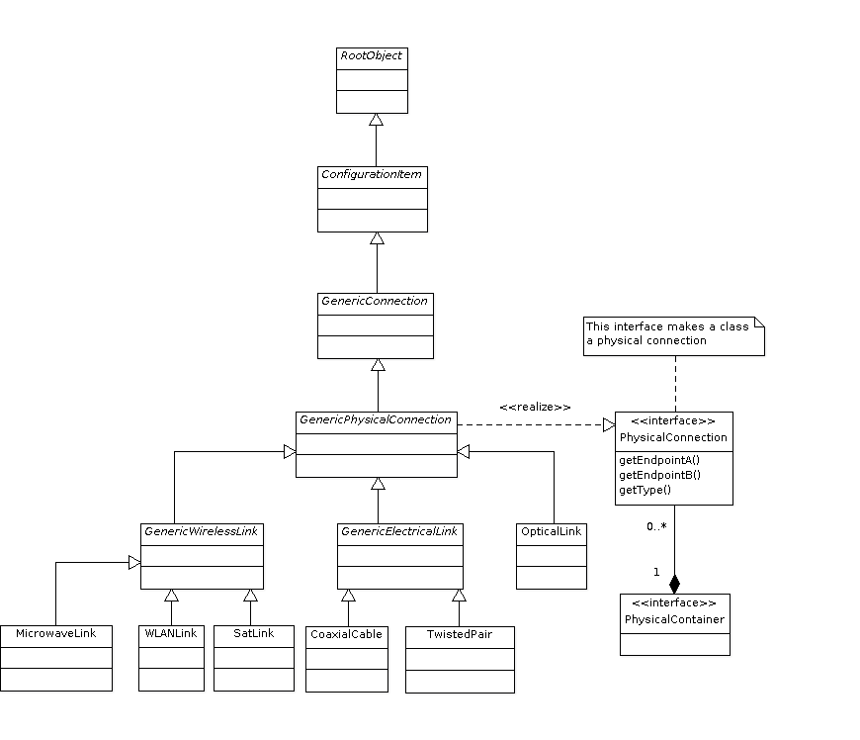
Figure 5. Class diagram with the classes related to the physical connections
Every physical connection implements the PhysicalConnection interface and has two endpoints (physical connections are -mostly, for transport purposes- point-to-point) and a type. This one indicates what kind of connection is. i.e., “Microwave”, “Ethernet”, ”Monomode Fiber”. These types will be explained in detail in the next chapter. The composition relationship between PhysicalConnection and PhysicalContainer indicates that the latter can actually contain zero or more connections inside of it.

At the end, we'll have something like this:

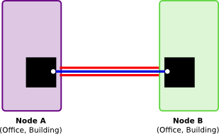
Where the red pipe is a container (conduit, ditch, etc), the white line a physical connection (UTP-5 cable, monomode fiber, etc), the black any equipment (ODF, DDF, board, hub) and the white dot, an endpoint (typically, a port).

Chapter 3. Types
In this chapter we will detail the types proposed for every

Endpoint (port) Types

Name | Class
USB-1  USB-2  USB-3  DA-15  DB-25  DC-37  DD-50  DE-9  BNC  TNC  IEEE-1394  PS/2  RJ45  RJ11 | ElectricalPort
Avio  ADT-UNI  Biconic  D4  Deutsch 1000  DIN (LSA)  DMI  E-2000 (AKALSH)  EC  ESCON  F-3000  FC/PC  FC/SPC  FC/UPC  Fibergate  FSMA  LC  LuxCis  LX-5  MIC  MPO / MTP  MT  MT-RJ  MU  NEC D4  Opti-Jack  OPTIMATE  SC  SMA 905  SMA 906  SMC  ST / BFOC  TOSLINK  VF-45  V-PIN | OpticalPort

Connection Types

Name | Class | Superclass
RG-6/U  RG-6/UQ  RG-8/U  RG-8/X  RG-9/U  RG-11/U  RG-58/U  RG-59/U  3C-2V  RG-60/U  RG-62/U  RG-62A  RG-174/U  RG-178/U  RG-179/U  RG-180B/U  RG-213/U  RG-214/U  RG-218  RG-223/U  RG-316/U  H155  H500  LMR-100  LMR-195  LMR-200  HDF-200  CFD-200  LMR-400  HDF-400  CFD-400  LMR-600  LMR-900  LMR-1200  LMR-170 | CoaxialCable | GenericElectricalLink
CAT-3  CAT-4  CAT-5  CAT-6  CAT-7 | TwistedPair | GenericElectricalLink
MonoMode  MultiMode Graded Index  MultiMode Step Index | OpticalLink | OpticalLink
Channel? | MicrowaveLink | GenericWirelessLink
IEEE 802.11-a  IEEE 802.11-b  IEEE 802.11-g | WLANLink | GenericWirelessLink
? | SatLink | GenericWirelessLink

Container Types

Name | Class
WaveGuide  RadioLink? | WirelessContainer
Pipe?  Conduit  Cable Ditch  Cable Rack | CableContainer

Resources
[1] OSI Model.http://en.wikipedia.org/wiki/OSI_model.

