**ФКПОУ «НТТИ» Минтруда России**

**ОТЧЕТ**

**о практической работе №5**

по МДК 01.02 (ПМ.01)

**Инструментальные средства разработки**

|  |  |  |  |
| --- | --- | --- | --- |
| Выполнил |  | Студент гр. П 3с  Некипелов А.Е.  ______________________  (Фамилия, инициалы) | |
| Принял |  | Преподаватель  Арапова Е.А. |
| Оценка  Дата сдачи отчета |  | __________ __________  (подпись)  26 сентября 2018 г. |
|  |  |  |
|  |  |  |

**2018**

**Практическая работ №4**

**Тема 2.1** Общие понятия и назначение инструментальных средств разработки программного обеспечения

**Название работы: Работа с данными в приложениях WindowsForms. Технология ADO.NET.**

**Цель работы:** изучить возможности технологии ADO.NET для работы с данными в приложениях Windows Forms.

**Задание 1**

Разработать автоматизированную информационную систему (АИС) учета движения книжной литературы (поступления, выдачи и списания) для библиотеки РГЭУ (РИНХ).

**Решение**

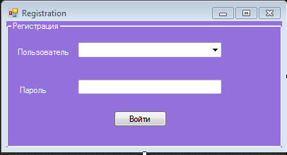

Рисунок 1 – Дизайн формы регистрации

Код формы:

using System;

using System.Collections.Generic;

using System.ComponentModel;

using System.Data;

using System.Drawing;

using System.Linq;

using System.Text;

using System.Threading.Tasks;

using System.Windows.Forms;

namespace Library

{

public partial class Registration : Form

{

public Registration()

{

InitializeComponent();

}

private void button1_Click(object sender, EventArgs e)

{

if (comboBox1.SelectedIndex == 0)

{

if (textBox1.Text == "123")

{

FMain frm = new FMain();

frm.Text = "Library 1.0 Добро подаловать";

frm.ShowDialog();

}

else

{

MessageBox.Show("Для пользователя " + comboBox1.Text + " пароль не верный");

}

}

if (comboBox1.SelectedIndex == 1)

{

if (textBox1.Text == "321")

{

FMain frm = new FMain();

frm.Text = "Library 1.0 Добро пожаловать";

frm.ShowDialog();

}

else

{

MessageBox.Show("Для пользователя " + comboBox1.Text + " пароль не верный");

}

}

}

}

}

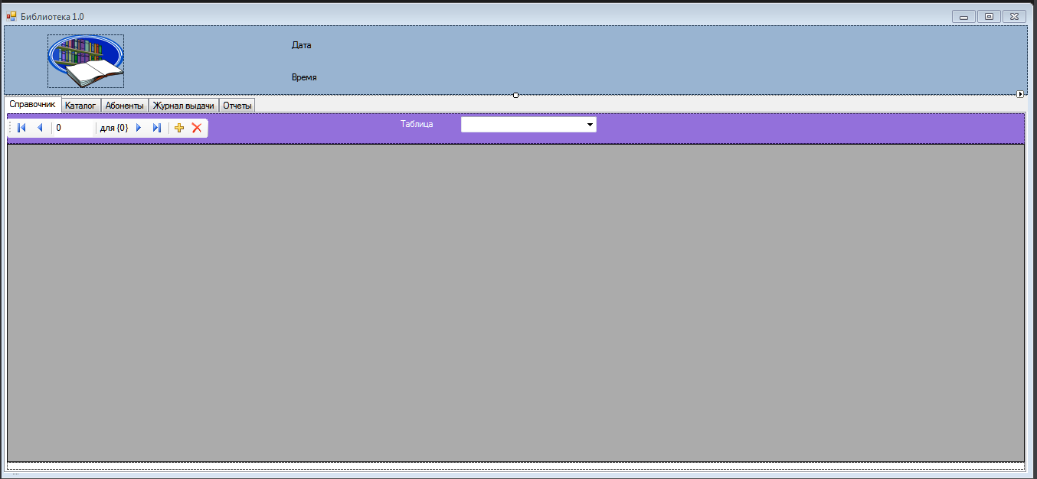

Рисунок 2 – Дизайн страницы Справочники

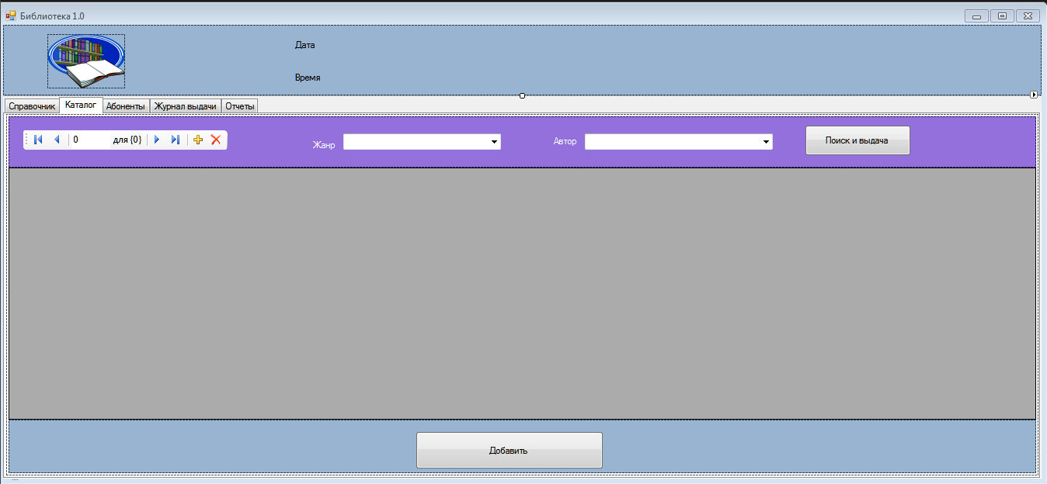

Рисунок 3 – Дизайн страницы Каталог

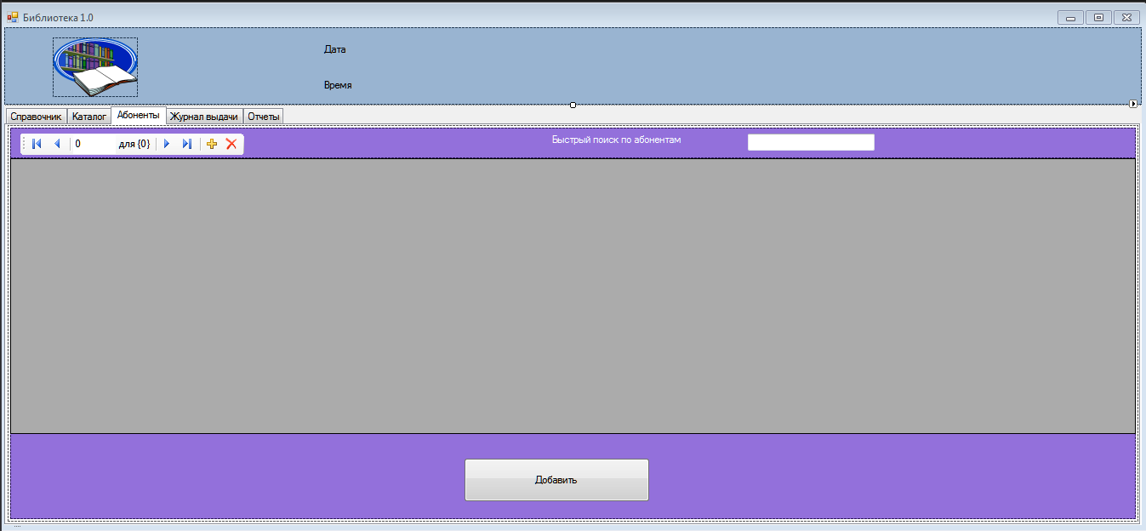

Рисунок 4 – Дизайн страницы Абоненты

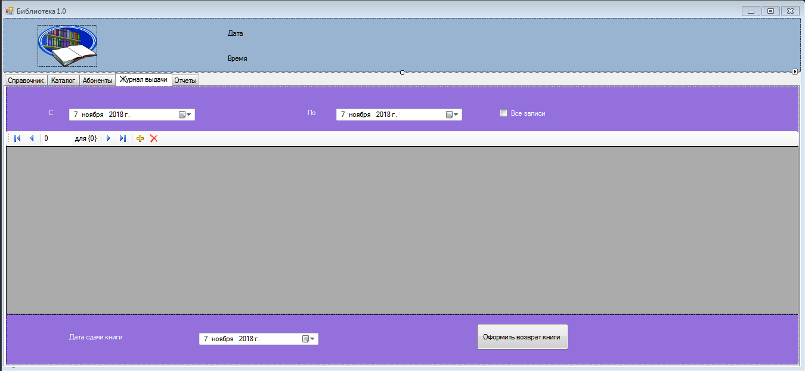

Рисунок 5 – Дизайн страницы Журнал выдачи

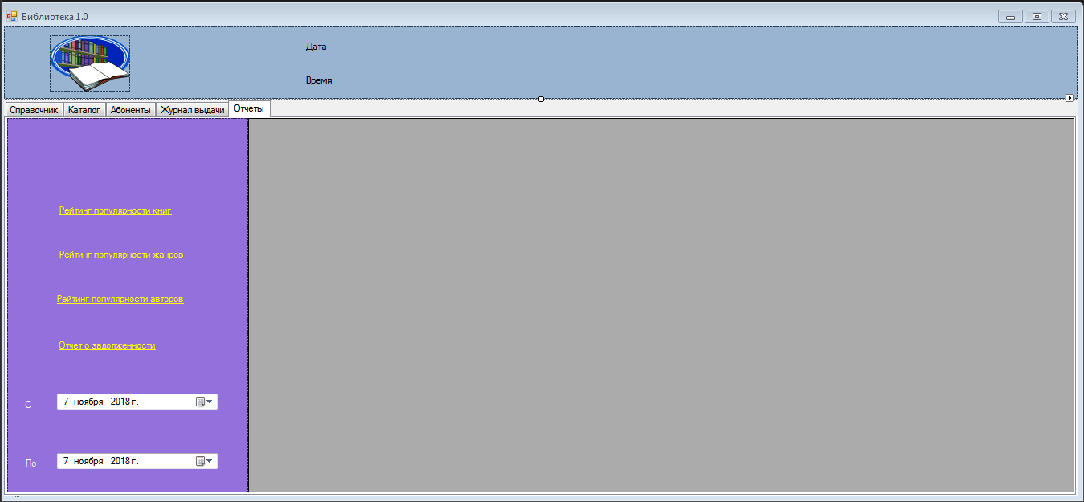

Рисунок 6 – Дизайн страницы Отчеты

Код главной формы приложения:

using System;

using System.Collections.Generic;

using System.ComponentModel;

using System.Data;

using System.Drawing;

using System.Linq;

using System.Text;

using System.Threading.Tasks;

using System.Windows.Forms;

using System.Data.OleDb;

using System.Data.SqlClient;

using System.Configuration;

namespace Library

{

public partial class FMain : Form

{

public FMain()

{

InitializeComponent();

SelfRef = this;

SqlConnectionStringBuilder csBuilder = new SqlConnectionStringBuilder(ConfigurationManager.ConnectionStrings["SQLServer"].ConnectionString);

string ServerName = csBuilder.DataSource;

string DBName = csBuilder.InitialCatalog;

connectionString = "Data Source=" + ServerName + "; Initial Catalog = " + DBName + "; Integrated Security = True";

conn(connectionString, select_Ganre, dataGridView1);

conn(connectionString, select_Author, dataGridView1);

conn(connectionString, select_Book, dataGridView3);

conn2(connectionString, select_Ganre, comboBox2, "Название", "IDЖанра");

conn2(connectionString, select_Author, comboBox3, "Имя", "IDАвтора");

conn(connectionString, select_Reader, dataGridView2);

conn(connectionString, query_delivery, dataGridView4);

}

public static FMain SelfRef

{

get;

set;

}

public string query_a = "";

public string query_g = "";

public string connectionString = "";

const string select_Ganre = "SELECT ID_Genre AS IDЖанра, Name_G as Название FROM Ganre";

const string select_Author = "SELECT ID_Author as IDАвтора, Name_Author as Имя FROM Author";

const string select_Book = "SELECT Book.ID_Book AS ID, Book.Name_B AS Название, Author.Name_Author AS Автор, Ganre.Name_G AS Жанр, " +

"Book.Sourse AS Источник, kol AS Количество, Book.Price AS Цена, Book.Publisher AS Издательство, Book.Number_of_Pages AS [Кол-во стр]," +

" Book.Year_of_Pub AS [Год издания] FROM Author,Ganre,Book WHERE Author.ID_Author = Book.ID_Author AND Book.ID_Genre =Ganre.ID_Genre";

const string select_Reader = "Select id_Reader AS [ID читателя], Name_R as ФИО, Date_B AS[Дата рождения], Adres as Адрес, Tel as Телефон, " +

"Date_R AS [Дата регистрации] from Reader";

public string query_delivery = "SELECT Delivery.ID_Delivery AS [№пп],Reader.Name_R AS [ФИО абонента],Doc.ID_Doc AS [рег. №],Delivery.Date_D AS [Дата выдачи],Delivery.Date_Return_Plan AS [План.дата возврата],Delivery.Date_Return_Fact AS [Факт.дата возврата] FROM Delivery INNER JOIN READER ON Delivery.ID_Reader=Reader.ID_Reader INNER JOIN Doc ON Delivery.ID_Doc=Doc.ID_Doc";

public void conn(string CS, string cmdT, DataGridView dgv)

{

SqlDataAdapter Adapter = new SqlDataAdapter(cmdT, CS);

DataSet ds = new DataSet();

Adapter.Fill(ds, "Table");

dgv.DataSource = ds.Tables["Table"].DefaultView;

}

public void conn2(string CS, string cmdT, ComboBox CB, string field1, string field2)

{

SqlDataAdapter Adapter = new SqlDataAdapter(cmdT, CS);

DataSet ds = new DataSet();

Adapter.Fill(ds, "Table");

CB.DataSource = ds.Tables["Table"];

CB.DisplayMember = field1;

CB.ValueMember = field2;

}

private void FMain_Load(object sender, EventArgs e)

{

lblDate.Text = "Сегодня " + DateTime.Now.ToShortDateString();

lblTime.Text = "Время " + DateTime.Now.ToLongTimeString();

}

private void timer1_Tick(object sender, EventArgs e)

{

lblTime.Text = "Время " + DateTime.Now.ToLongTimeString();

timer1.Start();

}

private void comboBox1_SelectedIndexChanged(object sender, EventArgs e)

{

if (comboBox1.SelectedIndex == 0)

{

conn(connectionString, select_Ganre, dataGridView1);

}

if (comboBox1.SelectedIndex == 1)

{

conn(connectionString, select_Author, dataGridView1);

}

}

private void comboBox2_SelectedIndexChanged(object sender, EventArgs e)

{

conn2(connectionString, select_Ganre, comboBox2, "Name_G", "ID_Genre");

}

private void comboBox3_SelectedIndexChanged(object sender, EventArgs e)

{

conn2(connectionString, select_Author, comboBox3, "Name_Author", "ID_Author");

}

private void comboBox2_SelectedValueChanged(object sender, EventArgs e)

{

if (Convert.ToString(comboBox2.SelectedValue) != "System.Data.DataRowView")

{

string select_Book = "SELECT Book.ID_Book AS ID, Book.Name_B AS Название, Author.Name_Author AS Автор, Ganre.Name_G AS Жанр, " +

"Book.Sourse AS Источник, COUNT(ID_Book) AS Количество, Book.Price AS Цена, Book.Publisher AS Издательство, Book.Number_of_Pages AS [Кол-во стр]," +

" Book.Year_of_Pub AS [Год издания] FROM Author,Ganre,Book WHERE Author.ID_Author = Book.ID_Author AND Book.ID_Genre =Ganre.ID_Genre and Ganre.ID_Genre = " + Convert.ToString(comboBox2.SelectedValue) +

" GROUP BY Book.ID_Book, Book.Name_B, Author.Name_Author, Ganre.Name_G, Book.Sourse, Book.Price , Book.Publisher , Book.Number_of_Pages, Book.Year_of_Pub";

query_g = select_Book;

}

else query_g = select_Book;

conn(connectionString, query_g, dataGridView3);

}

private void comboBox3_SelectedValueChanged(object sender, EventArgs e)

{

if (Convert.ToString(comboBox3.SelectedValue) != "System.Data.DataRowView")

{

string select_Book = "SELECT Book.ID_Book AS ID, Book.Name_B AS Название, Author.Name_Author AS Автор, Ganre.Name_G AS Жанр, " +

"Book.Sourse AS Источник, COUNT(ID_Book) AS Количество, Book.Price AS Цена, Book.Publisher AS Издательство, Book.Number_of_Pages AS [Кол-во стр]," +

" Book.Year_of_Pub AS [Год издания] FROM Author,Ganre,Book WHERE Author.ID_Author = Book.ID_Author AND Book.ID_Genre =Ganre.ID_Genre and Author.ID_Author = " + Convert.ToString(comboBox3.SelectedValue) +

" GROUP BY Book.ID_Book, Book.Name_B, Author.Name_Author, Ganre.Name_G, Book.Sourse, Book.Price , Book.Publisher , Book.Number_of_Pages, Book.Year_of_Pub";

query_a = select_Book;

//MessageBox.Show(query_g);

}

else query_a = select_Book;

conn(connectionString, query_a, dataGridView3);

}

private void button2_Click(object sender, EventArgs e)

{

Ins_Book FIns_I = new Ins_Book();

FIns_I.ShowDialog();

}

private void button1_Click(object sender, EventArgs e)

{

Ins_Book FIns_I = new Ins_Book();

FIns_I.ShowDialog();

}

private void txtSearch_TextChanged(object sender, EventArgs e)

{

string query_r = select_Reader;

if (txtSearch.Text!="")

{

query_r = select_Reader + " where Name_R LIKE " + "'" + txtSearch.Text + "%" + "'";

}

else

{

query_r = select_Reader;

}

conn(connectionString, query_r, dataGridView2);

}

private void button2_Click_1(object sender, EventArgs e)

{

Add_reader abon = new Add_reader();

abon.ShowDialog();

}

private void button4_Click(object sender, EventArgs e)

{

Search sch = new Search();

sch.ShowDialog();

}

private void dateTimePicker1_ValueChanged(object sender, EventArgs e)

{

string query_d = "";

query_d = query_delivery + " where delivery.date_d >= " +

"'" + dateTimePicker1.Value + "'" ;

conn(connectionString, query_d, dataGridView4);

checkBox1.Checked = false;

}

private void checkBox1_CheckedChanged(object sender, EventArgs e)

{

if (checkBox1.Checked)

{

conn(connectionString, query_delivery, dataGridView4);

}

}

private void button3_Click(object sender, EventArgs e)

{

SqlConnection conn1 = new SqlConnection();

conn1.ConnectionString = connectionString;

conn1.Open();

SqlCommand cmd = conn1.CreateCommand();

cmd.CommandType = CommandType.StoredProcedure;

cmd.CommandText = "[Upd_Delivary]";

cmd.Parameters.Add("@Date_Return_Fact", SqlDbType.Date, 150);

cmd.Parameters["@Date_Return_Fact"].Value = dateTimePicker3.Value;

cmd.Parameters.Add("@ID_Delivery", SqlDbType.Int, 4);

string ID_Delivery = dataGridView4[0, dataGridView4.CurrentRow.Index].Value.ToString();

cmd.Parameters["@ID_Delivery"].Value = ID_Delivery;

cmd.Parameters.Add("@ID_Doc", SqlDbType.Int, 4);

string ID_Doc= dataGridView4[2, dataGridView4.CurrentRow.Index].Value.ToString();

cmd.Parameters["@ID_Doc"].Value = ID_Doc;

cmd.ExecuteNonQuery();

MessageBox.Show("Изменения внесены.", "Добавление записей");

conn(connectionString, query_delivery, dataGridView4);

}

private void linkLabel1_LinkClicked(object sender, LinkLabelLinkClickedEventArgs e)

{

SqlConnection conn1 = new SqlConnection();

conn1.ConnectionString = connectionString;

conn1.Open();

SqlCommand cmd = conn1.CreateCommand();

cmd.CommandType = CommandType.StoredProcedure;

cmd.CommandText = "[REPORT_1]";

cmd.Parameters.Add("@D1", SqlDbType.Date, 4);

cmd.Parameters["@D1"].Value = dateTimePicker4.Value;

cmd.Parameters.Add("@D2", SqlDbType.Date, 4);

cmd.Parameters["@D2"].Value = dateTimePicker5.Value;

SqlDataAdapter ReportAdapter = new SqlDataAdapter();

ReportAdapter.SelectCommand = cmd;

DataSet dsReport = new DataSet();

ReportAdapter.Fill(dsReport, "Report");

dataGridView5.DataSource = dsReport.Tables["Report"].DefaultView;

}

private void linkLabel2_LinkClicked(object sender, LinkLabelLinkClickedEventArgs e)

{

SqlConnection conn1 = new SqlConnection();

conn1.ConnectionString = connectionString;

conn1.Open();

SqlCommand cmd = conn1.CreateCommand();

cmd.CommandType = CommandType.StoredProcedure;

cmd.CommandText = "[REPORT_2]";

cmd.Parameters.Add("@D1", SqlDbType.Date, 4);

cmd.Parameters["@D1"].Value = dateTimePicker4.Value;

cmd.Parameters.Add("@D2", SqlDbType.Date, 4);

cmd.Parameters["@D2"].Value = dateTimePicker5.Value;

SqlDataAdapter ReportAdapter = new SqlDataAdapter();

ReportAdapter.SelectCommand = cmd;

DataSet dsReport = new DataSet();

ReportAdapter.Fill(dsReport, "Report");

dataGridView5.DataSource = dsReport.Tables["Report"].DefaultView;

}

private void linkLabel3_LinkClicked(object sender, LinkLabelLinkClickedEventArgs e)

{

SqlConnection conn1 = new SqlConnection();

conn1.ConnectionString = connectionString;

conn1.Open();

SqlCommand cmd = conn1.CreateCommand();

cmd.CommandType = CommandType.StoredProcedure;

cmd.CommandText = "[REPORT_3]";

cmd.Parameters.Add("@D1", SqlDbType.Date, 4);

cmd.Parameters["@D1"].Value = dateTimePicker4.Value;

cmd.Parameters.Add("@D2", SqlDbType.Date, 4);

cmd.Parameters["@D2"].Value = dateTimePicker5.Value;

SqlDataAdapter ReportAdapter = new SqlDataAdapter();

ReportAdapter.SelectCommand = cmd;

DataSet dsReport = new DataSet();

ReportAdapter.Fill(dsReport, "Report");

dataGridView5.DataSource = dsReport.Tables["Report"].DefaultView;

}

private void linkLabel4_LinkClicked(object sender, LinkLabelLinkClickedEventArgs e)

{

SqlConnection conn1 = new SqlConnection();

conn1.ConnectionString = connectionString;

conn1.Open();

SqlCommand cmd = conn1.CreateCommand();

cmd.CommandType = CommandType.StoredProcedure;

cmd.CommandText = "[REPORT_4]";

cmd.Parameters.Add("@D1", SqlDbType.Date, 4);

cmd.Parameters["@D1"].Value = dateTimePicker4.Value;

cmd.Parameters.Add("@D2", SqlDbType.Date, 4);

cmd.Parameters["@D2"].Value = dateTimePicker5.Value;

SqlDataAdapter ReportAdapter = new SqlDataAdapter();

ReportAdapter.SelectCommand = cmd;

DataSet dsReport = new DataSet();

ReportAdapter.Fill(dsReport, "Report");

dataGridView5.DataSource = dsReport.Tables["Report"].DefaultView;

}

private void dateTimePicker2_ValueChanged(object sender, EventArgs e)

{

string query_d = "";

query_d = query_delivery + " where delivery.date_d <= " +

"'" + dateTimePicker2.Value + "'";

conn(connectionString, query_d, dataGridView4);

checkBox1.Checked = false;

}

}

}

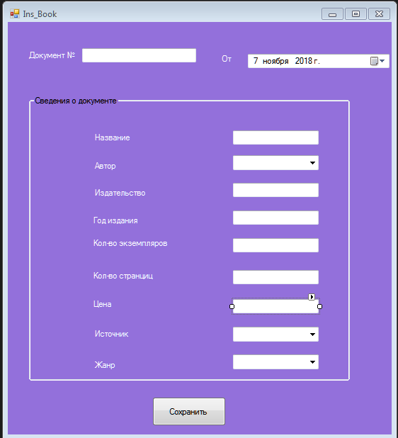

Рисунок 7 – Дизайн формы для ввода информации о партии книг и отдельных её экземпляров

Код формы:

using System;

using System.Collections.Generic;

using System.ComponentModel;

using System.Data;

using System.Drawing;

using System.Linq;

using System.Text;

using System.Threading.Tasks;

using System.Windows.Forms;

using System.Data.SqlClient;

namespace Library

{

public partial class Ins_Book : Form

{

public Ins_Book()

{

InitializeComponent();

FMain.SelfRef.conn2( FMain.SelfRef.connectionString, select_Ganre, comboBox2, "Название", "IDЖанра") ;

FMain.SelfRef.conn2(FMain.SelfRef.connectionString, select_Author, comboBox3, "Имя", "IDАвтора");

}

const string select_Ganre = "SELECT ID_Genre AS IDЖанра, Name_G as Название FROM Ganre";

const string select_Author = "SELECT ID_Author as IDАвтора, Name_Author as Имя FROM Author";

const string select_katalog = "SELECT Book.ID_Book AS ID, Book.Name_B AS Название, Author.Name_Author AS Автор, Ganre.Name_G AS Жанр, " +

"Book.Sourse AS Источник, kol AS Количество, Book.Price AS Цена, Book.Publisher AS Издательство, Book.Number_of_Pages AS [Кол-во стр]," +

" Book.Year_of_Pub AS [Год издания] FROM Author,Ganre,Book WHERE Author.ID_Author = Book.ID_Author AND Book.ID_Genre =Ganre.ID_Genre" ;

private void button1_Click(object sender, EventArgs e)

{

SqlConnection conn = new SqlConnection();

conn.ConnectionString = FMain.SelfRef.connectionString;

conn.Open();

SqlCommand cmd = conn.CreateCommand();

cmd.CommandType = CommandType.StoredProcedure;

cmd.CommandText = "[ins_Book]";

cmd.Parameters.Add("@NAME_B", SqlDbType.NVarChar, 150);

cmd.Parameters["@NAME_B"].Value = txtName.Text;

cmd.Parameters.Add("@SOURCE", SqlDbType.NVarChar, 70);

cmd.Parameters["@SOURCE"].Value = comboBox1.Text;

cmd.Parameters.Add("@DATE_P", SqlDbType.Date, 70);

cmd.Parameters["@DATE_P"].Value = dateTimePicker1.Value;

cmd.Parameters.Add("@COUNT", SqlDbType.Int, 4);

cmd.Parameters["@COUNT"].Value = Convert.ToInt32( txtCount.Text);

cmd.Parameters.Add("@PRICE", SqlDbType.Decimal, 5);

cmd.Parameters["@PRICE"].Value = Convert.ToDecimal(txtPrice.Text);

cmd.Parameters.Add("@ID_GENRE", SqlDbType.Int, 4);

cmd.Parameters["@ID_GENRE"].Value = comboBox2.SelectedValue;

cmd.Parameters.Add("@ID_AUTHOR", SqlDbType.Int, 4);

cmd.Parameters["@ID_AUTHOR"].Value = comboBox3.SelectedValue;

cmd.Parameters.Add("@PUBLISHER", SqlDbType.NVarChar, 150);

cmd.Parameters["@PUBLISHER"].Value = txtPub.Text;

cmd.Parameters.Add("@NAMBER_PAGES", SqlDbType.Int, 4);

cmd.Parameters["@NAMBER_PAGES"].Value = Convert.ToInt32( txtPageCount.Text);

cmd.Parameters.Add("@YEAR_PUB", SqlDbType.Int, 4);

cmd.Parameters["@YEAR_PUB"].Value = Convert.ToInt32(txtYear.Text);

cmd.Parameters.Add("@Id", SqlDbType.Int, 4);

cmd.Parameters["@Id"].Direction = ParameterDirection.Output;

cmd.ExecuteScalar();

int ID_Book = Convert.ToInt32(cmd.Parameters["@id"].Value);

MessageBox.Show("Изменения внесены. ID= " + ID_Book.ToString()+ "Добавление записей");

int Count_Doc = Convert.ToInt32(txtCount.Text);

int k = 0;

for(int i=0; i<Count_Doc;i++)

{

SqlCommand cmdd = conn.CreateCommand();

cmdd.CommandType = CommandType.StoredProcedure;

cmdd.CommandText = "[INS_DOC]";

cmdd.Parameters.Add("@ID_Book", SqlDbType.Int, 4);

cmdd.Parameters["@ID_Book"].Value = ID_Book;

cmdd.Parameters.Add("@Status", SqlDbType.Int, 4);

cmdd.Parameters["@Status"].Value = "0";

cmdd.ExecuteNonQuery();

k++;

}

MessageBox.Show("Изменения внесены. Добавлено документов - " + k, "Добавление записей");

if(FMain.SelfRef!=null)

{

FMain.SelfRef.conn(FMain.SelfRef.connectionString, select_katalog, FMain.SelfRef.dataGridView3);

}

}

}

}

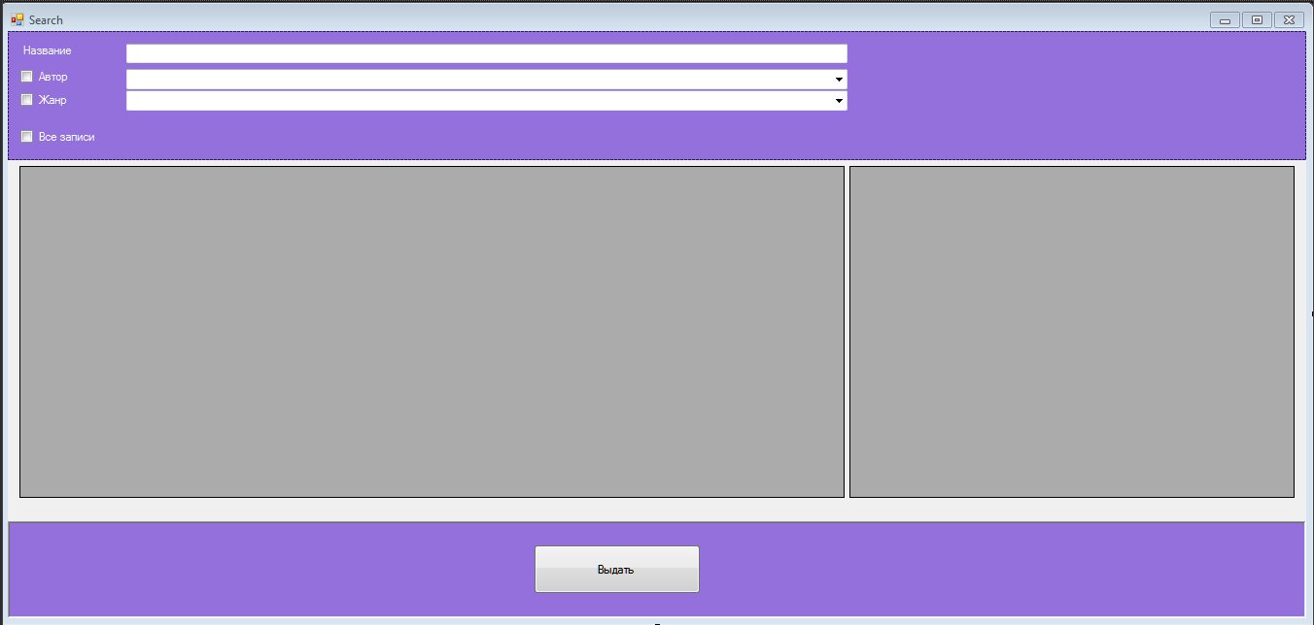

Рисунок 8 – Форма поиска книги для её выдачи

Код формы:

using System;

using System.Collections.Generic;

using System.ComponentModel;

using System.Data;

using System.Drawing;

using System.Linq;

using System.Text;

using System.Threading.Tasks;

using System.Windows.Forms;

using System.Data.SqlClient;

namespace Library

{

public partial class Search : Form

{

public Search()

{

InitializeComponent();

FMain.SelfRef.conn(FMain.SelfRef.connectionString, select_book, dataGridView1);

FMain.SelfRef.conn(FMain.SelfRef.connectionString, select_doc, dataGridView2);

FMain.SelfRef.conn2(FMain.SelfRef.connectionString, select_Ganre, comboBox2, "Название", "IDЖанра");

FMain.SelfRef.conn2(FMain.SelfRef.connectionString, select_Author, comboBox1, "Имя", "IDАвтора");

SelfRef = this;

}

public string select_book = "SELECT Book.ID_Book AS ID, Book.Name_B AS Название, Author.Name_Author AS Автор, Ganre.Name_G AS Жанр, " +

"Book.Sourse AS Источник, kol AS Количество, Book.Price AS Цена, Book.Publisher AS Издательство, Book.Number_of_Pages AS [Кол-во стр]," +

" Book.Year_of_Pub AS [Год издания] FROM Author,Ganre,Book WHERE Author.ID_Author = Book.ID_Author AND Book.ID_Genre =Ganre.ID_Genre";

public string select_doc = "Select * From Doc ";

string select_Ganre = "SELECT ID_Genre AS IDЖанра, Name_G as Название FROM Ganre";

string select_Author = "SELECT ID_Author as IDАвтора, Name_Author as Имя FROM Author";

string query_g = "";

string query_a = "";

public static Search SelfRef

{

get;

set;

}

private void dataGridView1_CellMouseClick(object sender, DataGridViewCellMouseEventArgs e)

{

string query_d = "";

string id_book = dataGridView1[0, dataGridView1.CurrentRow.Index].Value.ToString();

query_d = select_doc + " WHERE Doc.id_book=" + id_book;

//MessageBox.Show(query_d);

FMain.SelfRef.conn(FMain.SelfRef.connectionString, query_d, dataGridView2);

}

private void textBox1_TextChanged(object sender, EventArgs e)

{

string query_b = select_book;

if (textBox1.Text != "")

{

query_b = select_book + " and Name_B LIKE " + "'" + textBox1.Text + "%" + "'";

}

else

{

query_b = select_book;

}

FMain.SelfRef.conn(FMain.SelfRef.connectionString, query_b, dataGridView1);

}

private void comboBox1_SelectedValueChanged(object sender, EventArgs e)

{

if (Convert.ToString(comboBox1.SelectedValue) != "System.Data.DataRowView")

{

string select_Book = "SELECT Book.ID_Book AS ID, Book.Name_B AS Название, Author.Name_Author AS Автор, Ganre.Name_G AS Жанр, " +

"Book.Sourse AS Источник, COUNT(ID_Book) AS Количество, Book.Price AS Цена, Book.Publisher AS Издательство, Book.Number_of_Pages AS [Кол-во стр]," +

" Book.Year_of_Pub AS [Год издания] FROM Author,Ganre,Book WHERE Author.ID_Author = Book.ID_Author AND Book.ID_Genre =Ganre.ID_Genre and Author.ID_Author = " + Convert.ToString(comboBox1.SelectedValue) +

" GROUP BY Book.ID_Book, Book.Name_B, Author.Name_Author, Ganre.Name_G, Book.Sourse, Book.Price , Book.Publisher , Book.Number_of_Pages, Book.Year_of_Pub";

query_a = select_Book;

//MessageBox.Show(query_g);

}

else

query_a = select_book;

FMain.SelfRef.conn(FMain.SelfRef.connectionString, query_a, dataGridView1);

}

private void comboBox2_SelectedIndexChanged(object sender, EventArgs e)

{

if (Convert.ToString(comboBox2.SelectedValue) != "System.Data.DataRowView")

{

string select_Book = "SELECT Book.ID_Book AS ID, Book.Name_B AS Название, Author.Name_Author AS Автор, Ganre.Name_G AS Жанр, " +

"Book.Sourse AS Источник, COUNT(ID_Book) AS Количество, Book.Price AS Цена, Book.Publisher AS Издательство, Book.Number_of_Pages AS [Кол-во стр]," +

" Book.Year_of_Pub AS [Год издания] FROM Author,Ganre,Book WHERE Author.ID_Author = Book.ID_Author AND Book.ID_Genre =Ganre.ID_Genre and Ganre.ID_Genre = " + Convert.ToString(comboBox2.SelectedValue) +

" GROUP BY Book.ID_Book, Book.Name_B, Author.Name_Author, Ganre.Name_G, Book.Sourse, Book.Price , Book.Publisher , Book.Number_of_Pages, Book.Year_of_Pub";

query_g = select_Book;

}

else query_g = select_book;

FMain.SelfRef.conn(FMain.SelfRef.connectionString, query_g, dataGridView1);

}

private void checkBox1_CheckedChanged(object sender, EventArgs e)

{

if(checkBox1.Checked)

{

comboBox1.Enabled = true;

}

else

{

comboBox1.Enabled = false;

}

}

private void checkBox2_CheckedChanged(object sender, EventArgs e)

{

if (checkBox2.Checked)

{

comboBox2.Enabled = true;

}

else

{

comboBox2.Enabled = false;

}

}

private void Search_Load(object sender, EventArgs e)

{

comboBox1.Enabled = false;

comboBox2.Enabled = false;

}

private void checkBox3_CheckedChanged(object sender, EventArgs e)

{

if (checkBox3.Checked)

{

string query_all = select_book;

FMain.SelfRef.conn(FMain.SelfRef.connectionString, query_all, dataGridView1);

}

}

private void button1_Click(object sender, EventArgs e)

{

vydacha frm = new vydacha();

frm.textBox1.Text = dataGridView2[0, dataGridView2.CurrentRow.Index].Value.ToString();

frm.textBox2.Text = dataGridView1[2, dataGridView1.CurrentRow.Index].Value.ToString();

frm.textBox3.Text = dataGridView1[1, dataGridView1.CurrentRow.Index].Value.ToString();

frm.ShowDialog();

}

}

}

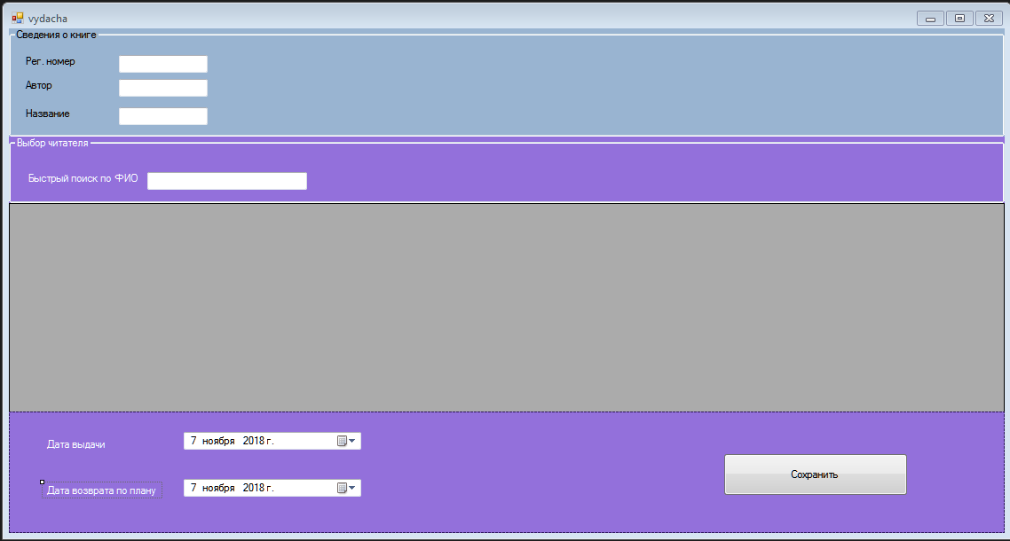

Рисунок 9 – Дизайн формы выдачи

Код формы:

using System;

using System.Collections.Generic;

using System.ComponentModel;

using System.Data;

using System.Drawing;

using System.Linq;

using System.Text;

using System.Threading.Tasks;

using System.Windows.Forms;

using System.Data.SqlClient;

namespace Library

{

public partial class vydacha : Form

{

public vydacha()

{

InitializeComponent();

select_r = "Select id_Reader AS [ID читателя], Name_R as ФИО, Date_B AS[Дата рождения], Adres as Адрес, Tel as Телефон, " +

"Date_R AS [Дата регистрации] from Reader";

FMain.SelfRef.conn(FMain.SelfRef.connectionString, select_r, dataGridView1);

}

const string select_doc = "Select * From Doc ";

string select_r = "";

string query_r = "";

private void textBox4_TextChanged(object sender, EventArgs e)

{

string query_r = select_r;

if (textBox4.Text != "")

{

query_r = select_r + " where Name_R LIKE " + "'" + textBox4.Text + "%" + "'";

}

else

{

query_r = select_r;

}

FMain.SelfRef.conn(FMain.SelfRef.connectionString, query_r, dataGridView1);

}

private void vydacha_Load(object sender, EventArgs e)

{

dateTimePicker1.Value = DateTime.Now;

dateTimePicker2.Value = DateTime.Now;

}

private void button1_Click(object sender, EventArgs e)

{

SqlConnection conn = new SqlConnection();

conn.ConnectionString = FMain.SelfRef.connectionString;

conn.Open();

SqlCommand cmdd = conn.CreateCommand();

cmdd.CommandType = CommandType.StoredProcedure;

cmdd.CommandText = "[Ins_Delivary]";

cmdd.Parameters.Add("@ID_Doc", SqlDbType.Int, 4);

cmdd.Parameters["@ID_Doc"].Value = textBox1.Text;

cmdd.Parameters.Add("@ID_Reader", SqlDbType.Int, 4);

cmdd.Parameters["@ID_Reader"].Value = dataGridView1[0,dataGridView1.CurrentRow.Index].Value.ToString();

cmdd.Parameters.Add("@Date_D", SqlDbType.Date, 40);

cmdd.Parameters["@Date_D"].Value = dateTimePicker1.Value;

cmdd.Parameters.Add("Date_Return_Plan", SqlDbType.Date, 40);

cmdd.Parameters["Date_Return_Plan"].Value = dateTimePicker2.Value;

cmdd.ExecuteNonQuery();

MessageBox.Show("Изменения внесены", "Добавление записей");

FMain.SelfRef.conn(FMain.SelfRef.connectionString, FMain.SelfRef.query_delivery, dataGridView1);

FMain.SelfRef.conn(FMain.SelfRef.connectionString, select_doc, Search.SelfRef.dataGridView2);

}

}

}

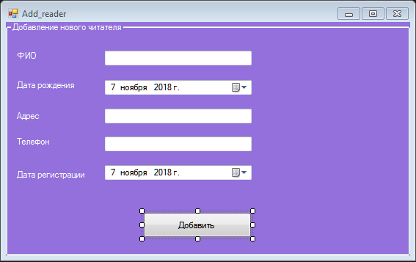

Рисунок 10 – Дизайн формы добавления нового читателя в базу

Код формы:

using System;

using System.Collections.Generic;

using System.ComponentModel;

using System.Data;

using System.Drawing;

using System.Linq;

using System.Text;

using System.Threading.Tasks;

using System.Windows.Forms;

using System.Data.SqlClient;

namespace Library

{

public partial class Add_reader : Form

{

public Add_reader()

{

InitializeComponent();

}

const string select_Reader = "Select id_Reader AS [ID читателя], Name_R as ФИО, Date_B AS[Дата рождения], Adres as Адрес, Tel as Телефон, " +

"Date_R AS [Дата регистрации] from Reader";

private void button1_Click(object sender, EventArgs e)

{

SqlConnection conn = new SqlConnection();

conn.ConnectionString = FMain.SelfRef.connectionString;

conn.Open();

SqlCommand cmd = conn.CreateCommand();

cmd.CommandType = CommandType.StoredProcedure;

cmd.CommandText = "[ins_Reader]";

cmd.Parameters.Add("@NAME_R", SqlDbType.NVarChar, 50);

cmd.Parameters["@NAME_R"].Value = textBox1.Text;

cmd.Parameters.Add("@Date_b", SqlDbType.Date, 70);

cmd.Parameters["@Date_b"].Value = dateTimePicker1.Value;

cmd.Parameters.Add("@Adres", SqlDbType.NVarChar, 70);

cmd.Parameters["@Adres"].Value = textBox2.Text;

cmd.Parameters.Add("@Tel", SqlDbType.NVarChar, 15);

cmd.Parameters["@Tel"].Value = textBox3.Text;

cmd.Parameters.Add("@Date_r", SqlDbType.Date, 15);

cmd.Parameters["@Date_r"].Value = dateTimePicker2.Value;

cmd.ExecuteScalar();

MessageBox.Show("Добавление записей в таблицу Reader ");

FMain.SelfRef.conn(FMain.SelfRef.connectionString, select_Reader, FMain.SelfRef.dataGridView2);

}

}

}