# PPO Hyper-Parameter Tuning

SA PPO hyper-parameter settings (April 16th at 4:15 PST):

batch_sizes = [5, 10, 20, 40, 100]  
epochs = [4, 8, 16, 32]  
gae_lambdas = [0.9, 0.95, 1]  
policy_clips = [0.1, 0.2, 0.3]  
gammas = [0.99, 0.9, 0.8]

# episodes = 250

# alpha = 0.0003

# D = 5

{'batch_size': 5, 'epoch': 4, 'gae_lambda': 0.95, 'policy_clip': 0.3, 'gamma': 0.99}:

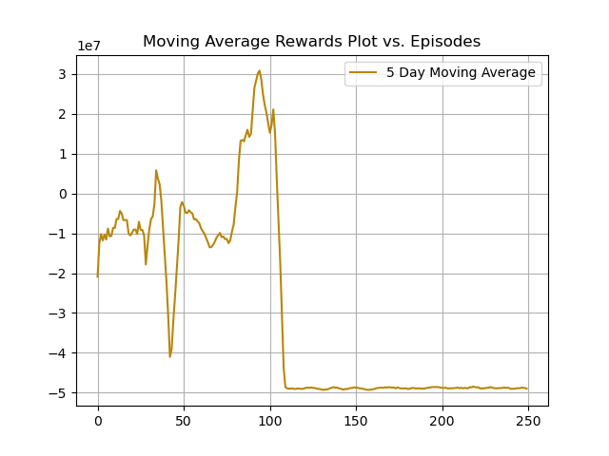

max_reward = 33,742,686.60