DSA210

**Trading vs Weather Analysis**

**Author**: Atakan Vardar

**Date**: January 2025

horizontal line

# Placeholder image

# Introduction

This report explores whether personal trading performance correlates with local Istanbul weather conditions (temperature, precipitation, humidity) and time‐based factors (weekday, hour of day, monthly patterns). The aim is to see if external factors can help explain or predict daily trading profit/loss (P/L).

## 

# Data Sources & Preprocessing

## Data Overview

Trading Data  
**Files**: trading_results_summary.csv

**Columns**:

* Open_Time, Close_Time (DateTime)
* Profit (daily net P/L)
* Result (Win/Lose/BreakEven)
* Risk and other columns (Stop_Loss, Take_Profit, etc.)

## Weather Data

**File**: Istanbul,Turkey 2023-08-18 to 2024-12-18.csv

**Columns**:

* Date
* temp, tempmax, tempmin, precip, humidity
* Other daily weather indicators (e.g., conditions like “Rainy”, “Cloudy”).

Both sets are merged on a daily Date to align trading outcomes with weather data.

# Preprocessing Steps

## **Date Conversion**:

* Extracted daily Date from Open_Time (trading).
* Renamed datetime → Date in weather and normalized times to 00:00.

## Feature Engineering:

* rain_indicator = 1 if precip > 0, else 0
* temp_range = tempmax - tempmin
* day_of_week (0=Monday, …, 6=Sunday)
* hour_of_day (0–23, from Open_Time)
* trade_duration_min = (Close_Time − Open_Time) in minutes

### Merged Dataset

After merging on Date with an **inner join**, the final dataset has **290 rows** of daily records, each containing:

* **Trading**: Profit, Result, Open_Time, Close_Time, etc.
* **Weather**: Temperature, precipitation, humidity, etc.

## 

# Exploratory Data Analysis (EDA)

### Profit Distribution

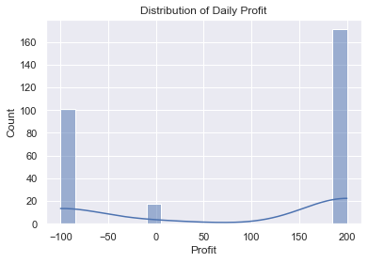

* Figure: *Distribution of Daily Profit* (Histogram)
* Shows strong peaks at approximately -100 and +200, suggesting frequently used stop-loss and take-profit levels.
* A smaller cluster near 0 indicates break-even trades.Weather Variables

### Temperature Distribution

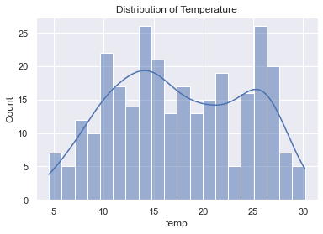

* Figure: *Distribution of Temperature*
* Ranges ~5°C to 30°C, with a typical peak around ~15–16°C

### Profit on Rainy vs. Non-Rainy Days

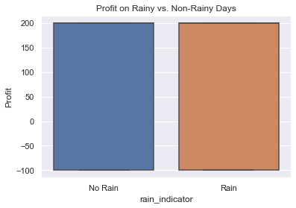

Figure: *Profit on Rainy vs. Non-Rainy Days* (Boxplot)

* + - Shows no obvious difference in average profit when comparing rainy vs. non-rainy days.

### Correlation Matrix

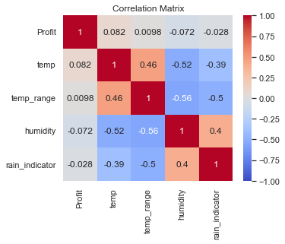

Figure: *Correlation Matrix (Profit, temp, humidity, rain_indicator, etc.)*

* + - Weak correlations between Profit and weather features.

## 

## Time-Based Analysis (Daily)

### By Day of Week

* 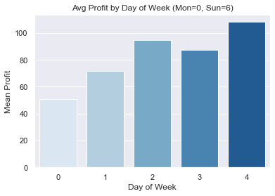
* **Figure**: *Avg Profit by Day of Week*
* 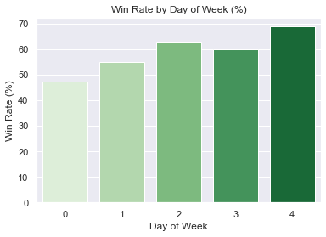
* **Figure**: *Win Rate by Day of Week*
* Observations: Friday (day=4) has the highest average profit (~100+). Monday (day=0) is lower (~40–50). Friday’s win rate is ~70%.

### 

### By Hour of Day

* 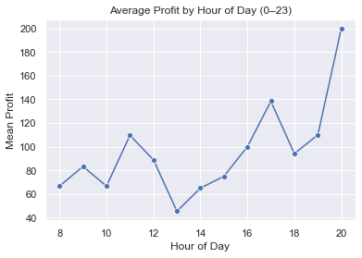
* **Figure**: *Average Profit by Hour of Day* (line chart)
* 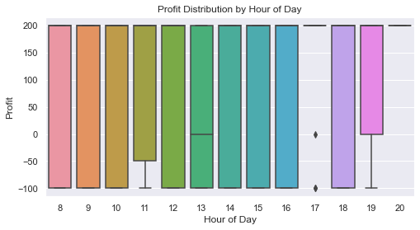
* **Figure**: *Profit Distribution by Hour of Day* (boxplot)
* Observations: Late evening trades (18–20) show a significant jump in average profit. Midday hours around noon can fluctuate or dip.

### Monthly Analysis (Temperature vs. Win Rate)

* 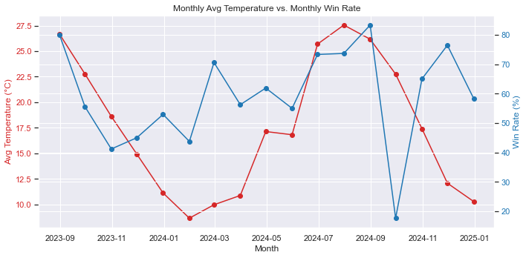
* **Figure**: *Monthly Avg Temperature vs. Monthly Win Rate*
  + Lines show monthly average temperature (°C) vs. monthly win percentage.
  + No clear strong parallel or inverse pattern is evident.

## Statistical Tests

## Rain vs. Non-Rain

* *H₀*: No difference in average Profit on rainy vs. non-rainy days.
* H₁: *There* ***is*** *a difference in average Profit on rainy vs. non-rainy days.*

## Day of Week

* *H₀*: Mean Profit is the same across weekdays (Mon–Sun).
* H₁: *Mean Profit* ***is not*** *the same across all weekdays; at least one weekday differs significantly.*

## Monthly Temp vs. Win Rate

* *H₀*: No linear or monotonic correlation between monthly temperature and win rate.
* H₁: *There* ***is*** *a linear or monotonic correlation between monthly temperature and win rate.*

## 

## Rain vs. Non-Rain (t-test)

* *t-statistic* ≈ -0.475, *p* ≈ 0.6355
* p > 0.05 → fail to reject H₀. No significant difference found.

### ANOVA & Kruskal–Wallis (Day of Week)

* *ANOVA*: F-stat ≈ 1.3971, p ≈ 0.2350
* *Kruskal–Wallis*: H-stat ≈ 5.4153, p ≈ 0.2473
* Both p > 0.05 → **fail to reject** H₀. No statistically significant weekday effect.

### Monthly Temperature vs. Win Rate (Pearson & Spearman)

* *Pearson Corr* ≈ 0.2641, p ≈ 0.3057
* *Spearman Corr* ≈ 0.3824, p ≈ 0.1299
* Both p > 0.05 → No significant correlation.

# 

# Simple Regression

A **Linear Regression** model predicted Profit from [temp, humidity, temp_range, rain_indicator, day_of_week, hour_of_day].

* **R²** ~ 0.033 (3.3% variance explained)
* **RMSE** ~ 141.17

Interpretation: Weather/time features alone do **not** strongly predict daily profit.

# Key Findings & Interpretations

**Rain vs. Non-Rain**

* Statistical tests show no significant difference in average daily profit.

**Day of Week**

* Visual patterns (e.g., Friday looks higher) are **not** statistically confirmed.

**Monthly Temp vs. Win Rate**

* Pearson/Spearman correlations are > 0.05, so no strong evidence of a relationship.

**Regression**

* Weather/time features alone yield low predictive power for daily P/L.

## 

## 

## 

## 

## 

## Conclusions & Future Work

### Weak Weather Impact

# Temperature, rain, humidity do not appear to systematically affect daily profit in this dataset.

### Time Factors

# While certain days/hours (like Friday or 8 PM) look better on average, significance tests do not support a robust effect.

### 

### Future Directions

# Longer Data Window: Increase sample size across different seasons/years.

# Market Indicators: Add volatility indices, news events, or macro data to see if they overshadow weather/time influences.

# Intraday Analysis: Investigate more granular intervals (e.g., 15–30 minute windows) for micro-trends.

# Advanced Models: Consider time-series forecasting (ARIMA, LSTM) or ensemble methods with more features.

# 