How To Run Code

This is maven based project using Rest Assured and TestNG

1. Click Get From VCS

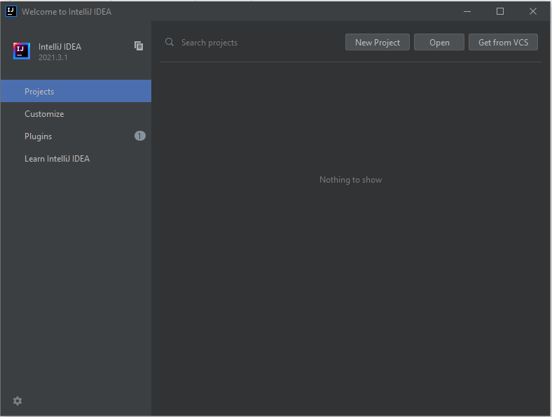

1. Paste Repository URL (<https://github.com/atkp1234/RuangGuru.git>) and click clone

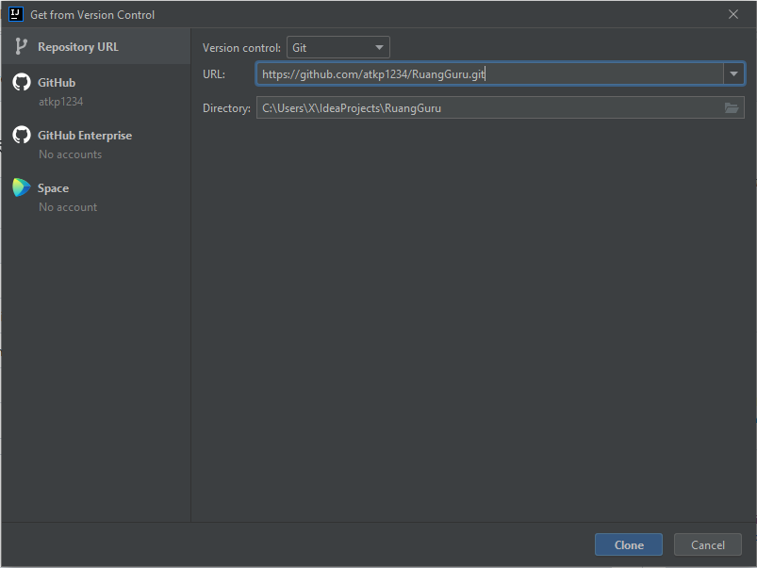

1. Right click on pom.xml -> select Maven -> select reload project

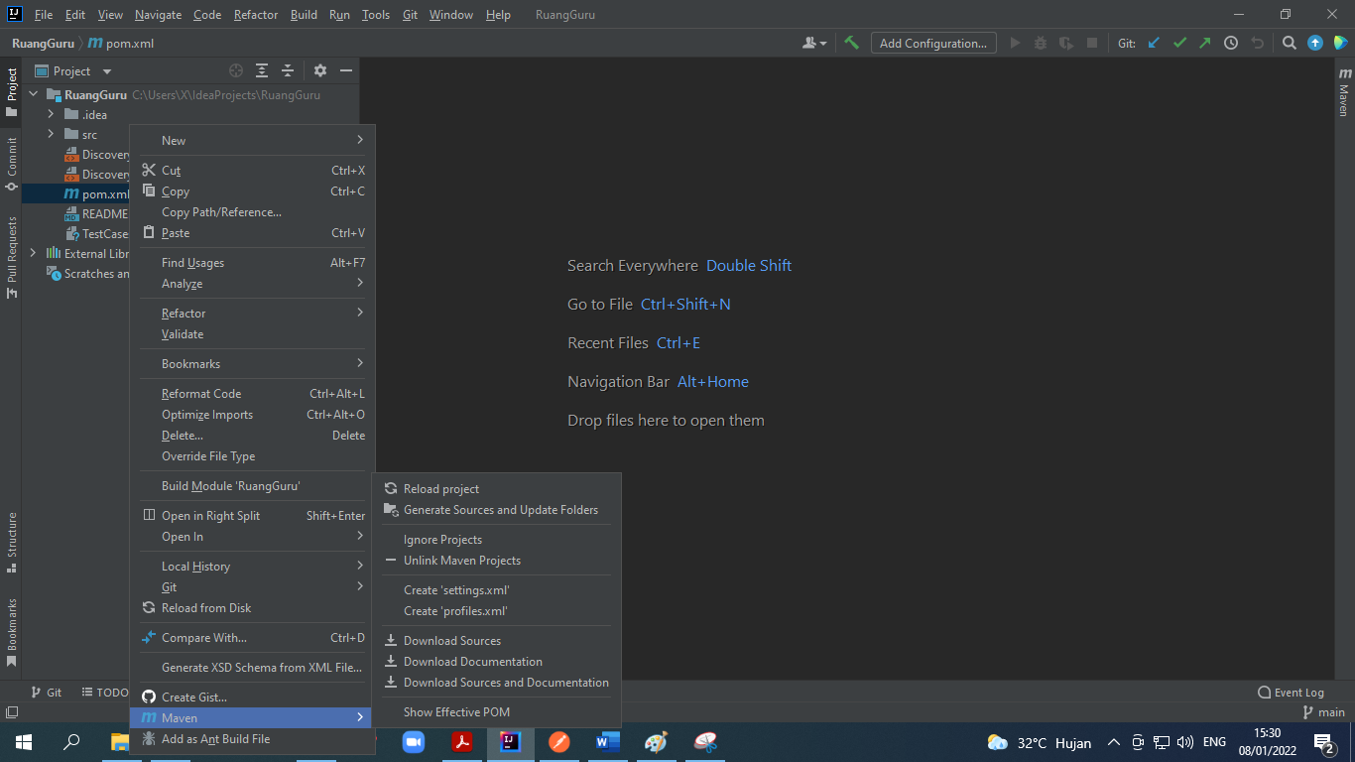

1. Right click on DicoveryRegressionTestSuite.xml -> select run

