ReadMe

Please read the following instructions:
To run Task 1:
- Please start a Command Prompt using: Start -> Run -> type in ‘cmd’ and click on ‘OK’
- Navigate to the directory where the executable PhraseCount.jar file is located.
- Execute the .jar file using the following cmd command: “java –jar PhraseCount.jar”
- Note: Make sure that you have the correct environment variable set and Java6 JVM, so that you can use the “java –jar …” command in CMD.
- Example:
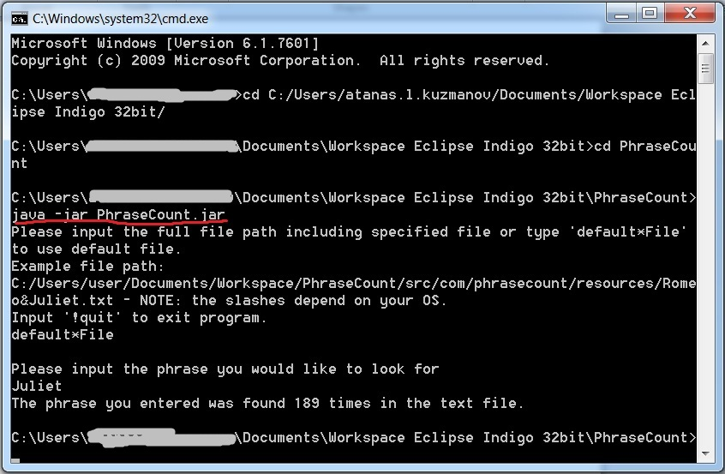

To run Task 2:
- Please start a Command Prompt using: Start -> Run -> type in ‘cmd’ and click on ‘OK’
- Navigate to the directory where the executable ConcurrentArrayListSort.jar file is located.
- Execute the .jar file using the following cmd command: “java –jar ConcurrentArrayListSort.jar”
- Note: Make sure that you have the correct environment variable set and Java6 JVM, so that you can use the “java –jar …” command in CMD.
- Example:
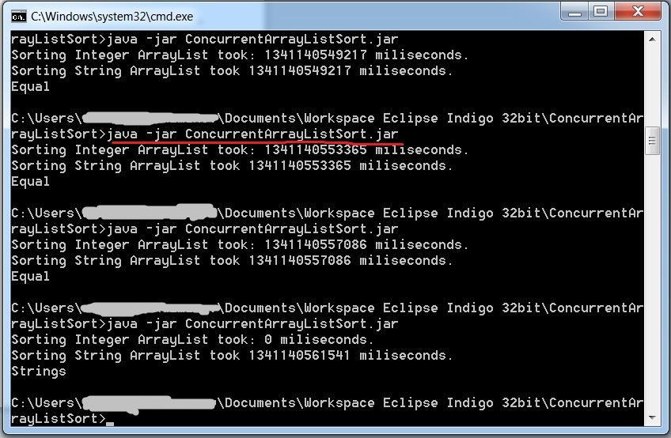

Sample results
Task 1:
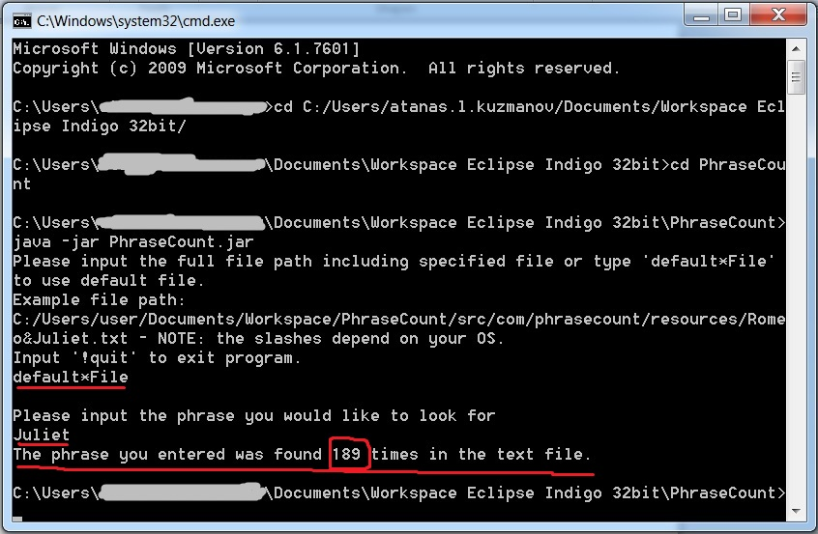
Task 2:
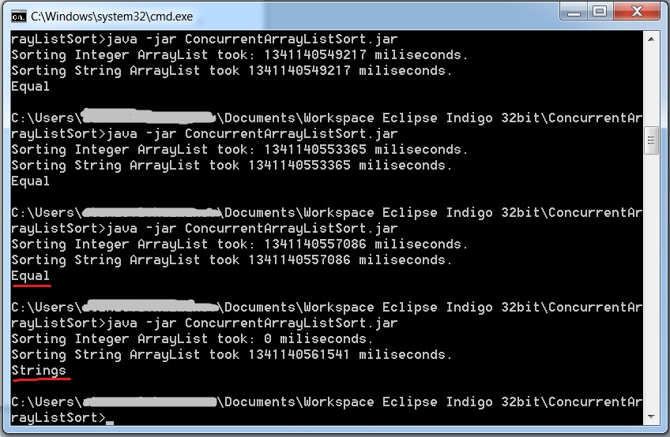
Dear Sir/Madam,
I have implemented the solutions in the best way given the time restrictions.
If you have any doubts regarding my knowledge I can assure you that even if there is something I currently do not know I can quickly catch-up, as I have proven my capabilities by becoming an Oracle Certified Java6SE Professional Programmer (OCJP), performing well in a corporate environment and by achieving a Distinction in my bachelor’s from University.
Please do not hesitate to contact me.
Kind regards,
Atanas

