Subject: April 2026 return-from-leave timeline, movement decisions, coach assignment decisions, public criticism, and comparator evidence

1. Purpose of Statement
I am submitting this evidence statement to assist the investigator in reviewing the sequence of events that occurred after my April 3, 2026 return from leave. This statement identifies relevant facts, supporting evidence, stated reasons given to me, and comparator evidence that may show inconsistent application of workplace rules and disparate treatment.
My concern is that neutral business explanations were applied to deny or disadvantage me and Todd, another Black employee, while similar or more favorable exceptions appear to have been made for non-Black employees or leaders. I am asking the investigator to review whether the stated reasons were applied consistently, whether decision-makers treated similarly situated employees differently, and whether the timing and changes to movement/team assignments support retaliation or pretext.

2. Central Evidence Theory
The key issue is not whether Respondent had general business discretion over movement, team assignments, or coach placement. The key issue is whether Respondent applied those stated business rules consistently.
The evidence raises four main concerns:
- Public criticism shortly after return from leave and after prior complaint activity: Cyndy Smith, Compliance Coordinator, and Michelle Swindell, Unit Manager, publicly questioned my practices during a leadership calibration meeting shortly after I returned from leave and after I had previously complained about Cyndy Smith’s work group.
- Inconsistent movement communications: On April 23, 2026, agents appeared to have already received movement information while I was told movement had not been sent. Amber Laye, Operations Manager, referenced movement as finalized or sent and referenced Steve Seever possibly communicating movement, but then stated movement had not been sent. Later that day, Jake Smith, Director, instructed exempt leaders to hold May movement announcements until formal communications were released.
- Todd assignment denial after Amber Laye became involved: Todd, a Black coach, reportedly did not want to remain under Michelle Swindell due to a corrective action/termination situation. I had worked with Todd, referred him for the coach role, and had a strong working relationship with him. Initially, the Todd pairing appeared acceptable. After Amber Laye became involved, Todd was kept with Michelle Swindell, and I was told business reasons required employees to stay with leaders they had worked with.
- Direct comparator evidence involving Julie Cahoon and Karena Lesure: I was later told that unit managers cannot request coaches and that Todd needed to remain with the leader he had worked with. However, Karena Lesure, Coach, later stated she was moved from Steve Seever, Unit Manager, to Julie Cahoon, Unit Manager, because Julie specifically requested her and a concession was made for Julie. Julie Cahoon is a white unit manager. This appears to directly contradict the reason given to me.

3. Condensed Timeline of Key Events
Date / Time | Event | Evidence Significance
February 2025 | I made a prior internal complaint involving Cyndy Smith and her work group after I believed they took my compliance-check idea, recreated it, and excluded me after I created related assessment materials and videos. HR later advised that they spoke with them. | Establishes prior complaint activity involving Cyndy Smith before she later publicly questioned my practices.
April 3, 2026 | I returned from leave. | Establishes the start of the relevant return-from-leave period.
April 21, 2026 | I asked Amber Laye about the waitlist and upcoming movement because I had recently returned and wanted to prepare for my upcoming team. Amber told me there was no availability to move and that I would not be going to the Capital One side. | Shows I proactively requested movement/team information and was told there was no availability.
April 21, 2026 | Amber initially indicated she would let me know as soon as she could and might be able to provide a “sneak peek.” Later, when I asked again, she said she could not tell me anything. | Shows inconsistent communication regarding whether movement information could be shared with me.
April 22, 2026 | During a leadership calibration meeting, Cyndy Smith publicly questioned my practices and stated that my approach lacked transparency to the customer. Michelle Swindell also joined in and questioned my practices in front of the group. | Public criticism shortly after my return from leave and after prior complaint history involving Cyndy Smith. Relevant to retaliation and disparate treatment.
April 22, 2026 | I spoke with Cyndy Smith after the meeting. I told her the way the issue was raised made me feel that my ethics and integrity were being questioned. Cyndy stated she had concerns about whether customers were fully educated that they were signing up for both a payment and automatic payments. She also stated she had reached out to Shawn McLaughlin for a successful call example to take to compliance/process. | Confirms the issue was escalated and that I contemporaneously objected to the public implication that I lacked transparency or integrity.
April 22, 2026 | I explained that the payment disclosure and direct-pay disclosure were still being read and that my agents had used the approach for over three years without compliance defects. I also told Cyndy that I did not feel equally treated in the group and asked that future concerns be addressed privately, with Shawn, or in an appropriate setting. | Shows I raised unequal treatment at the time and identified that the practice had not previously resulted in compliance defects.
April 23, 2026 | Frankie Hernanez told me she had already learned about movement. Based on what she told me, her unit manager/team leader had held a meeting and told employees who was moving. | Suggests movement information was communicated to some employees/teams before I received clear communication about my own team.
April 23, 2026, 12:31–12:34 PM | I asked Amber Laye if movement had come out because agents were reaching out to me. Amber responded, “It has been finalized or sent,” then said she would see what happened and referenced that most of my people were coming from Steve Seever and that she was not sure whether he had communicated anything yet. When I asked, “So was movement sent out?” Amber responded, “No, it was not.” | Amber’s response appears internally inconsistent. It shows movement information existed or was being discussed, while I was told it had not been sent.  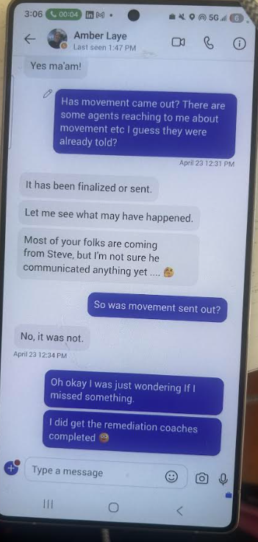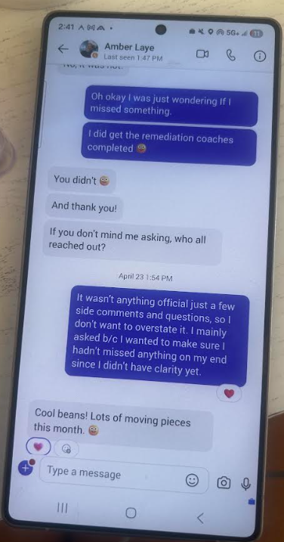
April 23, 2026, 12:58 PM | Jake Smith, Director, posted in the exempt manager chat instructing leaders to hold May movement announcements to agents until formal BBw2 communications were released the following Tuesday. | Supports that movement information was being managed at the leadership level and that agent announcements were supposed to be held. This is relevant because Frankie had already heard movement information.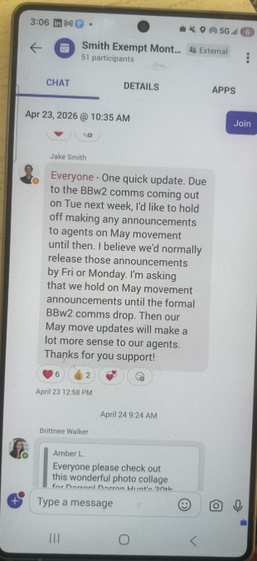
April 23, 2026 | I contacted Jodi Currant, Unit Manager, and told her Todd and I wanted to pair up the next month when I received my new team. I had previously worked with Todd, referred him for the coach role, and had a strong working relationship with him. Jodi said that sounded great and that she would check whether Michelle Swindell and Amber Laye were good with it. Later, Jodi indicated everything was good. | Shows the Todd pairing initially appeared acceptable before the decision later changed.
April 27, 2026 | I followed up with Jodi Currant about Todd. Jodi stated she had met with HR that morning and explained that Michelle Swindell and/or Amber Laye had pursued termination against Todd, but HR did not support termination because HR did not believe the evidence was sufficient. Jodi also stated Todd did not want to remain under Michelle because of the corrective action situation. | Shows Todd had a reason not to remain under Michelle and that HR did not support termination. Relevant to fairness and consistency of Todd’s placement.
April 27, 2026 | Jodi stated that Amber Laye was getting involved, that Michelle wanted to work with Todd, and that Todd could not move to my team for business reasons because they wanted employees to stay with leaders they had been working with. Jodi also expressed that Amber’s involvement seemed inappropriate. I told Jodi I believed Amber was retaliating against me and Todd. | Identifies Amber’s involvement and the stated business reason. This stated reason is later contradicted by the Karena/Julie comparator.  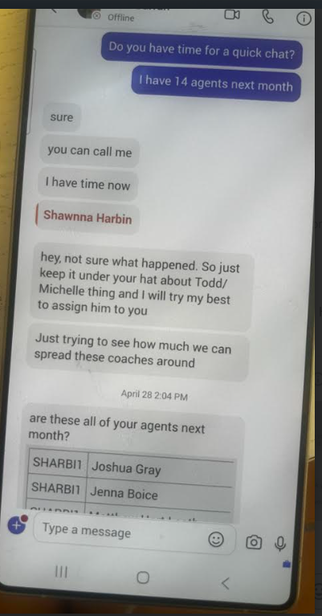
April 27, 2026 | Shawn McLaughlin shared movement with me, and I was able to see my initial team assignment. The initial team appeared balanced and included both stronger performers and lower performers. | Establishes the original team assignment before later changes.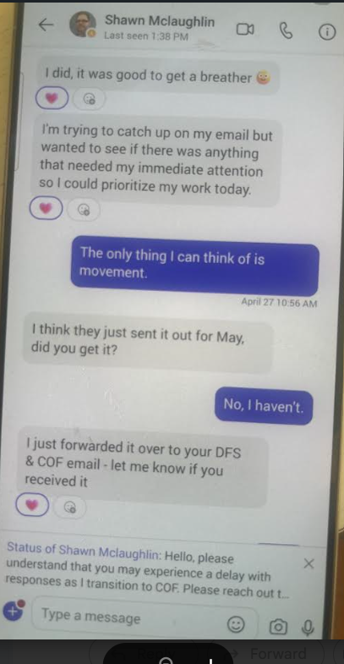
April 27, 2026 evening | Amber Laye messaged the PM team leaders and stated that there would be changes to movement and that teams would change the next day. | Shows Amber’s role in movement changes after I saw my initial assignment.
April 28, 2026 afternoon | After I saw the revised movement, I called Amber Laye and told her I was extremely frustrated. I asked why the movement changed, why I was assigned the agents I received, and who made the decision. Amber stated that it was only her decision, that it was up to her only, and that she redid the movement on her own. I explained that the revised team included very low performers, work avoiders, attendance issues, and employees already approaching termination, and that this would negatively affect my performance card and increase my workload. I told Amber that I was dissatisfied but would do the best I could with what I was given. | Direct evidence of Amber’s sole stated responsibility for the revised movement and the negative impact of the revised team assignment on my performance metrics and workload.
April 28, 2026 | Jodi told me Amber got involved and Todd would remain with Michelle. I was assigned to work with someone I had never worked with before, despite my prior relationship with Todd and despite Todd’s situation with Michelle. | Final denial of Todd pairing after Amber’s involvement.  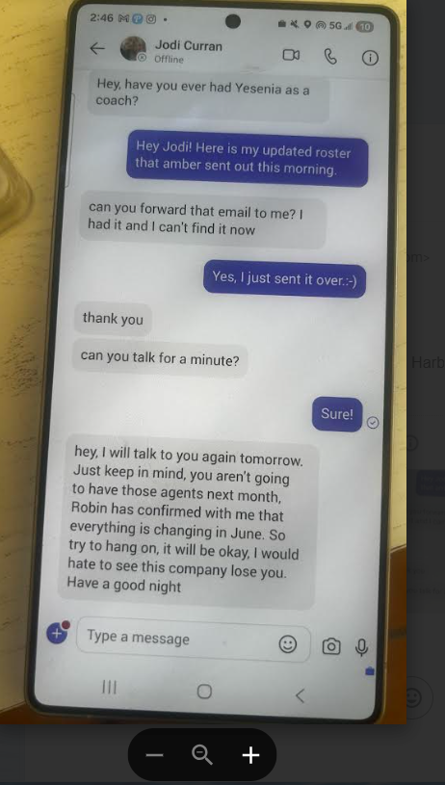
April 29, 2026 | After the movement changes, my revised team changed from a balanced team to a team made up largely of very low performers, including employees with attendance issues and work avoidance issues. | Potential adverse change to working conditions. Investigator should compare original vs. revised team quality and identify who benefited from the changes.
April 29, 2026 | I told Shawn McLaughlin that I believed Amber was taking retaliatory action and that both Todd and I are Black. I explained that I did not see Amber treating white employees the same way. Shawn responded that team leaders/unit managers cannot request a coach and that this was not how the business operates. | Protected race/retaliation complaint. Also creates a key stated reason: unit managers cannot request coaches.
May 1, 2026 | I went out on leave. | Occurred shortly after the April events and after I raised race/retaliation concerns to Shawn.
May 12, 2026 | Karena Lesure, Coach, contacted me and stated she was being moved from Steve Seever, Unit Manager, to Julie Cahoon, Unit Manager. Karena stated that when she asked Jodi Currant why, Jodi said Julie specifically asked for her and wanted to work with her, so they made a concession for Julie. | Direct comparator evidence. I was told unit managers cannot request coaches and employees should stay with leaders they had worked with, but Julie allegedly requested Karena and received a concession.

4. Disparate Treatment and Comparator Evidence

A. Julie Cahoon / Karena Lesure Compared to Lashawnna Harbin / Todd
This is the strongest comparator evidence because it directly conflicts with the stated reasons given to me.
Issue | Lashawnna / Todd | Julie Cahoon / Karena Lesure | Why It Matters
Manager request | I requested or supported Todd moving to my team. | Julie Cahoon allegedly specifically requested Karena Lesure. | I was told unit managers cannot request coaches, but Julie allegedly did.
Prior working relationship | I had worked with Todd, referred him for the coach role, and had a strong working relationship with him. | Karena had worked with Steve Seever for approximately six months and reportedly had a good relationship with him. | Todd had a stronger basis to move, while Karena was moved away from an established working relationship.
Employee need/conflict | Todd reportedly did not want to remain under Michelle Swindell because of the corrective action/termination situation. | Karena reportedly had a good relationship with Steve Seever. | Todd had a stronger reason to be moved, yet he was kept with Michelle.
Stated reason | I was told Todd should stay with the leader he had been working with. | Karena was moved away from Steve Seever to Julie Cahoon. | The stated rule appears inconsistently applied.
Race / protected concern | I raised concern that Amber’s actions affected me and Todd, both Black employees. | Julie Cahoon is a white unit manager. | Supports disparate treatment and pretext review.
Outcome | Todd stayed with Michelle; I was assigned someone I had not worked with before. | Karena moved to Julie after Julie allegedly requested her. | Shows different treatment under similar or less compelling facts.

B. Team Assignment Before and After Amber Laye’s Movement Change
Issue | Initial April 28 Assignment | Revised Assignment After Amber Laye’s Message | Why It Matters
Team quality | Balanced team with a mix of stronger and lower performers. | Largely low performers, attendance issues, and work avoidance issues. | May show a negative change to my working conditions.
Timing | Shawn McLaughlin shared the initial team assignment on April 28. | Amber Laye announced changes that evening; team changed the next day. | Shows a clear before-and-after change following Amber’s involvement.
Comparator question | Which leaders had balanced teams before the revision? | Which leaders benefited after the revision? | Investigator should compare whether similarly situated non-Black PM leaders received more favorable teams.

C. Public Criticism by Cyndy Smith and Michelle Swindell
Issue | My Treatment | Comparator Question
Public criticism | Cyndy Smith and Michelle Swindell questioned my practices in front of the department. | Were similarly situated non-Black leaders publicly questioned this way?
Integrity / transparency language | Cyndy stated my approach lacked transparency. I stated this felt like my integrity was being questioned. | Were similar concerns involving non-Black leaders framed privately as process coaching rather than public integrity/transparency concerns?
Escalation | Cyndy stated she reached out to Shawn McLaughlin for a call example. | Were similar issues involving non-Black leaders escalated the same way?
Compliance history | I stated the approach had been used for over three years without compliance defects. | Were other known practices treated as compliance defects or public credibility concerns?

5. Stated Reasons and Evidence of Inconsistency / Pretext
Stated Reason / Explanation | Related Event | Inconsistency / Issue for Review
Movement had not been finalized or sent. | Amber Laye, April 23 | Amber referenced movement as finalized or sent, referenced Steve Seever possibly communicating movement, and then denied movement was sent. Jake Smith later instructed exempt leaders to hold May movement announcements until formal communications, supporting that movement information existed and was being controlled.
Todd could not move because employees should stay with leaders they had worked with. | Jodi Currant relaying business reason, April 27 | Karena Lesure was moved away from Steve Seever after working with him for approximately six months.
Unit managers cannot request coaches. | Shawn McLaughlin, April 29 | Julie Cahoon allegedly specifically requested Karena Lesure and received a concession.
Business reasons prevented Todd from moving to me. | Todd assignment denial | A concession was allegedly made for Julie Cahoon to receive Karena Lesure.
Movement needed to change after April 28. | Amber Laye message to PM team leaders and April 28 call with me | My team changed from balanced to significantly weaker. During my April 28 call with Amber, she stated that she alone made the decision and redid the movement on her own. Investigator should review who benefited from the revised movement and why Amber assigned me a team with low performers, work avoiders, attendance issues, and employees approaching termination.
Cyndy’s concern was about process/customer transparency. | April 22 calibration and follow-up | My agents had used the process for over three years without compliance defects, and the issue was raised publicly shortly after my return from leave and after prior complaint history involving Cyndy’s group.

6. Records Requested for Review
I respectfully request that the investigator review or request the following records because they are directly relevant to the timeline, stated reasons, and comparator evidence:
- April 21 communications between me and Amber Laye regarding waitlist/movement.
- April 22 leadership calibration meeting invite, attendees, notes, and chat.
- Cyndy Smith’s communications with Shawn McLaughlin regarding my call-flow/practices.
- Records showing whether my agents had any compliance defects related to payment/direct-pay practices.
- Frankie’s April 23 message to me regarding movement.
- April 23 direct messages between me and Amber Laye regarding whether movement was finalized, sent, or communicated by Steve Seever.
- Jake Smith’s April 23 exempt manager chat message instructing leaders to hold May movement announcements until formal BBw2 communications.
- Communications showing when Steve Seever received movement information and whether he communicated it before I was informed.
- Jodi Currant’s April 23 and April 27 communications regarding Todd.
- Records showing Michelle Swindell and/or Amber Laye pursued termination against Todd and HR did not support termination.
- Communications showing Amber Laye’s involvement in keeping Todd with Michelle Swindell.
- Shawn McLaughlin’s April 28 movement/team assignment shared with me.
- Amber Laye’s April 28 evening message to PM team leaders stating movement would change.
- Records, notes, or call logs related to my April 28 call with Amber Laye where she stated she alone redid the movement and that the decision was up to her only.
- Original and revised movement/team rosters.
- Performance, attendance, and work-avoidance data for my original and revised teams.
- Records showing which agents on my revised team were already on corrective action, approaching termination, or identified as low performers/work avoiders.
- Records showing how terminations, attendance issues, and low performer metrics affect a unit manager’s performance card.
- Records showing which team leaders benefited from the revised movement.
- April 29 communications with Shawn McLaughlin regarding race/retaliation and his statement that unit managers cannot request coaches.
- Records showing Julie Cahoon requested Karena Lesure.
- Records showing a concession was made for Julie Cahoon to receive Karena Lesure.
- Records showing Karena Lesure’s movement from Steve Seever to Julie Cahoon.
- Any written policy or practice regarding whether unit managers/team leaders may request coaches or employees.
- Any records showing exceptions or concessions made during the May movement process.

7. Relevant Witnesses / Individuals
Person | Title / Role | Relevant Information
Amber Laye | Operations Manager | Waitlist/movement communications; Todd assignment decision; April 28 movement-change message.
Shawn McLaughlin | Operations Manager | April 28 movement shared with me; April 29 race/retaliation complaint; statement that unit managers cannot request coaches.
Cyndy Smith | Compliance Coordinator | April 22 calibration comments; follow-up conversation; prior complaint background.
Michelle Swindell | Unit Manager | Joined in public questioning of my practices; involved in Todd corrective action/termination issue.
Jodi Currant | Unit Manager | Todd pairing discussion; HR meeting regarding Todd; Amber involvement; Julie/Karena explanation.
Todd | Coach | Black coach; reportedly did not want to remain under Michelle due to corrective action/termination issue.
Karena Lesure | Coach | Reported that Julie specifically requested her and that a concession was made.
Julie Cahoon | Unit Manager | White unit manager who allegedly requested Karena and received a concession.
Steve Seever | Unit Manager | Karena’s prior unit manager; referenced by Amber in April 23 movement communication.
Jake Smith | Director | Posted April 23 instruction to hold May movement announcements.
Frankie | Employee / Agent | Told me she had already learned about movement before I was formally informed.
PM Team Leaders | Leadership group | Received Amber Laye’s April 28 message that movement would change.

