**Deployment of solution to work with EVO 3**

**Windows**

Copy whole solution to “C:/temp/wwwroot” (create wwwroot folder if it does not exist)

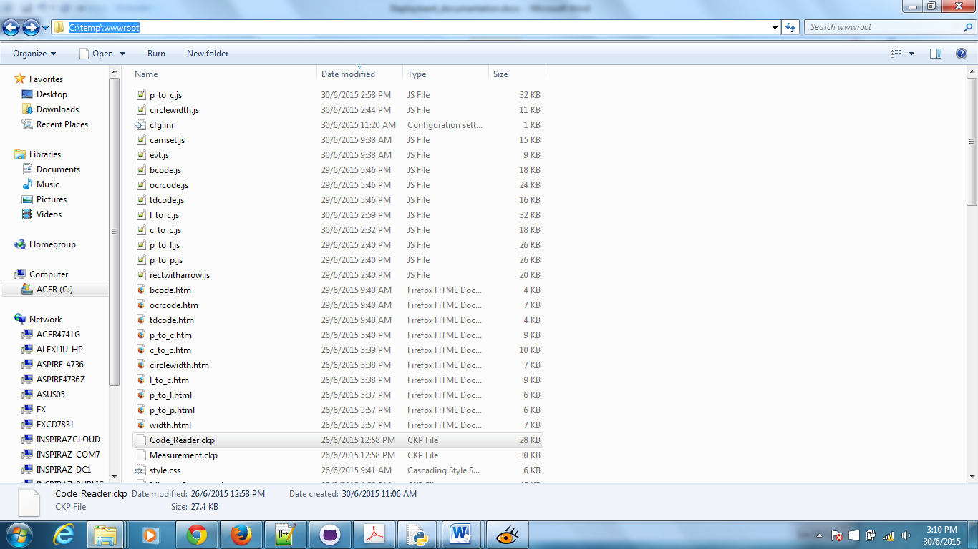

Open Evo3 tool

* Select “Open program”
* Select “measurement.ckp” or “code_reader.ckp” (Do note this 2 ckp file for windows as it contains pre-set setting for windows)

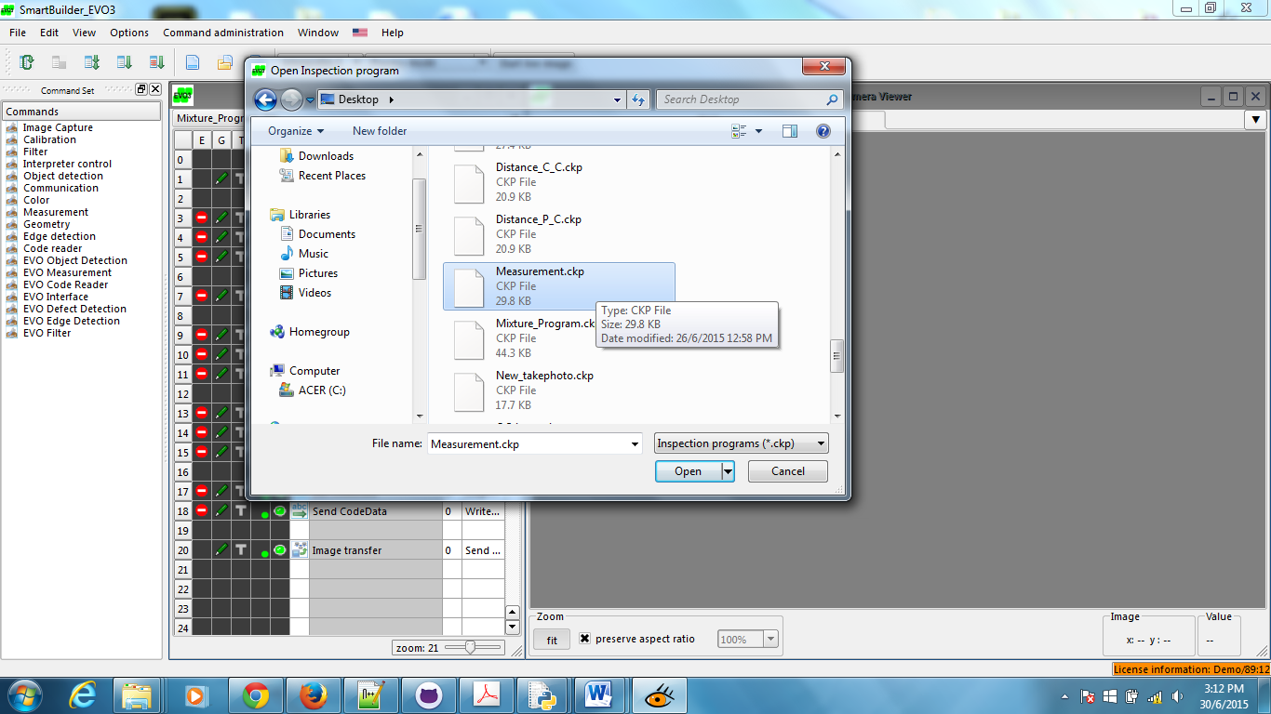

Select “Options”, “Application parameters”, “ProgramControl”

* Enable “Ini”,”TCP”, “UDP” and “Web server” by setting “Enabled” to “1”.

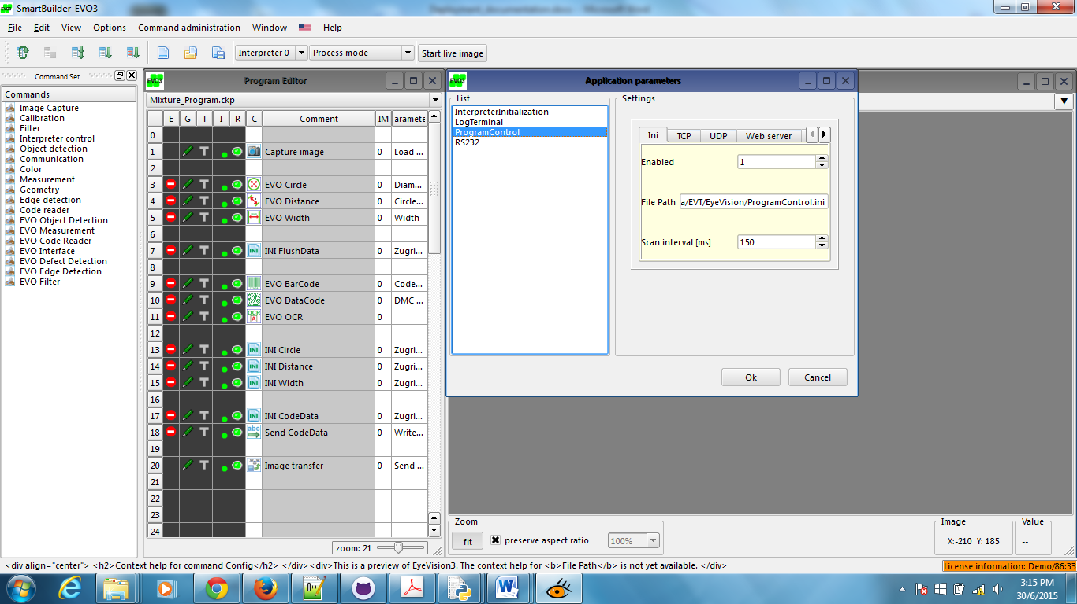

Under “Web server” tab, set the following parameters accordingly:

* Port to “8080”
* Maximum file size for sending to “499999” (maximize the sending file size)
* File Path for wwwroot folder to “C:/temp/wwwroot” (which was created in the previous step)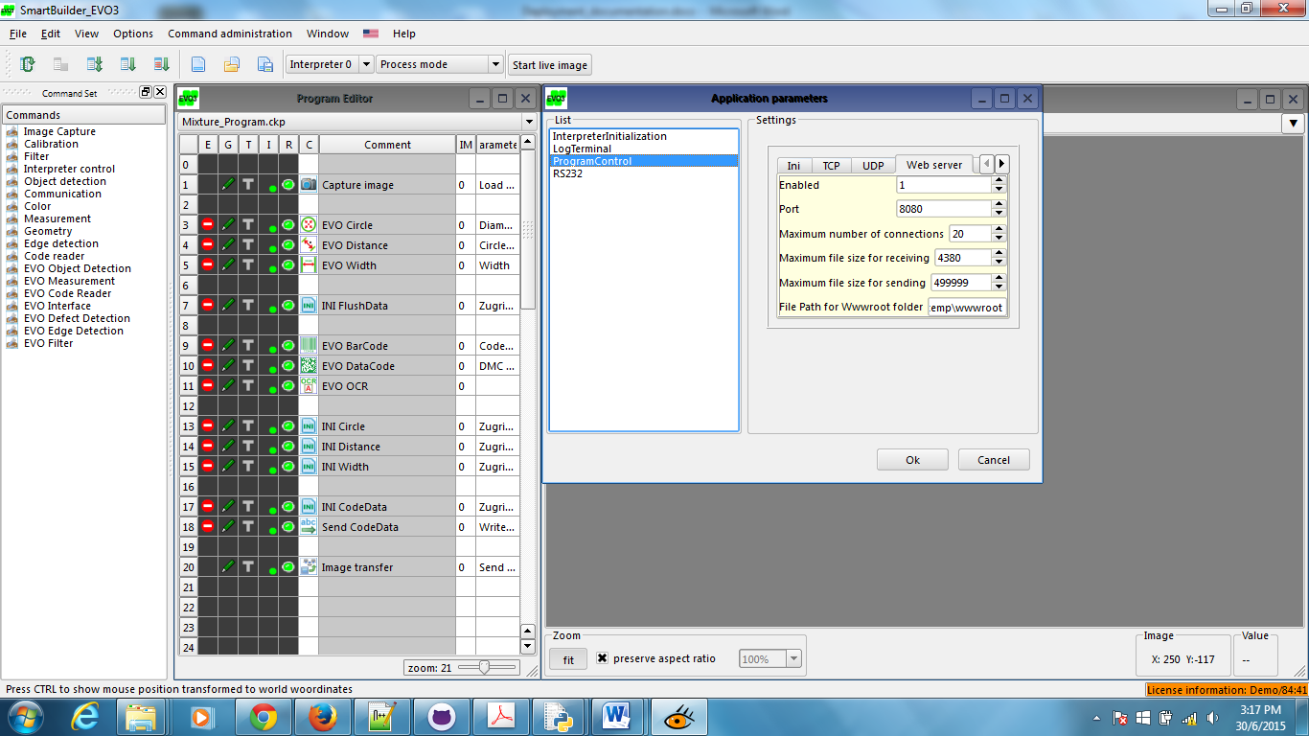

Open up the web browser and go to http://<your ip address>:8080/index.htm (in this case I’m using 192.168.66.6)



In order for the web to load images from the evo 3 applications. Image transfer must set accordingly. By having this setting, this will allow it to upload images to a cache folder call “snapshot” and the web will retrieve images from that cache folder.

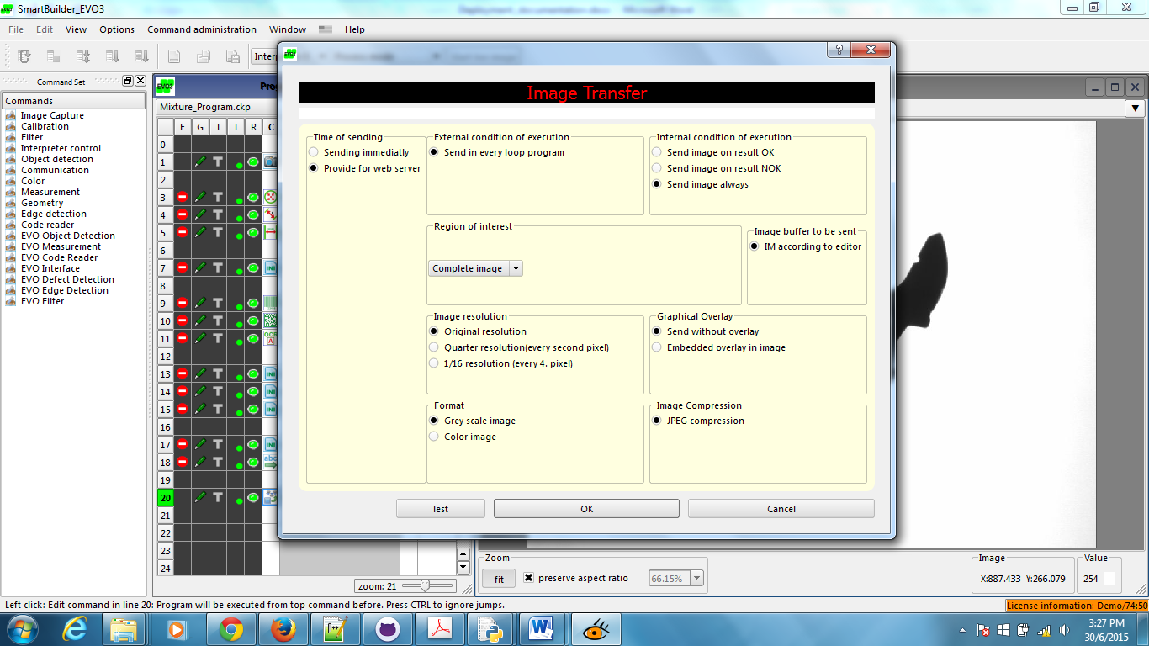

Make sure all the INI tools were set to “C:/temp/wwwroot/cfg.ini”

Apply the following settings for all INI tools:

* Set “Section name” to “cam1”
* Set “Entry name” to “result1”
* Set “Write data type” to “value”, “from pick-up list”
* Set “Selection” by pointing to the tools which wants to write to file “cfg.ini”

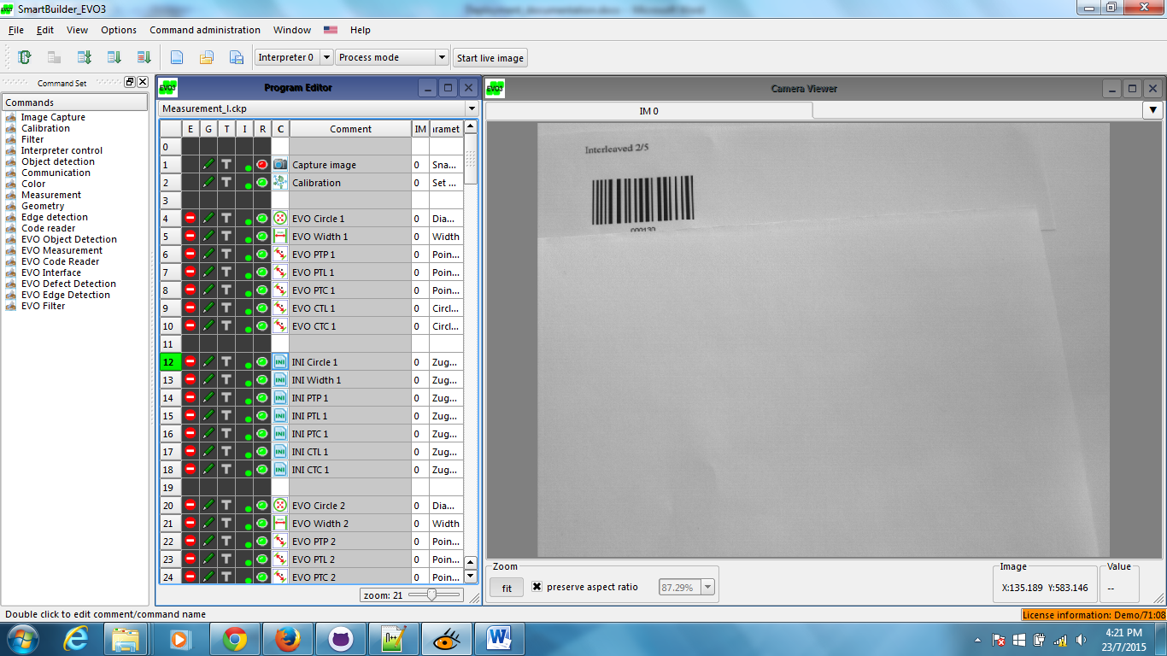

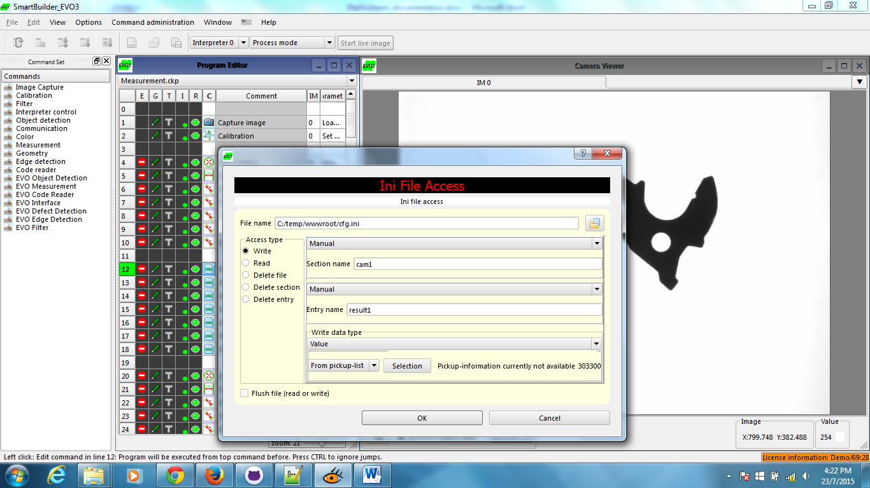

Make sure the script points writing of files accordingly:

* "C:\temp\wwwroot\circle.ini"
* "C:\temp\wwwroot\ptc.ini"
* "C:\temp\wwwroot\ctl.ini"
* "C:\temp\wwwroot\ctc.ini"
* "C:\temp\wwwroot\ptp.ini"
* "C:\temp\wwwroot\ptl.ini"
* "C:\temp\wwwroot\width.ini"

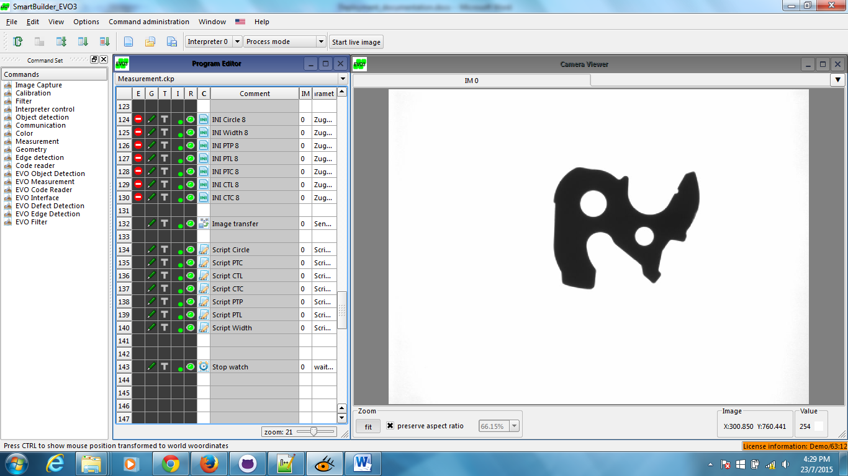

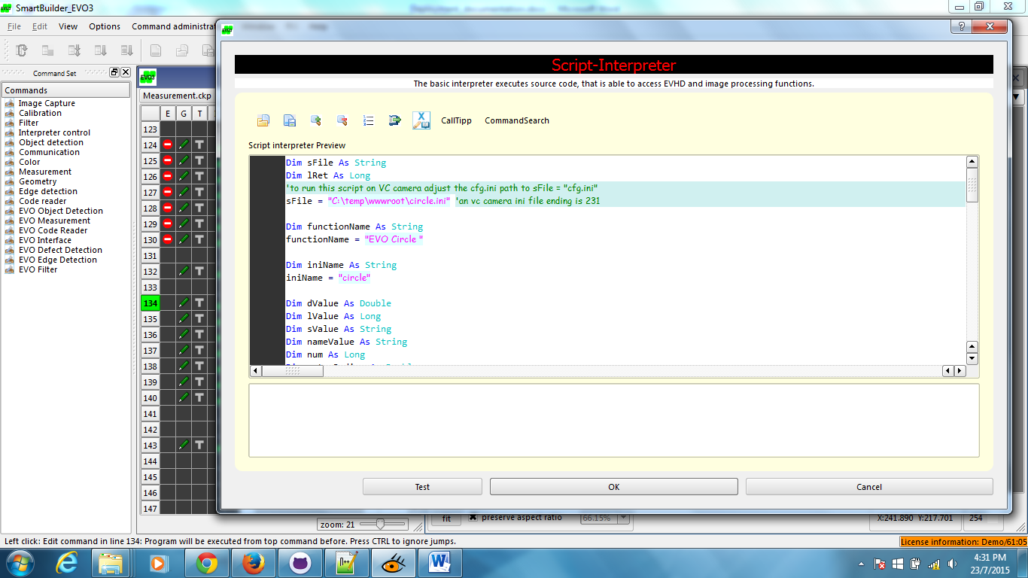

**LINUX**

Copy whole solution to “/home/root/EVT/EyeVision/Devices/PC_Local/Data/WWWROOT” (create WWWROOT folder if it does not exist)

Open Evo3 tool

* Select “Open program”
* Select “measurement.ckp” or “code_reader.ckp” (Do note this 2 ckp file for linux as it contains pre-set setting for linux)



Select “Options”, “Application parameters”, “ProgramControl”

* Enable “Ini”,”TCP”, “UDP” and “Web server” by setting “Enabled” to “1”.



Under “Web server” tab, set the following parameters accordingly:

* Port to “8080”
* Maximum file size for sending to “499999” (maximize the sending file size)
* File Path for wwwroot folder to “/home/root/EVT/EyeVision/Devices/PC_Local/Data/WWWROOT” (which was created in the previous step)

Open up the web browser and go to http://<your ip address>:8080/index.htm (in this case I’m using 192.168.66.6)



Make sure all the INI tools (Measurements.ckp) were set to “/home/root/EVT/EyeVision/Devices/PC_Local/Data/WWWROOT /cfg.ini”

Apply the following settings for all INI tools:

* Set “Section name” to “cam1”
* Set “Entry name” to “result1”
* Set “Write data type” to “value”, “from pick-up list”
* Set “Selection” by pointing to the tools which wants to write to file “cfg.ini”
* Make sure “Flush file (read or write)” is checked



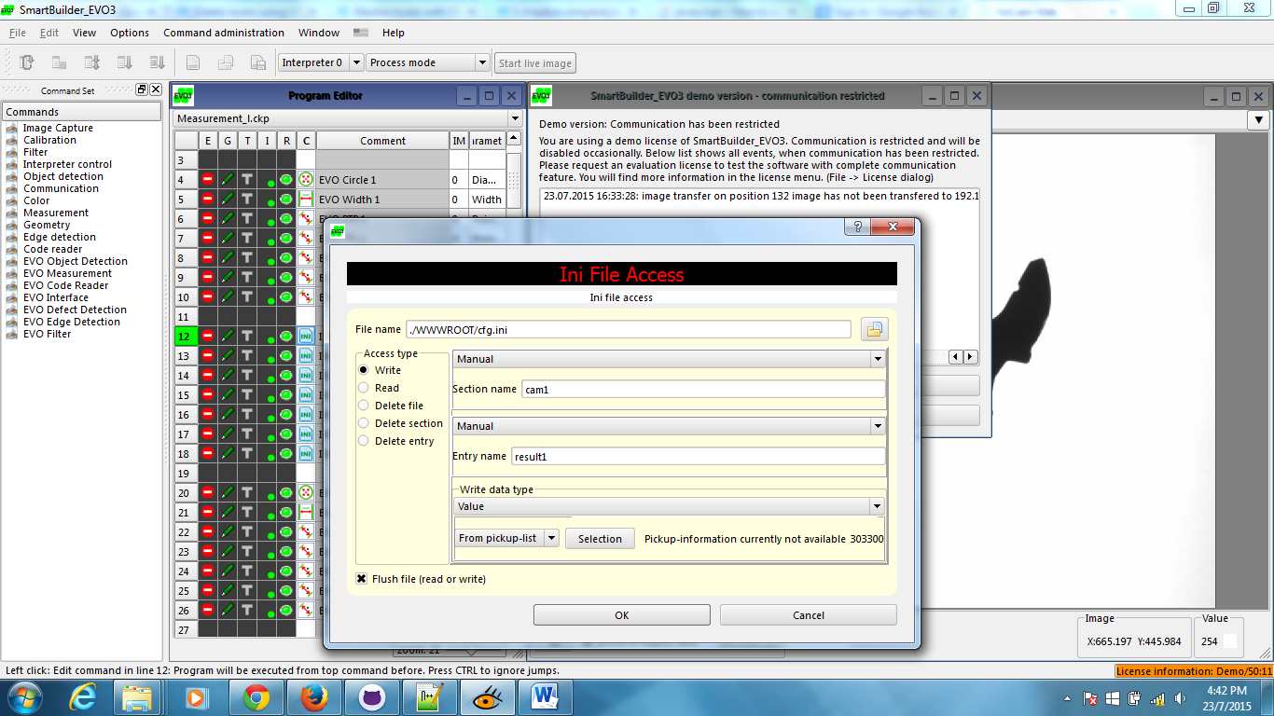

Make sure the script points writing of files accordingly:

* "/home/root/EVT/EyeVision/Devices/PC_Local/Data/WWWROOT/circle.ini"
* "/home/root/EVT/EyeVision/Devices/PC_Local/Data/WWWROOT/ptc.ini"
* "/home/root/EVT/EyeVision/Devices/PC_Local/Data/WWWROOT/ctl.ini"
* "/home/root/EVT/EyeVision/Devices/PC_Local/Data/WWWROOT/ctc.ini"
* "/home/root/EVT/EyeVision/Devices/PC_Local/Data/WWWROOT/ptp.ini"
* "/home/root/EVT/EyeVision/Devices/PC_Local/Data/WWWROOT/ptl.ini"
* "/home/root/EVT/EyeVision/Devices/PC_Local/Data/WWWROOT/width.ini"
* 

