Keywords:
- KM32MGA, MGA2XML
- KM3, ATL [1]
- GMT [2]
- Generic Modeling Environment [3]

1. KM32GME 2
2. Screenshots 2
2.1. Import a metamodel from an XMLfile 2
2.2. Create a new paradigm from a metamodel 8
2.3. Create a model conforms to a metamodel 10
3. Limitations 13
4. Errors 13
4.1. Unsolvable error 13
4.2. Solvable error 14
5. References 14

KM32GME
This document is a user manual to use the KM3 to GME metamodel bridge. This bridge is realized by using an ATL transformation chain and take a KM3 as input to produce an GME project serialized in XML format (.xme extension, conforms to MultiGraph Architecture DTD [3]).
The main part is constituted by some screenshots whose describe how import and use the XML file.
Other sections describe the error we encounter and the limitation of our transformation.

Screenshots
These screenshots are organized in tree sections:
- How to import a metamodel from an XML file
- How to register a new GME paradigm from this metamodel
- How to instanciate a model conforms to this metamodel
We import KM3 metamodel for this example [1].

Import a metamodel from an XMLfile
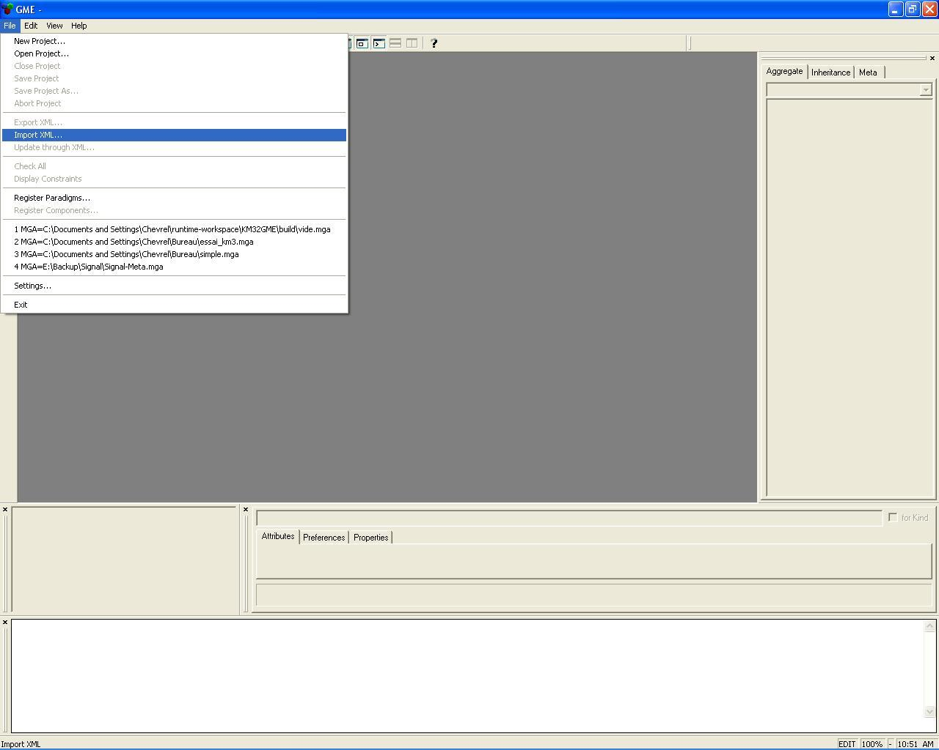

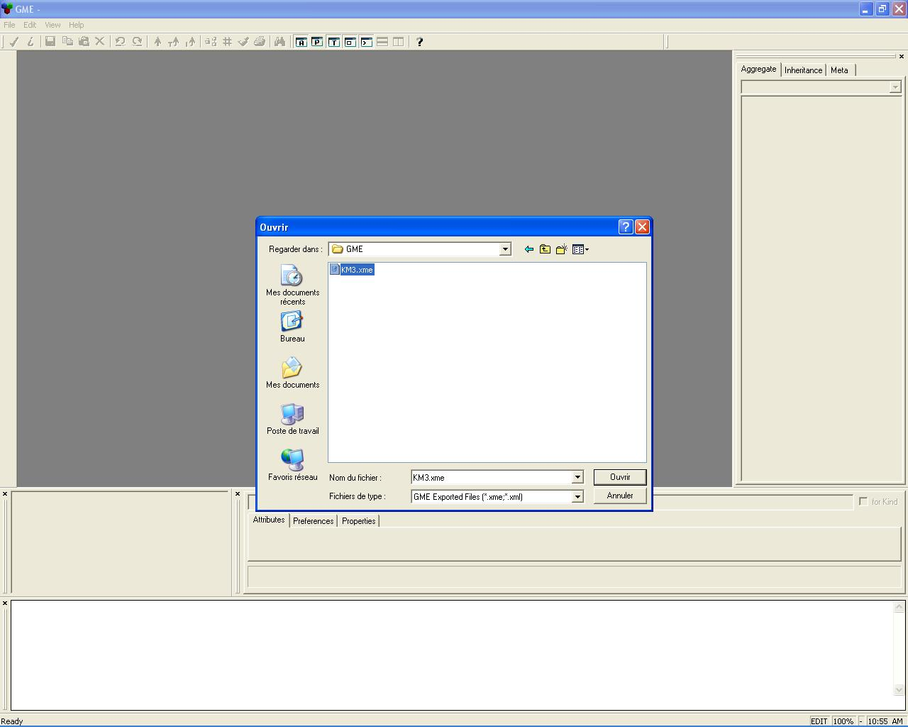
Choose the XME file to import

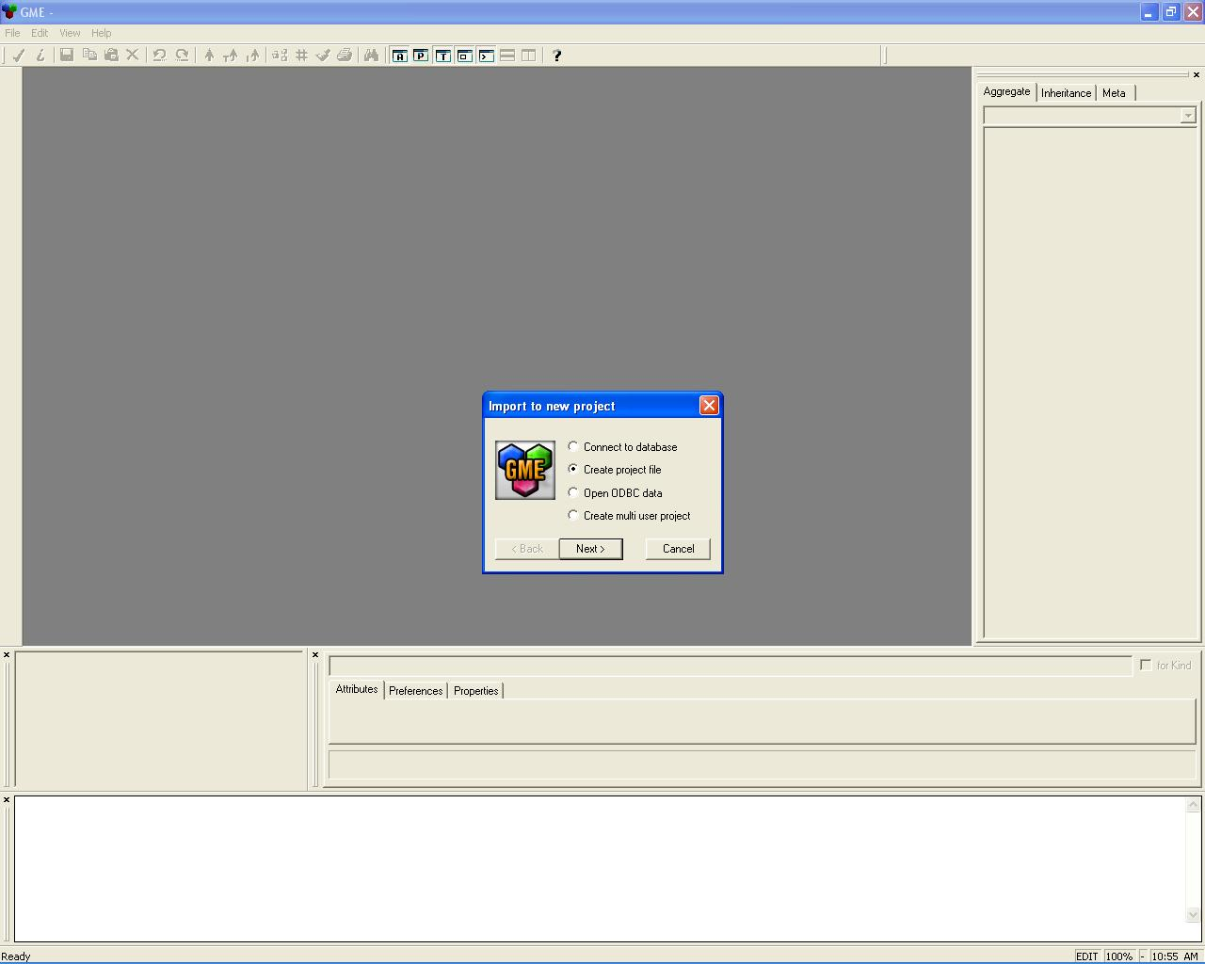

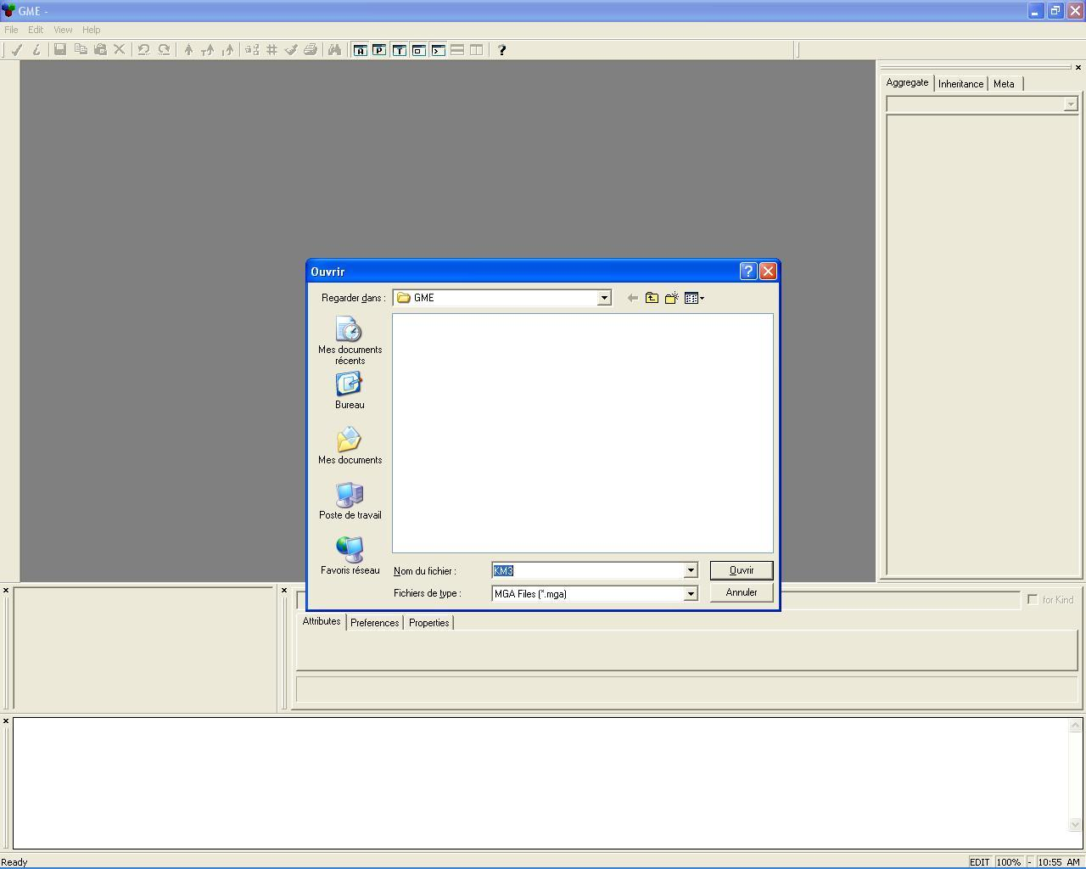
Create a new project to contain the metamodel

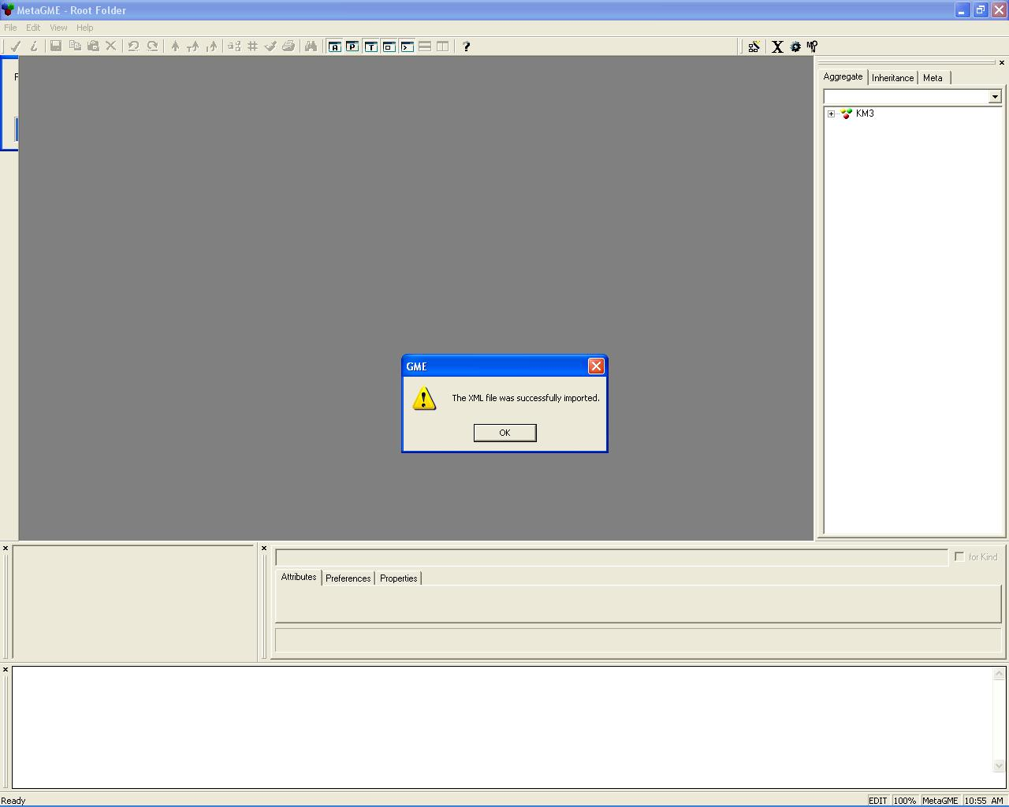
Successful import
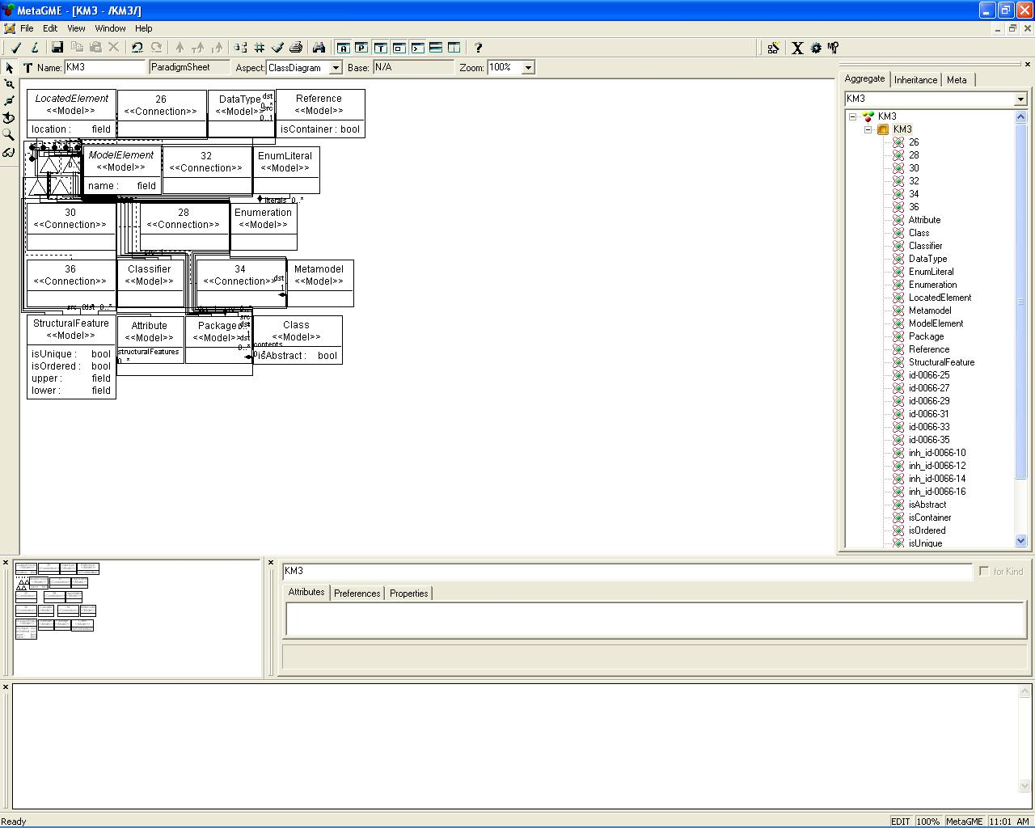
The metamodel appears without graphical organization

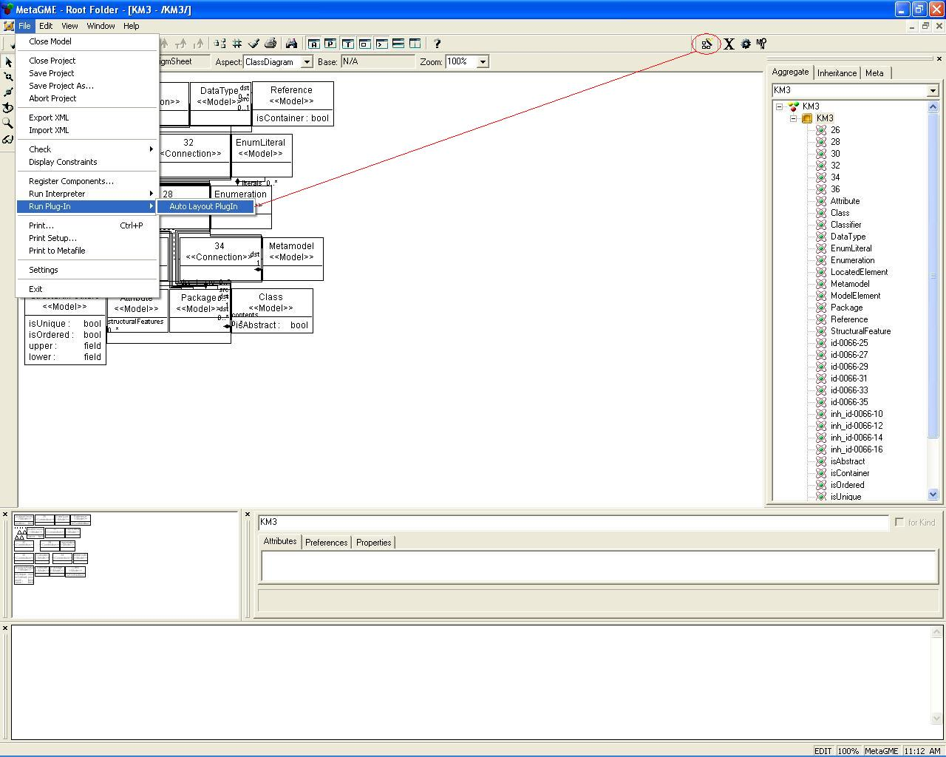
Use the GME auto-layout plug-in

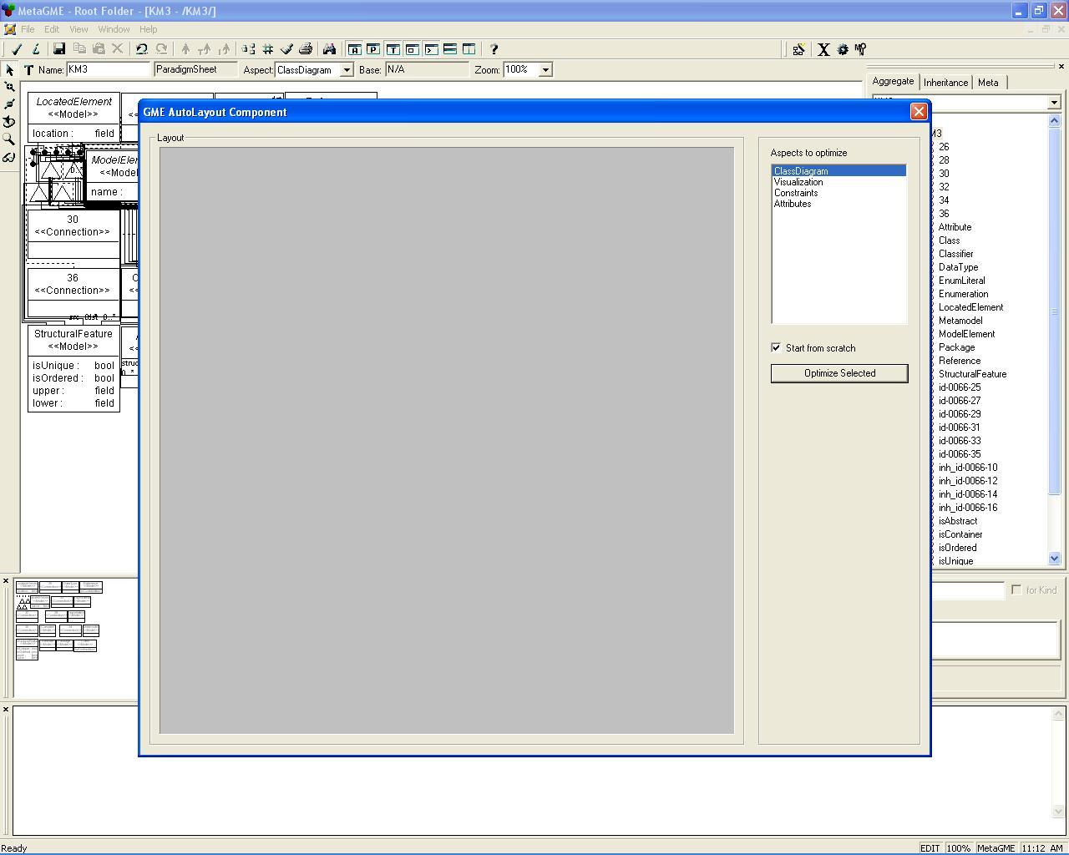
Run it for the view you want to use
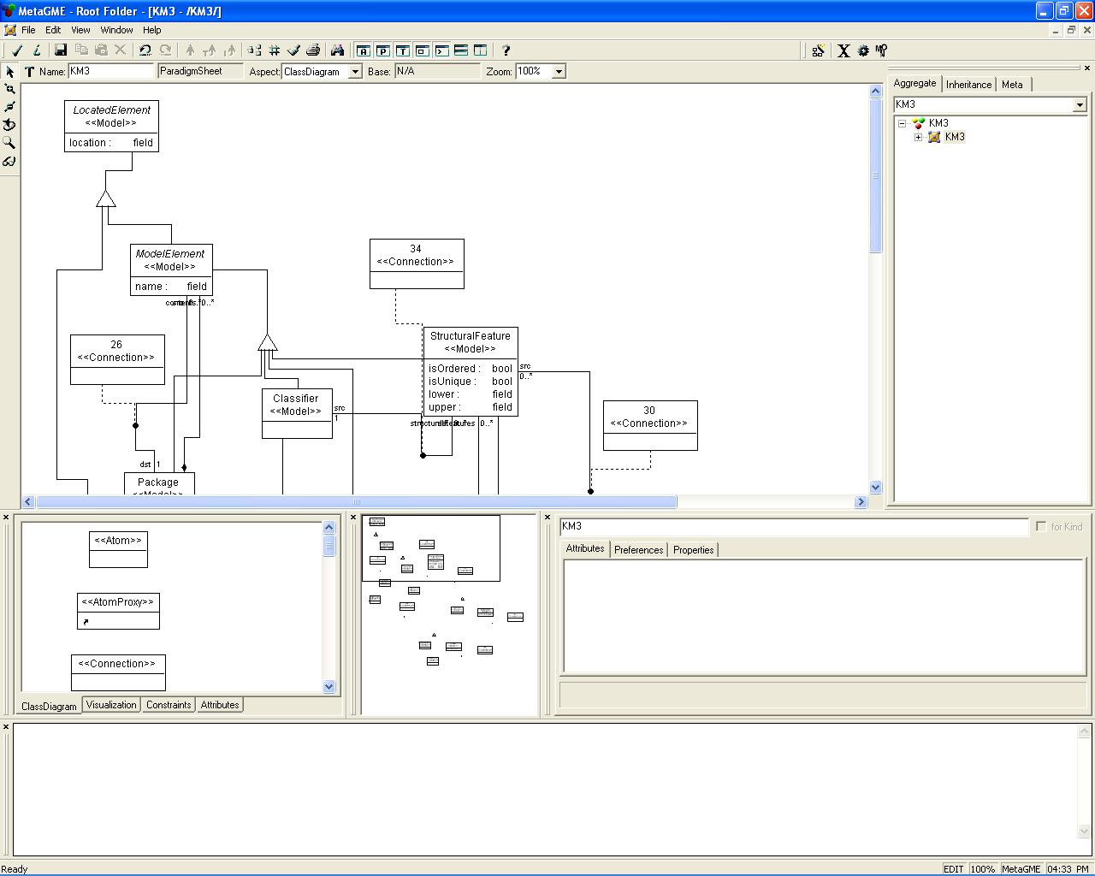
Metamodel model are automatically placed
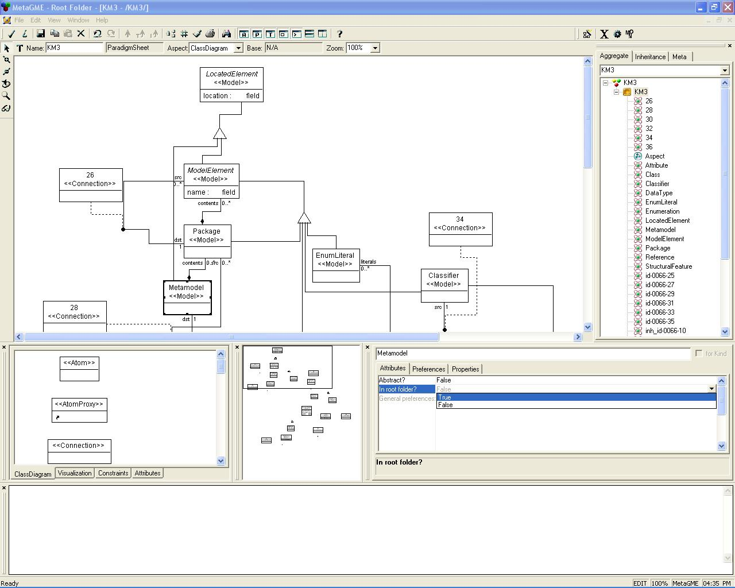
You have to define the root elements which are contained in the root-folder of a model conform to this metamodel. For example, for KM3, the root element is the “Metamodel” entity.

Create a new paradigm from a metamodel
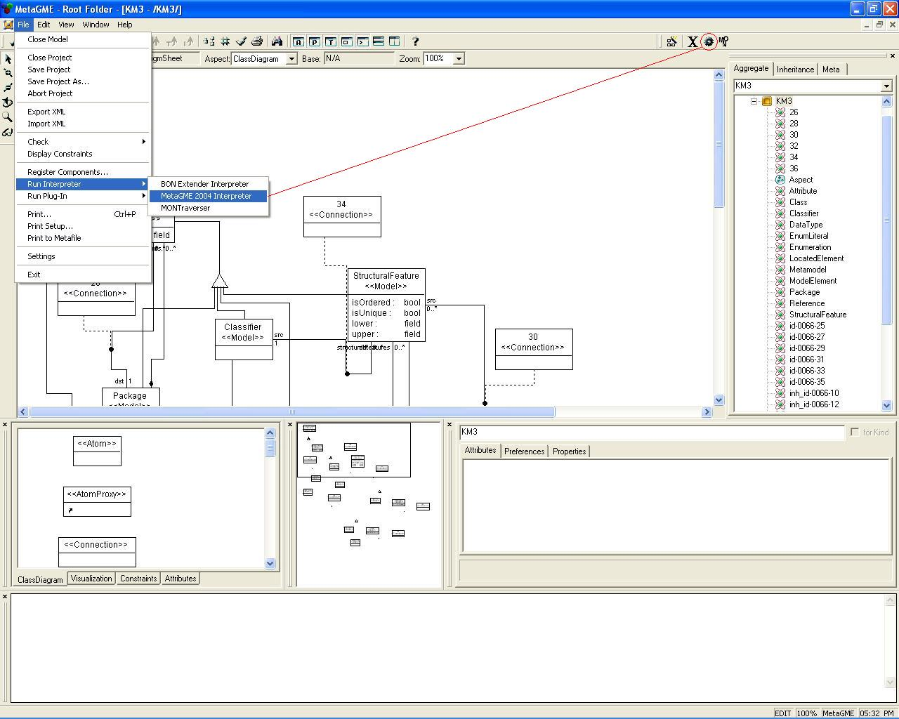
Run the MetaGME interpreter
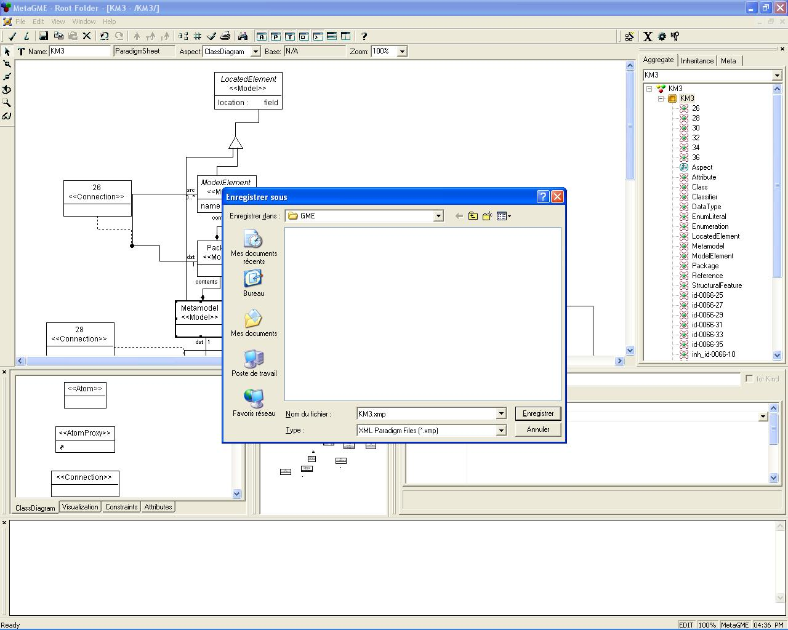

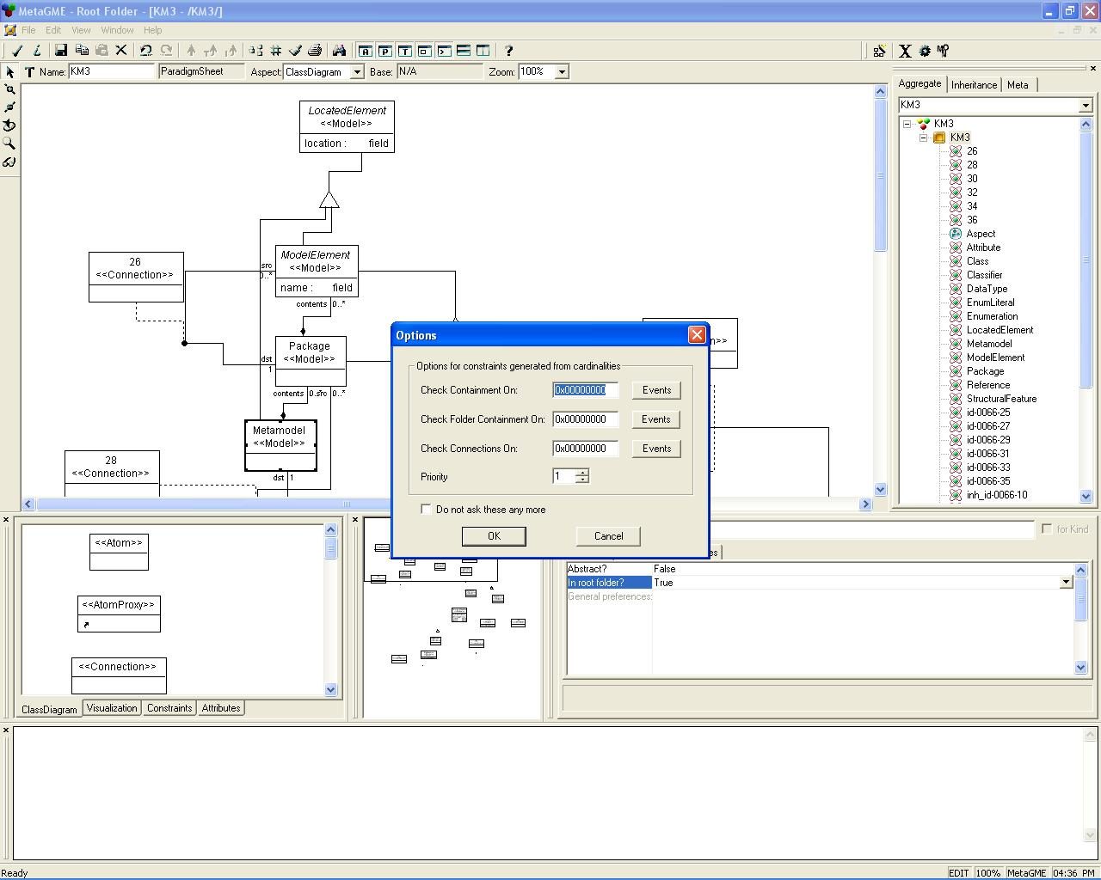
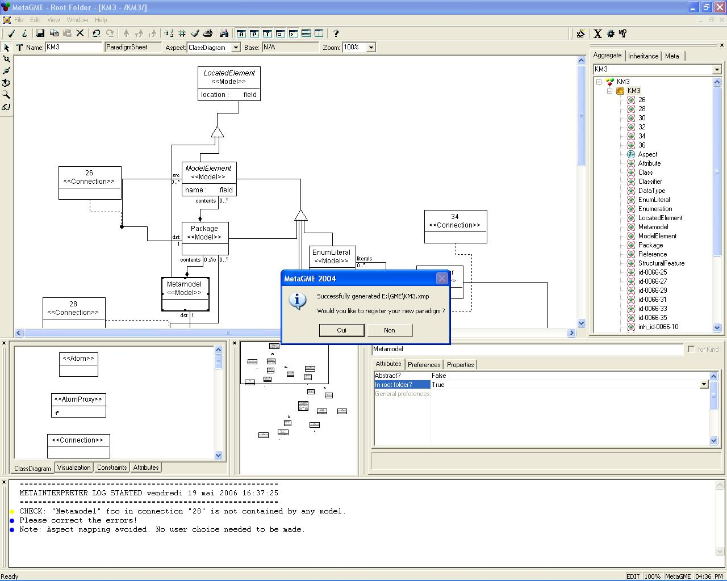
Register your new paradigm
(check the console if errors appears)

Create a model conforms to a metamodel

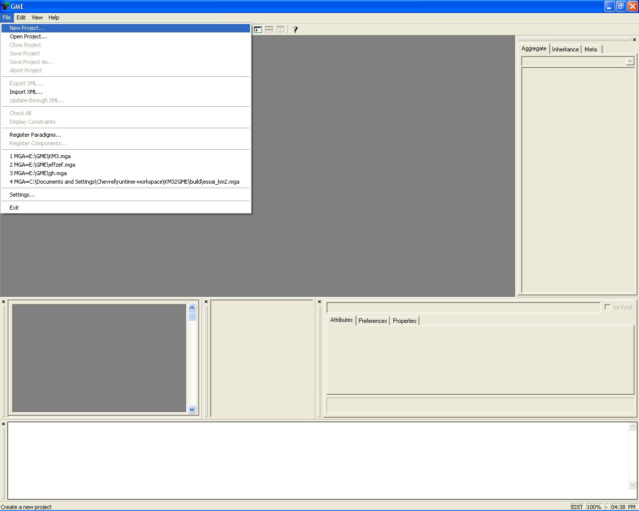
When you have register your new paradigm, you can instanciate a conform model.
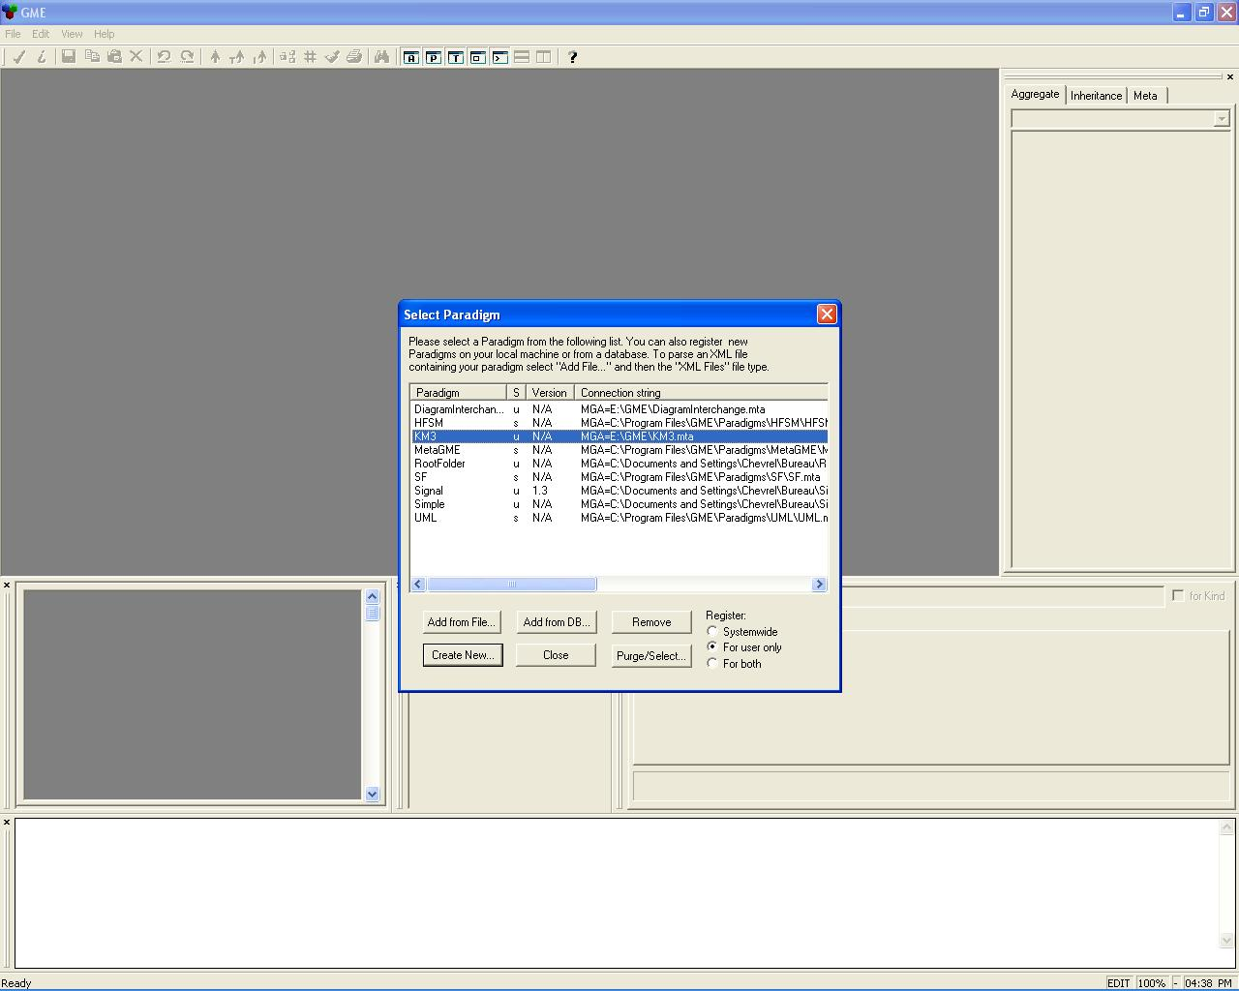

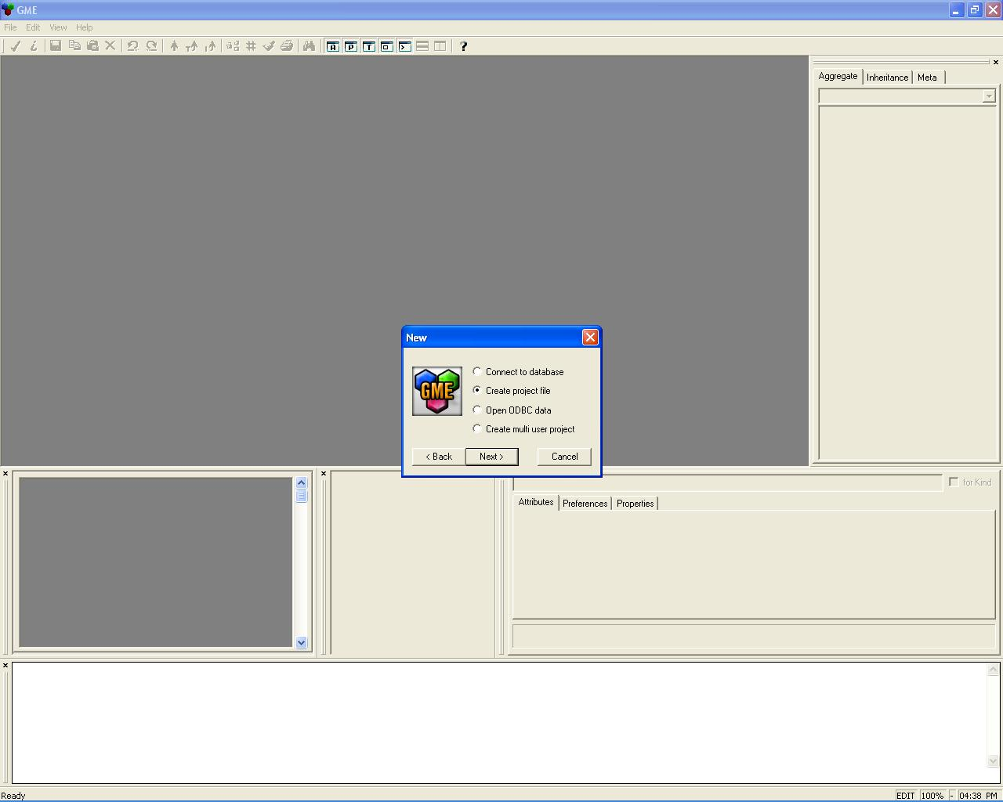

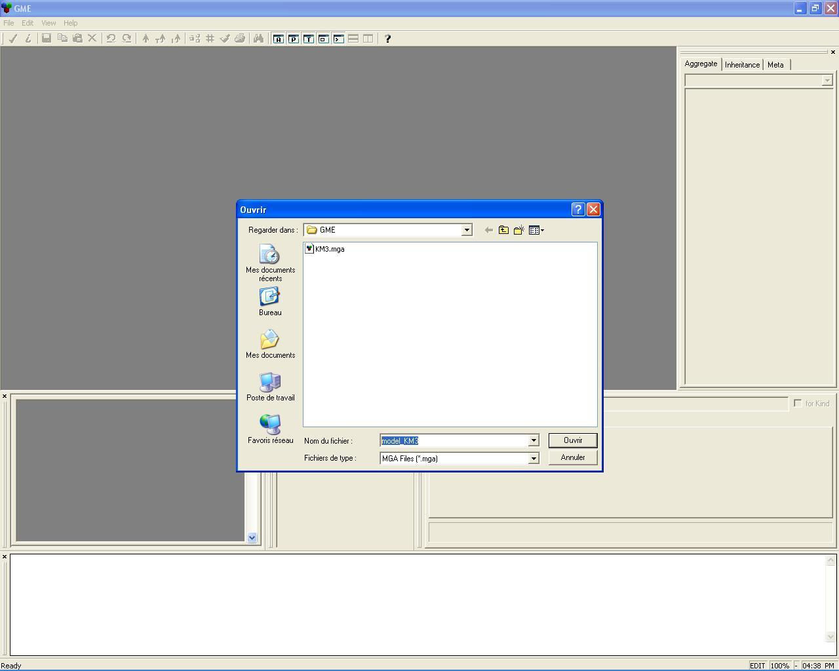
Create a new GME project for your model.
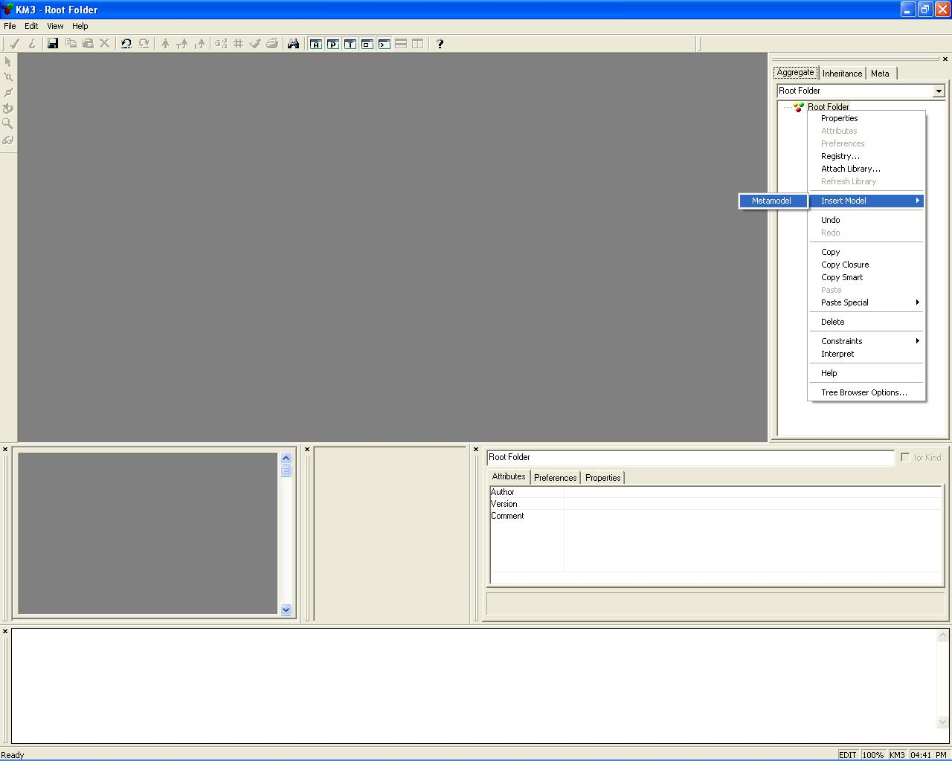
You can create a model which is conforms to your metamodel element definition.
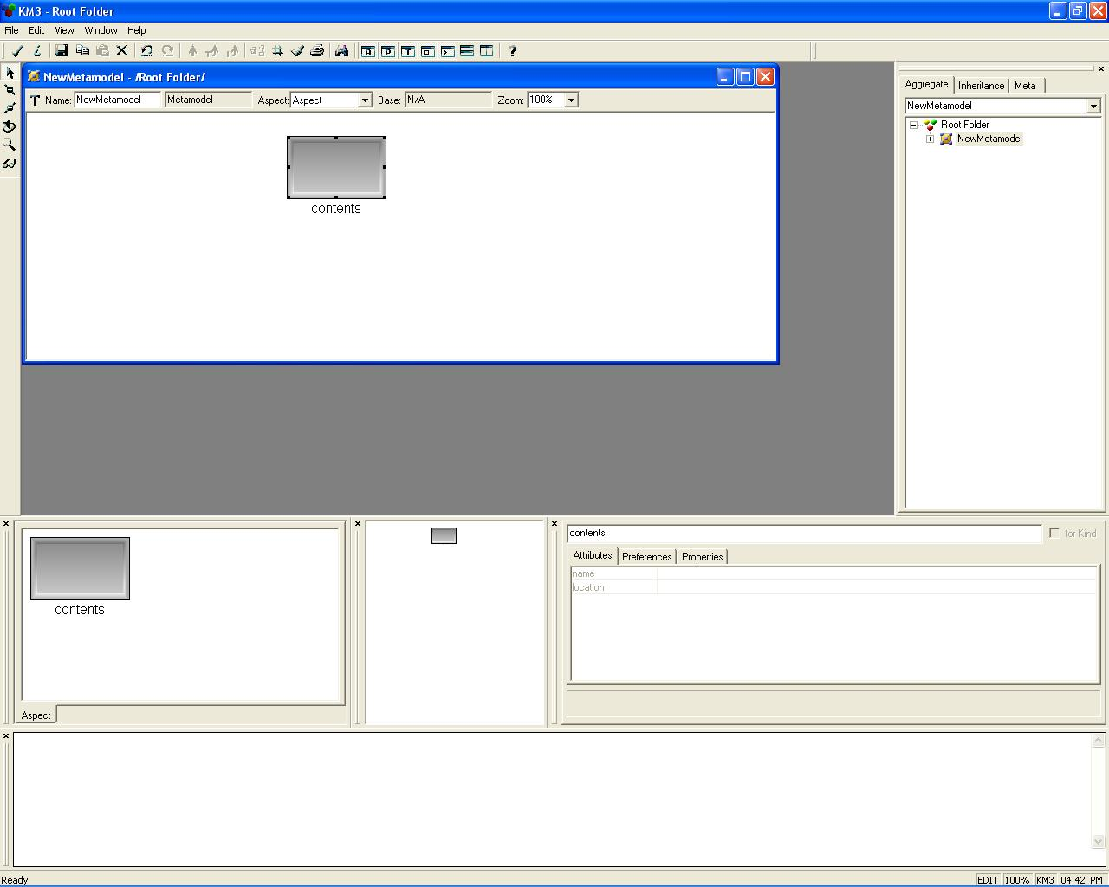

Limitations
Some information is lost during the bridge. We list it:
- From a KM3 containing reference to a GME containment: we lost the optional oppositeOf reference defined in KM3 metamodel and the GME containment redefine the container reference cardinality by fixing it to [0..1] (KM3 syntax).
- From a non-containing reference to a GME association: we lost all the relation names (reference and oppositeOf reference). This transformation can be improve by naming the GME AssociationClass with the KM3 reference name and by create two associations for the KM3 reference having oppositeOf reference.
Otherwise, we define only one Aspect which contains all the Model GME atom.

Errors
We sum-up the error we encountered during our tests.

Unsolvable error
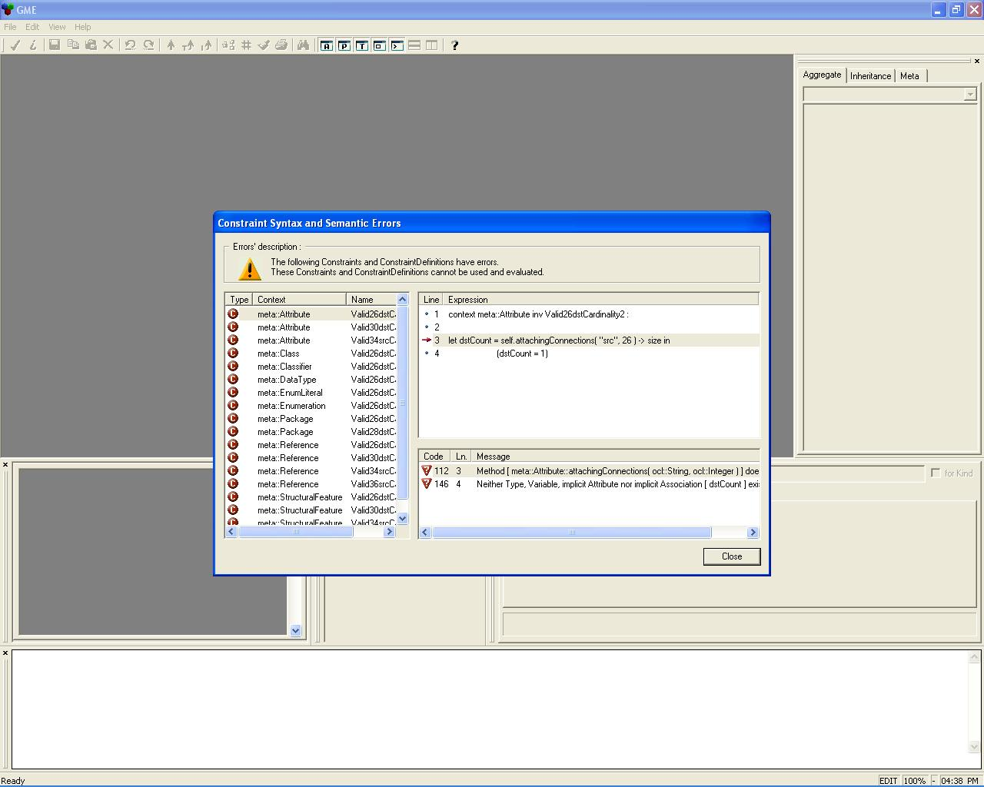
When you create a new model conforms to your metamodel previously imported and registered, there is some errors that we cannot solve about the associations cardinality definition. You can involve the ATL transformation if you see the problem [2].

Solvable error
Error: Duplicate global attribute name found "myAttribute".
This error is due to two attributes having the same name.
You can solve it by renaming one of these attributes.

References
- ATL Home Page
http://www.eclipse.org/gmt/atl/doc/
- GMT Zoo
http://www.eclipse.org/gmt/am3/zoos/
- Vanderbilt University, GME Home Page
http://www.isis.vanderbilt.edu/projects/gme/
- Régis Chevrel ATL Home Page
http://www.sciences.univ-nantes.fr/lina/atl/contrib/chevrel

